 | 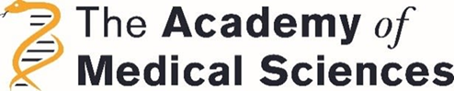 | 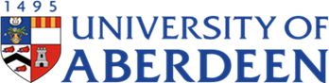

UNIVERSITY OF ABERDEEN
INSPIRE NATIONAL SUMMER RESEARCH SCHOLARSHIP PROGRAMME
This special scholarship category allows medical and dental students from Universities within the UK (out with UoA) to apply for a research scholarship of £1000 to spend their summer in Aberdeen to carry out a summer research project (stipend £150/week for up to 8 weeks plus £1000 to cover accommodation/subsistence.
The applicants will also require to submit class marks and to have identified a project supervisor from the UoA in their submission.
Students who intend to apply for this scholarship for 2024 Summer must complete and return this form by 17.00 hr, 22 March 2024, to:
Scholarship Admin smmsn-ugmed.summerresearch@abdn.ac.uk .
Please save your application as a Microsoft Word document with the file name <surname>< first name><INSPIRE National>
Specific queries can be emailed to Scholarship Admin smmsn-ugmed.summerresearch@abdn.ac.uk
Please complete all fields.
Date Submitted: |  |  | Office Only:
Student Name: |  |  | Student Medical / Dental Course Year:
Medical or Dental school name and address (including post code):
Student Telephone: |  | University student email address:
Current Address:
UoA Supervisor/s’ Name: |  | UoA Supervisor/s’ email(s):
Host Research Institute/Centre in UoA:
IAHS/IMS/RINH/IoD/IEHMS/Research Centre (specify)
Question 1: Tell us about yourself. Why did you decide to apply to this programme and how will it help your future career plans? (maximum word count 150)
Question 2a:  Have you done any prior research or independent study?  YES NO  2b: If yes, please describe what you have done |  | *Prior research experience is NOT a requirement for consideration
Question 3: Please use this space to tell us anything else you feel we should know that might add to your application (maximum of 300 words).

We are committed to making these scholarships available to as many applicants as possible. If you think you might need additional support/reasonable adjustments to attend for interview and/or perform the duties of the scholarship please give details here.
Proposed project title and brief description
(maximum of 200 words)
UoA Supervisor’s supporting statement
(maximum of 200 words)

IMPORTANT!
APPLICANTS WILL BE CALLED FOR AN INTERVIEW IF SHORTLISTED. INTERVIEWS WILL BE HELD IN March/April 2024.
THANK YOU VERY MUCH FOR YOUR INTEREST IN THIS PROGRAMME. WE LOOK FORWARD TO READING YOUR APPLICATION AND LEARNING MORE ABOUT YOUR ACADEMIC GOALS. BEST OF LUCK.

