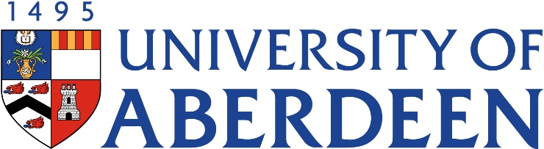

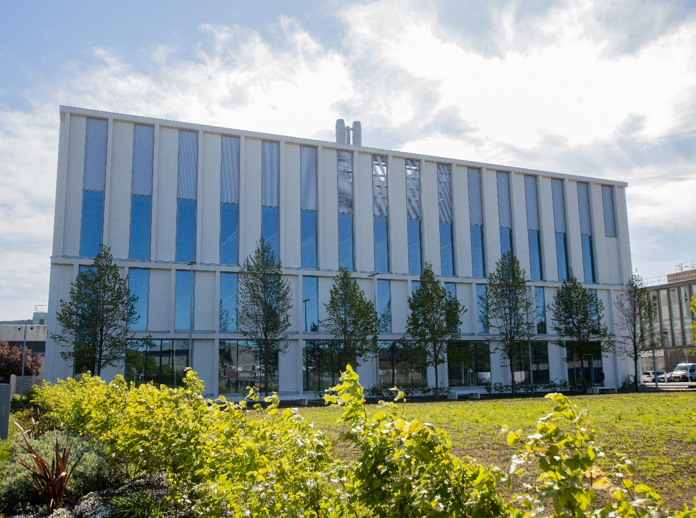
BM3501- Cardiovascular Physiology and Pharmacology
Course Handbook 2023-2024
Undergraduate Medical Sciences
School of Medicine, Medical Sciences & Nutrition
Contents

- Course Summary (3)
- Course Aims & Learning Outcomes
- Course Teaching Staff
- Assessments & Examinations
- Class Representatives (4)
- Problems with Coursework (5)
- Course Reading List
- Lecture Synopsis (6)
- Practical/Lab/Tutorial Work (8)
- University Policies (9)
- Academic Language & Skills support (10)
- Medical Sciences Common Grading Scale (11)
- Course Timetable BM3501: 2023-2024 (12)
- Campus and Floor Maps
Course Summary

The course will cover the physiology and pathophysiology of the mammalian heart and circulatory system. Normal control and adaptation of the cardiovascular system will be examined in detail. The mechanism of action of drugs currently used to treat cardiovascular diseases, such as heart disease and hypertension will be discussed. Practical work will be used to illustrate experimental techniques that are routinely applied to derive knowledge of the function of the cardiovascular system.

Course Co-ordinator: Dr Fiona Murray, fmurray@abdn.ac.uk

Course Aims & Learning Outcomes
1. To provide core knowledge of the physiology of the mammalian cardiovascular system at an advanced level.
2. To relate the pathophysiology of the cardiovascular system to the pharmacology at both a systems and cellular level.
3. To give experience of the appropriate technical skills used in examining the operation of the cardiovascular system.

Course Teaching Staff

Course Co-ordinator(s):
Dr Fiona Murray (FM), Medical Sciences, fmurray@abdn.ac.uk

Other Staff:
- Dr J. Hislop (JH), Medical Science, james.hislop@abdn.ac.uk
- Prof G. Nixon (GFN), Medical Sciences g.f.nixon@abdn.ac.uk
- Prof D. Scott (DAS), Medical Sciences d.scott@abdn.ac.uk
- Dr C Cunningham (CC), Medical Sciences catriona.cunningham@abdn.ac.uk
- Danielle Joyce (DJ), NHS Clinical Physiologist (Guest)

Assessments & Examinations
Students are expected to access and study ALL lectures, and online test materials, and to complete all exercises by the given deadlines. The minimum performance acceptable for the granting of a class certificate is evidence of engagement with, at least, 50% of the lectures and lab classes, and presentation of all set course work. Failure to achieve this may result in your class certificate being withheld.
Completed assignments will be handed in after the assessment via LT or uploaded in MyAberdeen via Turnitin. It is imperative that any reasonable excuses for the late handing in of work are made to the course organiser (Dr F. Murray) before the deadline date. Otherwise the work will not be marked and the class certificate, which is required to sit the examination, may be withheld. The minimum performance acceptable for the granting of a class certificate is attendance at 75% of the lecture classes, and presentation of all set course work, written and oral.
a). Continuous assessment - 20% of the total assessment will be based on 2 case studies. An additional 10% will be based on a laboratory report.
b). Examination - This will take place in the summer diet, April/May, with the re-sit examination in July. It will take the form of an essay-based examination, which will comprise 70% of the assessment for BM3501. The precise format will be a choice of 2 essay questions from a total of 4. The 4 questions will be split into 2 sections and students will answer 1 question from each section i.e. either question 1 or question 2 from section A AND either question 3 or question 4 from section B. Dr Murray will give further information on the exam during the course. All assessments (continuous and examined) will be made using the University Common Grading Scale (copy attached). The continuous assessment mark will normally be considered at a student's second diet of examination. It will be used in cases where a student has been unable to sit the first diet on medical or other grounds.

Class Representatives

We value students’ opinions in regard to enhancing the quality of teaching and its delivery; therefore, in conjunction with the Students’ Association we support the Class Representative system.

In the School of Medicine, Medical Sciences & Nutrition we operate a system of course representatives, who are elected from within each course. Any student registered within a course that wishes to represent a given group of students can stand for election as a class representative. You will be informed when the elections for class representative will take place.

What will it involve?
It will involve speaking to your fellow students about the course you represent. This can include any comments that they may have. You will attend a Staff-Student Liaison Committee and you should represent the views and concerns of the students within this meeting. As a representative, you will also be able to contribute to the agenda. You will then feedback to the students after this meeting with any actions that are being taken.

Training
Training for class representatives will be run by the Students Association. Training will take place within each half-session. For more information about the Class representative system visit www.ausa.org.uk or email the VP Education & Employability vped@abdn.ac.uk . Class representatives are also eligible to undertake the STAR (Students Taking Active Roles) Award with further information about this co-curricular award being available at: www.abdn.ac.uk/careers.

Problems with Coursework

If students have difficulties with any part of the course that they cannot cope with, alone they should notify the course coordinator immediately. If the problem relates to the subject matter general, advice would be to contact the member of staff who is teaching that part of the course. Students with registered disabilities should contact the medical sciences office, (medsci@abdn.ac.uk) (based in the Polwarth Building, Foresterhill) to ensure that the appropriate facilities have been made available. Otherwise, you are strongly encouraged to contact any of the following as you see appropriate:

- Course student representatives
- Course co-ordinator
- Convenor of the Medical Sciences Staff/Student Liaison Committee (Professor Gordon McEwan)
- Personal Tutor
- Medical Sciences Disabilities Co-ordinator (Dr Derryck Shewan)

All staff are based at Foresterhill and we strongly encourage the use of email or telephone the Medical Sciences Office. You may have a wasted journey travelling to Foresterhill only to find staff unavailable.

If a course has been completed and students are no longer on campus (i.e. work from second half session during the summer vacation), coursework will be kept until the end of Fresher’s Week, during the new academic year. After that point, unclaimed student work will be securely destroyed.

Course Reading List (most recent version available is advised)
- Introduction to Cardiovascular Physiology. Levick, J.R.
- Pharmacology. Rang, H.P., Dale, M.M., Ritter, J.M. & Flower, R.J.
- Medical Physiology. Boron, W.F. & Boupaep, E.L.
- Pathophysiology of Heart Disease. Lilly, L.S.
- Cardiovascular Physiology. Berne, R.M. & Levy, M.N.
- Integrated Pharmacology. Page, C. et al.
- Essential Haematology. Hoffbrand, Moss and Pettit (Eds).
- Netter’s Illustrated Pharmacology. Raffa R, Rawls S. Beyzarov E.
- Medical Pharmacology and Therapeutics. Waller D. Sampson T.
There are also other textbooks available in Heavy Demand or General Loan at the Medical School Library that may provide further information on haematology etc.

Lecture Synopsis
Lecture 1. Introduction & Cardiac Muscle Physiology - Prof D. Scott
Review of cardiac muscle contractility. Reading: Levick, Chapters 1 & 2; Lilly, Chapter 1.
Lecture 2. Excitation-contraction coupling in cardiac muscle - Prof D. Scott
The mechanisms which regulate the contractile function of cardiac muscle will be examined at the cellular level. These mechanisms will be related to structure of the cardiac cell. Reading: Levick, Chapter 3.
Lecture 3. Cardiac rhythm and arrhythmias - Prof D. Scott
Revision of the cardiac action potential and conduction. Potential mechanisms of arrhythmias. Drugs used in the treatment of arrhythmias will be examined at a cellular and systems level. Reading: Levick, Chapters 4 & 5; Lilly, Chapters 4, 11, 12 & 17.
Lecture 4. Endothelium – Prof G. Nixon
An introduction to the role of endothelium in the cardiovascular system. Reading: Levick, Chapter 9.
Lecture 5. Vascular smooth muscle contractility– Prof G. Nixon
The mechanisms which increase intracellular calcium, and how this leads to contraction of smooth muscle at a cellular level, will be discussed. Reading: Levick, Chapter 12.
Lecture 6. Physiology of platelets, haemostasis and thrombosis - Prof G. Nixon
What is haemostasis? Mechanisms of the fluid blood coagulation system; platelet function; blood vessel wall; fibrinolysis; natural inhibitors; an integrated haemostatic system. What is thrombosis? Involvement of coagulation and platelet activation in atherosclerosis and arterial thrombosis; the pathogenesis of heart attacks and stroke. Methods for study of platelets and coagulation. Reading: Rang et al., Chapter 24 and Moss and Pettit.
Lecture 7. Pharmacology of anticoagulants and antiplatelet drugs- Prof G. Nixon
Anticoagulants – mechanisms of action; antiplatelet drugs - mechanisms; indications for use; effectiveness; factors in variability or resistance; drug interactions; side-effects; clinical trials; development of new drugs. Reading: Rang et al., Chapter 24 and Moss and Pettit
Lecture 8. Atherosclerosis and Statins - Prof G. Nixon
The causes and cardiovascular consequences of atherosclerosis will be described. In addition, the therapeutics used to treat atherosclerosis, and particularly the success of statins, will also be discussed.
Lecture 9. Intravenous (IV) Fluids & Medications – Dr D. Scott
In this lecture, we will discuss the various types of fluid and medications that are administered intravenously. Some of the most commonly prescribed “medications” in clinical practice are IV fluids, but do you actually know what they contain or what they do? We will consider the various ways that we can replace fluid, electrolytes and nutrients, and explain the properties of various crystalloid and colloid solutions. Finally, we will consider what happens if these solutions are given inappropriately.
Lecture 10. Introduction to special circulations - Dr D. Scott
Each tissue has its own special function, and this often calls for specialised vascular control. The skin, for example, regulates body heat, and its blood flow is controlled largely by temperature. In the heart, by contrast, metabolic rate dominates vascular control. Five circulations (heart, skeletal muscle, skin, brain and lung) are introduced during this lecture to illustrate both their physiological importance and their contrasting characteristics. Reading: Levick, Chapter 15.
Lecture 11. Pathophysiology and Pharmacology of Diabetes - Dr D. Scott
This session will cover the pathophysiology of diabetes mellitus. The lecture will briefly cover how diabetes is diagnosed and monitored and what therapeutic options are available to control blood sugar levels and minimise diabetic complications. We will end by considering why diabetes can enhance cardiovascular risk. Reading: Rang et al., Chapter 26.
Lecture 12-13. Pathophysiology and Pharmacology of heart disease (Ischaemic heart disease/Congestive heart failure) – Dr F. Murray
The causes, risk factors, diagnosis and symptoms of angina, MI and heart failure will be defined. Drugs used in their management and their mechanism of action, adverse reactions and tolerance will be discussed: Beta-blockers, calcium channel antagonists, nitrates, potassium channel openers, diuretics, ACE inhibitors, Angiotensin receptor antagonists, aldosterone antagonists. Reading: Lilly, Chapters 6, 9, 16 & 17. See also individual drugs in Rang et al.
Lecture 14. Pathophysiology and Pharmacology of hypertension - Dr F. Murray
Essential and secondary hypertension will be defined. Changes in afterload and peripheral vascular resistance will be described and the resulting pathophysiological changes. Drugs used in the treatment of hypertension will be described. Reading: Lilly, Chapters 13 & 17. See also individual drugs in Rang et al.
Lecture 15. Pathophysiology and Pharmacology of Pulmonary Hypertension – Dr F. Murray
Pulmonary hypertension will be defined. The symptoms, causes and diagnosis of pulmonary hypertension will be outlined. Drugs used in the treatment of pulmonary hypertension and their mechanism of action will be discussed: Calcium channels antagonists, Prostacyclin analogues, Endothelin receptor antagonists and Phosphodiesterase 5 inhibitors. Reading: Lilly, Chapters 3 & 17. See also individual drugs in Rang et al.

Practical/Lab/Tutorial Work
Practical:
You are expected to participate in the practical session to obtain a class certificate.
Guidance will be given at each practical class and information about the lab classes will be available on MyAberdeen prior to each class.
Please read through the practical guidance using MyAberdeen so that you have some knowledge of what is expected. Below is a brief synopsis of the practical class.
This will take the form of 1 day of "wet" lab practical and will examine how blood samples are routinely analysed for specific metabolites. Students will learn how to carry out assays on specimens to help them understand how they might handle samples in a working research laboratory. Students will also be instructed about the safety and ethical concerns that they might have to consider when working with human subjects and blood samples.

Case Studies
You are required to complete 2 case study assessments on particular areas of cardiovascular physiology or pharmacology. Each case study will contribute 10% of the continuous assessment mark and the lab report 10% towards your final course mark. The content of each case study will be circulated to the class approximately 1 week before the deadline for completion. All students will have to undertake independent revision and study in order to find out the answers as you will not be able to rely on lecture notes alone. On the date of completion of a case study, the class will answer the questions via LT. Students are strongly encouraged to include as much extra reading, mechanistic detail and relevant discussion as they can during these case study assessments.

University Policies

Students are asked to make themselves familiar with the information on key education policies, available here. These policies are relevant to all students and will be useful to you throughout your studies. They contain important information and address issues such as what to do if you are absent, how to raise an appeal or a complaint and how the University will calculate your degree outcome.
These University wide education policies should be read in conjunction with this programme and/or course handbook, in which School specific policies are detailed. These policies are effective immediately, for the 2022/23 academic year. Further information can be found on the University’s Infohub webpage or by visiting the Infohub.

The information included in the institutional area for 2022-23 includes the following:
- Assessment
- Feedback
- Academic Integrity
- Absence
- Student Monitoring/ Class Certificates
- Late Submission of Work
- Student Discipline
- The co-curriculum
- Student Learning Service (SLS)
- Professional and Academic Development
- Graduate Attributes
- Email Use
- MyAberdeen
- Appeals and Complaints

Where to Find the Following Information:

C6/C7- University of Aberdeen Homepage > Students > Academic Life > Monitoring and Progress > Student Monitoriung (C6 & C7)
https://www.abdn.ac.uk/students/academic-life/student-monitoring.php#panel5179

Absences- To report absences you should use the absence reporting system tool on Student Hub. Once you have successfully completed and sent the absence form you will get an email that your absence request has been accepted. The link below can be used to log onto the Student Hub Website and from there you can record any absences you may have.

Log In - Student Hub (ahttps://www.abdn.ac.uk/studenthub/loginbdn.ac.uk)

Submitting an Appeal- University of Aberdeen Homepage > Students > Academic Life > Appeals and Complaints

https://www.abdn.ac.uk/students/academic-life/appeals-complaints-3380.php#panel2109

Academic Language & Skills support
For students whose first language is not English, the Language Centre offers support with Academic Writing and Communication Skills.

Academic Writing
- Responding to a writing task: Focusing on the question
- Organising your writing: within & between paragraphs
- Using sources to support your writing (including writing in your own words, and
citing & referencing conventions)
- Using academic language
- Critical Thinking
- Proofreading & Editing

Academic Communication Skills
- Developing skills for effective communication in an academic context
- Promoting critical thinking and evaluation
- Giving opportunities to develop confidence in communicating in English
- Developing interactive competence: contributing and responding to seminar discussions
- Useful vocabulary and expressions for taking part in discussions

More information and how to book a place can be found here

Medical Sciences Common Grading Scale

Grade | Grade Point | % Mark | Category | Honours Class | Description
A1 | 22 | 90-100 | Excellent | First | • Outstanding ability and critical thought  • Evidence of extensive reading  • Superior understanding  •The best performance that can be expected from a student at this level
A2 | 21 | 85-89 | Excellent | First
A3 | 20 | 80-84 | Excellent | First
A4 | 19 | 75-79 | Excellent | First
A5 | 18 | 70-74 | Excellent | First
B1 | 17 | 67-69 | Very Good | Upper Second | • Able to argue logically and organise answers well  • Shows a thorough grasp of concepts  • Good use of examples to illustrate points and justify arguments  • Evidence of reading and wide appreciation of subject
B2 | 16 | 64-66 | Very Good | Upper Second
B3 | 15 | 60-63 | Very Good | Upper Second
C1 | 14 | 57-59 | Good | Lower Second | • Repetition of lecture notes without evidence of further appreciation of subject  • Lacking illustrative examples and originality  • Basic level of understanding
C2 | 13 | 54-56 | Good | Lower Second
C3 | 12 | 50-53 | Good | Lower Second
D1 | 11 | 47-49 | Pass | Third | • Limited ability to argue logically and organise answers  • Failure to develop or illustrate points  • The minimum level of performance required for a student to be awarded a pass
D2 | 10 | 44-46 | Pass | Third
D3 | 9 | 40-43 | Pass | Third
E1 | 8 | 37-39 | Fail | Fail | • Weak presentation  • Tendency to irrelevance  • Some attempt at an answer but seriously lacking in content and/or ability to organise thoughts
E2 | 7 | 34-36 | Fail | Fail
E3 | 6 | 30-33 | Fail | Fail
F1 | 5 | 26-29 | Clear Fail | Not used for Honours | • Contains major errors or misconceptions  • Poor presentation
F2 | 4 | 21-25 | Clear Fail | Not used for Honours
F3 | 3 | 16-20 | Clear Fail | Not used for Honours
G1 | 2 | 11-15 | Clear Fail/Abysmal |  | • Token or no submission
G2 | 1 | 1-10 | Clear Fail/Abysmal |  | • Token or no submission
G3 | 0 | 0 | Clear Fail/Abysmal |  | • Token or no submission

BM3501 Course Timetable: 2023-2024
Date | Time | Place | Subject | Session | Staff
Week 26
Mon 22 Jan | 14:00-15:00 | St Mary’s (G3) | Introduction & Cardiac muscle Physiology | Lecture | DAS
Tue 23 Jan | 09:00-10:00 | Biomedical Physics lecture theatre | Excitation-contraction coupling in cardiac muscle | Lecture | DAS
Fri 26 Jan | 14:00-15:00 | St Mary’s (G3) | Cardiac rhythm and arrhythmias | Lecture | DAS
Week 27
Mon 29 Jan | 14:00-15:00 | St Mary’s (G3) | Endothelium | Lecture | GFN
Tue 30 Jan | 09:00-10:00 | Biomedical Physics lecture theatre | Vascular smooth muscle contractility | Lecture | GFN
Fri 2 Feb | 13:00-14:00 | Biomedical Physics lecture theatre | Physiology of platelets, haemostasis and thrombosis | Lecture | GFN
Week 28
Mon 5 Feb | 14:00-15:00 | St Mary’s (G3) | Intravenous Fluids | Lecture | DAS
Tue 6 Feb | 09:00-10:00 | Biomedical Physics lecture theatre | Pharmacology of anticoagulants and antiplatelet drugs | Lecture | GFN
Wed 7 Feb |  |  | Case Study Assessment I Released | Assessment (LT) | DAS/FM/CC
Fri 9 Feb | 14:00-15:00 | St Mary’s (G3) | Atherosclerosis and Statins | Lecture | GFN
Fri 9 Feb | 15:00-16:00 | St Mary’s (G3) | Clinical Cardiac Physiology | Tutorial | DJ
Week 29
Mon 12 Feb | 14:00-15:00 | St Mary’s (G3) | Introduction to special circulations | Lecture | DAS
Tue 13 Feb | 09:00-10:00 | STH (Flexi lab_0.004) | Measurement of blood lactate | Practical | FM/JH
Fri 16 Feb | 14:00-15:00 | Biomedical Physics lecture theatre | Pathophysiology and Pharmacology of Heart Disease – Part 1 | Lecture | FM
Week 30
Mon 19 Feb | 14:00-15:00 | LT3 | Pathophysiology and Pharmacology of Heart Disease – Part 2 | Lecture | FM
Tue 20 Feb | 09:00-10:00 | Biomedical Physics lecture theatre | Pathophysiology and Pharmacology of Diabetes | Lecture | DAS
Wed 21 Feb |  |  | Case Study Assessment 2 Released | Assessment (LT) | DAS/FM/CC
Fri 23 Feb | 14:00-15:00 | St Mary’s (G3) | Pathophysiology and Pharmacology of Hypertension | Lecture | FM
Fri 23 Feb | 15:00-16:00 | St Mary’s (G3) | Pathophysiology and Pharmacology of Pulmonary Hypertension | Lecture | FM
Staff
- Dr Fiona Murray (FM), Medical Sciences, fmurray@abdn.ac.uk
- Dr J. Hislop (JH), Medical Science, james.hislop@abdn.ac.uk
- Prof G. Nixon (GFN), Medical Sciences g.f.nixon@abdn.ac.uk
- Prof D. Scott (DAS), Medical Sciences d.scott@abdn.ac.uk
- Dr C Cunningham (CC). Medical Sciences catriona.cunningham@abdn.ac.uk
- Danielle Joyce (DJ), NHS Clinical Physiologist (Guest)

Campus Maps - Foresterhill

