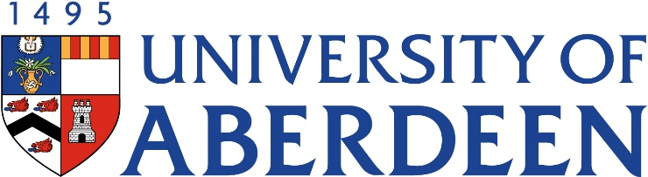
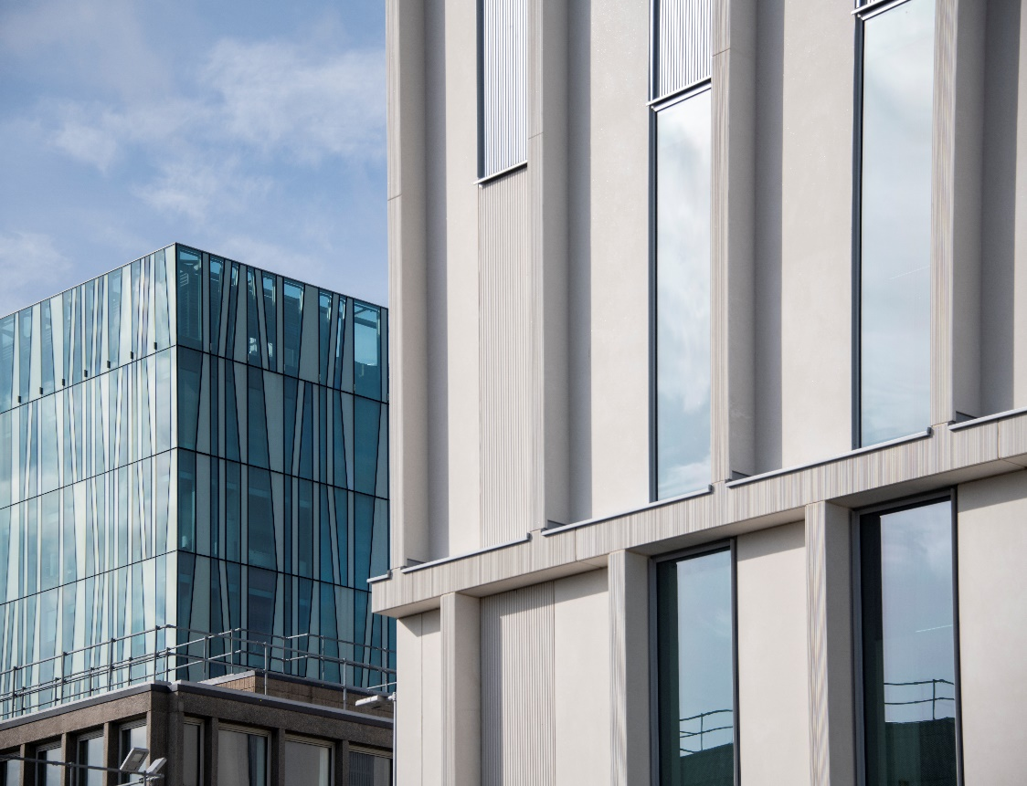
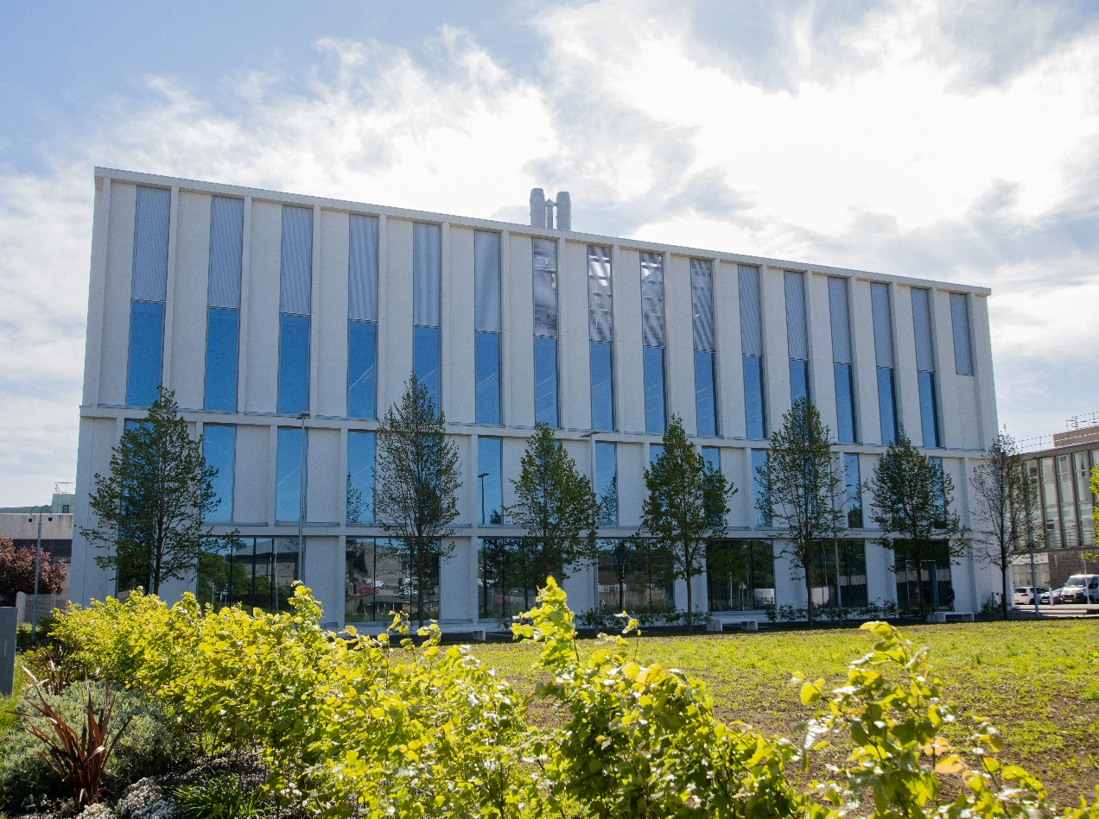
AN3504- Human Movement Dissected
Course Handbook 2023-2024
Undergraduate Medical Sciences
School of Medicine, Medical Sciences & Nutrition
Contents

- Course Summary (3)
- Course Aims & Learning Outcomes
- Course Teaching Staff
- Assessments & Examinations (4)
- Class Representatives
- Problems with Coursework (5)
- Course Reading List
- Lecture Synopsis (6)
- Practical/Lab/Tutorial Work (7)
- University Policies (9)
- Academic Language & Skills support (10)
- Medical Sciences Common Grading Scale (11)
- Course Timetable AN3504: 2023-2024 (12)
- Campus and Floor Maps

Course Summary
This course will give you an in-depth understanding of the human musculoskeletal system, how it produces movements of the body and how it can be affected by injury and disease. Students will gain hands-on experience of human dissection, imaging techniques and image analysis. They will learn which information can, and cannot, be obtained using different imaging techniques. The students will obtain transferrable skills, including problem-solving and presentation practice. This course will be taught jointly by basic scientists, clinicians and technicians.
​Acting Course Co-ordinators: Dr Bahgat Sami (ext. 4322) bahgat.sami@abdn.co.uk

Course Aims & Learning Outcomes

- Students will be able to explain structure-function relationships and clinical conditions in the musculoskeletal system.
- Students will be able to perform and describe dissections of cadaveric human specimens.
- Students will be able to interpret, compare and contrast images of the musculoskeletal system obtained with different imaging techniques (e.g. MRI, CT, PET, microscopy).
- Students will be able to perform histological staining of tissue samples, understand the procedure and analyse results.
- Students will be able to apply their knowledge about the musculoskeletal system and relevant imaging techniques to solve clinical problems.
- Students will be able to prepare and deliver an oral presentation and short report about a selected research topic.

Course Teaching Staff
Course Co-ordinator: Dr Bahgat Sami (ext. 4322) bahgat.sami@abdn.co.uk

Other Staff:
Prof Andy Welch (AW), a.welch@abdn.ac.uk
Prof Simon Parson (SP), simon.parson@abdn.ac.uk
Dr Flora Groening, f.groening@abdn.ac.uk
Dr David Chorn Dr (DC) d.j.chorn@abdn.ac.uk
Dr Jenny Gregory (JG), j.gregory@abdn.ac.uk
Dr Debbie Wilkinson (DW), debbie.wilkinson@abdn.ac.uk
Ms. Lucy Wight (LW), l.wight@abdn.ac.uk
Mr Ron Coutts (RC), ron.coutts@abdn.ac.uk
Mrs Gillian Milne (GM), gillian.milne@abdn.ac.uk
Dr Arimantas Lionikas (AL), a.lionikas@abdn.ac.uk
Dr Brian Morrissey (BM), brian.morrissey2@abdn.ac.uk

Assessments & Examinations
The continuous assessment mark for this course is made up as follows:-

15% Dissection report Lab Report Individual
5% MCQ test for microscopy practical MCQ exam
5% Short report on selected research topic Project plan, summary of abstract
5% PechaKucha talk on selected research topic Oral Presentation Individual
10% Clinical case assessment Take Home Exam

40% Total Continuous assessment
60% Written exam

100% Overall total marks

Students are expected to attend all lectures, laboratory classes and other elements of the course, and to complete all class exercises by the stated deadlines. Marks will be deducted where deadlines fail to be met without a legitimate reason e.g. sickness accompanied by a medical certificate. It is imperative that any reasonable excuses for the late handing in of work are made to the course organisers Dr Bahgat Sami, before the deadline date. Failure to submit work on time with no legitimate cause may result in deduction of marks or withdrawal from the course.
The course will be assessed by continual assessment and by a 1.5 hour written examination held in April/May. The continuous assessment contributes 40% to the final mark and the written exam will contribute 60%. The overall performance of the student will be expressed as a grade awarded on the common grading scale (CGS).
The resit examination is held in June/July. The continuous assessment mark will also be included at a student's second and any subsequent diets of examination. It is therefore imperative that students apply the same effort to their continuous assessment exercises as their exam preparation. Failure to submit this work without due cause can severely hamper the overall mark for the course.

Class Representatives

We value students’ opinions in regard to enhancing the quality of teaching and its delivery; therefore, in conjunction with the Students’ Association we support the Class Representative system.

In the School of Medicine, Medical Sciences & Nutrition we operate a system of course representatives, who are elected from within each course. Any student registered within a course that wishes to represent a given group of students can stand for election as a class representative. You will be informed when the elections for class representative will take place.

What will it involve?
It will involve speaking to your fellow students about the course you represent. This can include any comments that they may have. You will attend a Staff-Student Liaison Committee and you should represent the views and concerns of the students within this meeting. As a representative, you will also be able to contribute to the agenda. You will then feedback to the students after this meeting with any actions that are being taken.

Training
Training for class representatives will be run by the Students Association. Training will take place within each half-session. For more information about the Class representative system visit www.ausa.org.uk or email the VP Education & Employability vped@abdn.ac.uk . Class representatives are also eligible to undertake the STAR (Students Taking Active Roles) Award with further information about this co-curricular award being available at: www.abdn.ac.uk/careers.

Problems with Coursework

If students have difficulties with any part of the course that they cannot cope with, alone they should notify the course coordinator immediately. If the problem relates to the subject matter general, advice would be to contact the member of staff who is teaching that part of the course. Students with registered disabilities should contact the medical sciences office, (medsci@abdn.ac.uk) (based in the Polwarth Building, Foresterhill) to ensure that the appropriate facilities have been made available. Otherwise, you are strongly encouraged to contact any of the following as you see appropriate:

- Course student representatives
- Course co-ordinator
- Convenor of the Medical Sciences Staff/Student Liaison Committee (Professor Gordon McEwan)
- Personal Tutor
- Medical Sciences Disabilities Co-ordinator (Dr Derryck Shewan)

All staff are based at Foresterhill and we strongly encourage the use of email or telephone the Medical Sciences Office. You may have a wasted journey travelling to Foresterhill only to find staff unavailable.

If a course has been completed and students are no longer on campus (i.e. work from second half session during the summer vacation), coursework will be kept until the end of Fresher’s Week, during the new academic year. After that point, unclaimed student work will be securely destroyed.

Course Reading List
There is no single recommended textbook that covers all the material in the course. The lecturers responsible for each section of the course will provide detailed guidance to enable students to follow up topics of particular interest. All lecture slides will be available through My Aberdeen and they contain the key information students are expected to know for the examination. Below are some recommended references for this course:

Moore's Essential Clinical Anatomy, 6th Ed. (2019)
Agur, A. M. R. Moore’s Essential Clinical Anatomy . Edited by Arthur F. Dalley and Keith L. Moore, 6th ed. / Anne M.R. Agur, Arthur F. Dalley II., Keith L. Moore., Lippincott Williams & Wilkins, 2019.
ISBN: 9781975114435 https://abdn.leganto.exlibrisgroup.com/leganto/public/44ABE_INST/citation/5264659290005941?auth=SAML

Grant's Dissector, 17th Ed. (2021)
Detton, Alan J. author. Grant’s Dissector. Edited by J. C. Boileau (John Charles Boileau) Grant, Edition 17 / Alan J. Detton, PhD., Wolters Kluwer, 2021.
ISBN: 9781975134655
https://abdn.leganto.exlibrisgroup.com/leganto/public/44ABE_INST/citation/5264659260005941?auth=SAML

Lecture Synopsis
Lecture 1. Introduction to the course & key elements of musculoskeletal anatomy – Bahgat Sami
Introducing the course to the students and highlighting the importance of the MSK structure-function relationships. Explain the hand on activities (dissection & histological staining) which will enable the students to understand the structure and function of the MSK and the relevant imaging techniques which are required to solve clinical problems.

Lecture & practical 2. Musculoskeletal ultrasound imaging - Dr Ross Thomson
The origins of ultrasound technology will be reviewed. Its use in both the clinical and research environments will be explored followed by a hands-on session exploring the benefits and limitations of the technology.

Lecture 3. Biomechanics of human movement – Dr Flora Groening
This session will provide an overview of basic biomechanical principles and explore how those principles explain key structure-function relationships in the human musculoskeletal system. It will discuss the forces involved in producing movements, internal and external forces that act on the body during movement and the ways in which the human body is adapted to dissipate those forces without injury. The session will include some interactive elements.

Lecture 4. Microscopy Lecture – AL/GM
Overview of microscopy techniques: - including sample preparation and imaging methods for light, fluorescence and electron microscopy.

Lecture and practical 5. Staining & image analysis: JG/AL /DW/LW/GM
The practical is designed to provide some experience in laboratory and imaging techniques used to study tissues involved in locomotion, including sectioning, staining, microscopy and image analysis. It will specifically focus on bone, skeletal muscle and cartilage.

Lecture 6. Musculoskeletal Clinical Radiology - BM
The development of MRI and CT scanning techniques will be described and their advantages and disadvantages, over the more traditional X-ray, in clinical applications will be considered.

Lecture 7. Nuclear Medicine Bone Imaging – Prof. Andy Welch
How PET scanning works will be explained and some applications in clinical medicine and biological research will be discussed.

Practical/Lab/Tutorial Work/Assessments
The practical work required in this course may present difficulties to students with special educational needs. For such students, alternative arrangements will be made. Any student with special needs should make these known to the Course Co-ordinator when registering for the class and should then also discuss their needs with the Medical Sciences Disabilities Co-ordinator, to ensure that they have the best possible outcome. A detailed protocol for each activity, and any related report writing, will be provided at each session.

The following laboratory/course activities/assessments will be organised:

- Anatomy Dissection- Three Sessions (15%): Suttie Centre, Anatomy Lab, Room 313

This part of the course provides you with an introduction to the practical skills necessary to carry out dissection of human cadaveric material. It acts as a preparatory guide to the practical anatomy in the fourth year. You will be required to prepare a dissection of a part of the upper/lower limb. You will NOT be penalised for the dissection procedure; indeed, you will be awarded for your efforts rather than the quality of the dissection.
In these sessions, you will be guided in stages through the preparation of a human cadaveric part including superficial dissection i.e. removing the skin and deep dissection to explore the underlying structures likes muscles, tendons, joints, bones etc. Each session will be guided by a member of staff. Emphasis should be on care and precision – it is not a speed exercise. We don’t expect you to finish the dissection completely in each session, however, you must write a brief report about what you have done by the end of each session to complete a portfolio by the end of the course.

- Microscopy & Saining practical lab at the new state-of-the-art Science Teaching Hub (TBC)

The practical will include a tour of histology facility in the Lab, followed by hands on staining of bone/muscle wax sections using Haematoxylin and Eosin and also Safranin O/Fast green and staining of ATPase on frozen muscle sections. Images will then be captured of these different sections and image analysis carried out using ImageJ/FIJI.
Bone is comprised of three main cell types; osteoblasts, osteocytes and osteoclasts. Osteoblasts are responsible for the formation of new bone and osteocytes are the cells formed when an osteoblast becomes embedded in the newly formed bone matrix. Osteoclasts are large multinucleated cells which are responsible for the resorption of bone. To prepare the sections the bone must be decalcified in a solution of ethylenediaminetetraacetic acid (EDTA) for several weeks. Once decalcification is complete, 5 µm sections can be cut on a microtome, mounted onto glass slides and then stained.
Skeletal muscle is composed of muscle fibres, large, polynucleated cells, able to contract in response to neural excitation. Muscle fibres are not homogeneous in their contractile, morphological and metabolic properties. Histochemical staining based on ATPase activity of the main contractile protein, myosin, can be used to discriminate between the type I and type II fibres present in human muscles and study them in health and disease. Image analysis of these fibres will be carried out using ImageJ software.
Cartilage is a semi rigid flexible connective tissue involved in support in bone development and has a high mechanical strength. There are three types – hyaline (cartilage), elastic (external ear) and fibrocartilage (intervertebral discs). It consists of chondroblasts - secretes extracellular matrix and fibres and chondrocytes - mature cells derived from the chondroblasts that have embedded themselves within the cartilage matrix.
You will do a test within this staining and microscopy practical.

This test will form (5%) part of your continuous assessment for this course.

- Musculoskeletal Clinical Radiology Tutorial

You will attend a tutor-led plenary discussion about clinical imaging, having been given material to study beforehand. Students must attend and are expected to be fully prepared for this exercise. Students must also fully participate in the tutorial.

- Short report on selected research topic (5%)

You will work individually and are given a selected (musculoskeletal) topic that can be investigated using imaging techniques. You consider which techniques might be applicable to investigating the problem and research the methodologies. You will write an individual report and should be submitted online via MyAberdeen. Further detailed instructions will be provided via MyAberdeen during the course. This exercise is intended to make you think about everything you have learned in the course and improve your ademic writing.
This report will form (5%) part of your continuous assessment for this course.

- PechaKucha talks (5%)

You will prepare a brief presentation (PechaKucha talks) to be given individually then a brief time afterwards for questions or discussion of the interesting points you cover. You should use no more than 15 slides in the PechaKucha format, and you should display each slide on the screen for no more than 20 seconds, (PechaKucha is 15 slides * 20 seconds).

- Clinical case-study assessment (10%)

You will be given a case study that presents a several MSK clinical conditions that can be investigated using different imaging techniques likes x-rays, US, CT, MRI and biopsy with histology. This exercise is intended to make you apply everything you have learned in the course. You need to answer a set of questions and you will consider which specific techniques might be applicable to investigating each situation. To support your answers, you might search libaray/online reliable clinical resourses, and you will need to cite any references/resources into your report.
Your report should be submitted online via MyAberdeen. Further detailed instructions will be provided via MyAberdeen during the course.

This assessment will form (10%) part of your continuous assessment for this course.

University Policies

Students are asked to make themselves familiar with the information on key education policies, available here. These policies are relevant to all students and will be useful to you throughout your studies. They contain important information and address issues such as what to do if you are absent, how to raise an appeal or a complaint and how the University will calculate your degree outcome.
These University wide education policies should be read in conjunction with this programme and/or course handbook, in which School specific policies are detailed. These policies are effective immediately, for the 2022/23 academic year. Further information can be found on the University’s Infohub webpage or by visiting the Infohub.

The information included in the institutional area for 2022-23 includes the following:
- Assessment
- Feedback
- Academic Integrity
- Absence
- Student Monitoring/ Class Certificates
- Late Submission of Work
- Student Discipline
- The co-curriculum
- Student Learning Service (SLS)
- Professional and Academic Development
- Graduate Attributes
- Email Use
- MyAberdeen
- Appeals and Complaints
Where to Find the Following Information:

C6/C7- University of Aberdeen Homepage > Students > Academic Life > Monitoring and Progress > Student Monitoriung (C6 & C7)
https://www.abdn.ac.uk/students/academic-life/student-monitoring.php#panel5179

Absences- To report absences you should use the absence reporting system tool on Student Hub. Once you have successfully completed and sent the absence form you will get an email that your absence request has been accepted. The link below can be used to log onto the Student Hub Website and from there you can record any absences you may have.
Log In - Student Hub (ahttps://www.abdn.ac.uk/studenthub/loginbdn.ac.uk)

Submitting an Appeal- University of Aberdeen Homepage > Students > Academic Life > Appeals and Complaints
https://www.abdn.ac.uk/students/academic-life/appeals-complaints-3380.php#panel2109

Academic Language & Skills support
For students whose first language is not English, the Language Centre offers support with Academic Writing and Communication Skills.

Academic Writing
- Responding to a writing task: Focusing on the question
- Organising your writing: within & between paragraphs
- Using sources to support your writing (including writing in your own words, and
citing & referencing conventions)
- Using academic language
- Critical Thinking
- Proofreading & Editing

Academic Communication Skills
- Developing skills for effective communication in an academic context
- Promoting critical thinking and evaluation
- Giving opportunities to develop confidence in communicating in English
- Developing interactive competence: contributing and responding to seminar discussions
- Useful vocabulary and expressions for taking part in discussions

More information and how to book a place can be found here
Medical Sciences Common Grading Scale

Grade | Grade Point | % Mark | Category | Honours Class | Description
A1 | 22 | 90-100 | Excellent | First | • Outstanding ability and critical thought  • Evidence of extensive reading  • Superior understanding  •The best performance that can be expected from a student at this level
A2 | 21 | 85-89 | Excellent | First
A3 | 20 | 80-84 | Excellent | First
A4 | 19 | 75-79 | Excellent | First
A5 | 18 | 70-74 | Excellent | First
B1 | 17 | 67-69 | Very Good | Upper Second | • Able to argue logically and organise answers well  • Shows a thorough grasp of concepts  • Good use of examples to illustrate points and justify arguments  • Evidence of reading and wide appreciation of subject
B2 | 16 | 64-66 | Very Good | Upper Second
B3 | 15 | 60-63 | Very Good | Upper Second
C1 | 14 | 57-59 | Good | Lower Second | • Repetition of lecture notes without evidence of further appreciation of subject  • Lacking illustrative examples and originality  • Basic level of understanding
C2 | 13 | 54-56 | Good | Lower Second
C3 | 12 | 50-53 | Good | Lower Second
D1 | 11 | 47-49 | Pass | Third | • Limited ability to argue logically and organise answers  • Failure to develop or illustrate points  • The minimum level of performance required for a student to be awarded a pass
D2 | 10 | 44-46 | Pass | Third
D3 | 9 | 40-43 | Pass | Third
E1 | 8 | 37-39 | Fail | Fail | • Weak presentation  • Tendency to irrelevance  • Some attempt at an answer but seriously lacking in content and/or ability to organise thoughts
E2 | 7 | 34-36 | Fail | Fail
E3 | 6 | 30-33 | Fail | Fail
F1 | 5 | 26-29 | Clear Fail | Not used for Honours | • Contains major errors or misconceptions  • Poor presentation
F2 | 4 | 21-25 | Clear Fail | Not used for Honours
F3 | 3 | 16-20 | Clear Fail | Not used for Honours
G1 | 2 | 11-15 | Clear Fail/Abysmal |  | • Token or no submission
G2 | 1 | 1-10 | Clear Fail/Abysmal |  | • Token or no submission
G3 | 0 | 0 | Clear Fail/Abysmal |  | • Token or no submission

AN3504 Course Timetable: 2023-2024
Date | Time | Place | Subject | Session | Staff
Week 26
Mon 22 Jan | 14:00-15:00 | PW 1:039/40 (40) | Introduction to course & key elements of MSK anatomy | Lecture | BS
Tue 23 Jan | 11:00-14:00 | MP D2 | Musculoskeletal ultrasound imaging | Lecture | RT
Wed 24 Jan
Thu 25 Jan
Fri 26 Jan | 14:00-17:00 | PW 2:054 (80) | Biomechanics of human movement | Lecture | FG
Week 27
Mon 29 Jan | 14:00-15:00 | PW 2:054 (80) | Microscopy & Staining | Lecture | GM
Tue 30 Jan | 10:00-17:00 | STH Flexi Lab 0.004 | Microscopy & Staining | Practical | LW/RS/DW/JG/AL
Wed 31 Jan
Thu 1 Feb
Fri 2 Feb | 09:00-11:00 | PW 1:039/40 (40) | Musculoskeletal Clinical Radiology | Lecture | BM
Fri 2 Feb | 14:00-17:00 | SC 304 Lab | Dissection lab 1 | Practical | BS
Week 28
Mon 5 Feb
Tue 6 Feb | 12:00-17:00 | SC 304 Lab | Dissection lab 2 | Practical | BS
Wed 7 Feb
Thu 8 Feb
Fri 9 Feb | 10:00-12:00 | PW 1:039/40 (40) | Musculoskeletal Clinical Radiology | Tut | BM
Fri 9 Feb | 14:00-17:00 | SC 304 Lab | Dissection lab 3 | Practical | BS
Week 29
Mon 12 Feb
Tue 13 Feb
Wed 14 Feb
Thu 15 Feb
Fri 16 Feb | 10:00-11:00 | PW 1:039/40 (40) | Nuclear Medicine Bone Imaging | Lecture | AW
Week 30
Mon 19 Feb | 14:00-17:00 | PW 1:039/40 (40) | Prepare talks/reports/case study | Private study | DC/BS
Tue 20 Feb | 10:00-13:00 | PW 1:039/40 (40) | Prepare talks/reports/case study | Workshop | DC/BS
Tue 20 Feb | 14:00-17:00 | PW 1:032/33 (40) | Presentation PechaKucha talks | Presentation | DC/BS
Wed 21 Feb
Thu 22 Feb
Fri 23 Feb | 14:00-17:00 | PW 2:054 (80) | Presentation PechaKucha talks | Presentation | DC/BS

Venues:
PW: Polwarth Building
MP: Medical Physics Building
SC: Suttie Centre
STH: Sciences Teaching Hub

Staff:
- Dr Bahgat Sami (BS), (Course Co-ordinator), bahgat.sami@abdn.ac.uk
- Mr David Chorn (DC), d.j.chorn@abdn.ac.uk
- Dr Jenny Gregory (JG), j.gregory@abdn.ac.uk
- Dr Debbie Wilkinson (DW), debbie.wilkinson@abdn.ac.uk
- Ms. Lucy Wight (LW), l.wight@abdn.ac.uk
- Prof Andy Welch (AW), a.welch@abdn.ac.uk
- Dr Flora Groening, f.groening@abdn.ac.uk
- Mrs Gillian Milne (GM), gillian.milne@abdn.ac.uk
- Dr Arimantas Lionikas (AL), a.lionikas@abdn.ac.uk
- Dr Rebecca Symons (RS), rebecca.symons1@abdn.ac.uk
- Dr Brian Morrissey (BM), brian.morrissey2@abdn.ac.uk

Campus Maps - Foresterhill

Polwarth Floor Plans

