Make a recycled bird feeder (Taken from rspb.co.uk)
Make a bird feeder from the bottles you would throw away.

Stuff you need
Plastic drinks bottles, yoghurt pots or milk cartons (make sure they're clean), wire or string, bird seed, scissors.
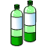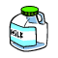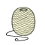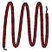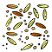

Important notes
This will require adult help with cutting. Be aware of nut allergies.

Steps
- Cut a hole in the side large enough to allow a free flow of seeds, but in such a way that it won’t all fall out on the ground in the slightest puff of wind, and won’t get wet if it rains.
- Make a few small holes in the bottom of your feeder to allow any rainwater to drain away.
- Hang it with wire, or even strong string from a tree or your washing line.
.
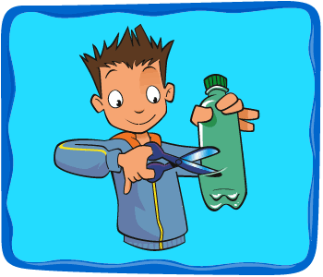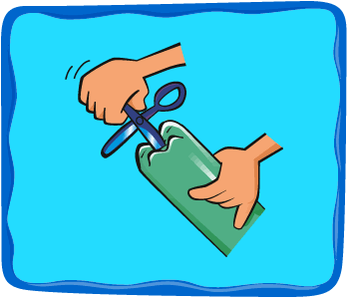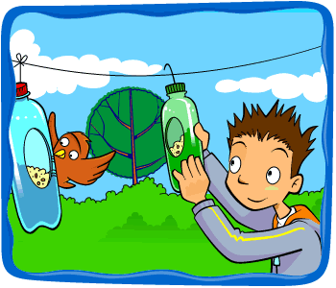

- If your feeder starts to wear out or the food in it goes mouldy, recycle it and make another one!
Remember to keep your feeders well stocked, especially in winter. Birds come to rely on them and will go hungry if you forget.
