Back-to-Office Report: Seedling germination rate and performance of Albizia schimperiana under different seed treatments in the Bilate catchment
CROSSROADS team members
1. Introduction
The field visit aimed to assess nursery seedling performance by collecting key growth indicators, including germination rates under different dormancy breaking treatments, seedling height, collar diameter, branch number, and root length, to understand overall seedling growth and quality,

2. Approaches and Date collection
Data were collected using a field-based measurement approach to assess seedling performance across key growth indicators. Germination rates were evaluated by comparing seedlings under different seed dormancy-breaking treatments. Seedling height was measured from the soil surface to the top tip, while collar diameter was measured at the stem base to assess thickness. Branch number was counted to indicate leaf development and growth potential, and root length was measured to evaluate below-ground development and resource uptake capacity.
A graduated meter stick was used to measure seedling height and root length (Figure 1), while a vernier caliper was used to measure collar diameter. The vernier caliper consists of a fixed main scale and a sliding vernier scale, enabling precise measurements to a fraction of a millimeter. Growth parameters were recorded to evaluate the effects of different seed treatment methods, namely hot water treatment, scarification, and the control (untreated seeds).
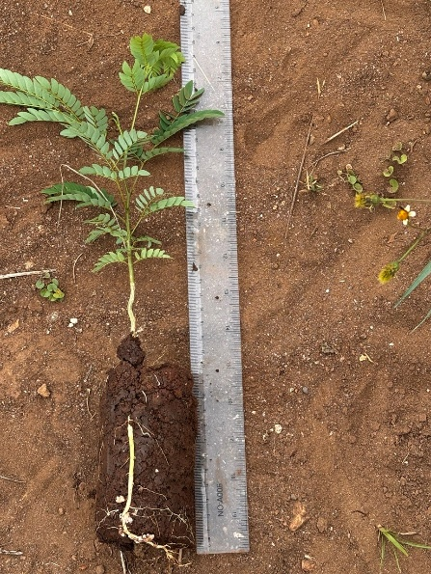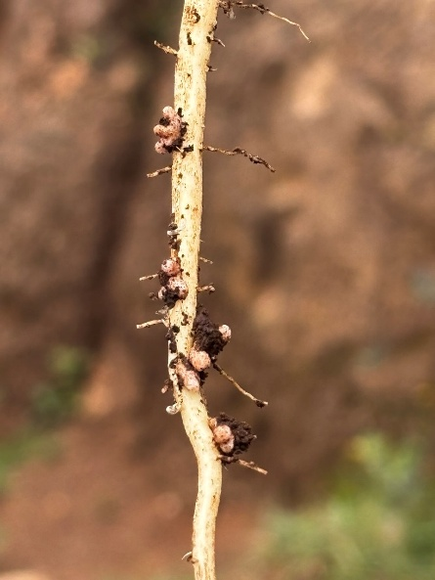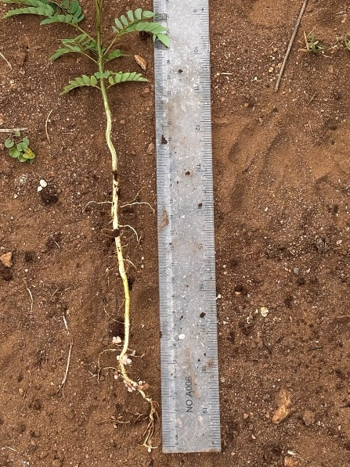
Figure 1. Root length measurement at lower Bilate catchment
3. Results and Key Findings
The results revealed that all growth parameters of Albizia schimperiana were influenced by the different seed pretreatment methods at the middle and lower Bilate catchments (Figure 2). Hot water treatment (HW) consistently produced the best overall seedling performance across both catchments, showing the highest values for height, collar diameter, branch number, and root length. Scarification (SC) ranked second, improving growth compared to the control but remaining below HW. Control (CT) treatments showed the lowest performance across all indicators. In both Lower (LC) and Middle (MC) Bilate catchments, similar trends were observed, although MC generally exhibited slightly higher root length and comparable or slightly lower values for other growth parameters compared to LC.

Figure 2. Average values of seedling height, collar diameter, branch number and root length for different pre-sowing seed treatments. HW: Hot water treatment, SC: Scarification, CT: Control, LC: Lower Bilate catchment, MC: Middle Bilate catchment.
Similarly, Hot water treatment resulted in the highest germination rates in both catchments (29.7% in Lower and 26% in Middle Bilate), followed by scarification (23.5% and 19%, respectively), while untreated seeds showed the lowest germination (13.7% and 10%) (Figure 3). This pattern was consistent across all growth indicators, where hot water treatment produced the strongest seedling performance, scarification showed moderate improvement, and control treatments performed the poorest.
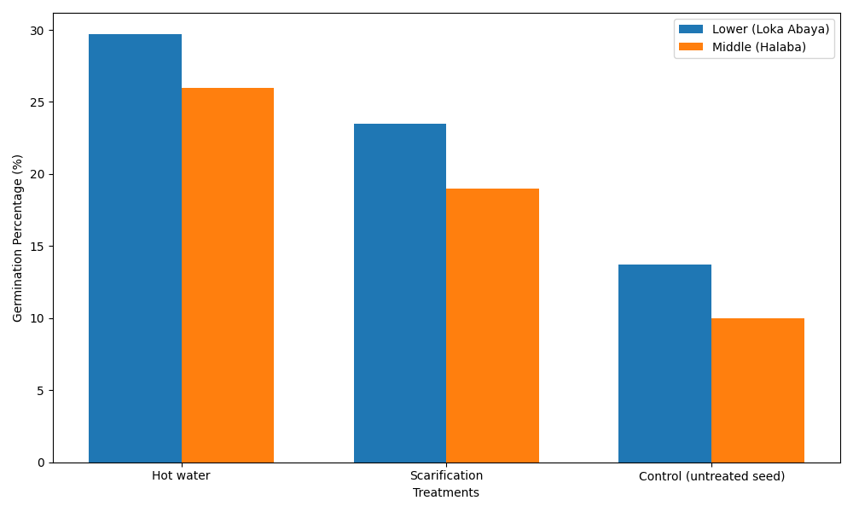
Figure 3. Germination percentage of seeds under different pre-seed treatments in lower and middle Bilate catchment
4. Conclusions and recommendations
Soaking seeds in hot water and mechanically abrading the seed coat (scarification) were found to improve the germination and seedling growth performance of Albizia schimperiana. However, both seed pretreatment methods resulted in germination percentages below 50%, indicating potential physiological dormancy of the test plant. As the two methods used to break seed dormancy mainly break physical dormancy, further research is recommended to verify that the test plant also exhibits physiological dormancy, identify additional pretreatment methods, and optimize germination conditions to improve the germination percentage of Albizia schimperiana.

