BACK TO OFFICE REPORT ON
Community engagement through key informant interviews and focus group discussions.

Duration: May – June 2025
Participated consortium members: HU, CEARI, IWMI

- Visited sites
The assessments to document underutilized species through engaging communities were conducted in three Woredas: Misrak Badwacho (representing the Badawacho Halaba Maize livelihood zone), Alicho Werero (Guraghe – Silte Highland Enset and Barely livelihood zone) and Loko Abaya (Bilate Agropastoral and pastoral livelihood zone). In each Woreda, a Kebele or catchment was selected, and participatory transect walks and community consultations were conducted. The visted kebeles and the catchments were:
- Misrak Badwacho woreda; Andegna Ambursa kebele; Edolla sub catchment.
- Alicho Weriro Woreda, Washo Kebele, Wera Watershed
- Loko Abaya Falka kebele Segechito sub catchment
- Key informants
The participants identified as knowledge sources are presented in Table 1. (Figure 1). Groups 1 -3 represent local communities and administrative bodies, and group 4 represents experts working in woreda agricultural offices
A 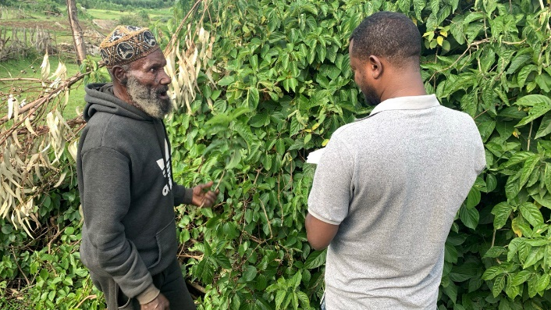 | B  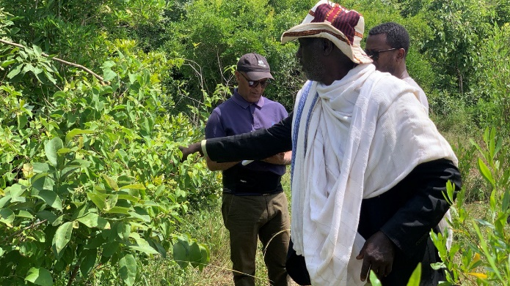

Figure 1 KII participants, Alicho Weriro (A) and Loko Abaya (B)

Table 1. Participants of the key informant study in the three study areas. MB refers to Misrak Badwacho; AW - Alicho Werero; LA - Loko Abaya.

Group | Knowledge sources | MB | AW | LA
Group 1 | Knowledgeable farmer | 1 | 1 | 1 | The work has been facilitated by the woreda experts
 | Herbalist |  | 1 | 1 | The work has been facilitated by the woreda experts
 | Formal leader Keble Chairman | 1 | 1 | 1 | The work has been facilitated by the woreda experts
 | Informal leader | 1 |  |  | The work has been facilitated by the woreda experts
 | women |  | 1 |  | The work has been facilitated by the woreda experts
Group 2 | Knowledgeable farmer | 1 | 1 | 1
 | Herbalist | 1 (W) | 1 | 1
 | Women | 1 | 1 | 1
 | Knowledgeable farmer /Elder |  | 1
 | Informal leader | 1 (H) | 1
Group 3 | Knowledgeable farmer | 1 | 1 | 1
 | Herbalist | 1 | 1 | 1
 | Women | 1 | 1 | 1
 | Informal leader | 1 | 1
Group 4 | Agroforestry | 1 | 1 | 1
 | Plant sciences | 1
 | Livestock | 1 | 1 | 1
 | Natural resources |  | 1 | 1
 | Watershed management |  | 1
 | Soil fertility |  | 1

The assessment of the first group involves two approaches: i) walking across the kebele to identify the land management types and features of the Keble landscape that are distinct for the study site and ii) discussing in depth the plants that are known in these landscapes, mainly focusing on the identification of plants in the different land management systems.
In the in-depth interviews, the farmers in Groups 2 and 3 focused on the identification of additional plants with respect to the identified land management practices and types, discussing the purposes and benefits of the plants. During these sessions the visits are mainly in the front yard and the back yards the main places where rich diversity has been observed and also ascertained by the key informants compared to the other land management types
The fourth group of key informants were experts of the agricultural office composed of 3-4 experts in the fields of agroforestry, livestock, natural resources, and extension.

- Land management types identified
Early assessment exercises along the selected transects were conducted by participating three to four farmers from the respective study areas. This exercise was facilitated by the kebele chairman and the experts accompanied us from the study area and woreda. The area has been visited across different landscapes and management types, from the highest to the lowest.
Four to seven land management types were identified at the study sites. The general descriptions of the land management types in the landscapes are briefly described, and the identified woreda are shown in Table 2.

Table 2: Land management types, brief description and identified woredas
 | LAND MANAGEMENT TYPES | BRIEF DESCRIPTION | IDENTIFIED WOREDAS
 | LAND MANAGEMENT TYPES | BRIEF DESCRIPTION | MB | AW | LA
1 | FARMLANDS | The observed farmland lands are in the relatively flat and fertile areas of the landscape. In both study site (Badiwacho and Loka Abaya), maize is the main crop growing but teff, beans, and others that are also grown widely. In the highland site, Alicho Woriro, barely and enset are also dominant crop produced. | X | X | X
2 | FRONT YARD / HOME STEAD | The front yard or homestead is a multifunctional space that is meant for livestock feeding, shelter and management and for use of various social affairs. It is often a flat, grass-covered area used for sitting, social gatherings, and day-to-day household activities. Perennial trees that can be considered as landmarks and identify the household are kept properly for the provision of shade, food, and social activities. | X | X | X
3 | BACK GARDEN | The backyard is located just behind the houses, which is mainly used for the production of herbs/spices and vegetables. Enset, coffee, and chat are commonly grown. There is a greater diversity of plants in these areas than in any other land management type. | X | X | X
4 | EXCLOSURE | These are closed for natural regeneration, but in all observed exclosures, there are interventions to enhance resilience. Trees of varying types contribute to the restoration of native vegetation, which adds to the ecological diversity. Grasses are grown for soil protection and source of feed for animals. | X | X | X
5 | THE COMMUNAL GRAZING AREA | is characterized by diverse vegetations composed of trees, shrubs and herbaceous plants. These common areas are accessible to all in the community |  |  | X
6 | TREE COVERED AREA / FOREST AREA | This area is covered with trees, shrubs, and grass. It can be seen that the natural vegetation status varies among the different woredas visited. In all cases, different trees and shrubs are noted, which are planted as a revegetation exercise for the restoration of the area | X |  | X
7 | WOOD LOT | Eucalyptus wood lots surround the Homesteads, which are owned by the individual farmers in their private parcels. |  |  | X
8 | RIVERINE VEGETATION | Eucalyptus globulus, Acacia spp, highland bamboo and Erythrina spp are grown along the banks of the river |  | X

- Observations and information collected on

Plant identification: The different plants available in the different land management types were identified by the key informants. Visits enabled us to take pictures of the plants, and the names were recorded in the local language (Siltegna, Hadiyagna, and Sidamigna) and Amharic. first-step classification into herbs, vegetables, trees, shrubs, or vines was made in the field. Dominant plants were also observed with respect to land management.
Associated information on uses and benefits: During the interview, the uses of the plants were also noted, and the participants shared their knowledge. The specific uses we asked were the use of plants as medicine, fuelwood, food, feed, soil conservation, soil improvement, and income generation. As much as possible, these uses have been noted, with details of how, when, and to what extent.
Related to management, extension, challenges, etc.: Additional information concerning plants that are underutilized, potential uses in the future, challenges, and both institutional and extension support were also discussed.

- Focus group discussions
Two separate focus group discussions (male and female) were held for each woreda (Figure 2). The kebele chairman and informal leader selected the key informants. The issues for discussion were the identification of plants in different land management types, their uses, and management. It is mainly aimed at verifying the information collected through KII and collecting additional information to clarify the issues noted in KII.
A  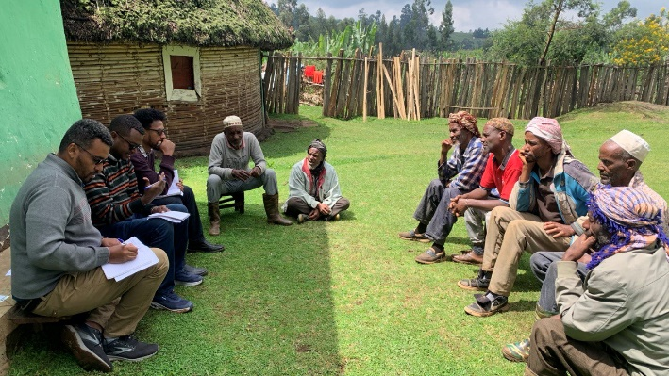 | B  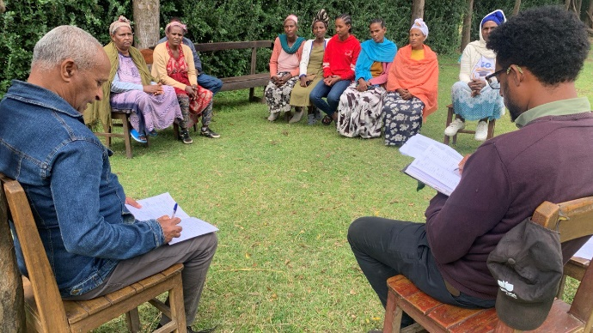
Figure 2. FGD Participants Alicho Weiro (A) and Misrak Badwacho (B)

- Next step
The collected information was checked for consistency among the participants’ notes. Categorization and analysis of the information collected are being processed and a draft outline is prepared for writing the draft reports from the key informant interviews and focus group discussion. It is planned to present the first draft of the report ready in August.

- Draft outline

- SUMMARY

- INTRODUCTION
This section should include description of the project in general and referring to the cataloguing activity. The specifying the need for community engagement in collection data on plants available in the representative areas of the Bilate catchment
2. METHODS
2.1. The study area
The key features of the study areas will be presented using a table which will include like location, rainfall, elevation slope topography landuse livelihood major crops etc. The map / figures of the study areas also included here.
2.2. The Approach
The approach / methodology employed

2.3. Data collection
Describe the data collection instruments and Basic information on data collection with respect to the three study areas
3. RESULTS
3.1. Characteristics of the different components of investigated catchments
discuss the key features of the different components of catchments- the three study areas
3.2. Plants identified on the study areas
3.2.1. Edolla catchment, Misrak Badawacho Woreda

Table 3. List of plants identified in the Edolla catchment, Misrak Badawacho woreda

3.2.2. Wera catchment, Alicho Weriro Woreda

Table 4. List of plants identified in the Wera catchment, Alicho Weriro Woreda

3.2.3. Segetchito catchment, Loko Abaya Woreda

Table 5. List of plants identified in the Segetchito catchment, Loko Abaya Woreda

3.3. Discussion on major uses of the identified plants
Categorizing the importance of the identified plants discuss by comparing and contrasting the identified plants

4. CONCLUDING REMARKS

5. SPECIES
Acacia spp: According to the FAO brochure “Role of Acacia species in the rural economy of Dry Africa and near East” the following Acacia species are traditionally used by the population in Ethiopia: A. bussei, A. edgeworthii, A. etbaica, A. mellifera ssp. mellifera, A. nilotica ssp. indica, A. reficiens, A. senegal, A. tortilis ssp. spirocarpa.
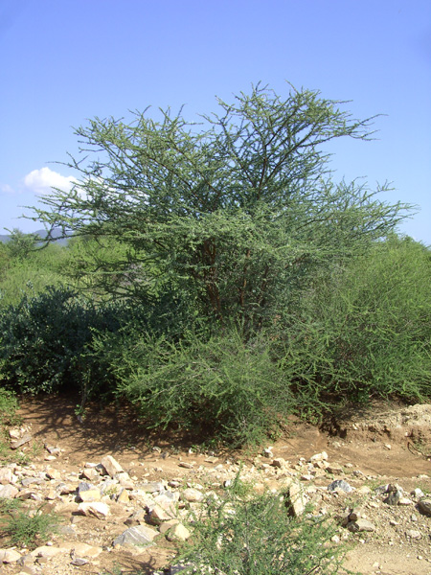
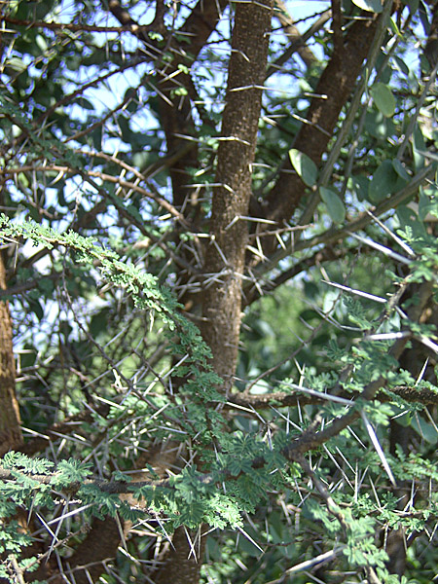

Bamboo (highland): Highland bamboo (Oldeania alpina) (K. Schum.) Stapleton (syn: Yushania alpina), is a naturally distributed and cultivated species in the south, south-west, central and north-western highlands of Ethiopia.
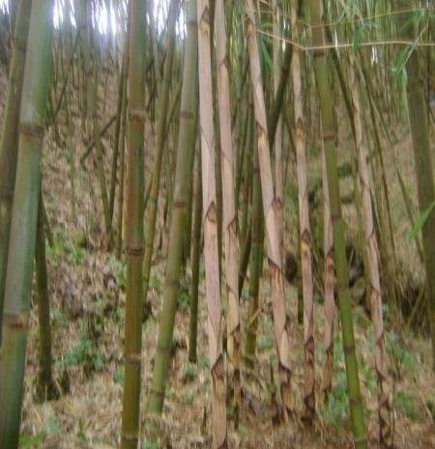

Erythrina spp.: Erythrina abyssinica Fabaceae – Indigenous. Ecology: A small thorny tree found all over Africa in warm temperate and tropical areas, as well as in Central America, Australia, Southern Asia and Hawaii. Found all over the country in open woodland or grasslands of the Moist and Wet Kolla and Weyna Dega agroclimatic zones, 1,300–2,400 m. As with many trees in areas with frequent fires, young trees establish a deep root system before stem growth and old trees a thick, corky and protective bark. Uses: Firewood, carving, utensils (mortars, drums, bee-hives), medicine (bark, roots), veterinary medicine (leaves), bee forage, ornamental, mulch, soil conservation, nitrogen fixation, live fence, necklaces (seeds), curios (seeds), ceremonial. Description: A deciduous tree with a short trunk and thick spreading branches, rounded crown, 6–12 m. BARK: Deeply grooved, brown, thick and corky, with or without woody spines. LEAVES: Compound with 3 leaflets, largest leaflet rounded to 15 cm; branchlets and under-leaves covered with grey‑brown hairs, veins and stalks sometimes prickly. FLOWERS: Orange‑red heads, often appearing on the bare tree. Both narrow calyx lobes and petals are coloured, each flower to 5 cm long. FRUIT: Woody pods, 4–16 cm long, hairy, strongly narrowed between seeds, opening to set free 1–10 shiny red seeds with a grey-black patch. Propagation: Seedlings, direct sowing at site. Also grow from cuttings, but raising seedlings is easy. Propagation from cuttings is successful if done immediately after the rainy season but not while the land is very wet. Seed: Low germination rate. About 6,800 seed per kg. Treatment: Not necessary. Storage: Seed stores for long periods if kept cool, dry and insect free. Management: Pollarding, coppicing. Slow growing. Remarks: The tree is resistant to fire and termites. The soft white wood is a poor timber but can be carved fairly easily. The tree is used on stream banks and for soil-conservation terraces. The seeds contain a poison but it is only released if they are crushed. Leaves: have been used to treat skin diseases in cattle.
Erythrina brucei and Erythrina burana are multipurpose trees which are endemic to Ethiopia. Both species, besides serving many purposes, have an important advantage in that they can be easily propagated vegetatively. However, little is known about their propagation by seed.
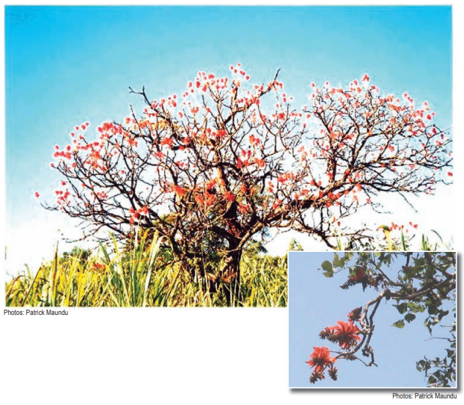
Eucalyptus Globulus: Eucalyptus globulus, commonly known as the blue gum tree, is a tall evergreen tree native to southeastern Australia, renowned for its medicinal properties and essential oil applications. Appearance: Eucalyptus globulus typically grows to a height of 45 meters (148 feet) but can reach up to 90 meters (300 feet) under ideal conditions. It features smooth, white to cream-colored bark and glossy green, lance-shaped leaves. Leaves: The juvenile leaves are often glaucous and waxy, while the adult leaves are dark green and lanceolate, measuring 150–300 mm long. Flowers and Fruit: The tree produces white flowers and woody fruit, with flower buds arranged in clusters.
