Back-to-Office Report: Field Day on Vermicompost Production and Quality Evaluation
CROSSROADS team members
1. Introduction
The field day on vermicompost production was held to demonstrate practical vermicomposting techniques, evaluate the quality of the vermicompost produced, and document how farmers assess compost quality. The activity aimed to foster knowledge sharing among farmers, extension agents, and experts, particularly in response to the growing demand for affordable and sustainable fertilizer alternatives. By showcasing local practices, the event promoted adaptable, low-cost biological fertilizer solutions to enhance soil fertility and agricultural productivity.
2. Objectives
The field day was designed to: (i) Demonstrate vermicompost production practices, (ii) Co-evaluate the quality of the produced vermicompost, and (iii) Gather farmers’ perspectives and experiences in evaluating vermicompost quality.
3. Approach and Methodology
3.1 Field Demonstration
The activity followed a participatory field-day approach that combined practical demonstrations (Picture 1), farmers' interactions (Picture 2), and joint compost quality evaluations (Picture 3). The process included (i) introduction of objectives by the project team, (ii) remarks from district agricultural leaders highlighting fertilizer challenges and the importance of biological alternatives (Picture 4), and (iii) hands-on demonstration of vermicompost production techniques.
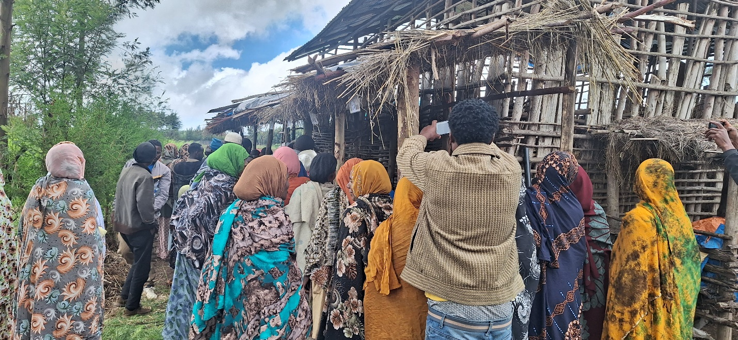
Picture 1. Farmers observing the production of vermicompost in an organized farmers' day (Photo: Wolde Mekuria)
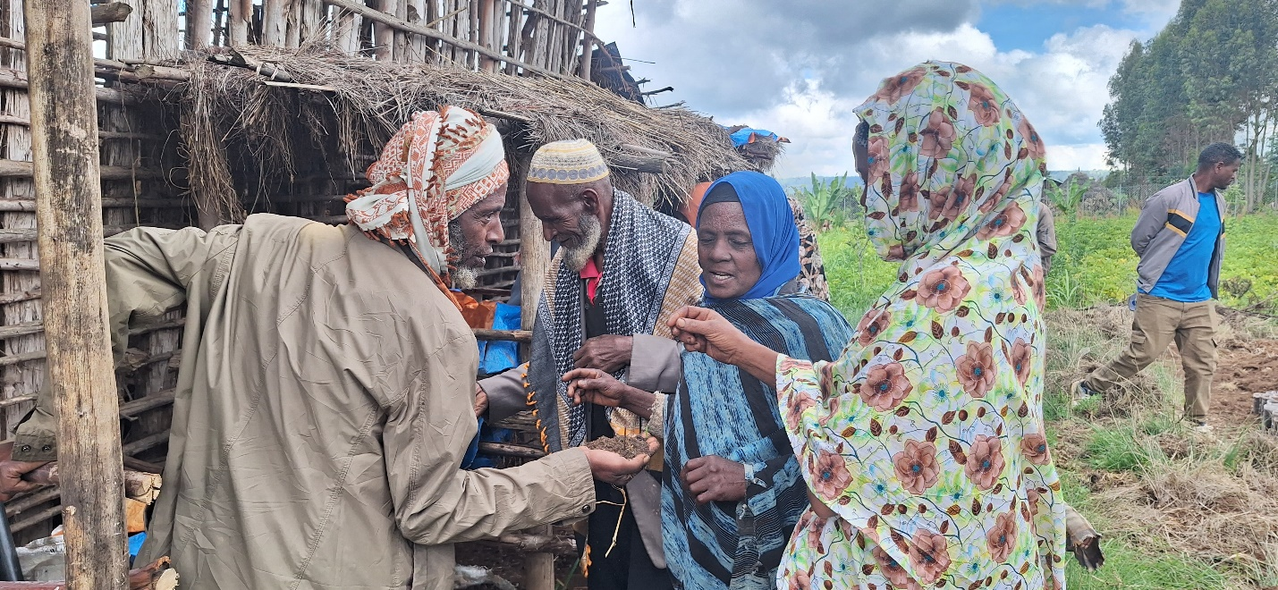
Picture 2. Farmers interacting with each other during the field day (Photo: Wolde Mekuria)
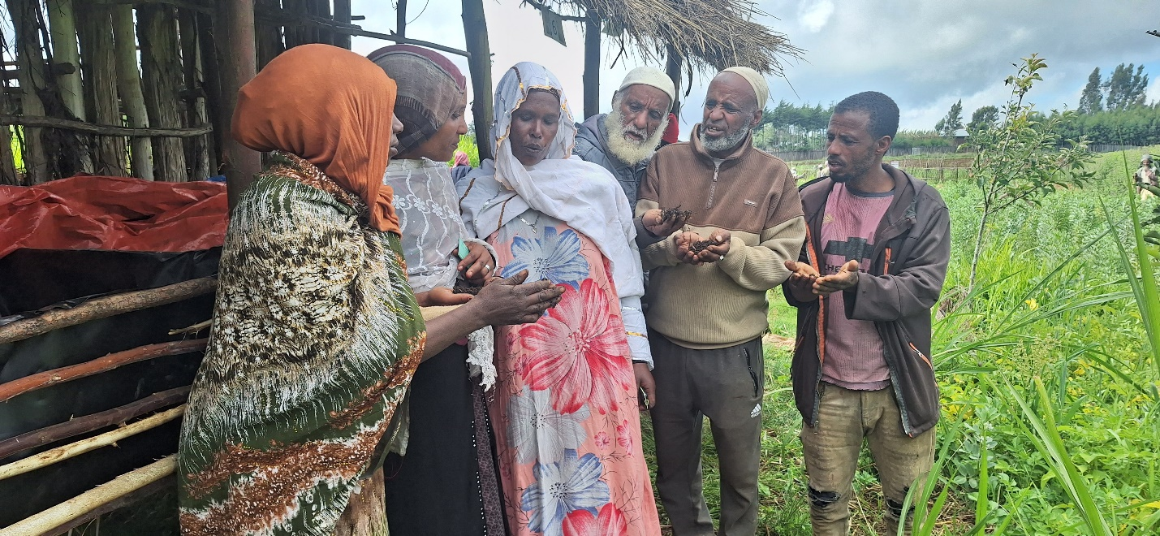
Picture 3. Farmers evaluating the quality of vermicompost produced from treatments made based on Kortch (Erythrina brucei), identified underutilized plant species (Photo: Wolde Mekuria)
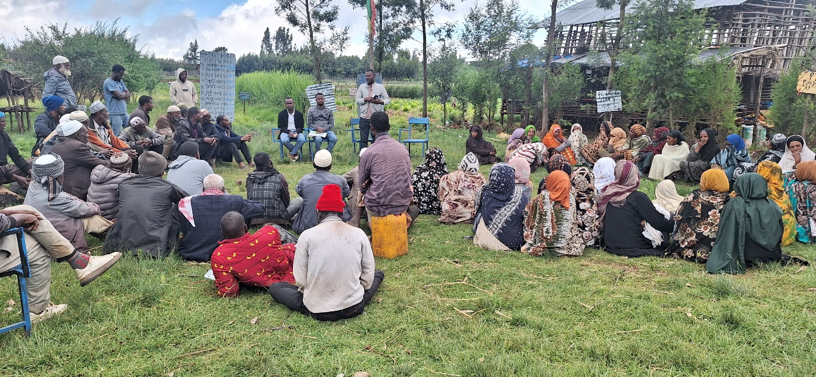
Picture 4. Opening the field day and briefing the participants about the importance of compost in reducing fertilizer use- Alicho Woreda agricultural office head (Photo: Wolde Mekuria)
3.2 Evaluation of Vermicompost Quality
A simple and farmer-friendly evaluation framework was developed using visual, odor, and touch-based indicators, enabling participants to assess vermicompost quality without laboratory analysis (Table 1). The assessment focused on six key indicators: colour, odour (smell), texture, moisture level, visible biological activity (worms/insects), and presence of undecomposed materials. Each indicator was scored on a scale of 1 (poor) to 3 (good), allowing farmers to identify high-quality compost (“black gold”) and areas requiring improvement.
Table 1. Indicators used to assess vermicompost quality
Indicator | 3 (Good Quality) | 2 (Moderate) | 1 (Poor Quality)
Color | Consistently dark brown to black (uniformly matured) | Mostly brown with some lighter patches or bits | Lighter or patchy color with many visible original bits (not fully broken down)
Odor (Smell) | Earthy “fresh soil” scent; no foul odors | Slight ammonia or musty hint (still curing) | Strong rotten or ammonia smell (anaerobic; incomplete)
Texture | Fine, loose, crumbly (like medium coffee grounds) | Some small clumps/fibers; partly crumbly | Wet, slimy clumps or large intact fibers (undigested material)
Moisture Level | Feels moist like a wrung sponge (forms a ball when squeezed, no dripping) | Slightly dry or somewhat sticky, but not extreme | Too dry (dusty, won’t hold shape) or waterlogged (drips when squeezed)
Visible Life (worms/insects) | A few worms or cocoons; small, harmless soil insects present – healthy compost | Several worms are still active (compose nearly finished) | No worms (pile overheated or dried out) or many worms feeding (not yet finished)
Undecomposed Material | No obvious original feedstock (only dark, soil-like particles) | Only a few small bits of leaves or straw remain | Many recognizable scraps of manure, straw, etc. (needs more time)
3.3 Evaluation Procedure
Fifteen vermicompost boxes were assessed using a participatory and comparative approach. The boxes were numbered (1–15), and participants were grouped into three categories: inexperienced farmers (6: 3 women, 3 men), experienced farmers (6: 3 women, 3 men), and experts (6 participants). After explaining the evaluation criteria and scoring system, each group independently assessed compost quality using the agreed-upon indicators. Reflections were then collected on the clarity, usability, and practicality of the evaluation approach.
4. Participants
The field day brought together 93 participants. This included 79 farmers from the demonstration kebele (47 women and 32 men), 8 representatives (kebele chairpersons and extension agents) from four neighboring kebeles, 4 district-level experts, and 2 development agents from the host kebele. This diverse participation facilitated knowledge exchange and strengthened linkages among farmers, extension services, and local institutions.
5. Results and Key Findings
5.1 Overall Assessment of Vermicompost Quality
The results show that vermicompost quality improves with increasing proportions of Erythrina brucei biomass (Figure 1). Treatments T5 (100% Erythrina) and T4 (75% Erythrina) consistently achieved the highest scores across most indicators. Odour scores were uniformly high across all treatments (approximately 2.4–2.9), indicating good decomposition. Texture and moisture improved with higher Erythrina content, reaching peak values in T5. Colour remained acceptable across treatments with only minor variation. However, scores for visible biological activity were relatively low (around 1.2–1.4), suggesting either limited biological presence or under-recognition by evaluators. Treatments T4 and T5 also showed the best results for absence of undecomposed material, indicating more complete decomposition. Overall, the findings confirm that increasing the proportion of Erythrina brucei biomass significantly enhances vermicompost quality.
.

Figure 1. Average quality scores of vermicompost produced using different input material combinations. T1 represents the existing Farmers Training Center (FTC) practice (45 kg manure + 100% barley residue). T2–T4 represent mixtures of barley residue and Erythrina brucei biomass in varying proportions (75:25, 50:50, and 25:75, respectively) combined with 45 kg manure. T5 represents 45 kg manure combined with 100% Erythrina brucei biomass.
5.2 Comparison Across Groups
Within each evaluation group, compost quality increases steadily from T1 to T5, indicating that higher proportions of Erythrina brucei biomass improve performance across all indicators (Figure 2). In Group 1 (inexperienced farmers), total scores are consistently high (approximately 14 to above 15), with clear gains in moisture, texture, and undecomposed material as treatments progress toward T5. In Group 2 (experienced farmers), overall scores are noticeably lower (around 10.5 to 13.5), although the same increasing trend from T1 to T5 is maintained, suggesting stricter evaluation, particularly for moisture and texture. In Group 3 (experts), scores range from about 12 to over 15, again showing improvement with higher Erythrina content, but generally remaining slightly below or comparable to Group 1 totals.
Across groups, Group 1 consistently receives the highest overall ratings, followed by Group 3, while Group 2 receives the lowest scores. Experienced farmers are conservative, while inexperienced farmers look generous. May seem logical that the more you know you have a bases to compare with. The experts are between the two, know theoretically but are less experienced. Despite these differences in scoring levels, all groups agree on the relative performance of treatments, with T4 and T5 ranked highest. This indicates strong consensus that increasing Erythrina brucei biomass enhances vermicompost quality, while differences among groups reflect variation in scoring stringency and evaluation perspectives rather than disagreement on treatment performance.

Figure 2. Perceived quality of vermicompost across the three groups
5.3 Key Insights
- Farmers can effectively use simple sensory indicators (sight, smell, and touch) to evaluate vermicompost quality.
- The developed evaluation checklist is practical, easy to use, and suitable for field application.
- Further training and practical experience could contribute to improving the accuracy of quality assessment.
6. Community Reflections
Participants expressed strong appreciation for the field day, emphasizing its practical relevance and learning value. The demonstration enhanced their understanding of vermicompost production and quality assessment, particularly through hands-on engagement.
Farmers highlighted that vermicompost production relies on locally available materials and requires relatively low labor and financial input, making it accessible to smallholders. Importantly, experienced farmers confirmed observable improvements in crop performance when using vermicompost, reinforcing its practical benefits.
Overall, the reflections indicate strong local acceptance of vermicomposting as a feasible and beneficial soil fertility management practice.
7. Conclusions
The field day effectively demonstrated the feasibility and benefits of vermicompost production while providing a platform for participatory learning and evaluation. The use of a simple, farmer-friendly assessment approach improved participants’ understanding of compost quality and strengthened their capacity to independently evaluate their products. The results clearly show that vermicompost quality improves with higher proportions of Erythrina brucei biomass, with T4 and T5 performing best across all indicators. Combined with strong farmer interest and positive field experiences, this confirms that vermicomposting is a viable, low-cost alternative to inorganic fertilizers. Apart from the compost produced the propagation of the vermi warms could also be used as input material for others to be engaged in vermicompost production and income source for the producers. Given current fertilizer constraints, vermicomposting presents a practical and scalable solution for improving soil fertility and supporting sustainable agricultural production.
8. Recommendations
Based on the findings and participant feedback, the following actions are recommended:
- Capacity building: Provide targeted training on vermicompost maturity indicators, particularly biological indicators, to improve farmers’ assessment skills.
- Scaling up: Promote vermicompost production in neighboring kebeles, with emphasis on using high-quality biomass inputs such as Erythrina brucei to enhance compost quality.
- Follow-up support: Strengthen extension services to provide continuous technical guidance and monitor adoption at the farmer level.
- Tool dissemination: Simplify and widely disseminate the compost evaluation checklist to support broader use by farmers and development agents.
- Policy engagement: Advocate for the integration of biological fertilizers, including vermicompost, into local and national sustainable agriculture strategies.

