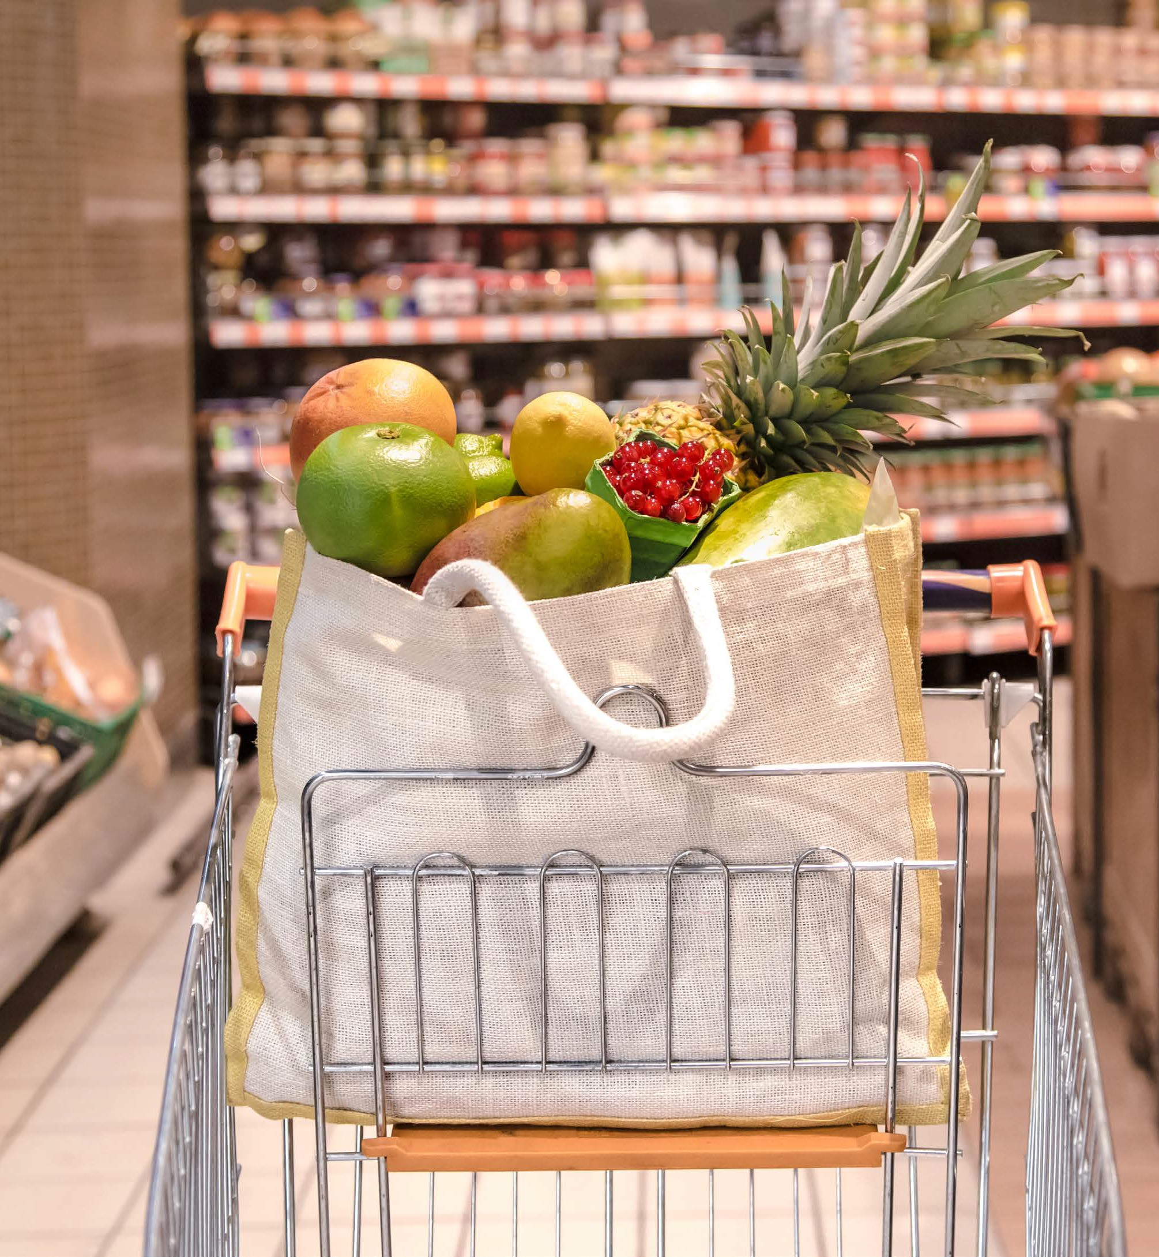
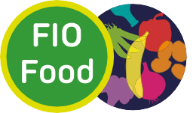

The FIO Food Project Citizens Manifesto 2026



In the UK, people living with obesity and food insecurity are unable to afford healthy, environmentally sustainable food from the supermarket. [1]
Government policies designed to address diet inequality have historically had minimal impact and may have even widened existing inequalities. [2]
The FIO Food and DIO Food projects, grounded in lived experience and rigorous research, call for urgent action to tackle this issue. [3,4]
We demand a food system that promotes accessible, affordable, safe, nutritious and culturally acceptable food.
Our citizens urge policymakers to make healthy, environmentally sustainable food a priority.

The FIO Food Project
The FIO Food Project aims to provide actionable evidence for policy on retail strategies to address dietary inequalities among people living with obesity and food insecurity, supporting more sustainable and healthier supermarket food choices in the UK.
Project website: abdn.ac.uk/rowett/research/fio-food/

Funding
The research was funded through the Transforming the UK Food System for Healthy People and a Healthy Environment SPF Programme, delivered by UKRI, in partnership with the Global Food Security Programme, BBSRC, ESRC, MRC, NERC, Defra, DHSC, OHID, Innovate UK and FSA.
Programme Information: The £47.5M ‘Transforming the UK Food System for Healthy People and a Healthy Environment SPF Programme’ is delivered by UKRI, in partnership with the Global Food Security Programme, BBSRC, ESRC, MRC, NERC, Defra, DHSC, OHID, Innovate UK and FSA. It aims to fundamentally transform the UK food system
by placing healthy people and a healthy natural environment at its centre, addressing questions around what we should eat, produce and
manufacture and what we should import, taking into account the complex interactions between health, environment and socioeconomic factors. By co-designing research and training across disciplines and stakeholders, and joining up healthy and accessible consumption with sustainable food production and supply, this Programme will deliver coherent evidence to enable concerted action from policy, business and civil society.
Programme website: https://ukfoodsystems.ukri.org/

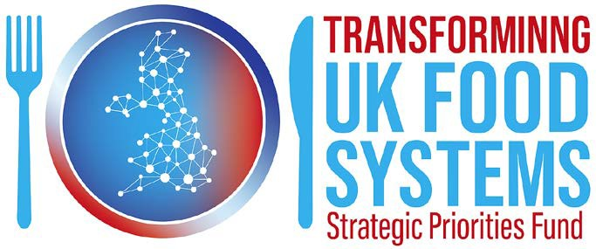

Citizens Manifesto

Summary of Asks
LIVED EXPERIENCE
What citizens need
1 | Secure stable, low prices for healthy staple foods.
2 | Extend discounts and loyalty rewards to fruit, vegetables, and healthy staples - not just processed foods and sweets.
3 | Ensure price changes are predictable and transparent. Provide  advance notice of increases  so people can budget.

RETAIL
What supermarkets must do
1 | Commit to stabilising prices on a range of healthy and sustainable foods that offer value for money for low-income customers.
2 | Communicate unavoidable increases clearly and in advance.
3 | Actively promote healthier food through reformulation and substitution strategies, supporting both planet and population health.
4 | Use clear, relatable images in promotional communications that include prices suitable for people on low budgets.

POLICY
What government must legislate
1 | Mandate affordable pricing for healthy food across all supermarkets to ensure fair access.
2 | Strengthen HFSS restrictions by closing loopholes and prohibiting everyday low pricing for HFSS products.
3 | Financially incentivise retailers to meet targets for healthy and sustainable food sales, addressing profitability concerns.
4 | Establish a regulatory framework for retailers to share intervention evidence, modelled on the Food Data Transparency Partnership.

Nadya | Project Advocate

We believe all citizens should be able to access affordable, healthy food. Do not wait to implement these actions. To address dietary inequalities, we call on supermarkets to lock in fair prices on healthy staples, on researchers to partner with retailers to build evidence that drives real-world change and on policymakers to legislate for equity. Together we can make healthy, sustainable food choices the easy choice for all citizens and drive lasting change.

Ken | Project Advocate

The FIO food project took PPI/E onto the next level and delivered true co-production throughout.





I was a small part party of the steering group and always felt valued and listened to, lived experience was at the core of this work.
On a personal level I gained insights into food insecurity which opened my eyes to the reality of many people living with obesity.
I was honoured to be asked to take part in a panel discussion during presentation of findings at UKCO in Aberdeen in 2025

Embedding lived experience into our research
In the FIO-Food project, we employed a co-production approach that involved people with lived experience of obesity and food insecurity from the beginning to the end of the research process.
Through surveys [5,6], interviews and focus group discussions with people with lived experience [7,8], we have engaged with UK citizens to hear first-hand, the challenges they face when shopping in the supermarket for healthy, environmentally sustainable food.
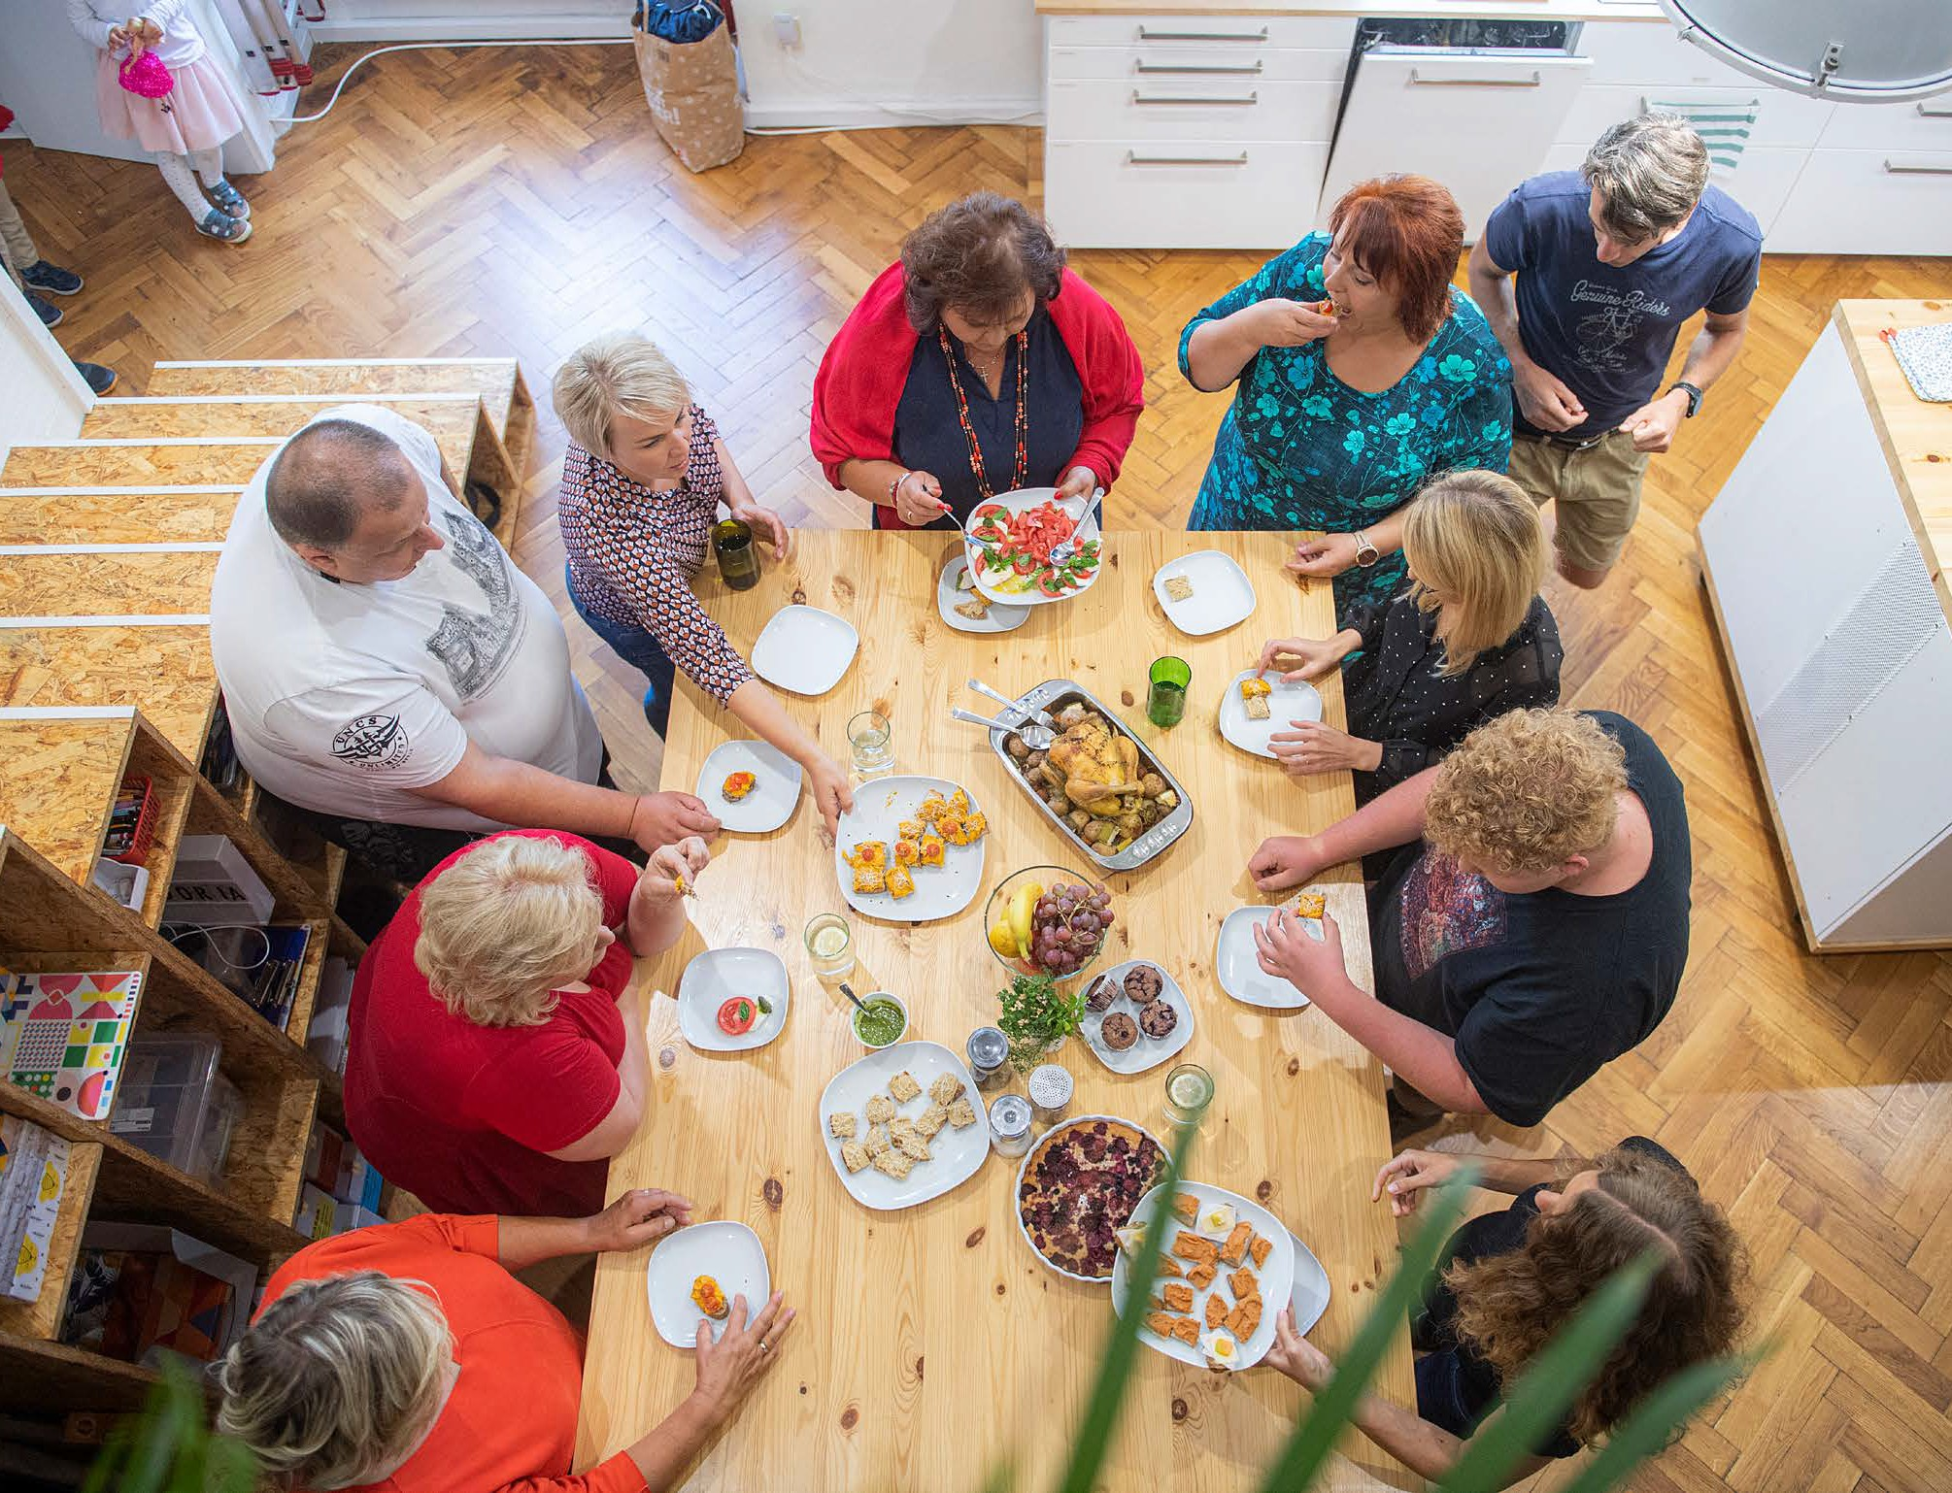
In addition to formal data collection, we collaborated with patient and public involvement (PPI) groups who have guided the development of the project design and study procedures and have helped interpret the data gathered.

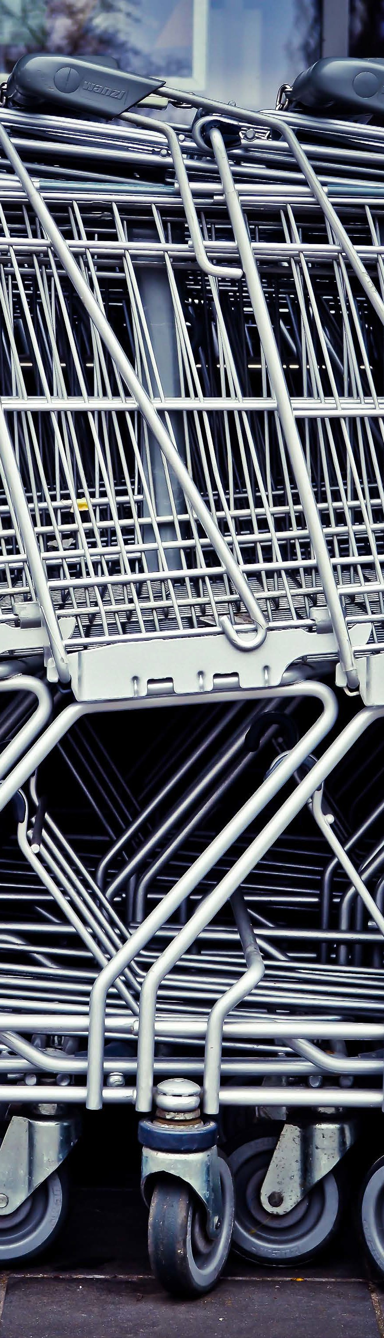
What do people living with obesity and food insecurity want?

People living with obesity and food insecurity are not making unhealthy choices out of indifference - they are navigating an unaffordable and inequitable food environment.
This is what they are asking for…
- Lower prices on healthy, sustainable foods
Our research respondents indicated the main behaviour change lever that would enable them to purchase healthier and environmentally sustainable food was price and incentivisation, in the form of price discounts, money-off promotions and rewards on loyalty cards.

I very rarely see deals when it comes to fruit and veg.
Erm, I think sometimes you can get a deal where you do like the stir fry thing where you get your meat and you get the noodles and things like that, so I guess that would be like a multi-buy thing, but I don't really see it on anything else, it's always like your Cadbury's, or Coke-a-Cola
(Interview participant, female, age range 35-44)

- Keep stable prices on healthy staples
People with lived experience told us how healthy food fluctuated in price, making food budgeting and meal planning more challenging.
They reported perceiving more (and greater money-saving) offers on less healthy food in store, compared to offers available on healthier food items. There was a call for deals on everyday staples rather than foods with which they were unfamiliar, i.e., exotic fruits.

I might do it (eat a healthy food item) one week when something is in, something that is healthier, is on offer and then that'll be for four weeks…I could do it for four weeks, four weeks isn't gonna’ have, is no, it’s that drop in the ocean you know, so it's just pointless.
(Interview participant, female, age range 45-54)

- Make healthy shopping easier.
People with lived experience told us that shopping in the supermarket is mentally exhausting - navigating crowded aisles, confusing pricing structures, and constant temptation from prominently placed, heavily promoted less healthy foods. We ask to reduce in-store complexity and limit the prominent placement of unhealthy food, making it easier to make healthy choices on a budget.

The Retailer Voice

Understanding what consumers want is only part of the picture. To explore whether the changes called for by people with lived experience are achievable within the current food retail system, we took these findings directly to the industry.
We have partnered with a major UK supermarket retailer throughout the entirety of the FIO Food Project and have also collaborated with other UK supermarket retailers regularly. This included conducting interviews with supermarket senior nutritionists (representative of 85% of the grocery market share) to allow us to better understand their perspectives, views, and experiences on the acceptability and feasibility of using price/ incentivisation as interventions
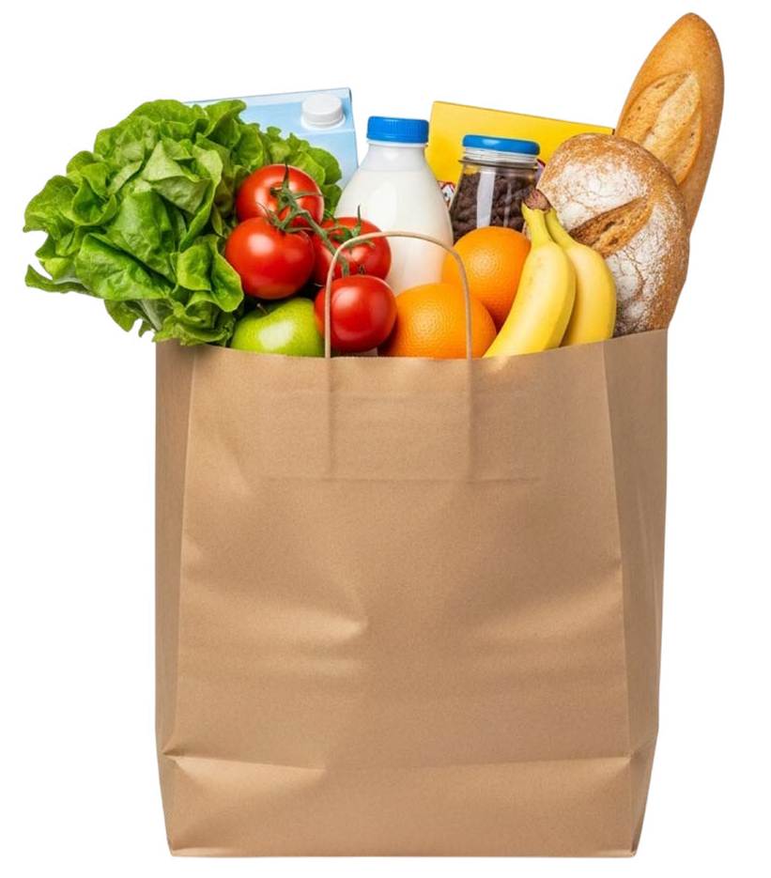
for health and environmental sustainability.

Retailers response to consumer demands

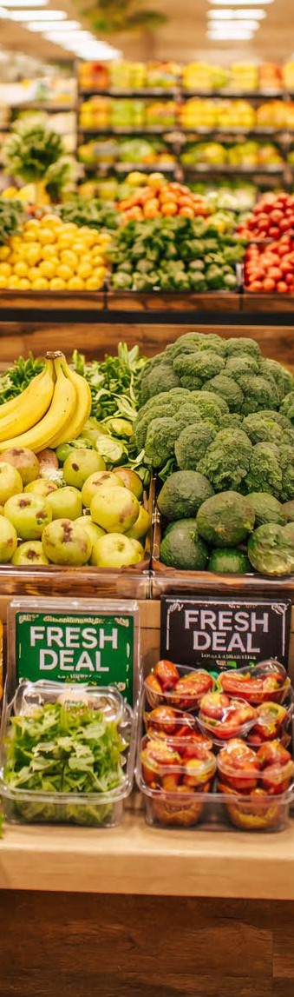
This is what they said...
- Complexity promoting healthy food
Supermarket retailers shared there is an unpredictability surrounding the outcome of any new intervention, a
perceived intention behaviour gap where consumers may hold good intention to buy healthy foods that is not reflected
in purchasing patterns and data and profitability concerns.
- Evaluation Gaps
Time constraints and workload demand on retail staff within what is a fast-paced and in-flux environment means evaluating interventions is challenging, and therefore, there is a lack of evaluation
of interventions aimed to increase the purchase of healthy, environmentally
sustainable food.
- Undefined concept
There is no operationalised, legal definition of sustainable food, making this category difficult to promote, create targets and to measure/ evaluate sales.

 In terms of price, If I'm being completely honest, in terms of inflationary pressures, it's a commercial business, it's really, really tricky to do something different…I think price is probably the most important thing to our customers, particularly in the cost-of-living crisis, but it's probably the hardest one to do from a business perspective.
(Supermarket G)

We urge retailers to:

Stabilise pricing of healthy and environmentally sustainable foods
Commit to offering a range of affordable, healthy and sustainable foods, emphasising value beyond cost — including convenience, ease of preparation, and shelf life. Retailers should prioritise discounts on products that are health-promoting, familiar to consumers, and easy to cook with, so that healthy meals are genuinely within reach for those with limited time and money. Where price increases to this range are
unavoidable, communicate them clearly and in advance so that people on low incomes can budget and plan.

Communicate benefits of tinned or frozen fruit and vegetables as a nutritious and cheaper alternative to fresh produce
Provide visible and culturally acceptable in-store and online messaging to customers and loyalty card holders around the healthiness of frozen and tinned fruit and vegetables, often assumed to be less healthy than their fresh counterparts by PLWO and FI.

Build partnerships with academia
Build relationships, form partnerships and share transaction data through jointly established data sharing agreements with academia to allow the accumulation of a body of evidence-based research and
evaluation to inform intervention and policies and successfully support citizens, including even the most vulnerable within society to eat a healthy, sustainable diet.

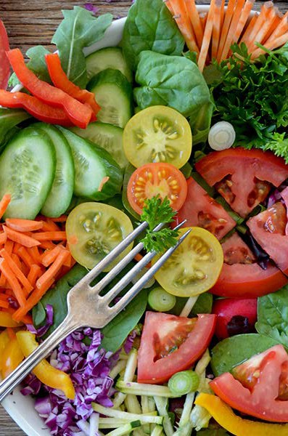
Eating sustainably – luxury or right?

People living with obesity and food insecurity make sustainable choices, for example, they reduce food waste or purchase less meat due to the high cost [ref]. This is a price-driven coping strategy rather than an environmentally driven decision. Our lived experience data [x,x,x] suggested that people on a low income were more likely to report barriers in purchasing healthier and environmentally sustainable foods.

I think about sustainability and I think about how healthy something is, and depending on what’s going on for me at that time and what is available, I find myself making choices where I ignore, sustainability,
environmental impacts in favour of getting the cheapest possible thing … Which makes me feel so ashamed saying that because no, I never used to be like that, urgh. [8]
(Interview participant, female, age range 45-54)

The good news is that eating more healthily and eating more sustainably often go hand in hand. To understand what was actually landing in people's shopping baskets, we analysed loyalty card data from a major UK supermarket - and the picture was revealing:
- Reducing dietary intake of animal products
Red meat, cheese, milk and chocolate were associated with poor sustainability and were among the highest-selling products. This contrasted to fresh fruit and vegetables that were more sustainable and tended to be lower cost.

Simple swaps can add up
Finding ways to change components of meals, such as substituting all (or some) beef mince with lentils or beans could help people shift to healthier and more sustainable diets.

Inequalities influence purchasing
People who lived in more deprived areas were more likely to purchase products that had higher environmental impacts. However, they also purchased less food overall leading to lower total environmental footprint.


A Citizens Call for Policy Change

Our research is unambiguous: the barriers preventing people living with obesity and food insecurity from eating healthily and sustainably are structural, not personal.[10]

The poor are really finding it hard to be able to make ends meet so, yeah, the government have a role to play, maybe bulk of the role is on the government...if they can be sensitive to the needs of everyone around
on the streets to, to work on the exchange rate so that at least, and to work on the inflation rate, so that everyone at least can be comfortable’
Participant 05FG
(Interview participant, female, age range 45-54)

People have the knowledge, the motivation, and the willingness — what they lack is a food system that works for them. Policymakers have both the power and the responsibility to change this.


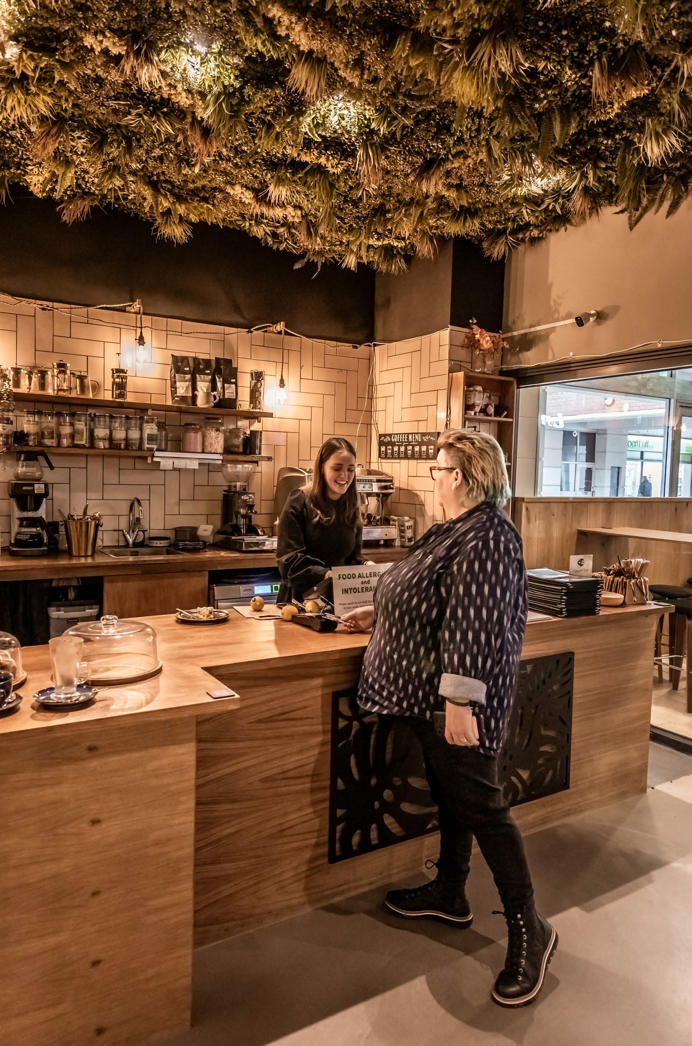
We advise policy makers to:

Mandate pricing of healthy food
Price is the greatest barrier preventing healthy food purchasing, especially in PLWO and FI. Being aware of the commercial implications of removing price as a barrier, policymakers should level the playing field between retailers and compel all supermarkets to price healthier food in line with inflation to ensure equitable access for all.

Legislation to prioritise health in food promotion
PLWO and FI perceived a greater number and more cost saving supermarket offers/ promotions on less healthy foods compared to healthier produce. While we support the government’s decision to restrict HFSS promotions, we urge policymakers to extend this guidance to prohibit retailers from utilising loopholes such as placing HFSS products on everyday low pricing.

Incentivise the sale of healthy, sustainable food
Retailers express profitability concerns associated with increasing the promotion of healthier food. We recommend incentivisation and
taxonomy clarity around the definition of ‘sustainability’ at the product level, to meet set targets for selling healthier and more sustainable food as a way to mitigate the potential commercial implications.

Framework to facilitate cross-retailer collaboration
With many trials conducted to support healthier purchasing within the retail space, cross-retailer sharing these insights for public good is lacking, despite there being an appetite for this from supermarket nutritionists. We highly recommend the establishment of a regulatory framework to provide the infrastructure to facilitate collaboration, similar to the Food Data Transparency Partners.

References
  - Johnstone A, Lonnie M; FIO-Food project team. The cost-of-living crisis is feeding the paradox of obesity and food insecurities in the UK. Obesity (Silver Spring). 2023; 31(6):1461-1462. doi: 10.1002/oby.23740
  - Johnstone AM, Lonnie M; FIO Food project team. Tackling diet inequalities in the UK food system: is food insecurity driving the obesity epidemic? (The FIO Food project). Proc Nutr Soc. 2024 Sep;83(3):133-141. doi: 10.1017/S0029665123004871.
  - Lonnie M, Hunter E, Stone RA, Dineva M, Aggreh M, Greatwood H, Johnstone AM; FIO Food team. Food insecurity in people living with obesity: Improving sustainable and healthier food choices in the retail food environment-the FIO Food project. Nutr Bull. 2023; 48(3):390-399. doi: 10.1111/nbu.12626.
  - Crabtree DR, Hunter E, Jenneson V, Fildes A, Kininmonth A, Pontin F. et al. Diet and health inequalities: Connecting with vulnerable groups to address food insecurity - the DIO food project. Nutrition Bulletin. 2024; 49, 561–571. doi: 10.1111/nbu.12709
  - Stone RA, Brown A, Douglas F, Green MA, Hunter E, Lonnie M, Johnstone AM, Hardman CA; FIO-Food Team. The impact of the cost of living crisis and food insecurity on food purchasing behaviours and food preparation practices in people living with obesity. Appetite. 2024; 196:107255. doi: 10.1016/j.appet.2024.107255
  - Stone RA, Christiansen P, Johnstone AM, Brown A, Douglas F, Hardman CA. Understanding the barriers to purchasing healthier, more environmentally sustainable food for people living
with obesity and varying experiences of food insecurity in the UK. Food Policy. 2025;131:102798. doi:10.1016/j.foodpol.2025.102798
  - Hunter E, Johnstone AM, Stone RA, Greatwood HC, Hardman CA, Brown A, Griffiths C, Douglas
F. The people behind the pounds: a qualitative exploration of factors that help or hinder healthy, sustainable food purchases for people living with obesity and food insecurity in the UK. Front Nutr. 2025;12:1646056. doi: 10.3389/fnut.2025.1646056.
  - Hunter E, Stone RA, Brown A, Hardman CA, Johnstone AM, Greatwood HC, Dineva M, Douglas F; FIO Food Team. "We go hunting …": Understanding experiences of people living with obesity and food insecurity when shopping for food in the supermarket to meet their weight related goals. Appetite. 2025; 205:107794. doi: 10.1016/j.appet.2024.107794
  - Stone RA, Brown A, Douglas F, Greatwood H, Griffiths C, Hunter E, Johnstone AM, Lonnie M, Morris M, Skeggs H, Hardman CA. Supermarket nutritionists' perspectives, views, and experiences on affordability interventions to support healthier and more environmentally sustainable food purchasing in UK retail settings. Front Nutr. 2025; 12:1710661. doi: 10.3389/ fnut.2025.1710661
  - Hunter E, Duncombe T, Johnstone A, Mitchell H, Shahrokni R, Bhunnoo R, Poppy G. Key Action Areas for Population and Planetary Health: Recommendations Arising From the Transforming the UK Food Systems Programme. Nutr Bull. 2025 Dec;50(4):703-709. doi: 10.1111/nbu.70035. Epub 2025 Oct 15. PMID: 41090601; PMCID: PMC12621151

Read the full document here abdn.ac.uk/rowett/research/fio-food/

