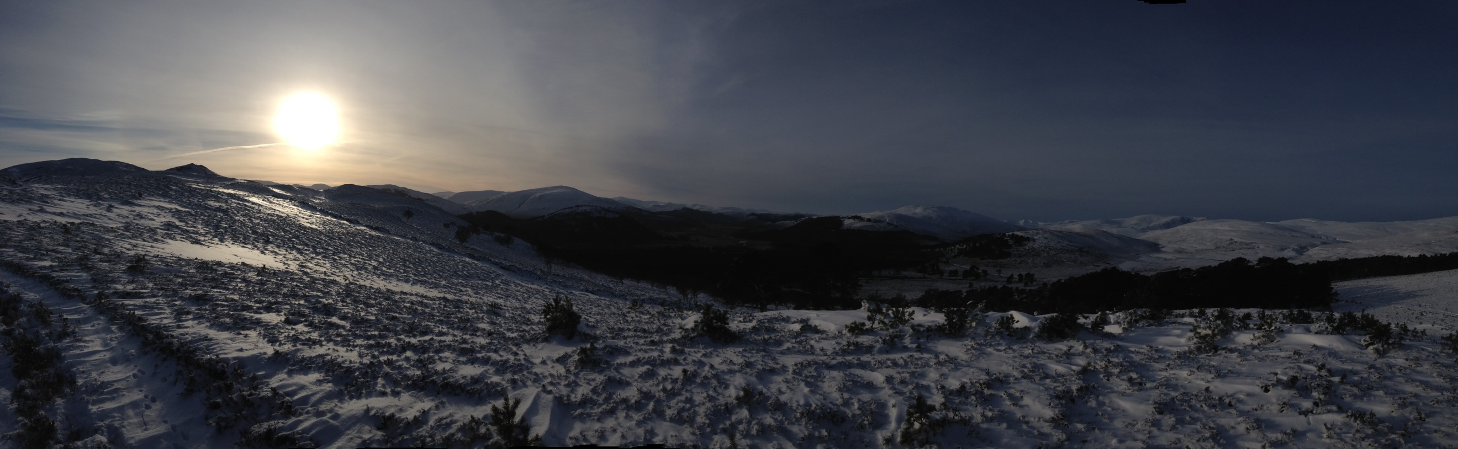
Nan Shepherd
Writing Competition
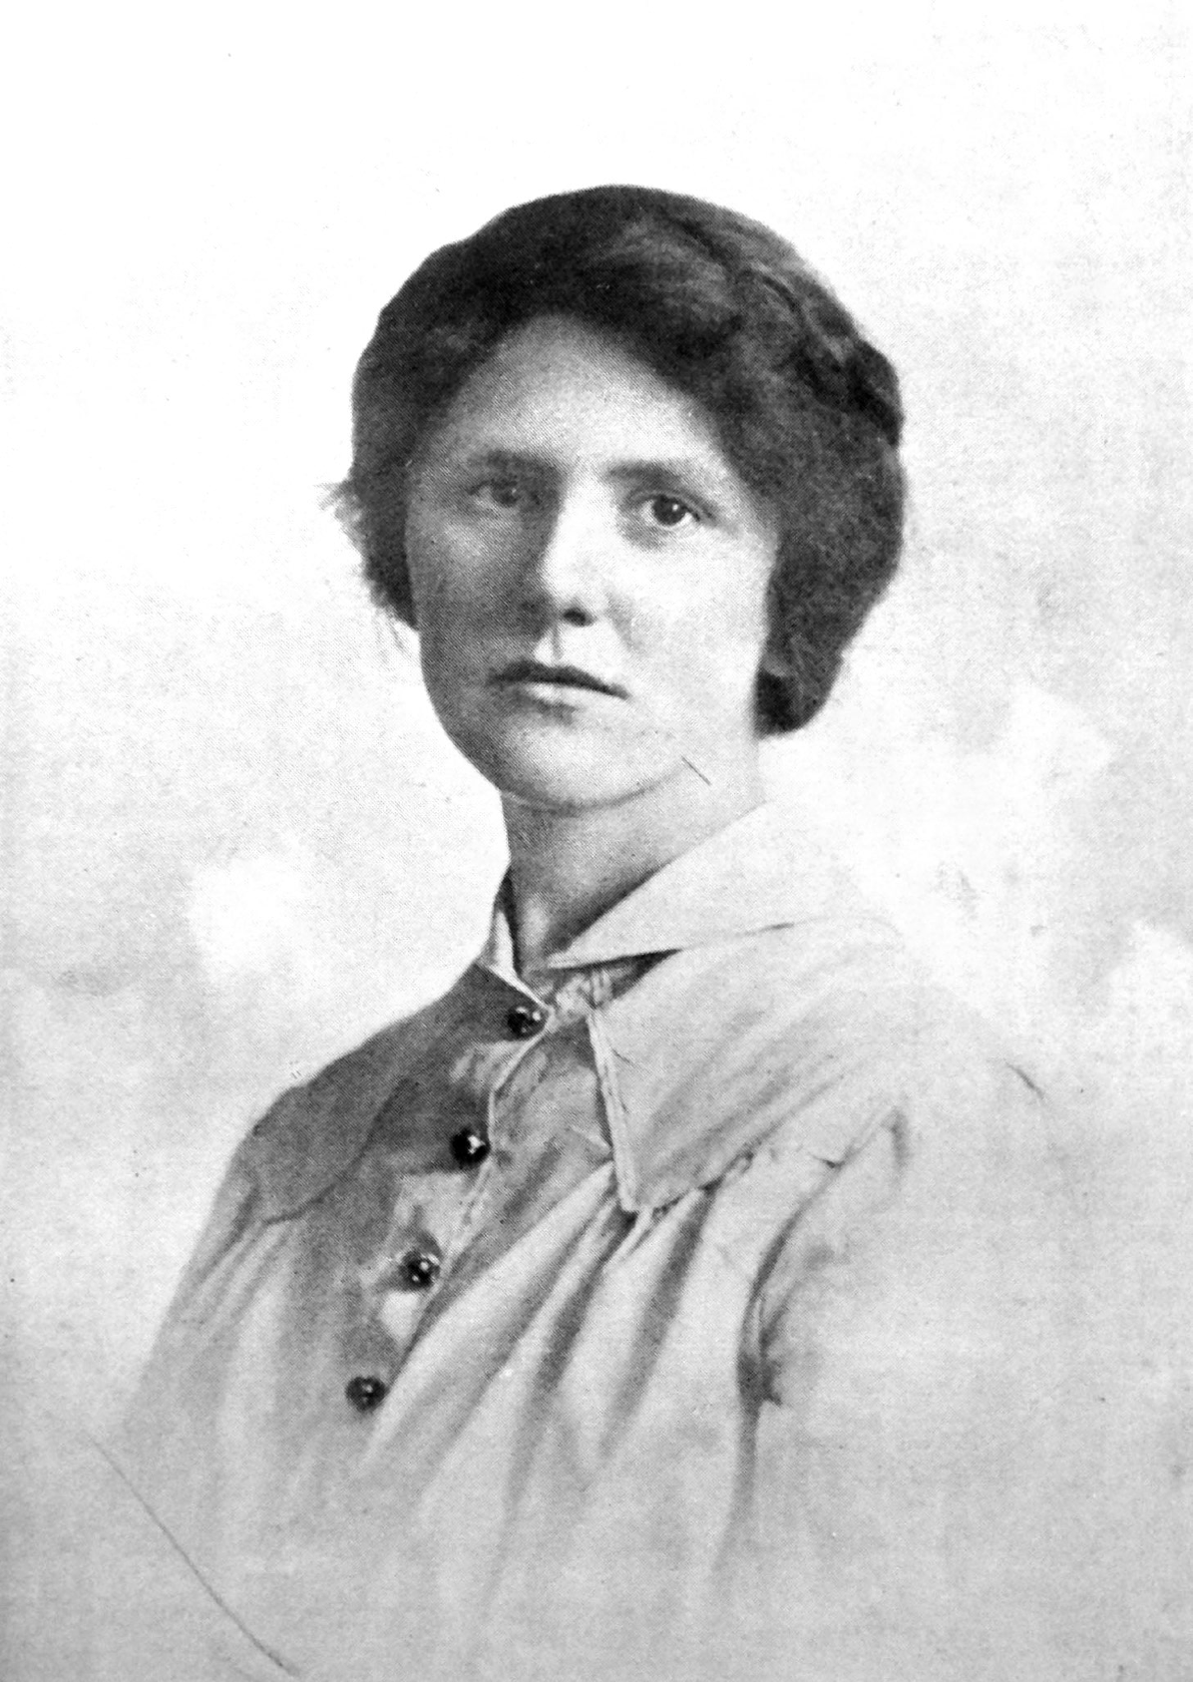

Nan Shepherd was among the first women to graduate from the University of Aberdeen and her experience there inspired her to devote the rest of her life to education and literature. Although she is best known today as the much-praised nature writer of The Living Mountain who appears on the Royal Bank five-pound note she accomplished much more in a lifetime of remarkable achievement, despite being notoriously modest. She was a celebrated writer of prose and poetry, an editor, lecturer, traveller, and tireless enthusiast who loved literature and landscape. Perhaps most importantly she encouraged and supported young writers in their work and inspired generations of teachers with her passion, particularly for North-east writing.

She graduated in 1915 but kept a close relationship with the University of Aberdeen throughout her life, guiding and editing Alma Mater magazine throughout the Great War, later editing the Aberdeen University Review and giving enthralling literary lectures until she was well into her eighties — always without notes.

Nan recognised the adventure of knowledge and believed that ‘a torch cannot be handed on that has not been lit’ and it is in her spirit of creative encouragement that the Word Centre for Creative Writing at the University of Aberdeen introduces a writing competition in her name. It is hoped that her legacy will further inspire young writers on their creative journey.

The theme this year is ‘Place and Belonging’ and the competition is open to S5 and S6 pupils in Aberdeen, Aberdeenshire, Morayshire and Angus.

Closing date for submissions is March 28th 2025.
Entries will be judged by staff from the University of Aberdeen.
There will be a 1st prize of £250 and two runners-up prizes of £100.
Full details and entry form overleaf.




Competition Rules
The competition is limited to schools in Aberdeenshire, Aberdeen City, Morayshire and Angus. The competition is open to S5 or S6 pupils; school entrants must be in the named year groups on the competition closing date. Entry is free and limited to one entry per pupil. The writing can be either prose or poetry inspired by the theme of ‘Place and Belonging’. PLEASE NOTE: repeat entries from previous years’ competitions are not permitted. The writing must be previously unpublished and can be in any variety of English or Scots or a combination of both. The length of entries is limited as follows: Prose up to 1300 words. Poetry up to 50 lines. The first prize will be £250 with two runners up prizes of £100. Copyright will remain with the author. The organisers reserve the right to publish winning and runners-up entries.
Submission of Entries
Early submission is encouraged. The last date for acceptance of entries is March 28th 2025.
- Entries by post: Three copies of each entry must be submitted on A4 paper. Entrants must NOT put their names on the entry itself but should attach one single completed entry form (or photocopy) to the three copies.
- Please send entries clearly marked:
‘Nan Shepherd Writing Competition’ to:
School of Language, Literature, Music and Visual Culture, Room A13, Block A, Taylor Building, King's College, Aberdeen, AB24 3UB.
- If an email address is supplied, receipt will be acknowledged by email.
For a posted acknowledgement of receipt, enclose a stamped self-addressed envelope marked ‘Receipt’.
- Entries by email: Entries may be sent in pdf format, with entry forms in Word or pdf format to nan.shepherd@abdn.ac.uk. Receipt will be acknowledged by email.

Entry Form
Name ……………………………………………………………………………
School …………………………………………………………………………..
Date of Birth …………………… Class: S5/S6 (ring or delete) as appropriate)
Address ……………………………………………………………………...….
…………………………………………………………………………………..…………………………………………………………………………………..
Email address (if you are submitting via a school email address, please supply a personal email address as well if you have one) ...…………………………………………………………………
Tel No……………………………………………

