UNIVERSITY OF ABERDEEN

UNIVERSITY COLLECTIONS

Volunteering Policy

1 University Collections Purpose
Since 1495, the University of Aberdeen has been open to all and dedicated to the pursuit of truth in the service of others. University Collections supports this foundational purpose, aiming to curate, enable, innovate and promote access for all to the University’s internationally important archives, museum collections and rare books for teaching, research and public engagement.

2 Volunteering
2.1 Role of volunteers
Volunteering is encouraged and supported whenever possible. It can offer valuable workplace experience and personal well-being as well as contributing to the work of University Collections. Volunteers carry out work without financial compensation alongside paid professional staff: they are not a substitute for employed staff, so will not be engaged in activities which would replace a paid post. Volunteering brings a diversity and depth of subject knowledge and so is a key part in helping to achieve strategic aims, while working with volunteers is a key part of the University’s commitment to engage with the wider community and lifelong learning, also offering experience in the workplace to support further professional training, study or employment. Volunteering within University Collections is governed by the University’s Staffing Policy on Volunteering.

2.2 Equality, Diversity and Inclusion
The University of Aberdeen celebrates and values the diversity of its community and recognises how the range of perspectives this brings enriches University life and contributes to its success. The appointment and management of volunteering therefore follows the University’s Equality, Diversity and Inclusion Policy. In accordance with the University’s commitment to equality and diversity applications are encouraged from prospective volunteers of all personal backgrounds. Volunteers will be encouraged to approach their supervisor regarding any reasonable adjustments they may require related to equality, diversity and inclusion; any such requests will be addressed promptly and supported where reasonable and practicable.

The particular opportunities and challenges presented by volunteering with the collections are recognised. On the one hand, the diverse backgrounds, experiences, and perspectives offered by volunteers can increase the knowledge and understanding of the collection and opportunities for widening engagement. On the other hand, the nature of the collection and the historic legacies it embodies could bring the potential for causing distress. Care is taken when advertising and describing volunteer positions to clearly represent what tasks involve and any aspect that might cause distress, so people can make an informed choice whether to volunteer. Induction sessions will include a discussion of what volunteers should do if they are uncomfortable with any aspect of their volunteering.

2.3 Work placements and Internships
Short unpaid work experience placements may be offered where operationally possible and mutually beneficial. Priority will be given to work experience placements by University of Aberdeen students as part of credit-bearing courses. Unpaid internships will not be supported. However, paid internships may be offered for work on specific projects during a defined period, such as those funded by the University, or where external funding is secured, with appointment procedures defined by the relevant funding scheme.

2.4 Health & Safety
Volunteers are required to share responsibility for Health and Safety, and to follow the University’s Health and Safety Policy. This includes assessing and managing the risks associated with working with, or near to, items in the collection, as well as the risks associated with the activity itself. Any personal protective equipment required to carry out agreed tasks will be provided by the supervising member of staff. Volunteers should discuss any health conditions or personal requirements with their supervising member of staff if it may affect their ability to work with University Collections. Volunteers are covered by University insurance whilst undertaking duties on behalf of University Collections. Volunteers are covered by the University’s liability insurance policies whilst undertaking duties on behalf of University Collections. Volunteers will not undertake any regulated work with children, and therefore they will not need a Protection of Vulnerable Groups check. The minimum age for volunteering is 16 years old. There is no upper age limit to volunteering, but volunteers should not continue beyond a point which is detrimental to their health and safety or where they cannot carry out their tasks effectively.

2.5 Confidentiality
University Collections works within the University of Aberdeen’s Data Protection Policy and Information Security Policy, including the handling of personal information about volunteers. See appendix 2: Privacy Notice: Volunteering at the University of Aberdeen Collections. All volunteers are expected to maintain the confidentiality of privileged information to which they may be exposed while carrying out their assigned tasks.

3 Volunteer recruitment and management
3.1 Volunteer recruitment
A priority is given to accommodate students and recent graduates of the University of Aberdeen, though volunteer applications are welcomed from the wider community. As people volunteer for a variety of reasons, staff will endeavour to arrange placements so they are as mutually beneficial as possible to both the volunteers and to University Collections. Applications are made using the Volunteer Enquiry Form. Applicants will join a waiting list and are contacted when a suitable opportunity arises. Specific positions may also be advertised through student ezines and the Student Careers Service. For one-off volunteering events that offer an opportunity to a large number of volunteers (such as Housekeeping Days), events will be advertised to all current volunteers and to those on the volunteering waiting list, with places offered on a first come, first served basis. For regular volunteering placements, initial selection will be based on matching information on the Volunteer Enquiry Form with the personal specification for the specific volunteering role. Applicants are asked to provide the name and contact details of one referee. Placements will be made following a meeting with the member of staff responsible for volunteer coordination, and discussion with appropriate staff members, to match the applicant’s skills, talents, interests and desires with operational requirements.

3.2 Volunteer management
Volunteers will be directly responsible to a named member of staff and will discuss and agree a written role description and a signed volunteer agreement recording the tasks the volunteer has agreed to perform, prior to beginning their placement. This includes an agreement about when and how much time is to be committed. Volunteer placements last for a maximum of 12 months but may be renewed. The placement may be cancelled immediately at any time at the discretion of either of the parties and will expire automatically at the end of the period of agreement unless renewed by both parties. An initial review will be undertaken after a mutually agreed period of time, and regular review meetings will be held to discuss progress. Any complaints about volunteer supervisors or about volunteers will be dealt with according to the University’s Volunteering Policy (Appendix A: Complaints). Training will be given where necessary to enable volunteers to carry out the tasks detailed in the volunteer role description, with training and development needs reviewed and updated regularly. Out-of-pocket expenses will be recompensed if agreed in advance by the supervising member of staff. This includes travel expenses if incurred during travel between sites in the course of volunteering activities but does not include travel to/from work. There will be no financial renumeration for volunteer work with University Collections.

4 Honorary staff of University Collections
Established volunteers who are not otherwise members of staff of the University may be appointed as Honorary members of University staff where they demonstrate a substantial and continuing commitment to the work of University Collections. Such appointments will follow the University’s Policy for the Award of Honorary Status, and will be for a defined period of time, at which point appointment will be reviewed. Honorary status brings with it a staff contract and additional benefits and responsibilities such that staff are in most respects, other than payment, treated as members of University staff. This status differs from Honorary Curatorial Fellowship, which is described in the Research and Academic Engagement Operational Policy.

Honorary staff will report to the Head of University Collections and will be directly responsible to a named member of staff. They will discuss and agree a written role description, including an agreement about when and how much time is to be committed. Training will be given where necessary to enable them to carry out the tasks detailed in the volunteer job description, with training and development needs reviewed and updated regularly. Honorary staff are responsible for completing mandatory annual Data Protection and Information security training and any other training mandatory for the post. Out-of-pocket expenses will be recompensed if agreed in advance by the supervising member of staff. This includes travel expenses if incurred during travel between sites in the course of volunteering activities but does not include travel to/from work. There will be no financial renumeration for work undertaken as Honorary Staff of University Collections.

- Policy Responsibility and Review
This operational policy will be reviewed at least annually by the Management Team of University Collections, with changes to be approved by the Directorate of Digital and Information Services Leadership Team. Associated forms and guidance will be consistent with this operational policy, and are approved by the Management Team of University Collections.

Approved by Directorate of Digital and Information Services Leadership Team, 16 December 2025.

Appendix 1 Volunteer Application Form

The volunteer enquiry form is hosted online https://www.abdn.ac.uk/collections/get-involved/volunteering/
University Collections Volunteer Enquiry
When you submit this form, it will not automatically collect your details like name and email address unless you provide it yourself.

1 Name`
2 Address
3 Home phone
4 Email
5 Are you a current University of Aberdeen student? – Yes/No
6 If yes, what is your degree intention and your current year of study
7 What type of volunteering would you like to do with University Collections?
8 Please tick any of the following areas that are of interest:
Cataloguing (archives) / Conservation / Exhibitions / Guided Tours / Outreach/Schools /
Museums (general) / Cataloguing (rare books) / Digitisation / Events / Social Media /
Marketing & promotions / Zoology Museum / Gallery Assistance (greeting visitors)
9 When can you volunteer (Date from and available to)
10 Please tick any of the following that are preferable
Monday / Tuesday / Wednesday / Thursday / Friday / During the day / Morning / Afternoon /
In the evenings / Any time / Weekends / Other e.g. holiday periods
11 If you are available/unavailable on specific days/times, please give details below
12 Why do you want to volunteer?
13 What are your interests?
14 Are you entitled to work in the UK? Yes/No
15 Please give the contact details of one person who can act as a character referee (This may be a tutor/lecturer/former employer etc. not a friend or relative)

Appendix 2 Privacy Notice: Volunteering at the University of Aberdeen Collections

This notice explains how the University of Aberdeen uses any personal information we collect about individuals who volunteer at the University of Aberdeen Collections.

What information do we collect about you?
Please note that this list may not be exhaustive. We collect information from you when you apply for a volunteering opportunity through our online form. We collect the following information:
- Name and Contact details
- Whether you are a student and if so what degree/ year of study you are currently at
- What type of volunteering you are interested in and why you wish to volunteer
- Your availability
- Interests
- Whether you are entitled to work in the UK
- Details of a character referee.

We will also collect the following information about you while you are volunteering:
- Information about any health or disability requirements you may have
- Information about your progress while volunteering
- Financial information where there are applicable expenses due to travel.

Why do we collect this information?
There are several lawful bases on which the University routinely processes your personal information. These are:
- to fulfil the University's contractual relationship with you
- to comply with our legal obligations under equalities and health and safety legislation
- for the University's statutory powers to provide teaching, promote research and administer the University

Who might we share the information with?
The third party suppliers we use for IT and service delivery support also have access to your personal information in order to provide these services to the University. We may disclose personal information to other recipients in exceptional circumstances or when required to do so by law. We will transfer your personal information to countries and organisations outside the European Union where necessary when you participate in our exchange or study abroad programmes. We have agreements in place with our partners to safeguard your information.
How long will we keep your information for?
- Enquiries by applicants will be held on file for 12 months and will be reviewed within this period should a suitable opportunity become available.
- Contact details and emergency contacts of current volunteers will be held on file during their period of volunteering. This data will be deleted after the agreed volunteering period ends.
- Basic details of past volunteers - name, dates of volunteering, and tasks performed in the role - will be kept on file for 5 years after the volunteering period ends, to assist with providing references for former volunteers. Other data, such as health data, progress reports and volunteer agreement, will be deleted when volunteering ends.

Your data rights
Applicants who have not yet taken on a volunteer role, can ask for their name to be removed from the contact list by emailing uoacollections@abdn.ac.uk. For more information on how to exercise your data rights and to contact the Data Protection Officer please visit: Your Rights | About | The University of Aberdeen

Appendix 3 Template Volunteer Role Agreement Form

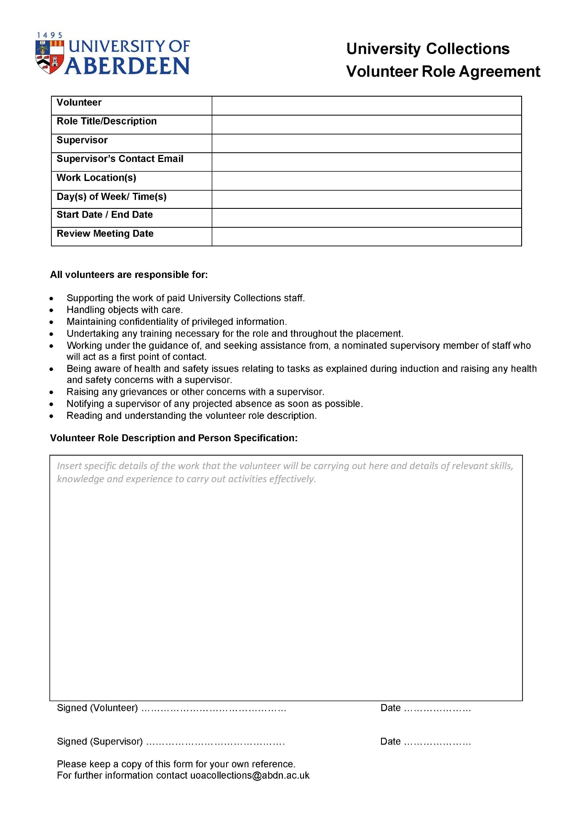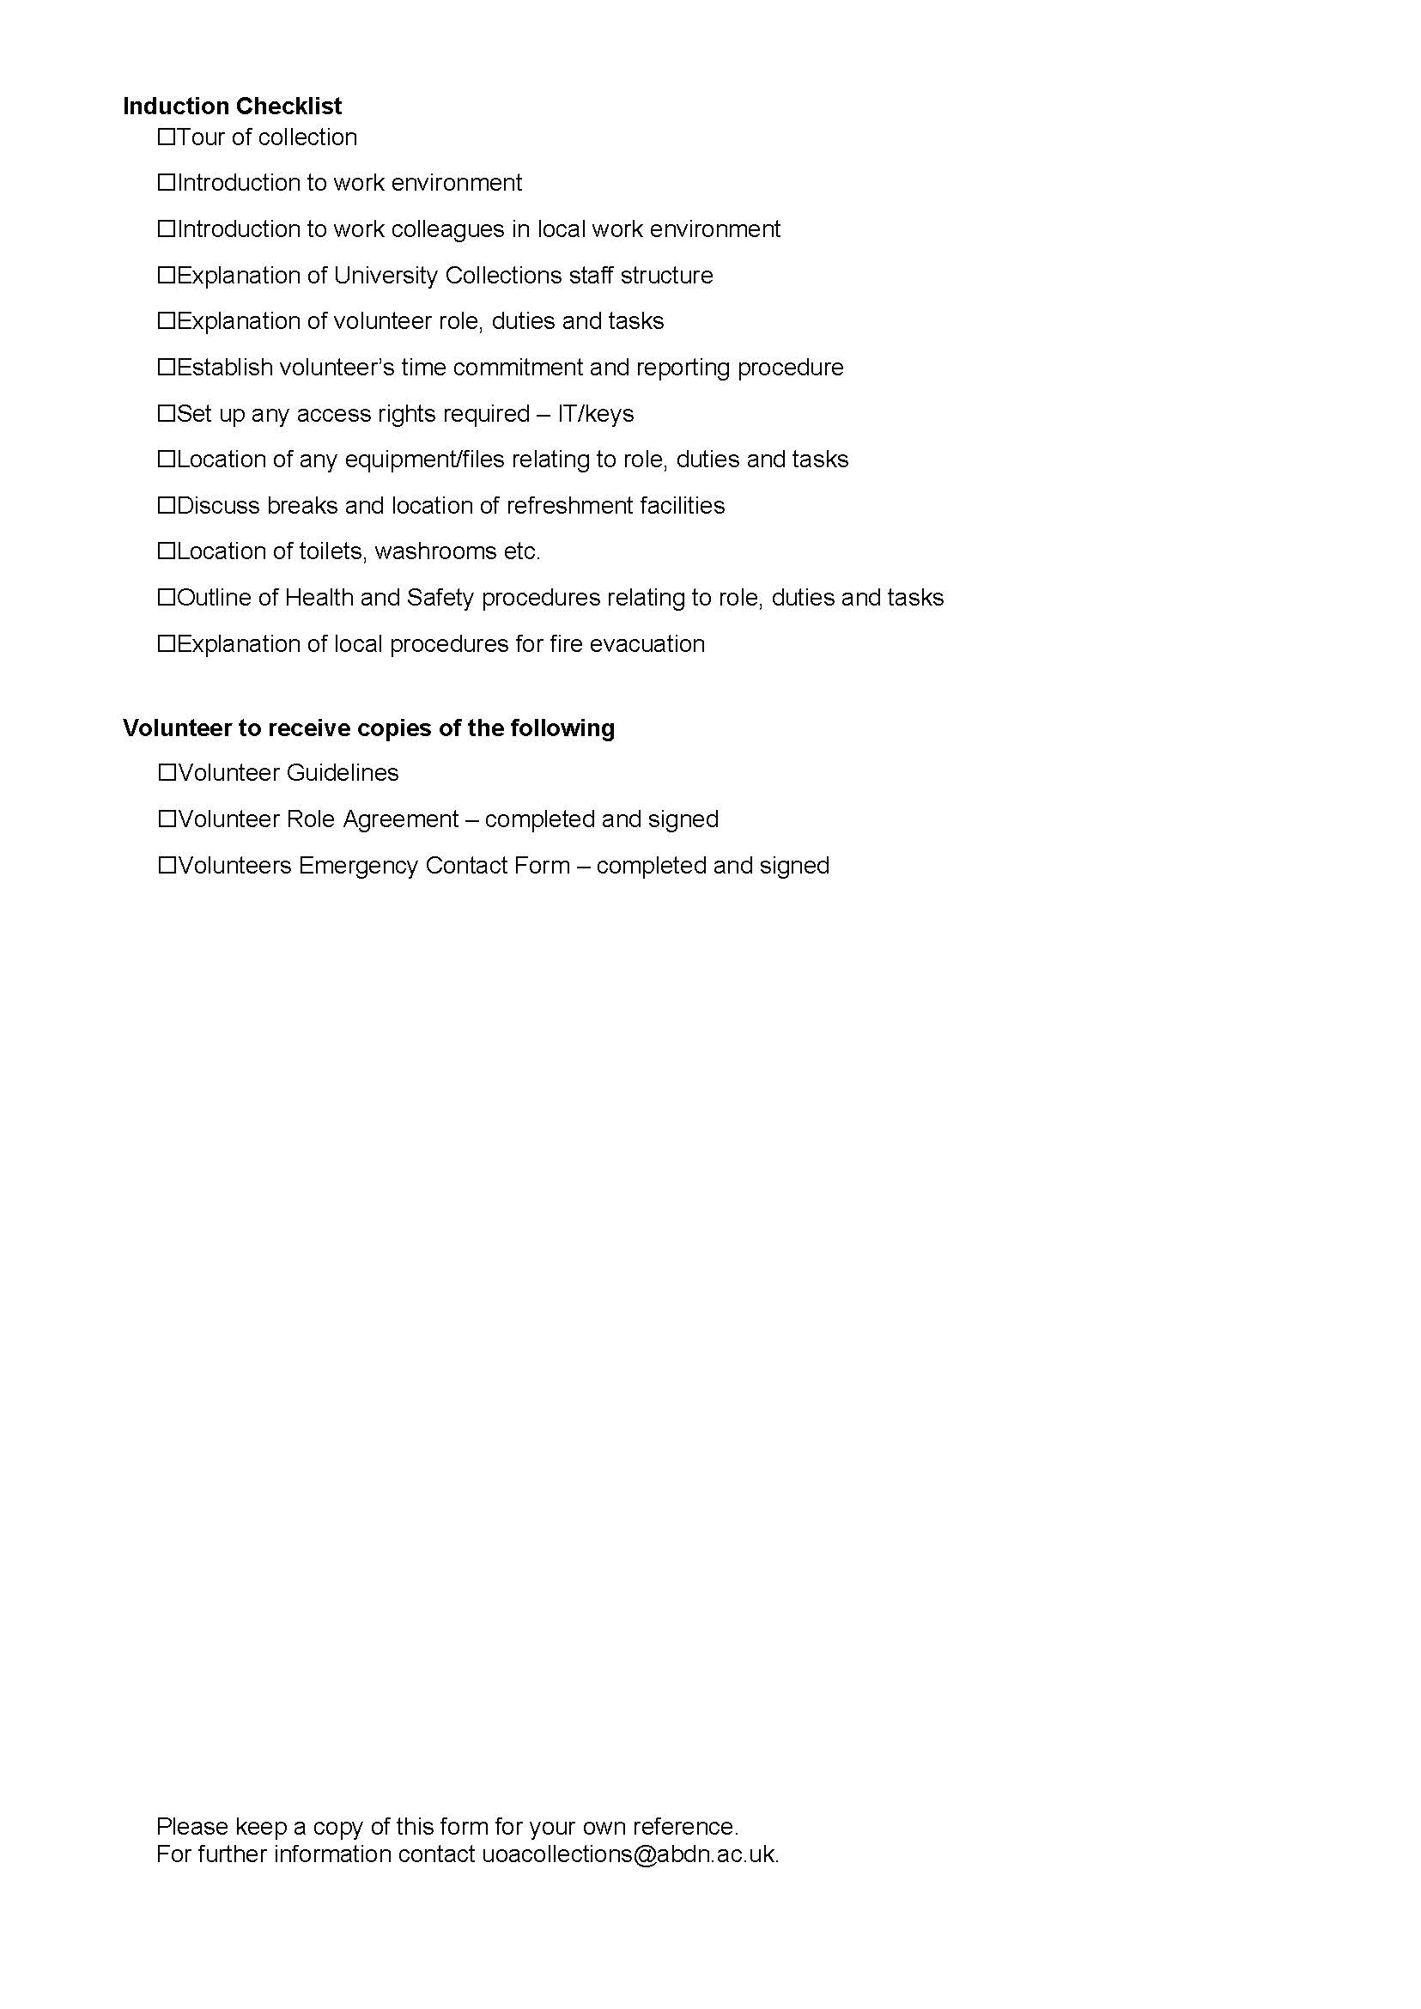

Appendix 4 Emergency Contacts Form

