UNIVERSITY OF ABERDEEN

UNIVERSITY COLLECTIONS

Research and Academic Engagement Policy

1 University Collections Purpose
Since 1495, the University of Aberdeen has been open to all and dedicated to the pursuit of truth in the service of others. University Collections supports this foundational purpose, aiming to curate, enable, innovate and promote access for all to the University’s internationally important archives, rare books and museum collections for teaching, research and public engagement.

2 Principles for Research with the Collections
2.1 Enabling access to collections
Research is encouraged that leads to greater understanding of the collections and opportunities for engagement and impact. University Collections support research by providing information about the collections (mainly through online access to catalogues and responses to email enquiries), as well as physical and digital access to collections items, for example through digitisation (see the Collections Access Operational Policy and the Digitisation Operational Policy). Where there are restrictions, such as due to the fragility of items, health and safety considerations, limited staff availability, confidentiality or other issues, staff will endeavour to give a full explanation.

2.2 Widening access and collaborative research
University Collections ensures that the collections, activities and spaces in its care, along with staff expertise, are open to all for a wide range of formal and informal research. This can include creative explorations, as well as studies of specific items, and can be the work of individuals or groups. Research offers many opportunities to work with related people, ranging from finding out about needs and wishes, through working together on design and delivery (co-production), to spreading awareness of the results (dissemination). The views and experiences of relevant communities should be considered when planning research, including ways in which knowledge and understanding gained will be used.

2.3 Promoting good research practice
All people carrying out research with University Collections must ensure that they care for the collections and the people involved, and act fairly, responsibly and considerately. Those carrying out academic research are expected to understand and follow the UK Research Integrity Office Code of Practice for Research, which lists the key points of good practice for all research projects, along with any other relevant policies and guidelines, such as the University of Aberdeen’s Information Security Policy. Researchers based in the University of Aberdeen, including University Collections staff, are expected to follow the procedures laid out in the Research Governance Handbook, including institutional procedures for ethical review, while other researchers are expected to follow similar processes. People who are unsure whether their work might need ethical review, and do not belong to organisations which can help with this, should contact the Academic Engagement and Research Lead for advice. Anyone who becomes aware of potential misconduct in research should alert the Head of University Collections or the Director of the Directorate of Digital and Information Services, as well as following institutional procedures.

3. Research management
3.1. Planning research projects
University Collections endeavours to provide advice and support relating to substantial research projects focusing on the collections. Large-scale research projects, particularly if requiring external funding, must be discussed, planned and agreed in advance with the Academic Engagement and Research Lead. All projects should demonstrate healthy research cultures, from pre-project planning to post-project reporting, including adequate consideration of University Collections resources, and consideration and acknowledgement of staff as project leads, co-leads or specialists where appropriate. People and organisations hoping to submit funding applications involving University Collections must not do this without full agreement, and University Collections reserves the right to refuse to participate in work which has not been properly agreed in advance.

3.2 Funding research
An annual Research Award scheme open to all is administered by University Collections with funding from the Friends of Aberdeen University Library, while the Friends of Aberdeen University Library also provides a to support University of Aberdeen postgraduate students. Details of both schemes are in Appendix 4.

3.3 Research involving people or sensitive items
Proposed research involving people and their remains, and material that may be considered sacred or sensitive requires special care when planning, ideally including related people and communities in design. Proposals for research which would involve staff of University Collections as research subjects research must discuss this with the Academic Engagement and Research Lead during project design. University Collections will ensure that staff do not feel under any pressure to act as research subjects, but that they are enabled to give fully informed consent if they wish to participate.

3.4. Destructive sampling
In some cases, research relating to items in the collections can be furthered by destructive sampling. Decisions on whether this is approved are taken on a case-by-case basis by the relevant curator, in consultation with a conservator, who will decide whether damage to a sampled specimen is justified by the potential knowledge to be gained. It is expected that sampling and analytical techniques will have been trialed and perfected elsewhere before approaches are made to sample items. All applications for destructive sampling must be made in writing using the application form.

3.4.1 Criteria
The criteria to be considered are the availability, condition and nature of the item(s) to be sampled, the nature of the damage likely to be incurred, evidence of effectiveness and appropriateness of the proposed methods, evidence of the research value of the proposed research, the previous experience of researcher in proposed sampling and analytical techniques, and whether similar research has been conducted already. If sampling involves the remains of named people, permission should be sought from family members, if known.

3.4.2 Sampling protocols
When selecting which part of a specimen to sample, diagnostic areas and those of greater significance or display potential should be avoided and further justified if necessary. Every effort must be taken to prevent contamination in the sampling process. Successful pilot studies on a small selection of items will normally be required before sampling of large numbers of items is approved. Before and after photographs should be taken of all material to show the sampled area, some identifying number/label and should be taken with appropriate skill and lighting so that necessary details are visible and can form a permanent record.

3.4.3 Packing, transport and storage
All items loaned for sampling purposes should be packed according to recognised standards, as approved by the relevant conservator. All remaining parts of the sample (including DNA samples) should be returned to University Collections immediately following the completion of analysis. Individuals or institutions borrowing material must ensure they have the proper, recognised and necessary permits or licenses for shipping specific material. The transport of human remains and other sensitive material must be undertaken with particular discretion, dignity and respect, including every effort being made to ensure that the wishes of all involved with the transport and storage are respected.

3.5 Public engagement with research
All proposals for exhibitions and events that involve the use of the collections, staff or venues of University Collections for public engagement must be discussed and planned in advance with the Exhibitions and Public Programming Manager, bearing in mind that such activities tend to be scheduled months or years in advance. For further information, see the Exhibitions and Engagement Operational Policy.

3.6 Publication
To help University Collections keep a record of research undertaken and knowledge gained, research should be openly available and full details of any basic data relating to analysis of individual items, such as radiocarbon dating, provided to University Collections as soon as available. If there is a need for a delay in making it publicly available, this should be discussed with the Academic Engagement and Research Lead. Publications should make clear which items have been studied by use of catalogue numbers, while images should be credited as outlined in the Digitisation Operational Policy. For acknowledgments, the use of the Contributor Role Taxonomy (CRediT) is preferred, including the contributions of University Collections staff.

4 Academic Engagement and Teaching

4.1. Uses of the collection for teaching

The collection can offer powerful opportunities for learning as part of Higher, Further and Continuing Education, both for programmes within the University of Aberdeen and those elsewhere. Teaching involving direct access to items should be supervised by a member of University Collections staff or a specifically identified Honorary Curatorial Fellow in an appropriate venue, such as the Collections Seminar Room. All proposals for teaching, including those by University Collections staff, should use the online Teaching Enquiry form.

4.1.1 Resource allocation
For pedagogical and collections care reasons, teaching should be planned well in advance and adequately resourced. Within the University of Aberdeen the standard resource allocation model is used to allocate resources, based on the contributions of University Collections staff to teaching and teaching support. Planning teaching should involve discussion of financial resourcing where relevant, for example if the teaching contribution is regular or substantial, so should normally begin at least one month before the start of the coming academic year. One-off visits by classes will be supported at no charge, but should also be carefully planned using the Teaching Enquiry form.

4.1.2 Teaching quality
University Collections staff involved in delivery or management of teaching should evaluate this work and take part in relevant formal and informal continuous professional development, to ensure high standards throughout the process. Where relevant, they should be full members of teaching teams, with meaningful involvement in course or programme creation, planning and evaluation.

4.2 Honorary Curatorial Fellows
University of Aberdeen staff, including emeritus and honorary staff and research students, are eligible to be appointed as Honorary Curatorial Fellows in recognition of existing and intended substantial use of the University’s museum, archive and rare book collections for teaching, research or other activities. Subject to training and appropriate procedures being in place, they are eligible for enhanced access to collections for collections management, teaching, research, public engagement and other activities, and should also contribute to discussions of University Collections policy and practice, and champion the collections within the university. They do not have curatorial or managerial responsibility for the collections.

4.2.1 Appointment of Honorary Curatorial Fellows
Nominations can be suggested at any time to the Head of University Collections using the appropriate form, which includes the agreement of the relevant Head of School or Director. Appointments will be approved by the Head of University Collections, following consultation with the University Collections Management Team. Appointment are normally for a term of three years. On appointment, Honorary Curatorial Fellows receive training, principally relating to issues of conservation, security and ethics. The status of Honorary Curatorial Fellows may be withdrawn by mutual agreement, or if the appointee ceases to be a member of University staff, or if the Head of University Collections is satisfied that the conduct of the appointee has been inappropriate.

4.2.2 Responsibilities of Honorary Curatorial Fellows
As honorary members of staff of University Collections, Honorary Curatorial Fellows report to the Head of University Collections, and must follow the instructions of professional staff when working in University Collections venues and with items in the collections. Honorary Curatorial Fellows may be able to work in restricted areas, such as stores, and to supervise teaching activities, without requiring a full member of University Collections staff to be present. However, they are not collections key-holders, so access will be subject to mutually convenient arrangements being made with University Collections staff. Honorary Curatorial Fellows are not entitled to invite other people into restricted areas, nor to move items to other locations without the permission of professional staff, with appropriate records being made. Honorary Curatorial Fellows may be entitled to the short-term loan of items in the collections for teaching, research and other activities, subject to the satisfaction of specific requirements including conservation and security. Such loans must follow normal University Collections procedures, including completion of a signed agreement to specific requirements and a date of return (see Collections Documentation Operational Policy).

4.3 Academic Forum
The University Collections Academic Forum is established to draw together all Honorary Curatorial Fellows and other University staff interested in working with the collections, for the purpose of mutual learning and encouragement of multidisciplinary discussion, which may lead to interdisciplinary activity. Members are expected to contribute to University Collections planning and advocacy activities. At least three meetings of the Academic Forum will be held each year.

- Policy Responsibility and Review
This operational policy will be reviewed at least annually by the Management Team of University Collections, with changes to be approved by the Directorate of Digital and Information Services Leadership Team. Associated forms and guidance will be consistent with this operational policy, and are approved by the Management Team of University Collections

Approved by Directorate of Digital and Information Services Leadership Team, 25 November 2025.

Appendix 1 Destructive Sampling Request form

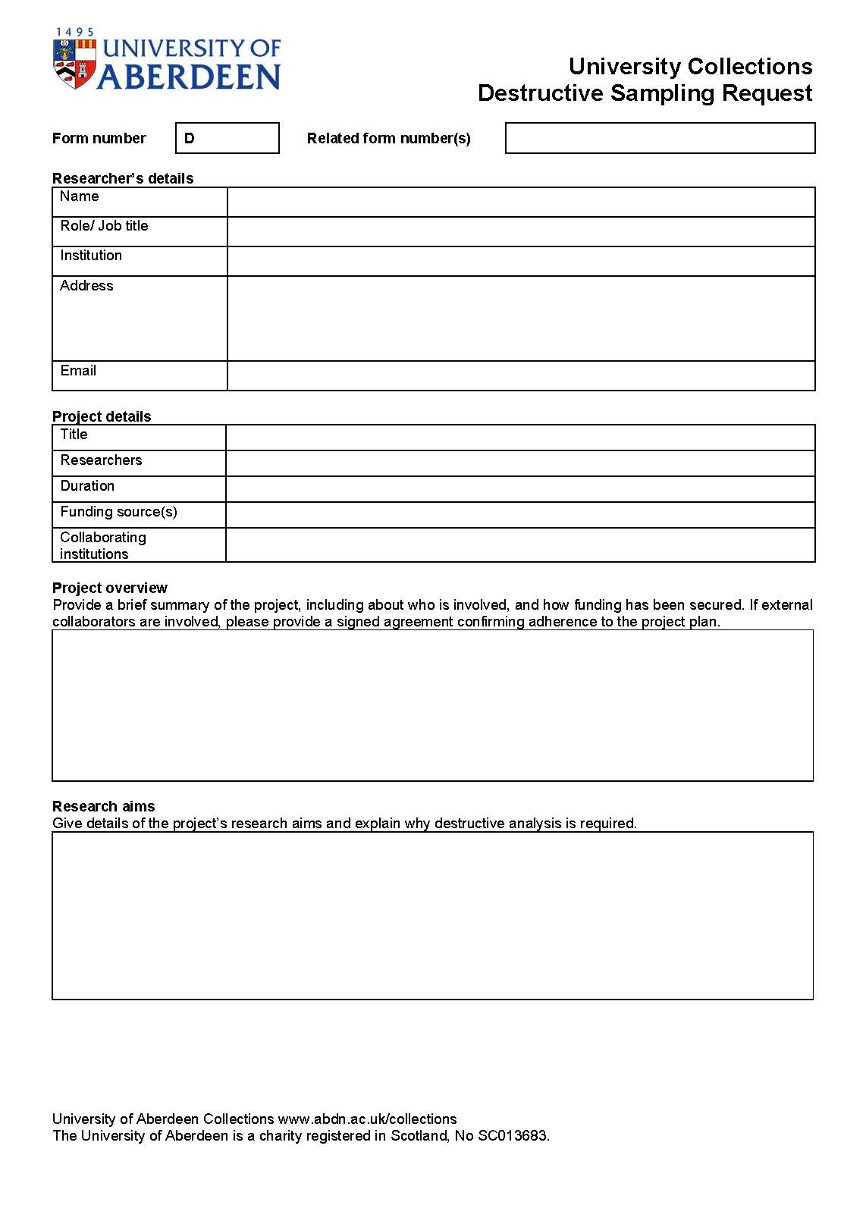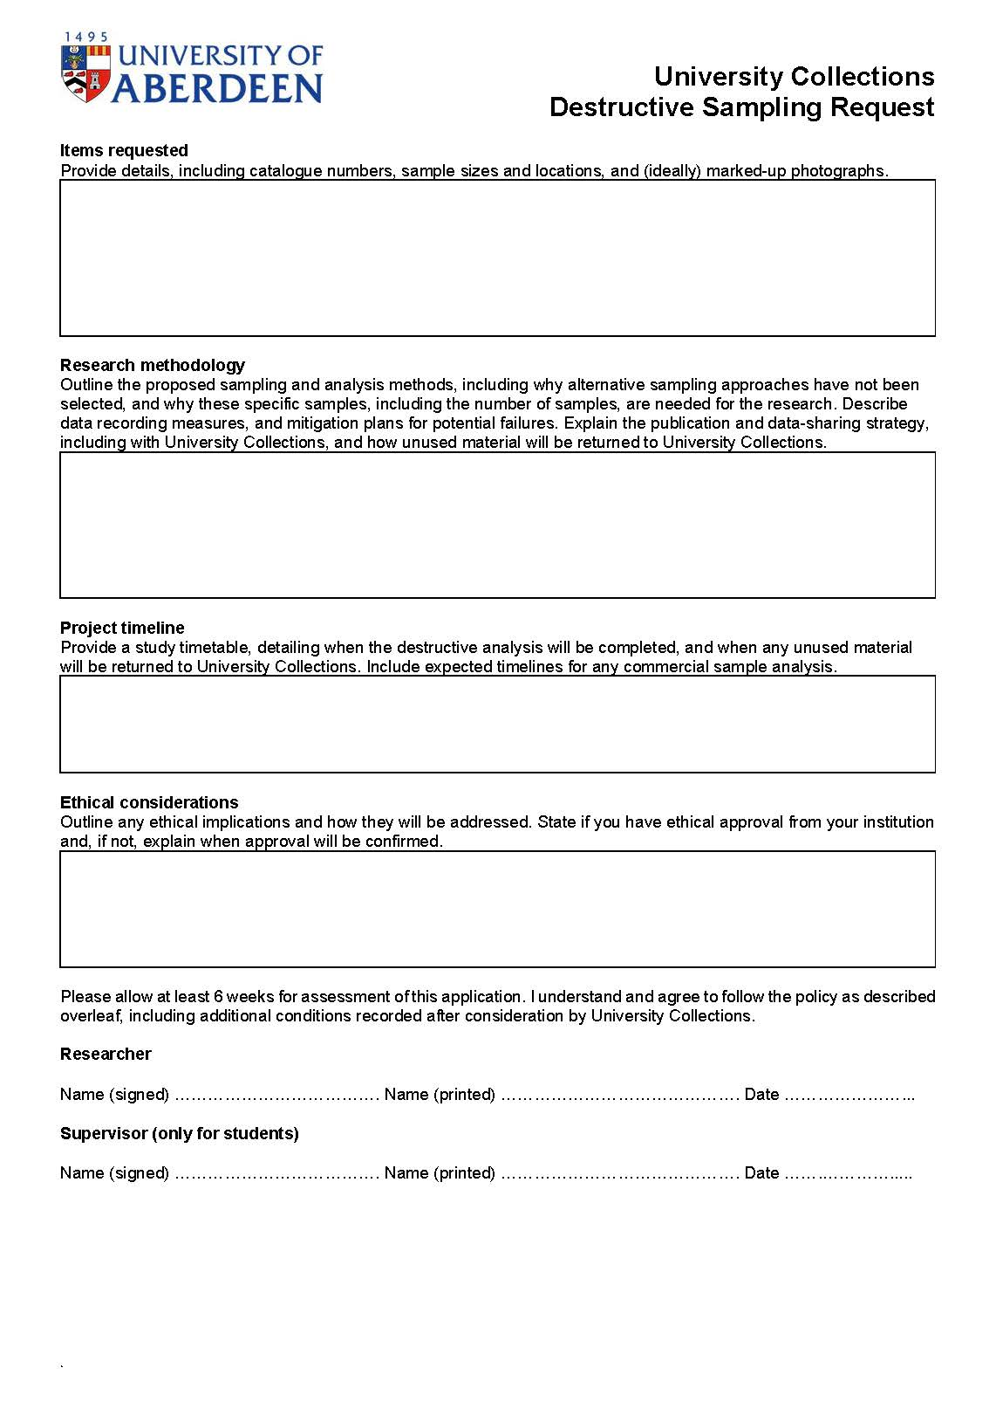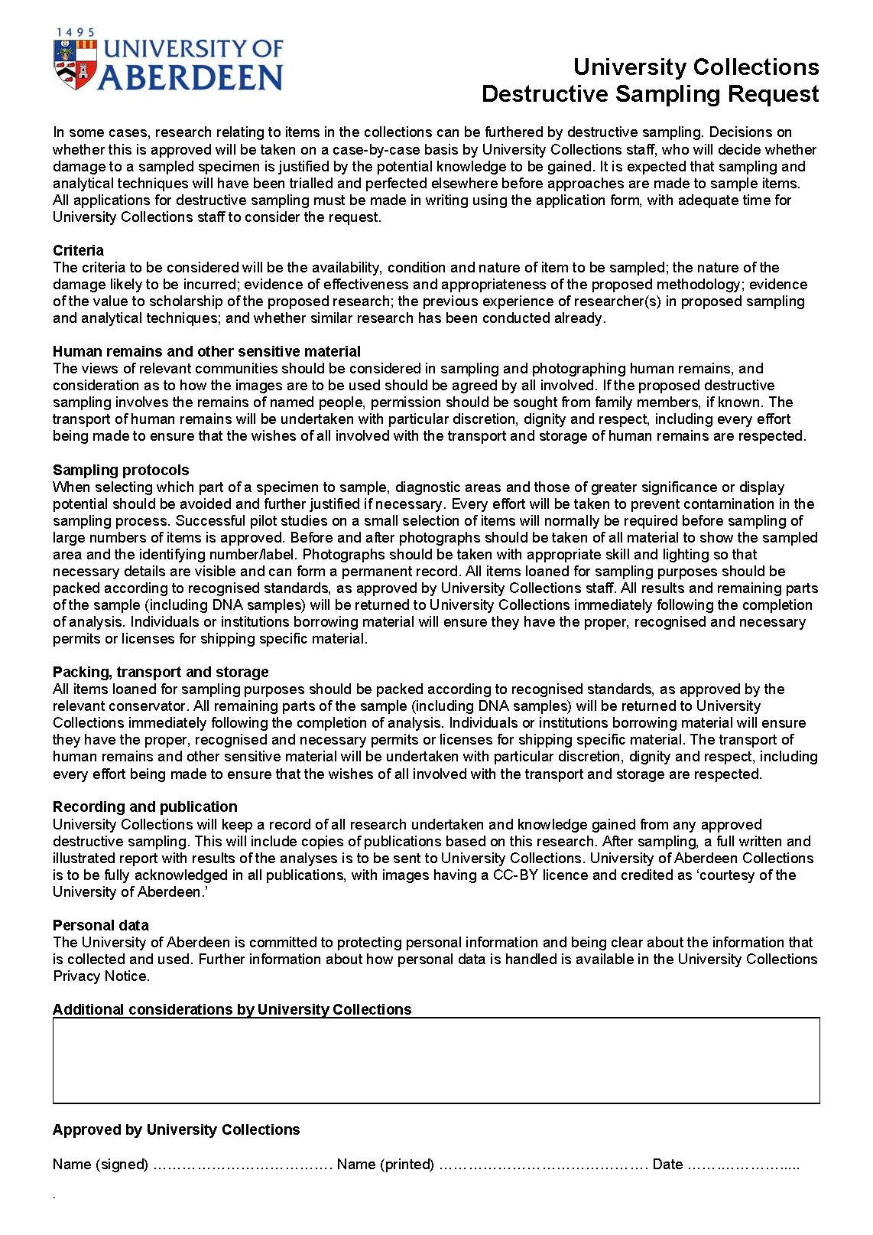

Appendix 2 Honorary Curatorial Fellow Application Form

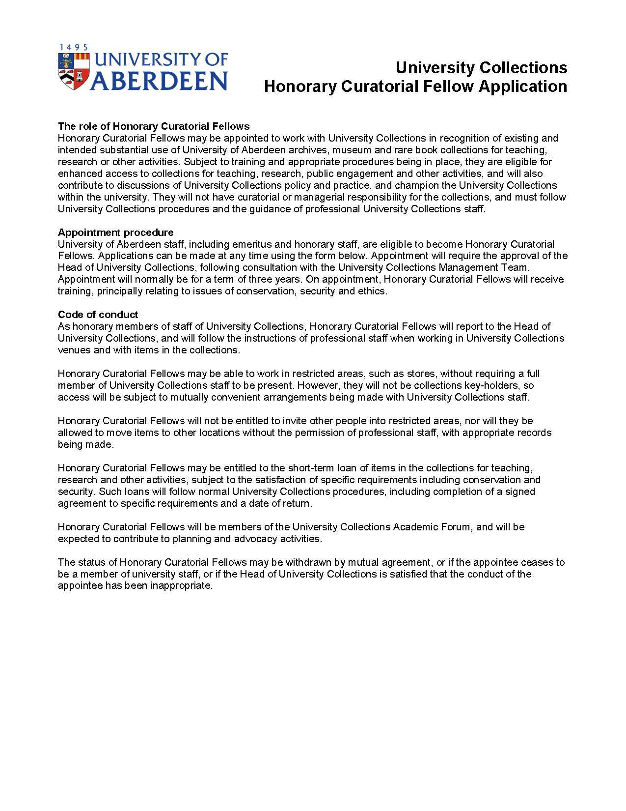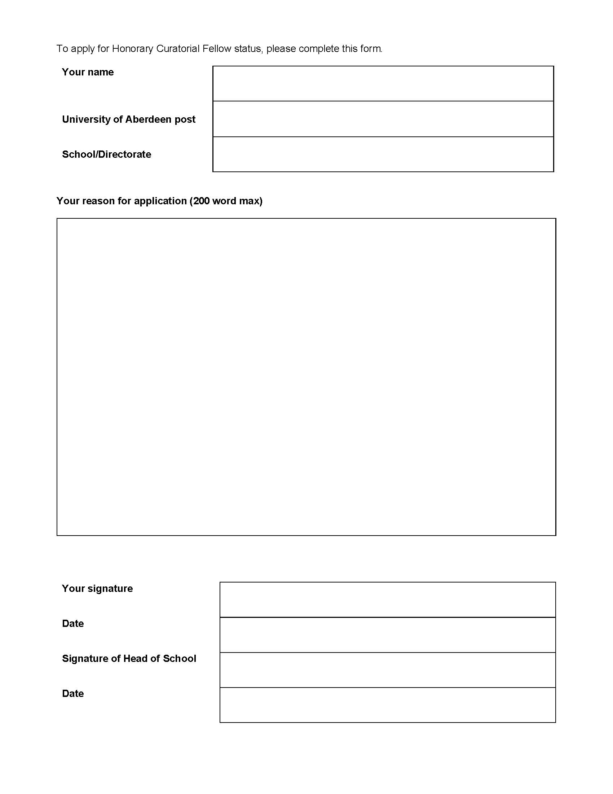

Appendix 3 Teaching Enquiry Form

The teaching enquiry form is hosted online https://www.abdn.ac.uk/collections/our-collections/research-teaching/teaching-enquiry/

University Collections Volunteer Enquiry

Your Enquiry
1 Is this enquiry about an existing or potential University of Aberdeen coded course (UG or PGT)? - Yes/No
2 Course code (if known)
3 Course name (if known)
4 Please outline your ideas
5 Most relevant or important learning aims *
6 Course catalogue (previous, current or draft)
7 Suggested University Collections staff member(s) if known
Student Numbers
8 Approximate number of students (if known)
Terms
9 Year
10 Term
September - December
January - April
May - August
Sessions
11 Number of sessions requested (if known)
12 Length of each session in hours (if known)
13 Preferred dates (if known)
Location
14 Preferred location (if known)
Online / Old Aberdeen / Foresterhill / Other
15 Location details
Suggested Contribution
16 How can we help?
Co-design of wider course, including learning aims
Assessment design / marking
Teaching or training (in person or remote) with collections
Teaching or training (in person or remote) without collections
Panel discussion (arrangement / participation)
Co-curation with students (physical or online exhibition / activity)
Pre-recorded presentation
Facilitation of teaching led by other staff (for example, material checking and supply)
Exhibition visit
Collections store visit
New digital images
Pre-session staff training (for example, handling)
17 Contribution details (if known)
18 Required materials with catalogue numbers (if known)
Additional information
19 Accessibility requirements
Please do not enter any confidential information here.
Details can be discussed at a later stage.
20 Any other questions?
21 Any relevant documents?

Appendix 4 Research Support Schemes

1 Friends of Aberdeen University Library Research Award scheme
A Research Award scheme is administered by University Collections with funding from the Friends of Aberdeen University Library. The normal award limit is £2000, although in exceptional cases awards of up to £3000 can be made. Funding can support travel, accommodation and subsistence, scientific analysis and public engagement relating to the rare and distinctive collections in the care of University Collections and Library Services, or which increase accessibility or understanding of professional practice in libraries, archives or museums in ways which will engage with or benefit practice at the University of Aberdeen. Applications are encouraged that have minimised their environmental impact, are interdisciplinary, aim to carry out public engagement, that increase accessibility, or otherwise adopt particularly innovative approaches. Applications for creative, practice-based, or community-engaged forms of research, as well as traditional research, are welcome. Awards will not support the employment of research assistant or existing accommodation and subsistence arrangements. Applications are encouraged from researchers from a diverse range of backgrounds. The criteria used to assess applications are:
- The research quality of the project.
- The extent to which the project connects with or requires use of the university’s library and museum, archive and rare book collections, or has the potential to advance relevant professional practice at the University of Aberdeen.
- The nature and clarity of any proposed outputs and future plans for the project.
- The credibility of the budget and costing as well as the extent to which the specific expenditure proposed is of an appropriate type and amount.
- The extent to which the project is logistically credible, including during the reimbursement phase following the project, for the application and university.
- The nature, credibility and potential impact of the proposed contribution to the Aberdeen community, which can include the public and/or the research community of the University.
- The strength of evidence for positive research culture and support by any person or group named as a collaborator, facilitator or beneficiary of this work, including professional services staff.
If there are more applications that are judged to be of a high quality according to the criteria above than can be funded, random selection will be used to make final decisions.

2 Friends of Aberdeen University Library Postgraduate Bursary
A Postgraduate Bursary scheme is awarded annually by the Friends of Aberdeen University Library to support University of Aberdeen postgraduate students working extensively with the rare and distinctive collections in the care of University Collections and Library Services, or which increase accessibility or understanding of professional practice in libraries, archives or museums in ways which will engage with or benefit practice at the University of Aberdeen. The award is a one-off bursary payment of £4000. Applications are encouraged that have minimised their environmental impact, are interdisciplinary, aim to carry out public engagement, that increase accessibility, or otherwise adopt particularly innovative approaches. Applications for creative, practice-based, or community-engaged forms of research, as well as traditional research, are welcome. Applications are encouraged from researchers from a diverse range of backgrounds. A FAUL Postgraduate Bursary cannot be held concurrently with a FAUL Research Award. The award may be held in conjunction with other awards so long as the total received in the academic year granted does not exceed the cost of fees and the current stipend awarded by UKRI PhD Schemes. Applicants must hold an offer of study from the University to begin in the current academic year or be less than 50% through their period of study at that time. The criteria used to assess applications are:
- The academic merit of the proposed project
- The feasibility of the proposed project
- The strength of the connection to the rare and distinctive collections in the care of University Collections and Library Services
Should the scholar receiving the award leave the University of Aberdeen, or fail to successfully complete their degree, the Friends of Aberdeen University Library reserves the right to seek that a portion of the scholarship will be refunded.

