UNIVERSITY OF ABERDEEN
UNIVERSITY COLLECTIONS
Collections Documentation Policy

- University Collections purpose
Since 1495, the University of Aberdeen has been open to all and dedicated to the pursuit of truth in the service of others. University Collections supports this foundational purpose, aiming to curate, enable, innovate and promote access for all to the University’s internationally important archives, rare books and museum collections for teaching, research and public engagement.

2 Aims
The collection has a long-term purpose and holds collections in trust for the benefit of the public in accordance with its stated objectives. This policy and associated procedures aim to ensure that University Collections fulfils its responsibilities in the management, access and security of the collections for which it cares. It aims to do this by:
- Improving accountability for the collections and their related data
- Maintaining the best possible standards in the documentation of the collections that meet the Accreditation standard
- Improving access to the collections for teaching, research and public engagement
- Enhancing the security of the collection

Documentation will follow procedures that are consistent with SPECTRUM 5.1 for the museum collections, ISAD(G) for the archive collections and MARC 21 for the printed collections. A standard set of forms are used across the collections (see appendix), with detailed procedures for the three domains. These procedures ensure that the capture, recording, safekeeping and use of information about the collections is completed in a consistent and ethical way. The procedures are to be followed by all staff and volunteers working with the University’s collections and with responsibility for documentation.

3 Access To Information
University Collections staff are committed to extending access to information about the collection. The provision of information will be considered in terms of compliance with the Freedom of Information (Scotland) Act 2002, the Environmental ( Information (Scotland) Regulations 2004, the Data Protection Act 2018 and the UK General Data Protection Regulation, by complying with the University of Aberdeen’s Data Protection Policy, Information Requests Policy and Information Security Policy.
The online delivery of catalogues enables researchers to discover relevant information, accompanied by finding aids and collection level descriptions. New acquisitions will be documented as quickly as possible, with collection-level descriptions and skeletal item records created and made available online, with full detailed records created at a slower pace.
Alongside the development of innovative approaches to maximise accessibility, the sustainability of information will be given the highest priority. A priority is also given to making digital images of items available on the University Collections web-pages and for harvesting by other online initiatives. University Collections staff are committed to recording sufficient information about objects in the collection so that all can be identified and located. Staff will also ensure the physical security and long-term preservation of all documentation records; both paper and digital. This includes ensuring that digital records are backed up regularly, archival paper copies of acquisition forms are created and physical object history files are formed, with unique material stored in secure locations.

4 Documentation procedures
University Collections brings together the University’s archive, museum and rare printed collections. To enable better curation and access, policies and procedures are being converged wherever appropriate. Due to differences between the way that material has been documented, there are, however, different procedures for the three areas of the collection. Documentation procedures are outlined in manuals, accompanied by a training programme for relevant staff, ensuring that all new staff involved in collections management will be familiar with procedures, and that existing staff are provided refresher training. The need for training will be identified during the Annual Review process and in response to changes in this manual and in software applications used.

5 Forms
As a step towards greater convergence between the three domains of the collection, a single set of forms has been developed and appended to this policy. These are used across University Collections.
Appendix 1: Acquisition Agreement form
Appendix 2: Copyright Agreement form
Appendix 3: Loan In Template
Appendix 4: Entry Receipt form
Appendix 5: Loan Request form
Appendix 6: Loan Agreement template
Appendix 7: Exit Receipt form

6 Museum Documentation Procedures
The documentation of the museum collections are consistent with SPECTRUM 5.1. Detailed procedures are given in Appendix 8: ‘Museum Collections Documentation Procedure’s, with a history and overview of the museum collections and their documentation at appendix 9.

7 Policy responsibility and review
This operational policy will be reviewed at least annually by the Management Team of University Collections, following discussion by the Collections Management Working Group, with changes to be approved by the Directorate of Digital and Information Services Leadership Team. Associated guidance and plans will be consistent with this operational policy, and are approved by the Management Team of University Collections.

Approved by Directorate of Digital and Information Services Leadership Team, 13 February 2026.
Appendix 1: Acquisition Agreement form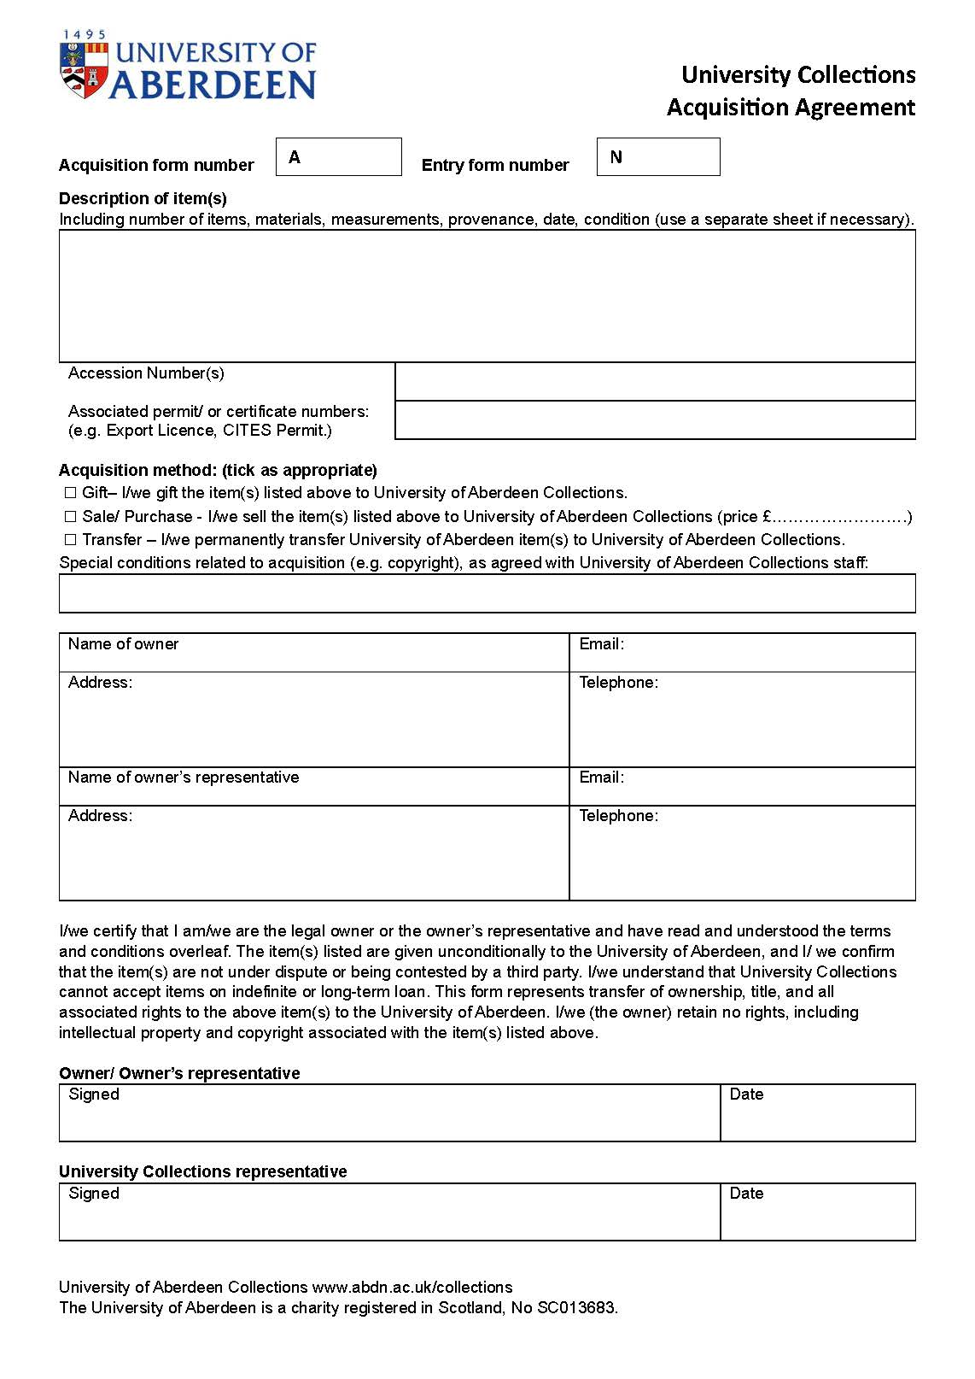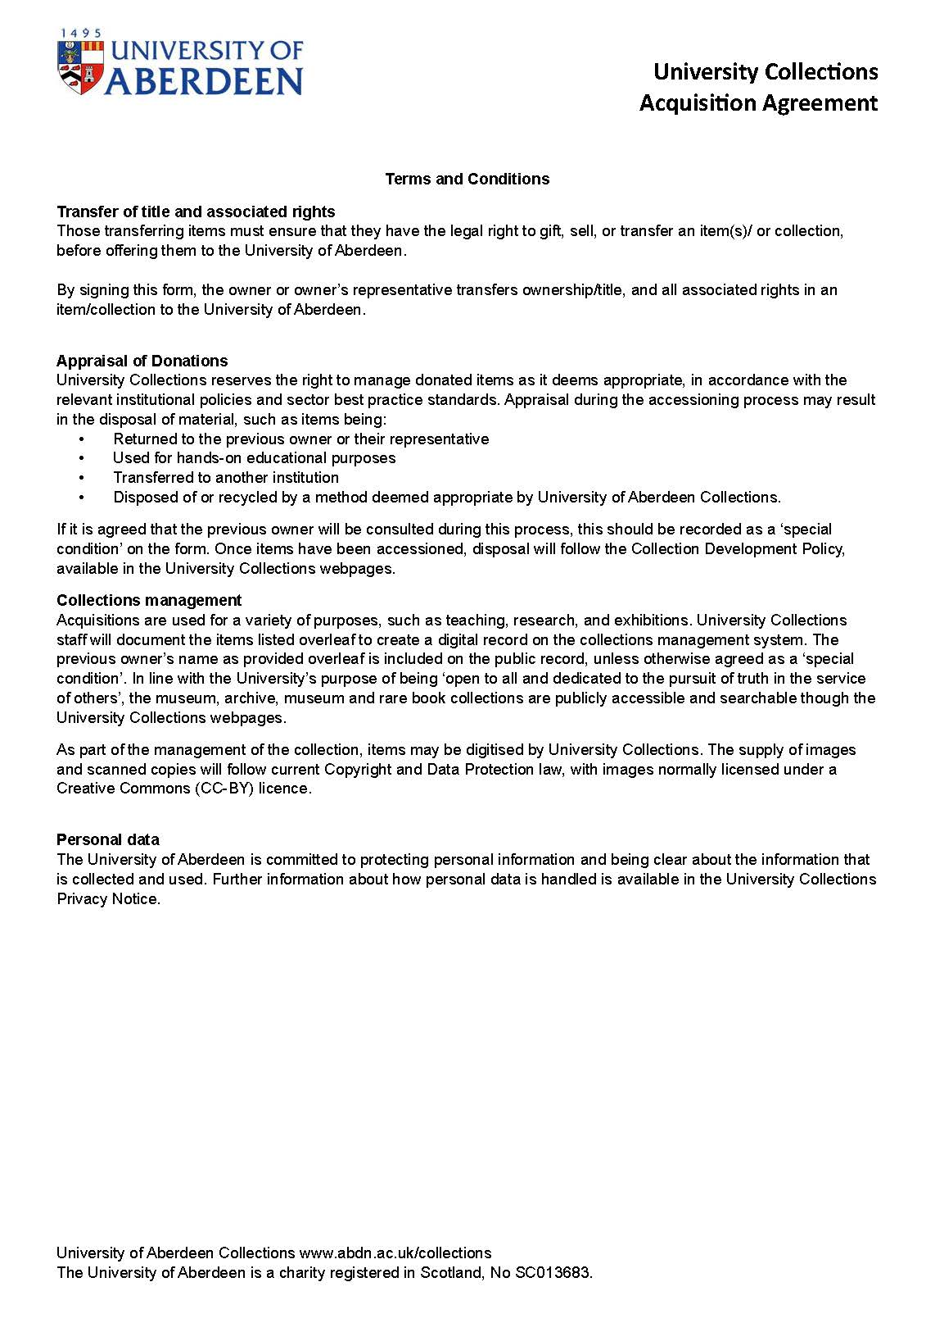

Appendix 2: Copyright Agreement form
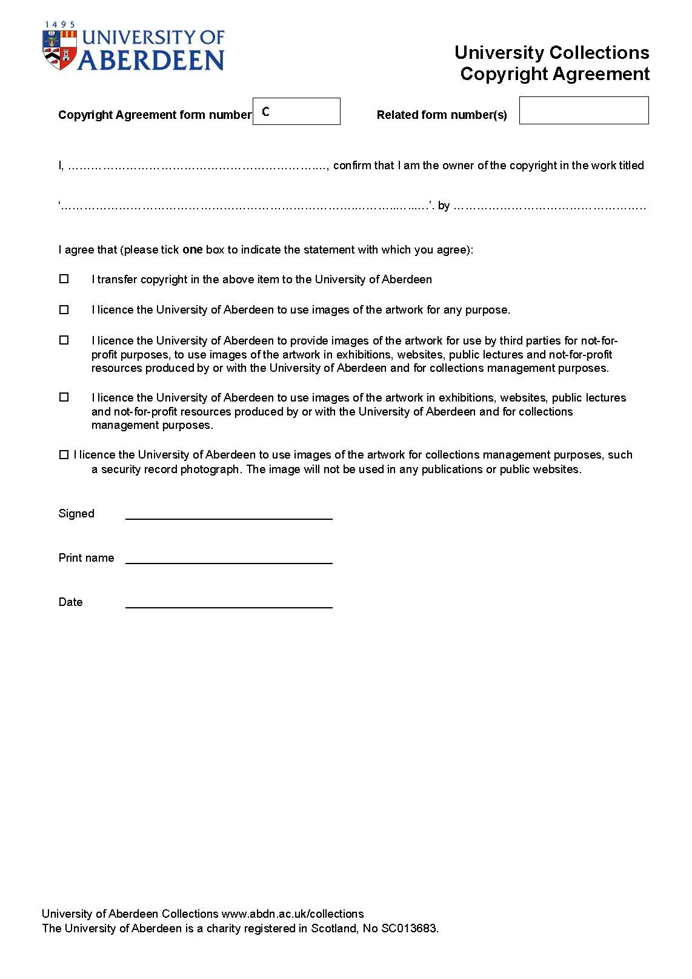

Appendix 3: Loan In template
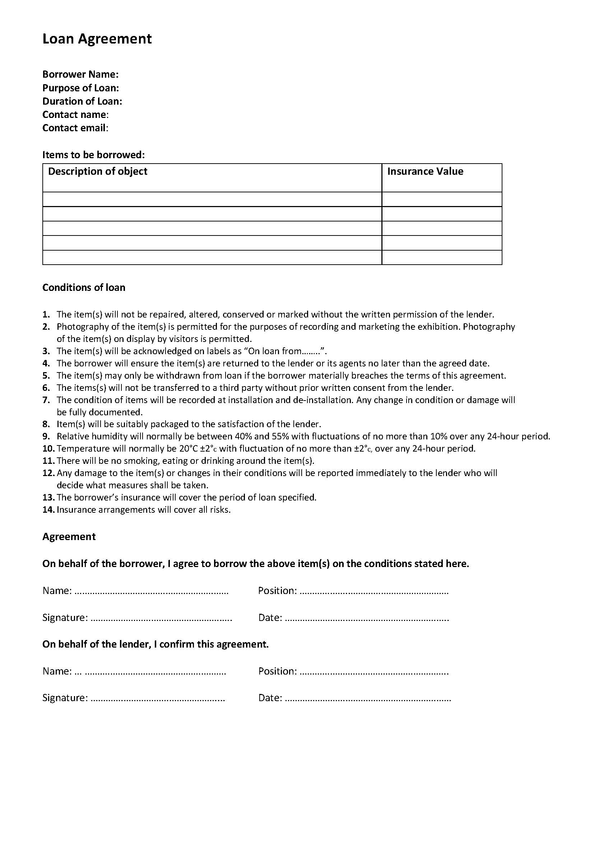

Appendix 4: Entry receipt Form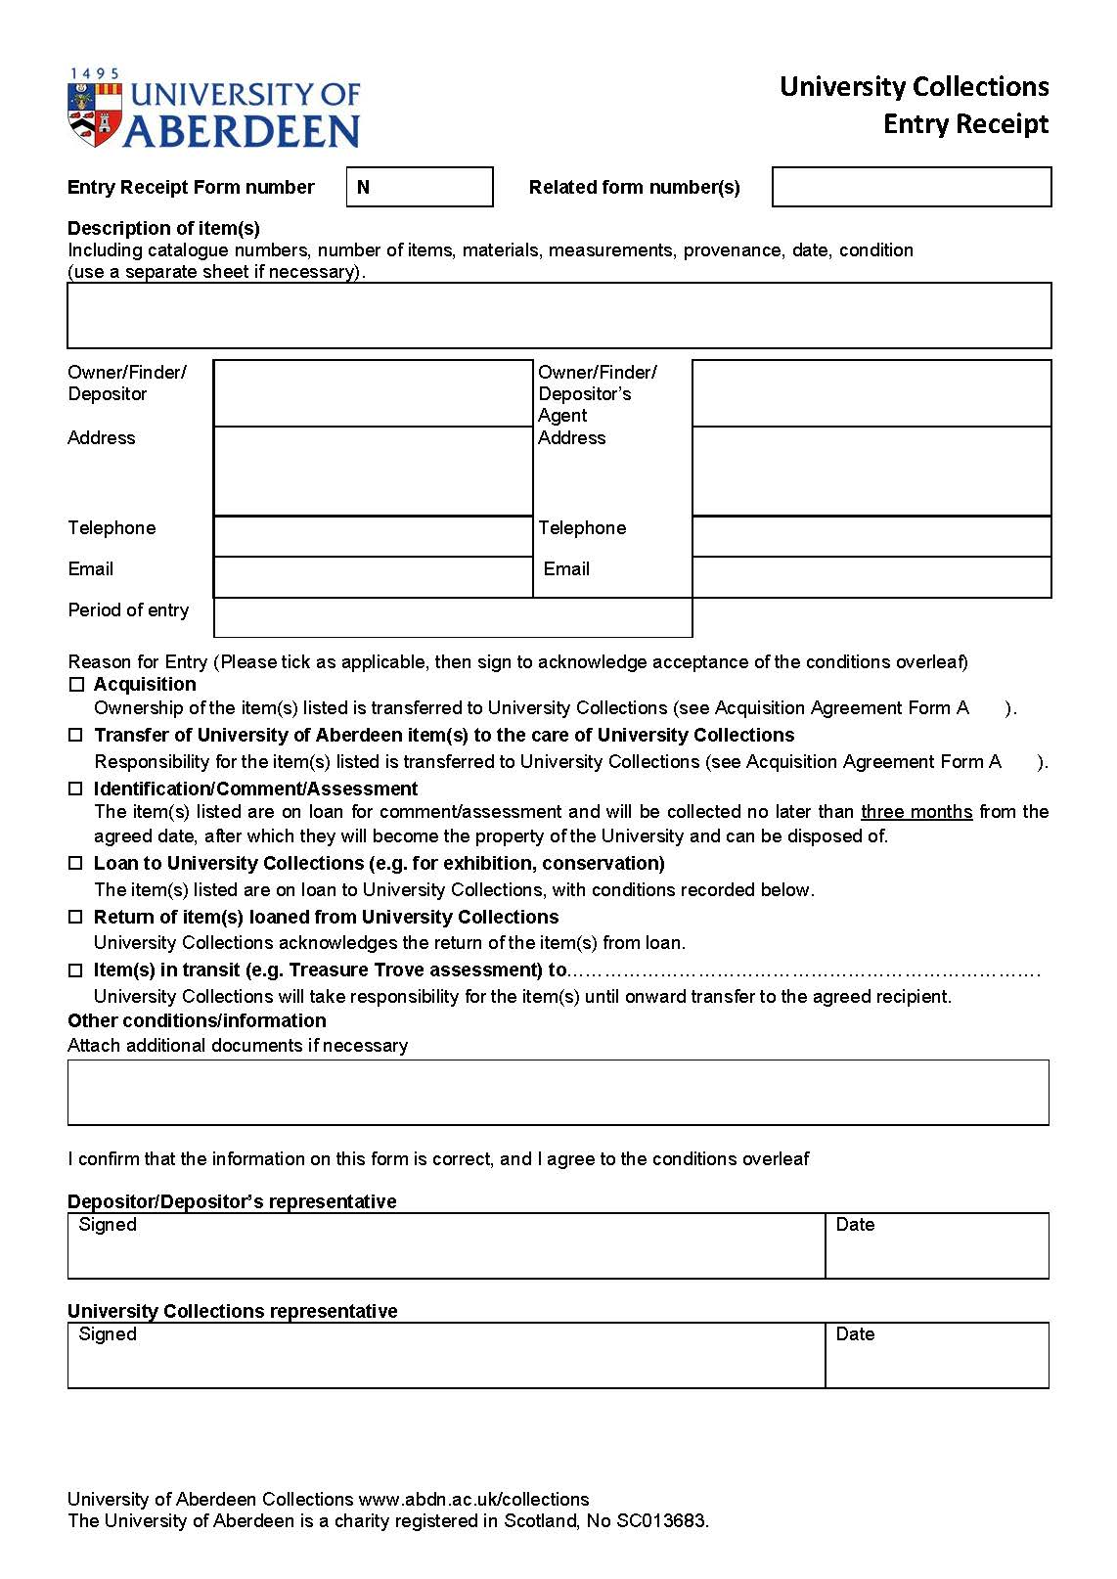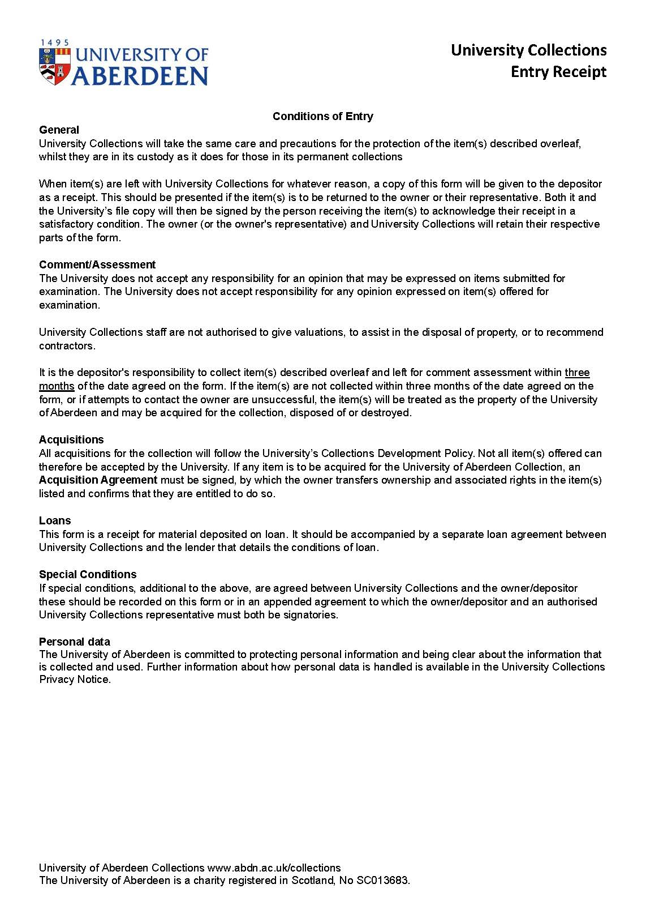

Appendix 5: Loan Request form 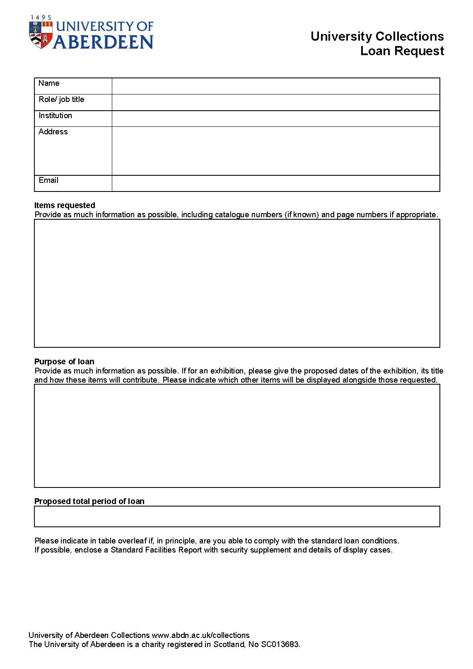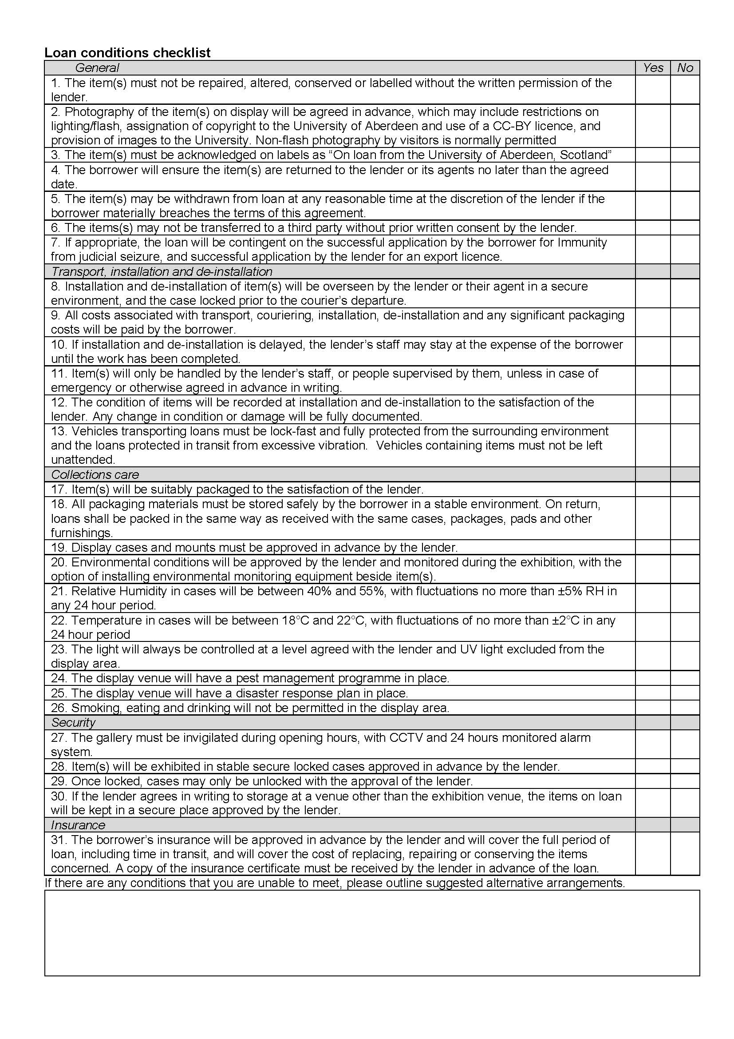

Appendix 6: Loan Agreement template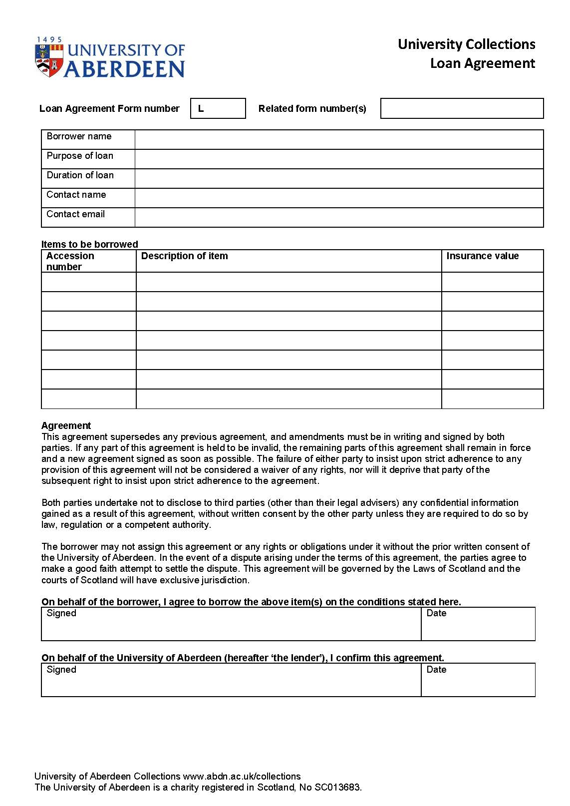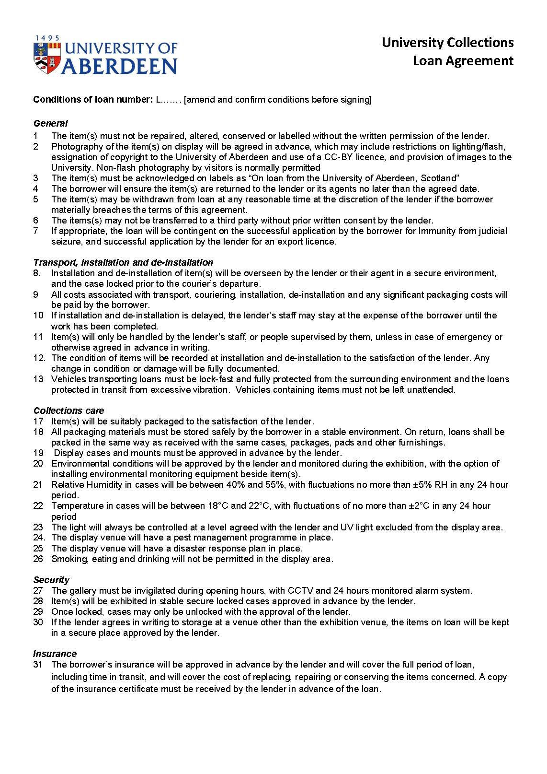

Appendix 7: Exit Receipt Form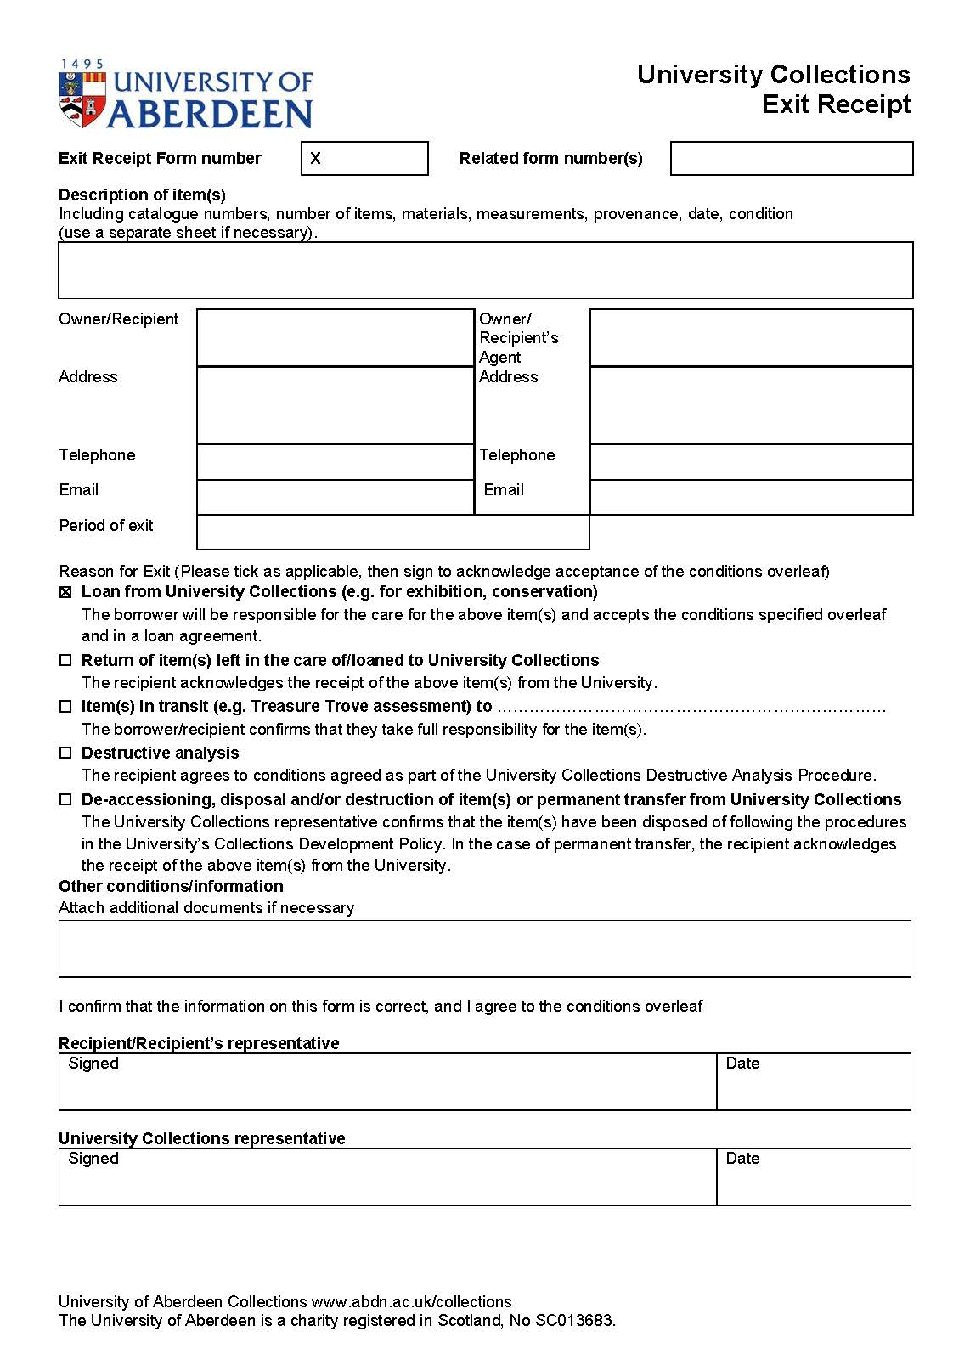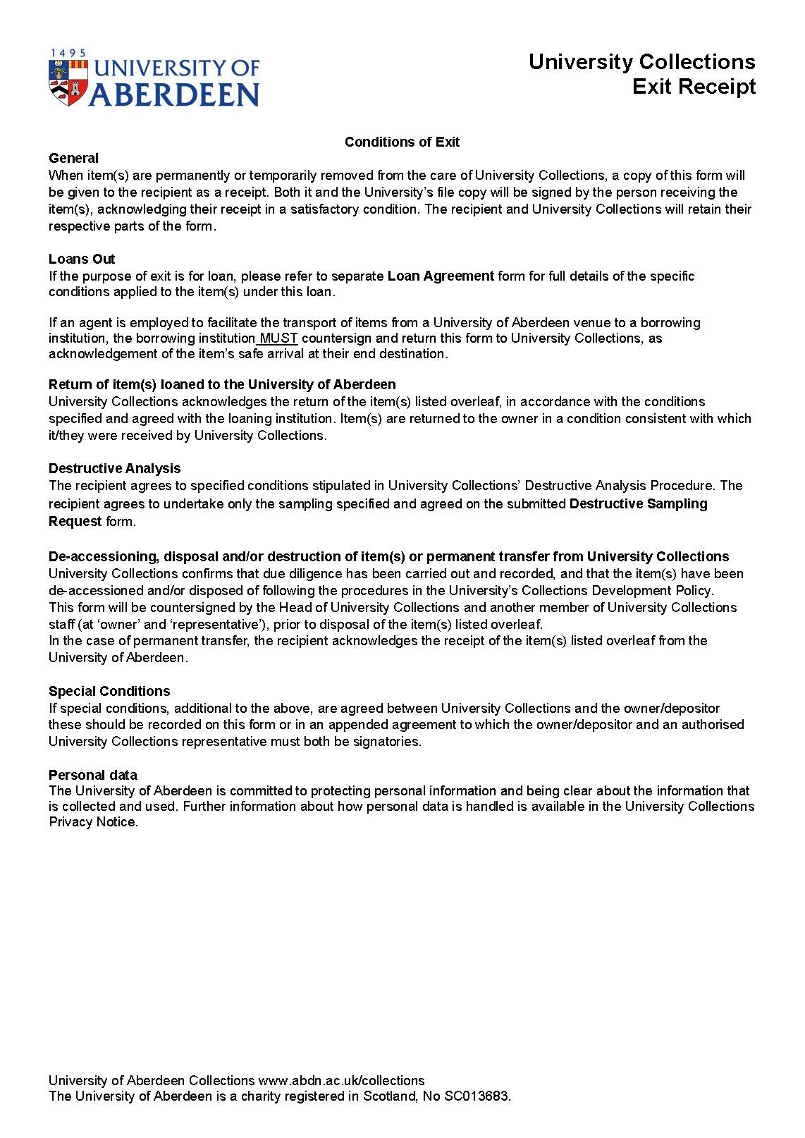

Appendix 8: Museum Collections Documentation procedures

Museum Collections Documentation Procedures

1 Documentation procedures
This set of procedures governs the documentation of the museum collections It follows the University Collections Collection Documentation Policy and is consistent with SPECTRUM 5.1. Procedures have been adapted for use with Axiell CALM, the documentation system used by University Collections for archive and museum collections.

A printed copy of these procedures will be stored in collections stores and offices (Marischal College, University Collections general office in the Sir Duncan Rice Library, and the Zoology Museum office). Digital copies are held in the University Collections SharePoint site and on the Museums shared drive at \Museums\Management\Policies, procedures and forward plans\CURRENT Policies, Plans and Procedures.

- Documentation Planning
University Collections reviews its Documentation Plan annually, ensuring that its objectives facilitate continual improvement of the museum collections and their associated archives. As well as ensuring that the collections continue to meet Accreditation standards, these objectives and outcomes align with the strategic aims set out in University Collections policies and plans, and in the wider University of Aberdeen 2040 Strategy.

The Museums Documentation Plan (Appendix 9) sets out objectives to be completed on specific areas of the collections throughout the year ahead. These range from inventory work, tackling cataloguing backlogs and retrospective appraisals, improvement of records and their management, reconciliation of collections, and enhancing accessibility.

Each objective is set against an achievable time limit, with a focus on ‘small wins,’ as well as the identification and implementation of longer-term collections reviews and project work. Staff with responsibility for the museums collections continually work to identify areas of the collection where improvements to CALM records are required, and these are then set as priority objectives within the Documentation Plan.

3 Forms
As a first step towards convergence, a single set of forms for University Collections has been developed and appended to this policy. These are included as appendices to the Collections Documentation Policy.
Appendix 1: Acquisition Agreement form
Appendix 2: Copyright Agreement form
Appendix 3: Loan In Template
Appendix 4: Entry Receipt form
Appendix 5: Loan Request form
Appendix 6: Loan Agreement template
Appendix 7: Exit Receipt form
The Destructive Sampling Request form is included as an appendix to the Research and Academic Engagement Policy.

4 Policy responsibility and review
This procedure will be reviewed and approved at least annually by the Management Team of University Collections, following discussion by the Collections Management Working Group.

Approved by Management Team of University Collections, 9 January 2026.

PROCEDURES

5 Acquisition, Entry and Accessioning
Acquisition to the collection is governed by the University’s Collection Development Policy, including offers of donation, purchases, transfers from other university sections, or items left anonymously. If an owner/ depositor leaves an object for identification, a return date will be agreed with the owner/ depositor that is no longer than one calendar year after deposit. Once an assessment is completed and a decision is made on whether to acquire the object(s), the owner/ depositor is informed of the outcome, and any object(s) not to be acquired will be returned to the owner using the Exit procedure. Any transport and insurance arrangements are confirmed with the owner/ depositor prior to any object(s) entering University premises. Staff should be informed in advance of any potential objects arriving at collections stores, so that sufficient storage space in the quarantine area for the object(s) prior to their arrival can be ensured

5.1 Entry procedure
The Entry procedure governs all objects entering University Collections, and covers:
- Loans In
- Return of items from loan/ conservation
- Acquisition
- Permanent transfers of university-owned items to University Collections
- Items deposited for Comment/ Assessment
- Items in transit (e.g. Treasure Trove assessment)

5.2 Creating an entry record and receipt
Entries are recorded on both a paper ‘Entry Form’, as well as on a Microsoft Excel spreadsheet. The form is allocated a number prefixed by the letter ‘N’ and consisting of the year of entry and a sequential identification number, which is recorded on both the paper form and the spreadsheet. The next available form number can be found on the Excel spreadsheet within the ‘Acquisitions & Object Entry Exit’ Folder on the University Collections shared drive. Both the spreadsheet and form should be completed at the same time to avoid any discrepancies in the form numbering system. A digital signed PDF copy of the completed form is kept on the University Collections shared drive, and the physical copy stays with the object(s) until it is formerly accessioned. Once accessioned, the paper form is filed by year and form number in the museum documentation filing cabinet (currently in the main office at Marischal College). The ‘Entry Form’ records the following information: brief description, condition, number of items, and dimensions of object, owner and/or depositors contact details, entry date, entry reason, entry method. The form also contains terms and conditions, which the owner/ depositor must agree to by signing. (Collections Documentation Policy: Appendix 4: Entry receipt form). Any other associated numbers such as ‘Loan in’, ‘Acquisition’, or ‘Exit’ are also recorded on this form.

If an owner/ depositor is present, they must agree and accept the terms and conditions on the ‘Entry Form’ and ‘Acquisition Agreement’ (where applicable) by signing. Once signed, a paper copy of the form(s) is given to the owner/ depositor for their records. If the owner/ depositor is not present, a copy of the form(s) will be sent to them for their own records, and a second copy will be sent for them to sign and return to University Collections. Donors will also be sent a message of thanks. . If an agent is acting on behalf of the owner/depositor, they will complete the form accordingly, and provide proof that they are acting on behalf of the owner/depositor.

5.3 Acquisitions - Transfer of Title
In conjunction with object entry, all acquisitions or permanent transfers must be documented on an ‘Acquisition Agreement’ (Collections Documentation Policy: Appendix 1: Acquisition Agreement form). The agreement confirms that the depositor has the legal right to transfer title in the objects(s) to the University of Aberdeen, and to transfer both ownership and any associated intellectual property rights. This form is also useful to record any further provenance information about an object or collection of objects. As with the object entry procedure, the ‘Acquisition Agreement’ form is allocated an individual identification number prefixed by the letter ‘A’ and consisting of the year of entry and a sequential identification number (e.g. A2025-01), which is recorded on both a paper form and the Excel spreadsheet found within the ‘Acquisitions & Object Entry Exit’ folder on the University Collections shared drive. Both the spreadsheet and acquisition form should be completed at the same time to avoid any discrepancies in the form numbering system. A digital signed PDF copy of the completed form is kept on the University Collections shared drive, and the paper form is filed in a documentation filing cabinet within the main office at Marischal College.

The ‘Acquisition Agreement’ records the following information: brief description, condition, number of items, dimensions of object, owner and/or depositors contact details, acquisition date, acquisition method, and any special conditions relating to acquisition. The agreement gives the option for the owner/ depositor to transfer all associated rights related to the item(s) at the time of acquisition, which should be encouraged during initial discussions with the owner around acquiring the material. By agreeing to transfer all associated rights at the time of acquisition, future queries regarding rights and usage associated with the item(s) are kept to a minimum. The reverse of the form also contains terms and conditions, which the owner/ depositor must agree to by signing. The associated ‘Entry Form’ number, plus any relevant permit numbers relating to import/ export, and/or collection of biological specimens are also recorded on the ‘Acquisition Agreement’. At the beginning of the new calendar year, the previous year’s ‘Acquisition Agreements’ are scanned and printed on to archival-quality paper, and bound, to create a printed ‘Accession Register’. ‘Entry’ forms are also scanned, printed and bound as above.

5.4 Archaeological Assemblages
Scottish archaeological assemblages will only be acquired following the procedures in the Treasure Trove Code of Practice. Assemblages will be deposited directly by the contractor which excavated the material once allocation has been confirmed by K&LTR. Transport arrangements are confirmed with the depositor prior to the arrival of the objects into University Collections and will follow the guidelines established through the ‘Before the Museum’ project.

5.5 Anonymous Donations
Anonymous donations will not usually be accepted into the collections, as a signature is required to confirm transfer of ownership. Should an anonymous donation arrive (e.g. through the post) then an ‘Entry Form’ will be created to log as much information about the object as possible, including photographs, with the expectation that the owner may be in touch in the future about the donation. A note will also be included to confirm that the depositor was not available to verify any details. University Collections will carry out due diligence to try to trace the rightful owner of the deposited material but reserves the right to dispose of any items in any way it sees fit, should a donor not come forward after one calendar year of deposit.

5.6 Processing newly arrived objects
Objects are given a temporary label marked with the object entry number or loan-in reference number. The paper-copy ‘Entry Form’ stays with the object(s) until it is formally accessioned into the museum collections (see section 5: Cataloguing). The object’s condition is assessed by the Museum Collections and Conservation Manager, and any objects which may carry a potential pest risk will be immediately frozen for at least 48 hours before entering the collections stores. Any potential preventive/ remedial conservation treatments, or hazardous materials will also be identified.

5.7 Record first location of objects
The first location of the object, the date, and the staff member recording the information is entered digitally on the Object Entry/ Exit Excel spreadsheet in the ‘Acquisitions & Object Entry Exit’ Folder on the University Collections shared drive.

5.8 Copyright
At the time of entry into the University’s collections, every effort should be made to establish and confirm who the current copyright holder is. This is particularly important for ‘created works’ such as artworks, photography, sculpture and literary works. If copyright details are known, these should be record on the ‘Acquisition Agreement’ at the time of acquisition. For retrospective copyright requests, a ‘Copyright Letter’ (Collections Documentation Policy: Appendix 2: Copyright Agreement form) should be sent to the rights holder to request permission in writing to reproduce images of the object for a variety of purposes. If the copyright holder is unknown, the name of the person or company that produced the object, and its date of creation, should be recorded if known on its CALM database record.

6 Location and Movement control
This procedure is to be used by University Collections staff when an object is to be moved from its normal location for more than one working day. This includes internal moves within collections stores/ buildings, as well as off-site moves.

6.1 Short-term object movement
Pre-printed triplicate carbon object movement tickets are used to record the temporary movement of objects from their normal location. These should be completed in ball-point pen, to ensure a clear copy is made on to each ticket layer. The tickets record the object’s accession number and description, when an object is moved, by whom, and where it was moved from and to. The procedure for using the tickets is:
- The top copy (white) is left in place of the object e.g., on the storage shelf/ in the storage box.
- The middle (yellow) copy always accompanies the object to its temporary location.
- The bottom copy (pink) stays within the ticket book and is used to update the digital ‘current location’ field on the object record within the collections management database (CALM).

When the object is returned to its permanent location, the pink copy inside the ticket book should be scored out with an ‘X’ and the white and yellow copies should be scored out and then thrown away.

6.2 Long-term object movement (CALM)
When dealing with longer-term movements of objects, such as for exhibitions or long-term loans, digital object movement must be completed in the collections management system (CALM), alongside the use of a printed object list, which accompanies the objects to their temporary location. For internal locations such as other university-owned buildings, rooms or exhibition spaces, the individual location reference is updated in the ‘current location’ field, for example ‘17291 - Old Aberdeen Campus/The Sir Duncan Rice Library/Ground Floor/Gallery’. For external loans, the ‘current location’ field is updated to ‘External Loan’ and a note of the object’s current location, exhibition name, loan reference number, movement purpose, and the person completing the move is added in to the ‘Current Location Note’ field. This is a free text field and allows up to 150 characters to be entered. When the object is returned to its permanent location, the ‘Current Location’ field should be returned to the same as the ‘Normal Location’ field, and notes in the ‘Current Location Note’ field should be removed. The ‘Normal Location’ field should always remain the same when making temporary moves but should be updated with the object’s new location when it has been decided by collections staff that an object should move to a new permanent location.

7 Cataloguing (including labelling and marking)
7.1 Cataloguing standards
All items in the University’s museum collections care must have – as a minimum - the fields below completed within the CALM record:
- Object Number
- Object Name
- Number of Objects
- Brief Description
- Current Location
- Full Acquisition Details (owner/ depositor, date, accession & entry form number, acquisition type e.g. gift)
- Cataloguer Details (name and date)

The CALM ‘Object Record’ template contains a variety of other fields such as ‘Condition, Materials, Dimensions, Field Collector, & Object History Note’ which should be completed as fully as possible by the cataloguer. CALM also enables other related fields to be selected from a list and inserted if deemed appropriate by Collections staff. See: http://www.dswebhosting.info/Documents/Manuals/ALM/V11/main_menu/basics/complete_field_list_catalog.htm

To aid consistency of data entry, fields are set to fixed formats (e.g. date = DD/MM/YYYY) and so will only allow data to be entered in the way specified. Any additional information about an item is discovered through the other procedures, documentation projects, or through academic research should be entered into the CALM record or filed in the Object History File as soon as possible.

To ensure data integrity, the Collections Management Database (CALM) and University Collections Shared Drive are backed up at regular scheduled intervals in line with University policies.

7.2 Sensitive or potentially offensive information
University Collections recognises that some historical records may contain content, language or terminology which may be sensitive, offensive to specific cultural groups or individuals, or that is inaccurate. As such, collections staff will endeavour to update records with additional information to aid context where possible, whilst also ensuring that the historical information which accompanied the object at the time of acquisition still remains within the record. As the online collections database is publicly accessible, the landing page features a prominent content warning. This says “Please be aware that there are descriptions and images of items in the records which may be considered to be sensitive or offensive. However, to understand past perceptions we include this information for its historic value.”

7.3 Object History files
Additional information accompanying an object which cannot be included in the digital record including correspondence, notes, reports, historical photographs and press cuttings are stored in individual object history files. These files are stored in filing cabinets within the main office at Marischal College and are organised according to their object number.

7.4 Labelling and marking
Objects are marked with their unique object number in an unobtrusive area using a layer of 10% Paraloid B72 dissolved in acetone, labelled in permanent archival ink or with a printed archival paper label, and then coated with a layer of Paraloid B67 in white spirit. For some objects this may not be practical given an objects condition, material, or size, in which case objects are labelled with a Tyvek or acid free cardstock label attached to the object securely with cotton tape. Paper objects are marked discreetly with their object number using graphite pencil, normally in the bottom left corner of the document.

8 Inventory
All objects in the collection should be catalogued to meet the Spectrum 5.1 minimum standard as outlined above. Regular inventory/ audits are therefore carried out to identify objects where record information may be lacking. Due to the historical nature and scale of the collections, over time objects may have become detached from their labels, or paper-based documentation may not have been fully transferred across to the Collections Management System (CALM). The Documentation Plan (see Appendix 2), specific areas of the collection are identified where object records may require updating, and an inventory/ audit of the area is then carried outf. Any old or temporary numbers are matched to existing paper-based documentation (e.g. old accession registers, committee reports etc) where possible, and their database records updated with this information. All objects are then clearly marked or labelled with their unique object number. Any objects which cannot be matched to existing documentation through the inventory/ auditing process, and so are considered not to have been accessioned, will be dealt with according to the Collections Development Policy, and a decision made as to whether to retrospectively accession, transfer, or dispose of the material. If it is decided that an item should be retrospectively accessioned, the comment “Retrospectively accessioned, found in store” along with the recorder’s name and the date is added in to the ‘Notes’ field on the CALM database.

9 Object Exit
The Exit form (Collections Documentation Policy: Appendix 8: Exit Receipt form) is used to record all objects leaving University Collections, and covers:
- Loans Out
- Return to owner/ depositor.
- Items in transit (e.g., Treasure Trove assessment)
- Analysis (inc. destructive)
- Conservation
- De-accessioning, permanent transfer, or repatriation.

An object exit is recorded on both a paper ‘Exit Receipt form’, as well as on a computerised Excel spreadsheet. The form is allocated a number prefixed by the letter ‘A’ and consisting of the year of entry and a sequential identification number (e.g., X2025-01), which is recorded on both the paper form and the Excel spreadsheet. The next available form number can be found on the Excel spreadsheet within the ‘Acquisitions & Object Entry Exit’ folder on the University Collections shared drive. Both the spreadsheet and form should be completed at the same time to avoid any discrepancies in the form numbering system. A signed digital PDF copy of the completed form is kept on the University Collections shared drive, and the paper form is filed in a documentation filing cabinet within the primary office at Marischal College. A physical copy is also given to the recipient/ owner/ agent. The ‘Exit Receipt form’ records the following information: brief description, condition, number of items, and dimensions of object, owner and/or recipients contact details, exit date, exit reason, and exit method. The form also contains terms and conditions, which the owner/ recipient must agree to by signing. Any other associated numbers e.g., ‘Loan in’ or ‘Entry Receipt’ numbers are also recorded on this form.

9.1 Recording collection
If an owner/ recipient is present, they must complete the contact information section and agree and accept the terms and conditions on the reverse of the ‘Exit Receipt form’ by signing. Once signed, a paper copy of the form is given to the owner/ recipient for their records.

If the object(s) are being collected by an agent or carrier on behalf of an owner/ recipient, then they must complete the contact information section and sign as an ‘Agent’ acting on behalf of the owner/ recipient. Once signed, a paper copy of the form is given to the agent/carrier. Once the object(s) are received at their end destination by the owner/ recipient, the owner/ recipient will be sent an electronic scanned copy of the signed form by University Collections staff, and will be requested to print, wet sign and then either return the form by post or electronically within one week of receipt of the items. At the beginning of the new calendar year, the previous year’s ‘Exit receipt forms’ are scanned, printed on to archival-quality paper, and then bound.

9.2 Return of item(s) to owner
For object(s) being returned to owner either after loan or assessment, or for item(s) in transit, the ‘Acquisitions & Object Entry Exit’ spreadsheet on the shared drive is updated with the note ‘Returned to owner/ depositor’, the date of return and the name of the University Collections staff member authorising the return. When returning ‘Loans in’ to the owner, the ‘Current Loans’ spreadsheet is also updated accordingly.

9.3 Updating locations of University Collections item(s)
For accessioned University Collections item(s), locations are updated both through movement forms and digitally on CALM (see section 4 Location and Movement Control). In the case of repatriation, the ‘Normal Location’ field in the CALM record is changed to ‘Repatriated.’

10 Loans out (Lending)
10.1 Initial Request
Requests for loans must be made in writing using the ‘Loan Request form’ (Collections Documentation Policy: Appendix 6: Loan Request form). The form collects the details of the request including the object number/s, brief description of object(s), borrowers’ details, reason for the loan, period of the loan and any special conditions of the loan. A decision in principle will be made by the Head of University Collections or the Museum Collections and Conservation Manager, who will notify the requester in writing and may suggest alternative object(s) depending on their condition/ availability. Any reasons why an object(s) may not be available/ suitable for loan will also be explained clearly to the requester.

If a loan is agreed, the details provided by the requester/ borrower on the ‘Loan Request form’ is then copied in to the ‘Current Loans’ spreadsheet on the University Collections shared drive, and a unique loan number e.g., “L2024-02” will be assigned to the loan request. Using this unique loan number, a digital folder in the ‘Loans’ section of the University Collections shared drive, and a physical hard copy folder kept in the ‘Loans’ filing cabinet in the main office is created, and copies of all the relevant forms and correspondence relating to the loan are filed accordingly. A note will be made to reserve the objects for the period of the loan in case they are requested by someone else. As the loan progresses, the ‘Current Loans’ spreadsheet status must be updated accordingly to Loan Requested, Loan Pending, On Loan, or Loan Returned.

10.2 Requesting further Information from the borrower
Once an initial loan request has been made by the borrowing institution, the Museum Collections and Conservation Manager will request further information from the borrower to agree on the conditions for borrowing. Facility reports, indemnity, and insurance documents, and if applicable, immunity from seizure, will be requested, alongside information about the institution’s loan and installation schedule, any costs associated with the loan (e.g., conservation work), and any provision of staff required to accompany objects (couriers). If after additional information is provided, University Collections decides not to lend the object(s), a written explanation is sent to the requester/ borrower detailing the reasons why the decision has been made. A hard and digital copy of any correspondence relating to a loan request regardless of whether it is successful, will be filed under the unique loan number in the relevant folders as detailed above.

10.3 Agreeing the Loan
Once the loan request is approved and agreed with the borrower, University Collections will provide an object list detailing the specific information about the object(s) requested including object number/s, description, dimensions, materials, provenance info, condition, handling requirements & risks, valuation, and any specific conditions for display such as environmental and mounting specifications. Once these conditions are finalised with the borrower a Loan Agreement will be drafted following the template (Collections Documentation Policy: Appendix 6: Loan Agreement template) which both parties then sign.

10.4 Preparing for the loan
Once the Loan Agreement has been signed by both parties, the following are completed and finalised by University Collections staff prior to the object(s) being sent out to the borrower:
- Export Licences are compiled and submitted if applicable (at least 8 weeks prior to loan going out)
- If required, information for an Immunity from Seizure application is sent to the borrowing institution
- Any required conservation treatments are undertaken on object(s) and bespoke mounts are made/ sourced (unless agreed otherwise by University Collections)
- Object(s) are condition checked and photographed, and digital and printed reports generated and compiled
- CALM database records are updated (location/movement, conservation, valuation)
- Security conditions must be met and confirmed by borrower
- Insurance must be arranged listing all objects to be borrowed with their valuations, ensuring that cover extends at least 2 weeks either side of the exhibition dates
- Arrangements made for any required couriering, installing and deinstalling

10.5 Sending the objects
Packing, transport and couriering requirements are arranged with the borrower and any relevant art handling/ courier companies. The loan is then dispatched to the borrower, alongside all of the relevant loan documentation which includes: a detailed list of all objects(s) on loan denoting required environmental conditions, mounts and handling procedures, signed Loan Agreement, Exit Receipt form, Export Licence (if required), CITES Certificate (if required), Immunity from Seizure Certificate (if required) and Condition Reports. On arrival of the object(s) at the borrowing institution, the art handling/ courier company and borrowing institution will confirm receipt of the object(s) in writing to the Museum Collections and Conservation Manager. Unless agreed otherwise with the borrower, condition checking and installation of the object(s) will be carried out by a designated member of staff from the University of Aberdeen. Once on loan, the object(s) and environmental conditions will be monitored through regular correspondence with the borrowing institution.

10.6 Extending the loan
If the borrower wishes to extend the loan beyond the fixed term of the original loan agreement, they must submit a request in writing as soon as possible before the end of the original loan term. This ensures that there is adequate time to amend any insurance cover, valuations, and transport arrangements. The request will be considered by the Head of University Collections and the Museum Collections and Conservation Manager, and a decision will be returned in writing to the borrowing institution. If an extension to the loan is approved, an amended loan agreement with a new fixed end date will be created, ensuring that all information is still current, which will then be sent to the borrower to sign and return.

10.7 Arranging for return and updating records upon receipt of object(s)
University Collections will then confirm the arrangements for the de-installation, including condition checking, packing and the transportation for the return of the loan with the borrower. Upon sending the objects from their institution, the borrower will notify University Collections staff in writing providing any relevant shipping/ tracking information or contact details of the art handling/ courier company. Once the objects are received by University Collections, their safe receipt will be acknowledged in writing and though completion of an Entry Receipt form and the borrower’s receipt form, a copy of which will then be returned to the borrower for their records. A written confirmation of return of the objects will also then be sent to the Export Licensing Unit (if required). Objects will then be condition checked, returned to their normal locations, and their CALM records updated to reflect their current location, plus any additional information such as exhibition references added. Information of damage or security incidents must be documented, and entered into the objects CALM record, and a hard copy should be kept in the loan folder. Any serious damage thought to have been caused during transit, must be raised with the borrowing institution and art handling/ courier company swiftly, so that a claim for remedial conservation work may be made through the relevant insurance policy. Any other remaining invoices for costs will also be sent to the borrowing institution to be settled.

11 Loans in (Borrowing)
11.1 Initial request
The first step in considering a loan to University Collections is the production of a written proposal sent to the Head of Collections. This proposal must include details of the item(s) to be borrowed, the reason for borrowing (e.g., exhibition - including venue and themes), dates/ period of the loan, details of the potential lender, predicted costs and any other specific conditions. Once the University Collections Management Team makes an agreement in principle, a request to borrow should be made to the potential lender, allowing a minimum of six weeks’ notice prior to the potential start date of the loan.

11.2 Managing Loans In
Once a loan has been agreed, details are then copied in to the ‘Current Loans’ spreadsheet on the University Collections shared drive, and a unique loan number e.g., “LI2024-02” will be assigned to the loan request. Using this unique loan number, a digital folder in the ‘Loans’ section of the University Collections shared drive, and a physical hard copy folder kept in the ‘Loans’ filing cabinet in the main office are created, and copies of all the relevant forms and correspondence relating to the loan are filed accordingly. The ’Current Loans’ spreadsheet records the Loan-in reference number, name and contact details of the lender and staff contact, the lender’s address, the reason for the loan, the loan period, object numbers and brief description of object, and the loan status and date e.g. ‘Loan Requested 24/03/2025’. As the loan progresses, the status of the loan on the ‘Current Loans’ spreadsheet is updated correspondingly.

Normally, the lender will have their own documentation policies and procedures which we will be required to follow as a condition of the loan. For potential lenders that do not specify an approach, the requirements of the University’s own insurance policy will be followed, the University’s loan in template (Collections Documentation Policy: Appendix 6: Loan In Agreement template) may be used, and documentation procedures for entry/ exit and loan followed. All loans will have a signed loan agreement, whether that of the lender or one prepared by University Collections. A signed copy of the Loan Agreement is then filed both digitally and electronically in the ‘Current Loans’ folders on the shared drive and the filing cabinet in the Marischal College Main Office alongside all other correspondence regarding the loan. The final loan list will include information about the lending institution; object number/s and description, valuation, condition, dimensions, display, environmental and handling requirements, potential risks, and colour photographs of the items. Where possible, details of any associated rights or requirements, and any associated provenance information should also be gathered to aid research of the item/s. The ‘Current Loans’ spreadsheet will be updated with the loan’s progress.

If after additional information is provided, the potential lender decides not to lend the object(s), a copy of the written explanation detailing the reasons why the decision has been made, is filed in the applicable loan folder. This information is a useful reference for any potential requests made to that specific lender in the future. A hard and digital copy of any correspondence relating to a loan request regardless of whether it is successful, will be filed under the unique loan number in the relevant folders as detailed above.

If University Collections wishes to extend the loan, an amended loan agreement with a new fixed end date will be discussed and agreed with the lender, ensuring that all information is still current.

11.3 Receipt of loans
Prior to receipt by University Collections, item(s) will be condition checked and photographed, and digital and printed reports generated and compiled by the lender. Insurance will be arranged by University Collections listing all objects to be borrowed with their valuations, ensuring that cover extends at least 2 weeks either side of the loan agreement dates. Upon arrival of the object(s) the University Collections Object Entry procedure will be followed to acknowledge safe receipt of the loaned material. Unless agreed otherwise with the lender, condition checking and installation of the object(s) will be carried out by a member of Collections staff from the University of Aberdeen, with any damage or issues immediately reported to the lender.

11.4 Returning loans to lender
University Collections will confirm the arrangements for the de-installation, including condition checking, packing and the transportation for the return of the loan with the lender. University Collections staff will notify the lender in writing once the object(s) have been collected/ sent, providing any relevant shipping/ tracking information or contact details of the art handling or courier company returning the loan. An ‘Exit Receipt’ form will also be sent with the object(s) to the lender for them to sign and return to University Collections, acknowledging safe receipt of the items. At the point of return, object(s) should be condition checked by the lender, and written confirmation sent to University Collections staff.

The ‘Current Loans’ spreadsheet will be updated with the loans progress set to ‘Returned’ and the date of return entered. Any final correspondence relating to the loan is then filed in the relevant loan folder both on the shared drive and in the hard copy files in the Marischal College main office.

12 Deaccessioning and Disposal
12.1 Deaccessioning of items - checking documentation
Sometimes an item(s) in the collection may be decided to be appropriate for disposal. This can be for a variety of reasons including being in poor condition/ irreparable, containing hazardous materials, lacking associated data, and/ or that they no longer fit within the University’s collecting priorities as set out in the Collection Development Policy. All disposals from the museum collections will be undertaken with guidance from the Museums Association’s Code of Ethics and Disposal Toolkit.

If an item has been identified for potential disposal, due diligence must first be conducted by thoroughly checking any documentation sources held by University Collections in case they hold any related information about the item. These sources include object entry and acquisition records, accession registers, annual reports, loan agreements, copyright letters/ agreements, catalogue and database records, general correspondence to donors, and object history files. Discussions will also be held amongst current staff and volunteers to try and determine the origin of the item(s) in question. If evidence clearly indicates that the item belongs to University Collections, and there are no legal conditions which apply to its disposal, then proceed to ‘Disposal Method and Authorisation.’ If evidence indicates that the item belongs to University Collections, but there may be a specific agreement with the donor, or other possible legal or ethical constraints, further curatorial and in some cases legal advice will be sought prior to proceeding. Where subject specialist curatorial advice is required, University Collections will seek this through professional networks. If evidence suggests that the item(s) may be on loan, and the lender is contactable, then every effort will be made to contact the lender to arrange return of the item(s) in the first instance. If the lender or their estate cannot be traced, then specialist curatorial and legal advice must be sought prior to proceeding.

At this point in the procedure, both a hard copy and digital ‘Disposals’ folder will be created on the Museums shared drive and in the filing cabinet in the main museum office at Marischal College. The folder will be assigned a unique disposal reference number e.g., ‘D2025-01’. All due diligence research, and any advice received both internally and externally regarding the ethical and legal disposal of the item(s) must be filed in both folders.

12.2 Disposal Method and Authorisation
Prior to seeking authorisation from the University Court for the disposal, a written report will be prepared detailing the research undertaken on the item(s), along with any expert guidance which has been sought prior to the final decision of disposal. The report should, where possible:
- Provide images of the item(s)
- Provide inventory details from CALM
- Provide an appraisal of the item’s significance within the museum collections
- Provide relevant clauses from the Collections Development Policy supporting disposal
- Provide examples of duplicate items in the collection
- Provide a condition report and expert assessment for hazardous items
- Provide third-party valuations
- Provide cost estimates for conservation, maintenance, and storage, with a conservator’s report if relevant

The report will then be filed in both the digital ‘Disposals’ folder on the Museums shared drive and in the filing cabinet in the main museum office at Marischal College.

12.3 Authorisation by University Court
All final decisions on disposal lie with University Court as the Governing Body and are made only after full consideration of the reasons for disposal as outlined in the written report.
If University Court decides against a proposed disposal, the ‘Disposals’ folder for that item(s) is closed, and the disposal procedure is ended. If University Court approves the disposal, this decision is recorded in writing, usually through the Court Minutes and/or written correspondence via email or letter. The approval documentation is then filed in both the digital and hard copy ‘Disposals’ folder as detailed above.

12.4 Disposal of items
Once a decision on disposal has been made, items will initially be offered as either a gift, exchange, or sale to other suitable organisations through the appropriate professional channels (e.g., North-East Scotland Heritage Network). When contacting potential recipients, full information on the item(s) offered will be provided, including quantity of material, a brief description of the item(s), the preferred method of disposal and any related terms of the disposal. Items will be offered for up for acquisition for a period of two months after the date of the University Court’s final decision.

12.5 Agree terms and transfer legal title
Once a recipient of the item(s) has been identified, agreement of the terms of the transfer/ exchange or sale, as well as the transfer of legal title must be documented in writing. The agreed terms will include all arrangements for transportation of the item, including uplift/ delivery date, associated costs, conservation work, packing requirements, and insurance. The written agreement will also function as a transfer of legal title and will state that the University of Aberdeen hands over all ownership and associated rights (where applicable) to the recipient. The agreement will be signed by both parties, and the University Collections copy will be filed in the item(s) digital and hard copy ‘Disposals’ folders.

12.6 Arrange for the items to be collected or delivered
Arrangements will then be made for delivery/ collection of the item(s), along with all associated documents such as original correspondence or copies of accession registers. At the point of transporting the item(s), the Object Exit procedure must then be completed, and location of the item(s) updated using the Location and movement control procedure.

12.7 Destruction of Items
If offering items for exchange/ transfer/ sale has failed to attract any expressions of interest, if the item is damaged beyond repair, or if the item(s) are deemed to pose a serious health and safety risk, a decision to destroy the item(s) may be made. In cases where hazardous substances are involved (e.g., radioactive materials), help and guidance from specialist companies will be sought, and destruction will be conducted in line with the applicable legislation and regulations at the time. In the case of bulk archaeological material such as soil or environmental samples from excavation, University Collections will retain only a small representative sample, provided that the material from the site has already been fully analysed and published.

12.8 Recording the disposal
All information about the disposal must be recorded in the spreadsheet located in the ‘Deaccessioning & Disposals’ folder on the Museum shared drive. The spreadsheet records the unique disposal number e.g., D2025-01, the date, disposal method and reason, authorising staff member/s, authorisation date, any terms/ restrictions of the disposal, plus a note and the date of the University Court meeting when the disposal decision was confirmed. If the item(s) were transferred/ exchanged or sold, the recipient’s name and contact details, and new object number must also be recorded, and disposal price (where applicable). Accession registers/ catalogues must then be annotated so that it is clear that the item(s) have been deaccessioned, and the digital CALM record must also be updated with the disposal information, including the unique disposal number which links it to the relevant ‘Disposals’ folder.

12.9 Repatriation
All proposals for repatriation will follow the approach specified in the Collection Development Policy. Report to University SMT and University Court will use the headings outlined in the policy, and will form the main record of the decision-making process. A transfer document will be used, modelled on the relevant clause in the Exit Receipt form, and am Disposal number allocated and recorded. Export arrangements will normally be the responsibility of the recipient, though the procedures outlined in the document may be helpful.

Appendix 9: History and overview of the museum collections and documentation

The collections are the product of hundreds of years of collecting, driven by the research and teaching activities of staff and the activities of graduates and other people. Items have been acquired by the University and its constituent institutions from their foundation in 1495. A library has been in existence since the earliest days, while museums were established in the 18th century in King’s College and Marischal College. The collections are of international importance and have a deep cohesion and quality stemming from the intellectual interests of staff, students and graduates, augmented by material from individuals, families, businesses and organisations associated with the University and the North-East of Scotland. The collections are managed together as ‘University Collections’ within the Directorate of Digital and Information Services with the aim of enhancing their care and accessibility.

The museum collections combine several former departmental collections with centrally managed art and heritage collections, now Accredited as three collections covering a wide range of Human Culture, Medicine and Health, and the Natural Sciences. The entire museum collection is Accredited and was awarded the status of a Recognised Collection of National Significance in 2007. As a large proportion of the museum collections originated as departmental collections, various processes were employed to document material entering the collections throughout the centuries. Handwritten catalogues and inventories exist from the 1810s to the early 1900s for many of the collections including Anthropology, Scientific Instruments, Natural History, Geology and Herbaria. In the early 1900s various attempts were made by university professors and a museum conservator, to catalogue the collections. A full catalogue of the anthropological collections was published in 1912, when R. W. Reid, Professor in Anatomy and Curator of the Museum compiled a complete illustrated catalogue of the objects housed in the Anatomy Museum at Marischal College. The catalogue split the collections into regions of the continent using a letter of the alphabet, followed by a sequential numbering system, for example ‘H147’, where H’ denotes ‘Africa - South of the Sahara’. From 1905 until the early 2000s, a series of Museum Committee Reports were produced annually, which detailed the items which were acquired for each of the museum departments, and their donors. From 1912 until the early 1980s, a ‘Slip Book’ catalogue system and hard-backed accession registers were employed. These built on the existing ‘Reid’ numbering system, allowing newly acquired material to be allocated numbers using the system as a classification scheme, e.g. ‘H147+3’.

In 1979, the Curator of Marischal Museum redesigned, re-numbered and re-catalogued all museum objects and entered them into the first computerised database using Cardbox software. The data was entered manually from the original catalogues and documents and was first copied onto standardised index cards, before then being entered into the digital database. Varying numbering and cataloguing systems were also used for the Zoology, Herbarium, Geology and Medical collections, further details of which can be found the in the ‘List of UOA Collections Catalogues and Accession Registers’ document (Appendix?). New MDA prefixes for each type of museum collection were allocated across the university, ABDUA, ABDUH, ABDUZ and ABDUG, with the last letter denoting which collection e.g. ABDUG = Geology.

In 2009, the computerised catalogue was transferred to a new digital Collections Management System, CALM (Axiell), which is still used to accession and manage the archive and museum collections today. As Axiell are due to withdraw support for CALM in 2027, a procurement project has started to identify a successor. This will also involve a revision of this procedure to ensure that it is consistent with the new application.

From 2010 onwards, paper-based entry and exit forms and a Microsoft excel worksheet was employed to document the acquisition of new objects into the museum collections. At the end of each calendar year, the forms are printed on to archival-quality paper and bound to create a hard-copy accession register. Following a review of the University’s acquisition process in 2024, steps were taken to increase convergence of procedures across the archive, museum, and rare book collections. As a result, a new Acquisition Agreement was developed and implemented to ensure that the transfer of ownership and title is documented in a more formal and consistent manner.

