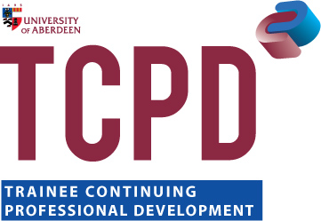

TCPD – BOOKING FORM FOR TRAINEES

Please complete this form and return to Jackie Ewen, Professional Programmes Secretary, School of Law, The University of Aberdeen, Room C41 Taylor Building, Dunbar Street, Aberdeen, AB24 3UB or book online via our website www.tcpd@abdn.ac.uk

DETAILS OF ATTENDEE
Surname:

Forename(s):

Organisation:

Telephone:

Email:

ETHICS COURSES
Mandatory Ethics Course (will be repeated through 2014/2015) |  | Please indicate your preference by circling YES or NO | Date
Ethics in Practice (Mandatory)  4 Hours 10.00-12.00 then 13.00-15.00  Total cost £150.00 |  | YES/NO | Wednesday 8th October 2014

