Please be respectful of other booth users- a few guidelines
Log off the system
Do not switch off the PC when you are finished
Do not unplug any cables from the equipment | 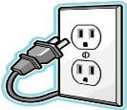
Take rubbish with you when you leave
Don’t drink, eat or leave litter in the booth- this will be followed up | 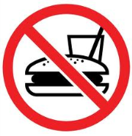
Vacate the booth promptly at the end of your timeslot

Who to contact for help

The Assistive Technology Team
Extension 3336
atech@abdn.ac.uk

