Setup of resource calendars in Outlook

From calendar tab, select “Open Calendar” and click on “From Address Book
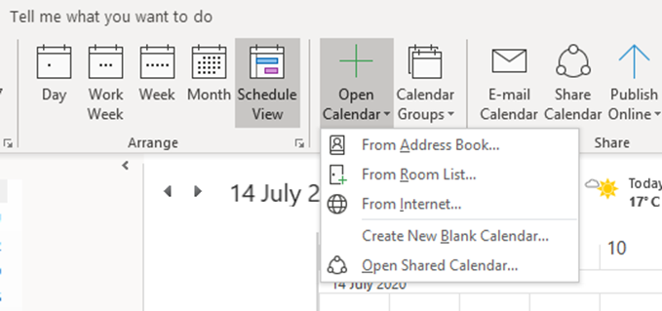

Select “All Users” from Address Book and then type in “resource” in Search field, and a list of all the CLSM – Core Facilities equipment will appear.

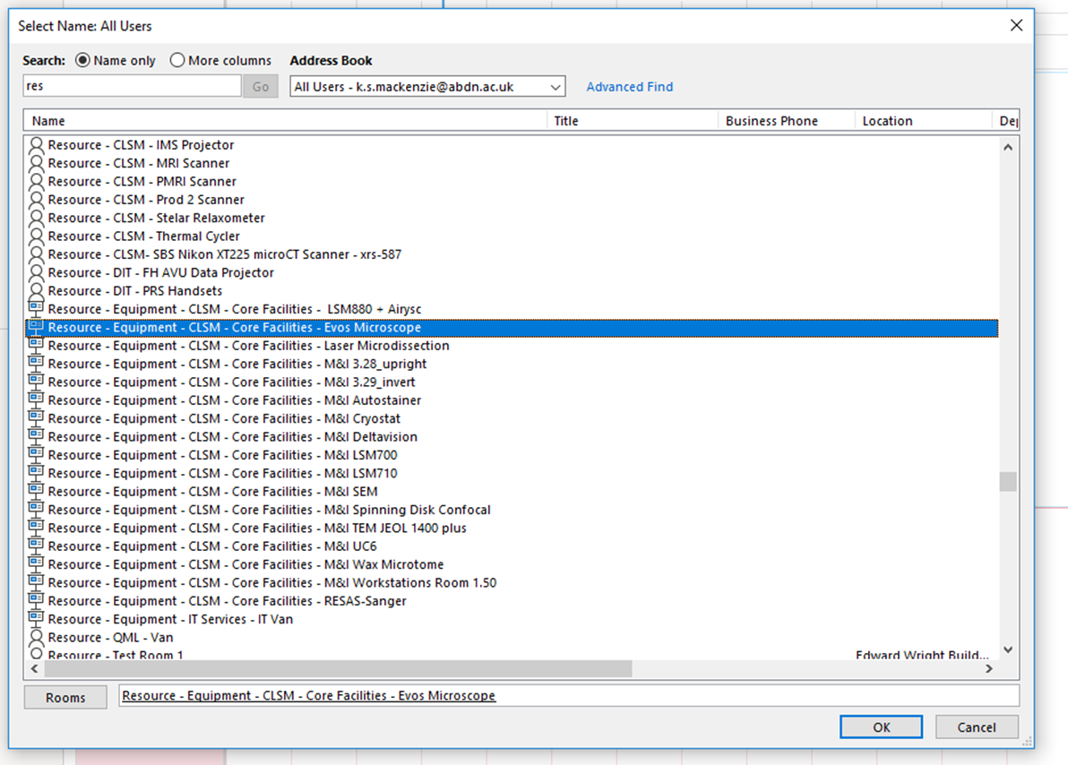

Double click on item you want to add and the click OK button.

