Thank you for taking part
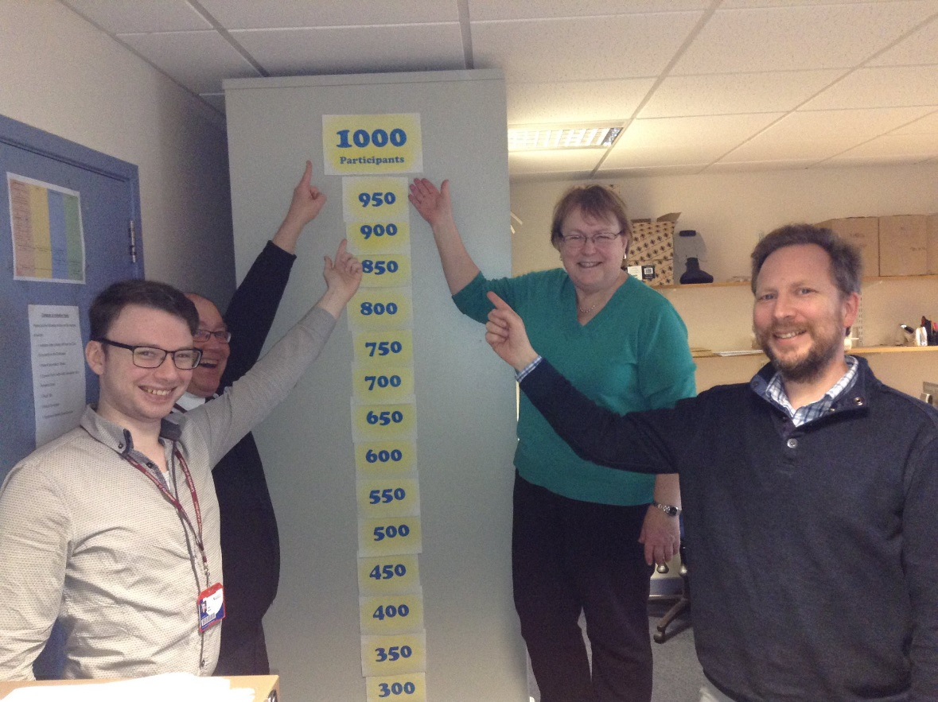 |  | MAmMOTH  - Newsletter  - Issue 1
Mark, Gary, Anne and marcus with the mammoth recruitometer |  | recruitment update

Recruitment of participants to the MAmMOTH (Maintaining Musculoskeletal Health) Study finished in spring 2017.
In all, 1002 people are taking part in the study.
Participants come from all across Scotland, including:
- 173 in Inverness
- 208 across the Highlands
- 332 in Aberdeen and Aberdeenshire
- 289 in Glasgow

Over the next year, we will continue to follow up all participants.
Most people are returning their follow-up questionnaires right now.
We expect the results of the study to be available in autumn 2019.

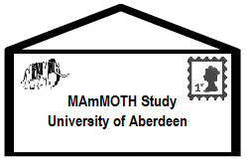
Reminder: Importance of returning the questionnaires
Filling out and returning the MAmMOTH questionnaires is vitally important for our research.
The responses we commonly hear are:
‘I no longer have any pain’ or ‘I have withdrawn from treatment’ and that their responses are no longer useful.
This is NOT true! We hope to garner responses that reflect a wide range of circumstances and a high response rate is essential to provide us with accurate and substantive results.
Introducing: Adam Fletcher (Project Assistant)
Adam joined the Epidemiology group as a part of the MAmMOTH study in July 2017. He earned his MSc in Strategic Studies and International Law from the University of Aberdeen in 2015. Prior to joining Epidemiology group, Adam was involved in research elsewhere at the University, working with both quantitative and qualitative data as part of the Arab Transitions project.
Results: Due Autumn 2019
The final questionnaires will be collected by the summer of 2019. The results will then be sent to participants and stakeholders via a newsletter in autumn 2019. This will include a summary of all the notable findings, with a link to the research paper if you would like more details.

Contact details
If you have any queries about the study, please contact:
Marcus Beasley, Study Coordinator

Telephone
01224 437087

email
mammoth@abdn.ac.uk

address
Epidemiology group
Health Sciences Building
University of Aberdeen
Foresterhill
Aberdeen, AB25 2ZD
More Information:
Where to find us
Website: https://w3.abdn.ac.uk/hsru/mammoth/
Twitter: @UoAEpi

