Executive summary
The outcome of Liver Intervention OR Surveillance in DiSappearing colorectal liver Metastases (LORDS-M Study)

Follow this link for further information and registration
(https://www.abdn.ac.uk/iahs/research/lordsmstudy-2390.php )

The clinical challenge
Colorectal cancer (CRC) is amongst the fourth commonest cancer worldwide ¹ and is the second leading cause of cancer-related death in the UK ². There are around 42,300 new colorectal cancer cases annually in the UK ³, while Scotland records over 3700 new cases ⁴. Liver metastases contributed to the death of approximately 50% of these patients ⁵.
Half of CRC patients develop liver metastasis ⁶. In Scottish liver centres, two-thirds of liver cancer surgery is for colorectal liver metastasis (CRLM). A Recent international survey demonstrated that almost all liver surgeons have experience with disappearing CRLM⁷.
Surgical resection remains the standard treatment for CRLM⁸. However, it is not always feasible without neoadjuvant chemotherapy ⁹. Most patients with CRLM receive chemotherapy ¹⁰ as the condition is often multiple ¹¹, affects both lobes of the liver ¹², and approximately half present with CRC present with a high systemic burden of the disease on their first presentation ⁶ .
Tumour response to chemotherapy has significantly improved, with up to 50% response rates for initially unresectable liver metastasis, of them 20% proceeding to liver resection with curative intent ^{13,14}. Lesions disappear on radiological assessment in approximately half of the cases following chemotherapy ^{15,16}. In subsequent investigations, this results in the disappearance of some or all metastatic diseases, a phenomenon termed “disappearing liver metastases” (dCRLM). ﻿The estimated affected population with dCRLM annually is approximately 360,000 cases globally. However, only a minority will have a complete pathological response (18% ¹⁷ to 25% ¹⁸) with the remainder (as high as 83%) having residual active cancer¹⁹. This poses a major therapeutic dilemma as most patients with a complete radiological response potentially still have residual disease. Indeed, there is a growing concern that the current observed rate of the pathologically viable tumour and rate of early recurrence is alarming ¹⁹. Preclinical studies suggested that surgery induces the growth of microscopic tumours ^{20,} and in clinical practice, the dropout rates following the first stage hepatectomy for CRLM is strong support for the potential adverse effect of operating only on visible lesions ²¹. Therefore, not operating on those lesions may not be justified.
However, the area with viable cancer is substantially difficult to localize intraoperatively and often requires complex techniques and tools, which still have a suboptimal detection rate ²². Furthermore, many of these patients are subject to complications of extending the resection because of residual liver volume limitations ^{11,23} . Therefore, blind surgery has a significant risk of potential morbidity and mortality without guarantying improved outcome.
Some surgeons will, therefore, not offer surgery to these patients, while some advocate observation ²⁴ and others endorse a surgical approach for all patients²⁵.
The majority of CRLM are multiple, as previously mentioned, and when patients receive chemotherapy, most commonly, some of these lesions disappear, and some remain detectable. For this study and to provide a clear distinction, the situation where some lesions disappeared, and some remain detectable will be called mixed disappearing colorectal liver metastasis (mDLMs). Despite the literature addressing the CRLM, high quality studies address neither dCRLM nor mDLMs. A recent systematic review on the management of dCRLM identified low quality studies that require further validation albeit not addressing the fundamental question of this study ²⁶. The fundamental question of this study is whether surgery is equivalent to observation in patients with multiple CRLM in whom some lesions disappeared and others remain detectable on preoperative imaging (mDLMs). Noteworthy the lack of clinical code specific to this condition and the reliance on routine health data did not show yield (communication with public health Scotland).

The approach

Concluded
Preliminary work:
Information gathering
&
Global engagement with the study
Collaborative engagement and appointing steering committee

Assessment of the need for a systematic review of literature
Survey of expert MDT attitudes on the management of specific case scenarios, inform the database design, reinforce engagement, and identify eligible centres
Development and refinement of database
Individual patient data collection in a secure database
Consensus conference and development of guidelines
Development of further research

Data collection and analysis

Translation into practice

IRB and Caldicot approval
The study has been awarded Caldicott approval through NHS Grampian Caldicott officer and registered as a UK wide study. Colleagues from outside the UK are encouraged to seek local approvals using the available documentations for this purpose.
Proposed timeline for the data collection phase
The study is currently open for data collection. https://redcap.link/lords-m-register follow the link to register and gain access to your database.
Timeline is subject to changes as dictated by the practical circumstances.

The study team
Having YOU and your team, we can have a better understanding on the best treatment of the disappeared colorectal liver metastasis.

How to join?
Register your interest here
Please fill out the LORDS-M project registration form to register your interest. Our administrators will then provide you with a REDCap account which can be used to submit your case files.

Login to submit your case files
Please login through the University of Aberdeen REDCap login portal to submit your case files. If you have forgotten your password, you can reset it here. If you have forgotten your REDCap username please contact digitalresearch@abdn.ac.uk for assistance.

Your proposed team composition
Each site PI is encouraged to choose additional 2 team members. Each site will have around 3 members and if more is required will be considered.
Although many cases would have been discussed in HPB MDT, there are many who have not gone through. You may want to liaise with colleagues who may have access to relevant patients records.
- Oncology team (e.g. oncologist, cancer nurse specialist),
- Pathology department (e.g. MDT pathologist for either CRC or HPB)
- Radiology department (e.g. Colorectal cancer or HPB radiologist)
- Colorectal surgical team
Funding:
The study is awarded funding for study manager, data curation and analysis.
If you are contributing from the UK, you could claim (into your research fund) reimbursement for time utilised for submission of COMPLETE case records at £30 per hour (up to £45 per bundle [case + control]). There are additional reimbursement at the same rate for up to 20% of data quality check from a senior team member different from the members submitting the records.

Important clause: The reimbursement will be for cases of disappeared colorectal liver metastasis AND the control which will be case files for patient received chemotherapy with active treatment intent but have not had disappeared lesions.

The information needed
Standard information. The study collects standard information on patients who received chemotherapy for colorectal liver metastasis. Collection will include all prospective and retrospective from January 2017.
Examples (zoom in to see)
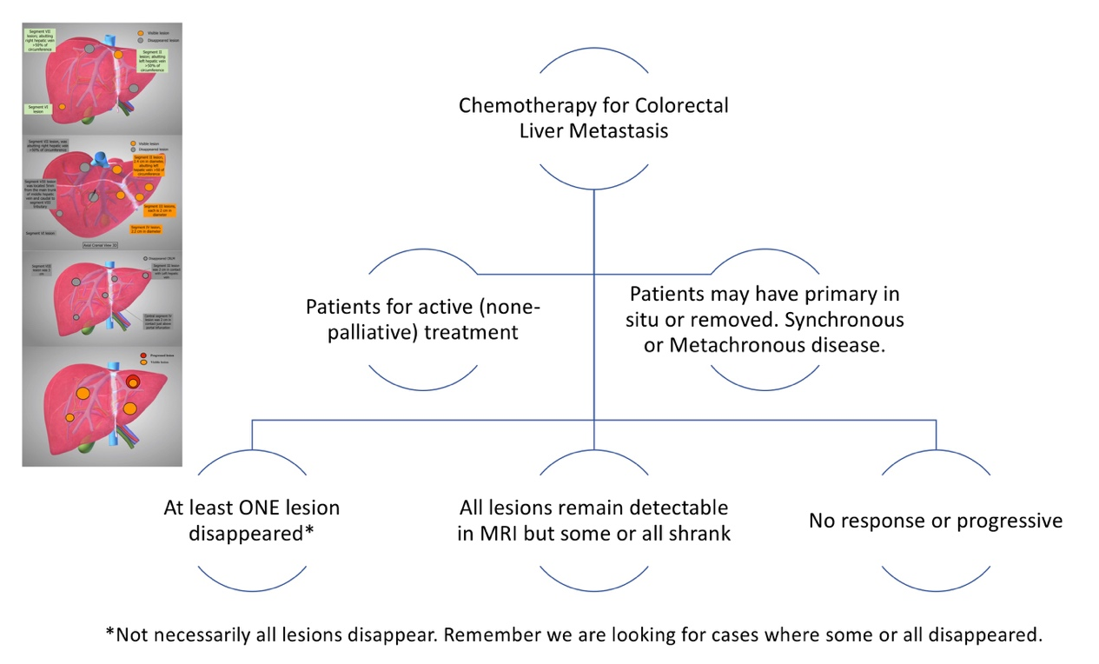
Authorship
All site PIs will be included in named authorship (provided there are complete case records submitted by the centre). All other contributions will be acknowledged in collaborative authorship.

Previous publications
Nassar A, Cimpean S, Abdelhamid A, Jones RP, Wahba R, Fiorentini G, Aldrighetti L, Teh C, Alikhanov R, Hammond J, Silva M, Abdelmabod A, Truant S, Ferrero A, Sturesson C, Ahmed I, Ghazanfar M, Takemura N, Pawlik TM, Bekheit M. The dilemma of the disappeared colorectal liver metastasis: systematic review of reviews and evidence gap map. BJS Open. 2022 May 2;6(3):zrac051. doi: 10.1093/bjsopen/zrac051. PMID: 35598157; PMCID: PMC9124362.

Ghazanfar et al . The management of dCRLM. International survey. In revision.

References
1. International Agency for Research on Cancer (2020). Worldwide Incidence of Colorectal Cancer.
2. Research C (2017). Leading Causes of Cancer Related Death in the UK.
3. Cancer Research UK (2018). Available at: https://www.cancerresearchuk.org/health-professional/cancer-statistics/statistics-by-cancer-type/bowel-cancer [Accessed January 20, 2001].
4. ISD (2018). Available at: https://www.isdscotland.org/health-topics/cancer/cancer-statistics/ [Accessed January 20, 2020].
5. Helling TS, Martin M (2014). Cause of Death from Liver Metastases in Colorectal Cancer. Ann Surg Oncol 21: 501–6. https://doi.org/10.1245/s10434-013-3297-7.
6. Manfredi S, Lepage C, Hatem C, Coatmeur O, Faivre J, Bouvier AM (2006). Epidemiology and Management of Liver Metastases from Colorectal Cancer. Ann Surg 244: 254–9. https://doi.org/10.1097/01.sla.0000217629.94941.cf.
7. Melstrom LG, Warner SG, Wong P, Sun V, Raoof M, Singh G, Chavin KD, Fong Y, et al (2021). Management of Disappearing Colorectal Liver Metastases: An International Survey. Hpb 23: 506–11. https://doi.org/10.1016/j.hpb.2020.10.005.
8. Raoof M, Haye S, Ituarte PHG, Fong Y (2019). Liver Resection Improves Survival in Colorectal Cancer Patients: Causal-Effects From Population-Level Instrumental Variable Analysis. Ann Surg 270: 692–700. https://doi.org/10.1097/SLA.0000000000003485.
9. Oki E, Ando K, Nakanishi R, Sugiyama M, Nakashima Y, Kubo N, Kudou K, Saeki H, et al (2018). Recent Advances in Treatment for Colorectal Liver Metastasis. Ann Gastroenterol Surg 2: 167–75. https://doi.org/10.1002/ags3.12071.
10. Van Cutsem E, Cervantes A, Adam R, Sobrero A, Van Krieken JH, Aderka D, Aranda Aguilar E, Bardelli A, et al (2016). ESMO Consensus Guidelines for the Management of Patients with Metastatic Colorectal Cancer. Ann Oncol 27: 1386–422. https://doi.org/10.1093/annonc/mdw235.
11. Pawlik TM, Schulick RD, Choti MA (2008). Expanding Criteria for Resectability of Colorectal Liver Metastases. Oncologist 13: 51–64. https://doi.org/10.1634/theoncologist.2007-0142.
12. Aloia TA (2006). Solitary Colorectal Liver Metastasis. Arch Surg 141: 460. https://doi.org/10.1001/archsurg.141.5.460.
13. Bischof DA, Clary BM, Maithel SK, Pawlik TM (2013). Surgical Management of Disappearing Colorectal Liver Metastases. Br J Surg 100: 1414–20. https://doi.org/10.1002/bjs.9213.
14. Kuhlmann K, van Hilst J, Fisher S, Poston G (2016). Management of Disappearing Colorectal Liver Metastases. Eur J Surg Oncol 42: 1798–805. https://doi.org/10.1016/j.ejso.2016.05.005.
15. Barimani D, Kauppila JH, Sturesson C, Sparrelid E (2020). Imaging in Disappearing Colorectal Liver Metastases and Their Accuracy: A Systematic Review. World J Surg Oncol 18: 1–9. https://doi.org/10.1186/s12957-020-02037-w.
16. Chua TC, Saxena A, Liauw W, Kokandi A, Morris DL (2010). Systematic Review of Randomized and Nonrandomized Trials of the Clinical Response and Outcomes of Neoadjuvant Systemic Chemotherapy for Resectable Colorectal Liver Metastases. Ann Surg Oncol 17: 492–501. https://doi.org/10.1245/s10434-009-0781-1.
17. Vujic J, Schöllnast H, Marsoner K, Wienerroither V, Bacher H, Mischinger HJ, Kornprat P (2019). Marking Disappearing Colorectal Liver Metastases after Complete Response to Neoadjuvant Chemotherapy via CT – A Pilot Study. Anticancer Res 39: 3847–54. https://doi.org/10.21873/anticanres.13534.
18. Park MJ, Hong N, Han K, Kim MJ, Lee YJ, Park YS, Rha SE, Park S, et al (2017). Use of Imaging to Predict Complete Response of Colorectal Liver Metastases after Chemotherapy: MR Imaging versus CT Imaging. Radiology 284: 423–31. https://doi.org/10.1148/radiol.2017161619.
19. Benoist S, Brouquet A, Penna C, Julié C, El Hajjam M, Chagnon S, Mitry E, Rougier P, Nordlinger B (2006). Complete Response of Colorectal Liver Metastases after Chemotherapy: Does It Mean Cure?. J Clin Oncol 24: 3939–45. https://doi.org/10.1200/JCO.2006.05.8727.
20. Govaert KM, Jongen JMJ, Kranenburg O, Borel Rinkes IHM (2017). Surgery-Induced Tumor Growth in (Metastatic) Colorectal Cancer. Surg Oncol 26: 535–43. https://doi.org/10.1016/j.suronc.2017.10.004.
21. Wicherts DA, Miller R, De Haas RJ, Bitsakou G, Vibert E, Veilhan LA, Azoulay D, Bismuth H, et al (2008). Long-Term Results of Two-Stage Hepatectomy for Irresectable Colorectal Cancer Liver Metastases. Ann Surg 248: 994–1003. https://doi.org/10.1097/SLA.0b013e3181907fd9.
22. Pak LM, Gagnière J, Allen PJ, Balachandran VP, D’Angelica MI, DeMatteo RP, Jarnagin WR, Miga MI, et al (2019). Utility of Image Guidance in the Localization of Disappearing Colorectal Liver Metastases. J Gastrointest Surg 23: 760–7. https://doi.org/10.1007/s11605-019-04106-2.
23. Truant S, Baillet C, Deshorgue AC, Leteurtre E, Hebbar M, Ernst O, Huglo D, Pruvot F-R (2016). Drop of Total Liver Function in the Interstages of the New Associating Liver Partition and Portal Vein Ligation for Staged Hepatectomy Technique. Ann Surg 263: e33–4. https://doi.org/10.1097/SLA.0000000000001603.
24. van Vledder MG, de Jong MC, Pawlik TM, Schulick RD, Diaz LA, Choti MA (2010). Disappearing Colorectal Liver Metastases after Chemotherapy: Should We Be Concerned?. J Gastrointest Surg 14: 1691–700. https://doi.org/10.1007/s11605-010-1348-y.
25. Tanaka K, Takakura H, Takeda K, Matsuo K, Nagano Y, Endo I (2009). Importance of Complete Pathologic Response to Prehepatectomy Chemotherapy in Treating Colorectal Cancer Metastases. Ann Surg 250: 935–42. https://doi.org/10.1097/SLA.0b013e3181b0c6e4.
26. Tsilimigras DI, Ntanasis-Stathopoulos I, Paredes AZ, Moris D, Gavriatopoulou M, Cloyd JM, Pawlik TM (2019). Disappearing Liver Metastases: A Systematic Review of the Current Evidence. Surg Oncol 29: 7–13. https://doi.org/10.1016/j.suronc.2019.02.005.

