

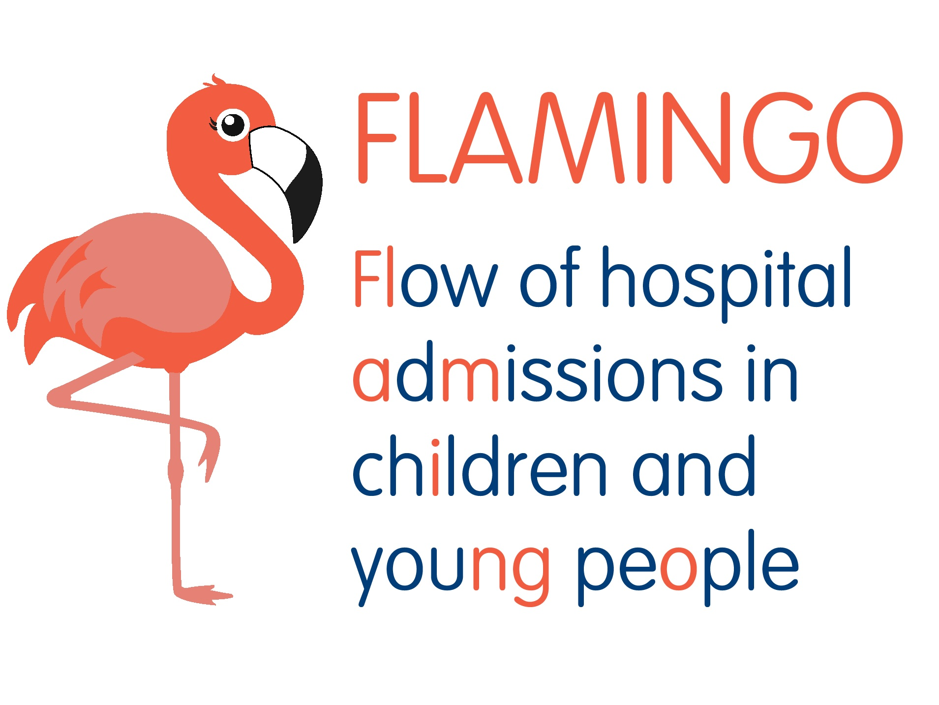

Study number:
FLAMINGO: FLow of AdMissions to hospital in chIldren and youNG peOple
Please initial boxes

- I confirm that I have read and understood the information sheet dated 12/11/2019 (version 5).

2. I have had the opportunity to consider the information, ask questions and have had these answered satisfactorily.

3. I understand that my participation is voluntary and that I am free to withdraw at any time, without giving any reason.

4. I agree to participate in a short interview that is recorded.

5. I understand that anonymised quotations from this interview may be used for presentations and publications.

- I understand that data collected during the study, may be looked at by individuals from the University of Stirling, from regulatory authorities or from the NHS Board/Trust, where it is relevant to my taking part in this research. I give permission for these individuals to have access to my data

- I agree to take part in the above study.

________________________ ______________ ____________________
Name of Participant Date Signature

Name of Researcher Date Signature

