Guidance
Details: The set of columns are suggestions and can be customized to meet the needs of the study.
Initials: The use of three initials is advised as the chance of participants having the same initials and birth date is high in large cohort studies.
If the participant does not have a middle initial, it is common practice to allocate a number for purposes of the study eg M1M, M2M.
Gender: Recording of gender may be useful in analysis, identification and preventing misidentification.
Date of birth/consent: The same consistent format should be used throughout the study ie 01.Jan.17 or 01.02.17.
Screening number: This should be written onto the Consent Form eg S01, S02.
Date (if screen fail): Not everyone who gives consent will go on to the main study. If they ‘screen fail’ for any reason, the date should be included; this is because the date they ‘screen fail’ may not be the same day as when consent was taken.
A line should be drawn through the remaining boxes in the row (Subject number etc).
Subject ID Number: This is the number that the participant should be given when they pass the inclusion/exclusion procedure.
Date (if withdrawn): Participants can withdraw themselves, or have to be withdrawn by the researcher.
The date this is confirmed should be recorded here and the Withdrawal Form stored alongside the Consent Form.
Date of completion: This is the date the participant finishes their active involvement in the study. If there is long term follow up, the date of their last treatment/visit may be recorded here. This should be kept consistent for all participants.

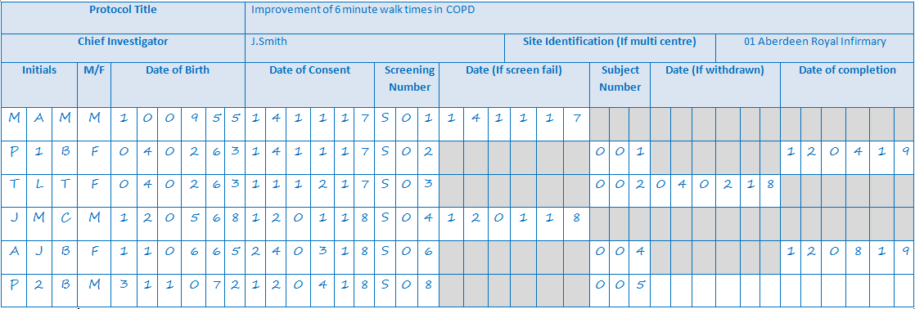
Example Subject Log

Protocol Title
Chief Investigator |  |  |  |  |  |  |  |  |  |  |  |  |  |  |  |  |  |  |  |  |  | Site Identification (If multi centre)
Initials |  |  | M/F | Date of birth |  |  |  |  |  | Date of consent |  |  |  |  |  | Screening number |  |  | Date (If screen fail) |  |  |  |  |  |  | Subject number |  |  | Date (If withdrawn) |  |  |  |  |  | Date of completion
 |  |  |  | D | D | M | M | Y | Y | D | D | M | M | Y | Y |  |  |  | D | D | M |  | M | Y | Y |  |  |  | D | D | M | M | Y | Y | D | D | M | M | Y | Y
 |  |  |  | D | D | M | M | Y | Y | D | D | M | M | Y | Y |  |  |  | D | D | M |  | M | Y | Y |  |  |  | D | D | M | M | Y | Y | D | D | M | M | Y | Y
 |  |  |  | D | D | M | M | Y | Y | D | D | M | M | Y | Y |  |  |  | D | D | M |  | M | Y | Y |  |  |  | D | D | M | M | Y | Y | D | D | M | M | Y | Y
 |  |  |  | D | D | M | M | Y | Y | D | D | M | M | Y | Y |  |  |  | D | D | M |  | M | Y | Y |  |  |  | D | D | M | M | Y | Y | D | D | M | M | Y | Y
 |  |  |  | D | D | M | M | Y | Y | D | D | M | M | Y | Y |  |  |  | D | D | M |  | M | Y | Y |  |  |  | D | D | M | M | Y | Y | D | D | M | M | Y | Y
 |  |  |  | D | D | M | M | Y | Y | D | D | M | M | Y | Y |  |  |  | D | D | M |  | M | Y | Y |  |  |  | D | D | M | M | Y | Y | D | D | M | M | Y | Y
 |  |  |  | D | D | M | M | Y | Y | D | D | M | M | Y | Y |  |  |  | D | D | M |  | M | Y | Y |  |  |  | D | D | M | M | Y | Y | D | D | M | M | Y | Y
 |  |  |  | D | D | M | M | Y | Y | D | D | M | M | Y | Y |  |  |  | D | D | M |  | M | Y | Y |  |  |  | D | D | M | M | Y | Y | D | D | M | M | Y | Y
 |  |  |  | D | D | M | M | Y | Y | D | D | M | M | Y | Y |  |  |  | D | D | M |  | M | Y | Y |  |  |  | D | D | M | M | Y | Y | D | D | M | M | Y | Y
 |  |  |  | D | D | M | M | Y | Y | D | D | M | M | Y | Y |  |  |  | D | D | M |  | M | Y | Y |  |  |  | D | D | M | M | Y | Y | D | D | M | M | Y | Y
 |  |  |  | D | D | M | M | Y | Y | D | D | M | M | Y | Y |  |  |  | D | D | M |  | M | Y | Y |  |  |  | D | D | M | M | Y | Y | D | D | M | M | Y | Y
 |  |  |  | D | D | M | M | Y | Y | D | D | M | M | Y | Y |  |  |  | D | D | M |  | M | Y | Y |  |  |  | D | D | M | M | Y | Y | D | D | M | M | Y | Y
 |  |  |  | D | D | M | M | Y | Y | D | D | M | M | Y | Y |  |  |  | D | D | M |  | M | Y | Y |  |  |  | D | D | M | M | Y | Y | D | D | M | M | Y | Y
 |  |  |  | D | D | M | M | Y | Y | D | D | M | M | Y | Y |  |  |  | D | D | M |  | M | Y | Y |  |  |  | D | D | M | M | Y | Y | D | D | M | M | Y | Y
Page of

