Guidelines for the use of Observation Cards

Observation cards are a way for staff, students and visitors to identify potential hazards or diversions from correct practices and procedures, which, if ignored could lead to a near miss or incident. (A safety observation is not a near miss or an incident. These should always be reported to your supervisor, a technician or other member of university staff.)
Safety observation cards should not be seen as a negative, but rather a means to make all lab users aware of their surroundings and target areas of concern. Observation cards can also be submitted in recognition of exemplary health and safety behaviours.
These cards are used extensively in the oil and gas industry, both on and offshore, and are increasing being used in many industries where health and safety is of concern.
They can be used by all, regardless of position, without fear of recrimination. You will NEVER be penalised for stopping unsafe work or speaking up about hazards and injuries.
Cards are located in every laboratory and can also be found throughout the corridors in Fraser Noble. Completed cards will be collected and reviewed periodically by the health and safety committee. This helps us to understand risks and address areas that need improvement.
It is important to remember that the subject of the safety observation card remains anonymous (with the exception of a “safety recognition”). The university operates a no blame culture. These cards are a means to identify behaviours and conditions that may require further attention and training.

Serious breaches in health and safety or refusal to stop work/take corrective action should be brought to the attention of technicians/supervisors immediately.

How to fill out a safety Observation Card
Below is an example of a completed observation card:
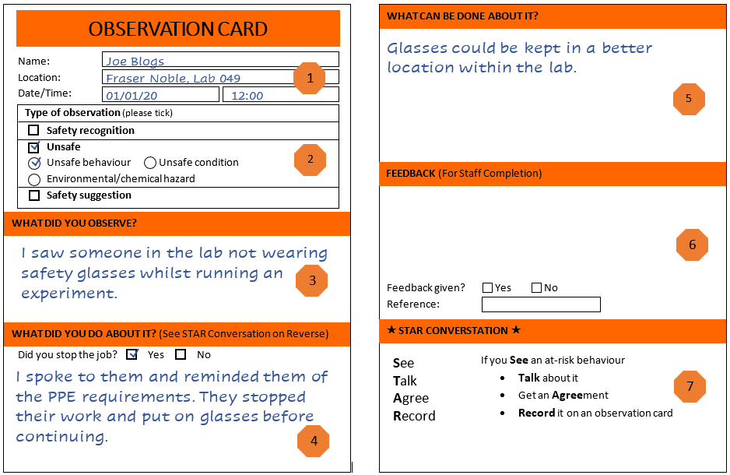
- Name - this is the name of the observer, not the person who was observed.
Location – either the number of the lab or location of the potential hazard, i.e. corridor
Outside FN053
Date/time – when the observation took place.

- The observer should select the correct box to check for the observed potential hazard.
Examples of potential hazards:
Unsafe behaviour – A lab worker not wearing correct PPE while handling chemicals.
Unsafe condition – Electrical cables trailing along floor.
Safety recognition – Identifying an individual or team who are correctly following health and safety procedures.
Safety Suggestion – Recommendations to improve health and safety conditions.

- The observer should describe what they observed.

- What actions were taken? Actions could include speaking to the individual or group that were not following correct practice (follow the STAR conversation guidelines) OR dealt with a potential hazard by removing it or informing a member of staff of the issue.

- What can be done about it? Do you have any suggestions that could prevent this from happening again?

- This area should be left clear. All cards will be submitted to the health and safety committee for discussion.

- S.T.A.R conversation
See – Have you seen an at-risk behaviour?
Talk – Stop the person and talk to them about it.
Agree – Get an agreement that the person understands the risks and will alter their
behaviour appropriately.
Record – Record the observation on a card and submit.

Once completed, cards should be dropped into the collection box located in the corridor.

It is NOT acceptable to observe a potential hazard and then do nothing to action the removal of that hazard.

