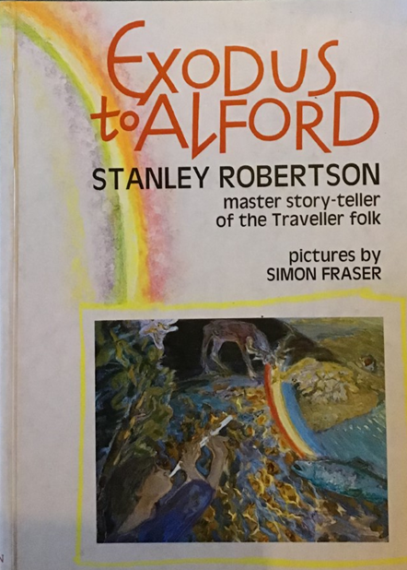
Stanley's Books

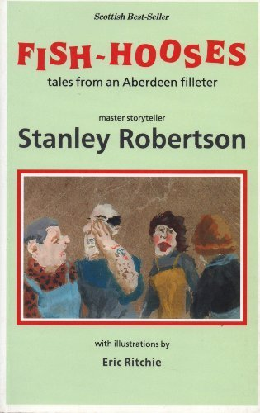
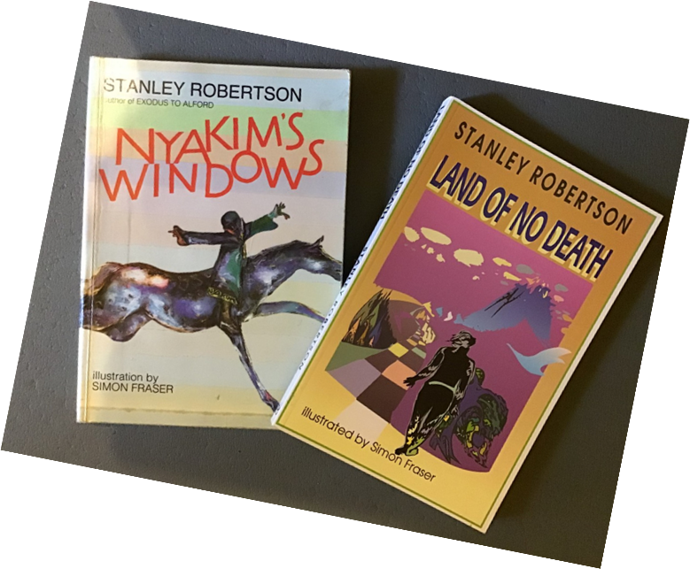

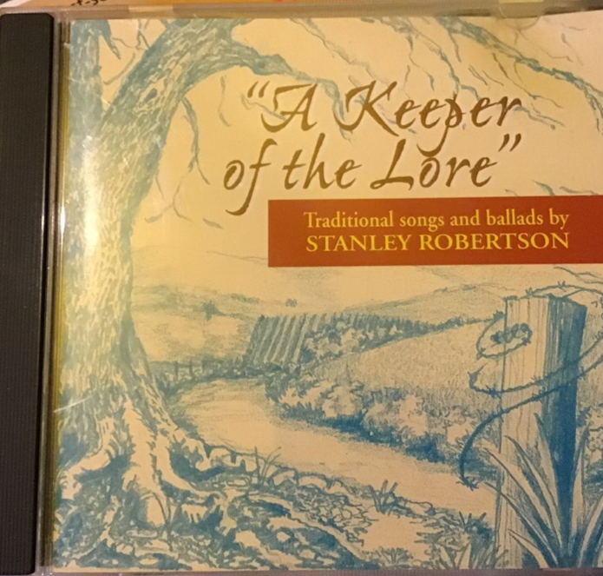
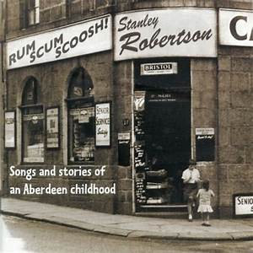
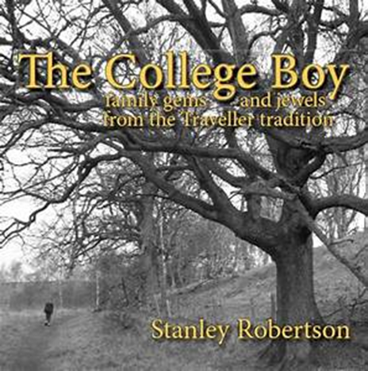
Stanley's CDs

Grampian Association of Storytellers – Stanley Robertson Prize for Storytelling
This trophy is presented to the best adult storyteller at the Aberdeen TMSA (Traditional Music and Song Association of Scotland) Traditional Competition each March.

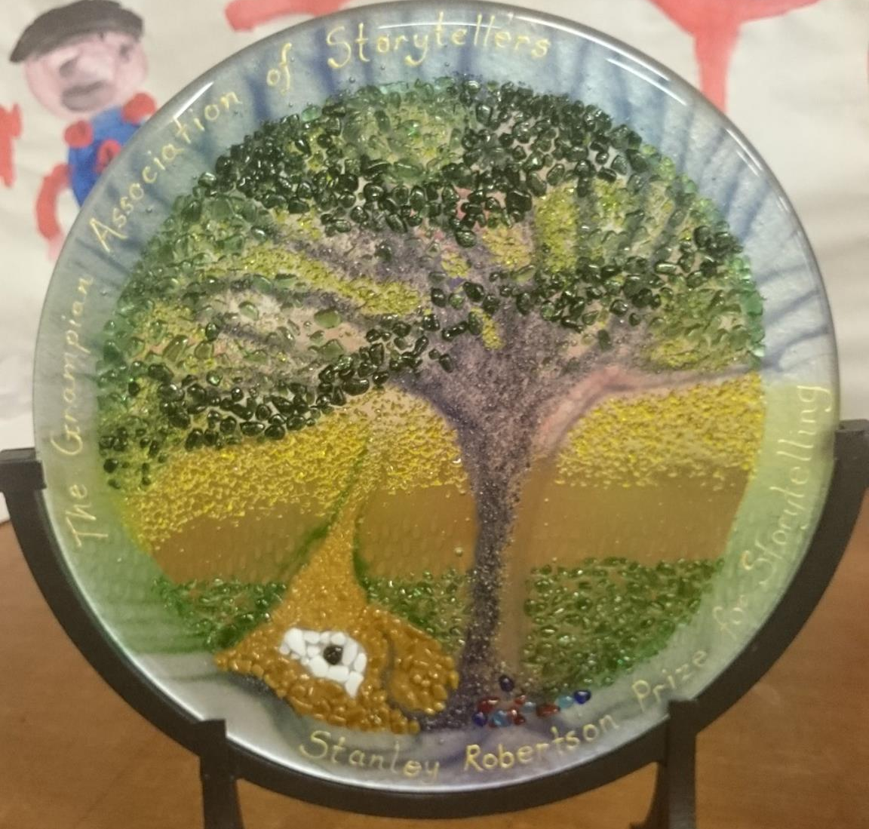

It shows 'Auld Croovie' – an old oak tree near the Lumphanan camp site where Stanley stayed as a boy. Stanley told a story about Auld Croovie – it was one of his favourites.

Evening Express Newspaper Article from August 28th 1995

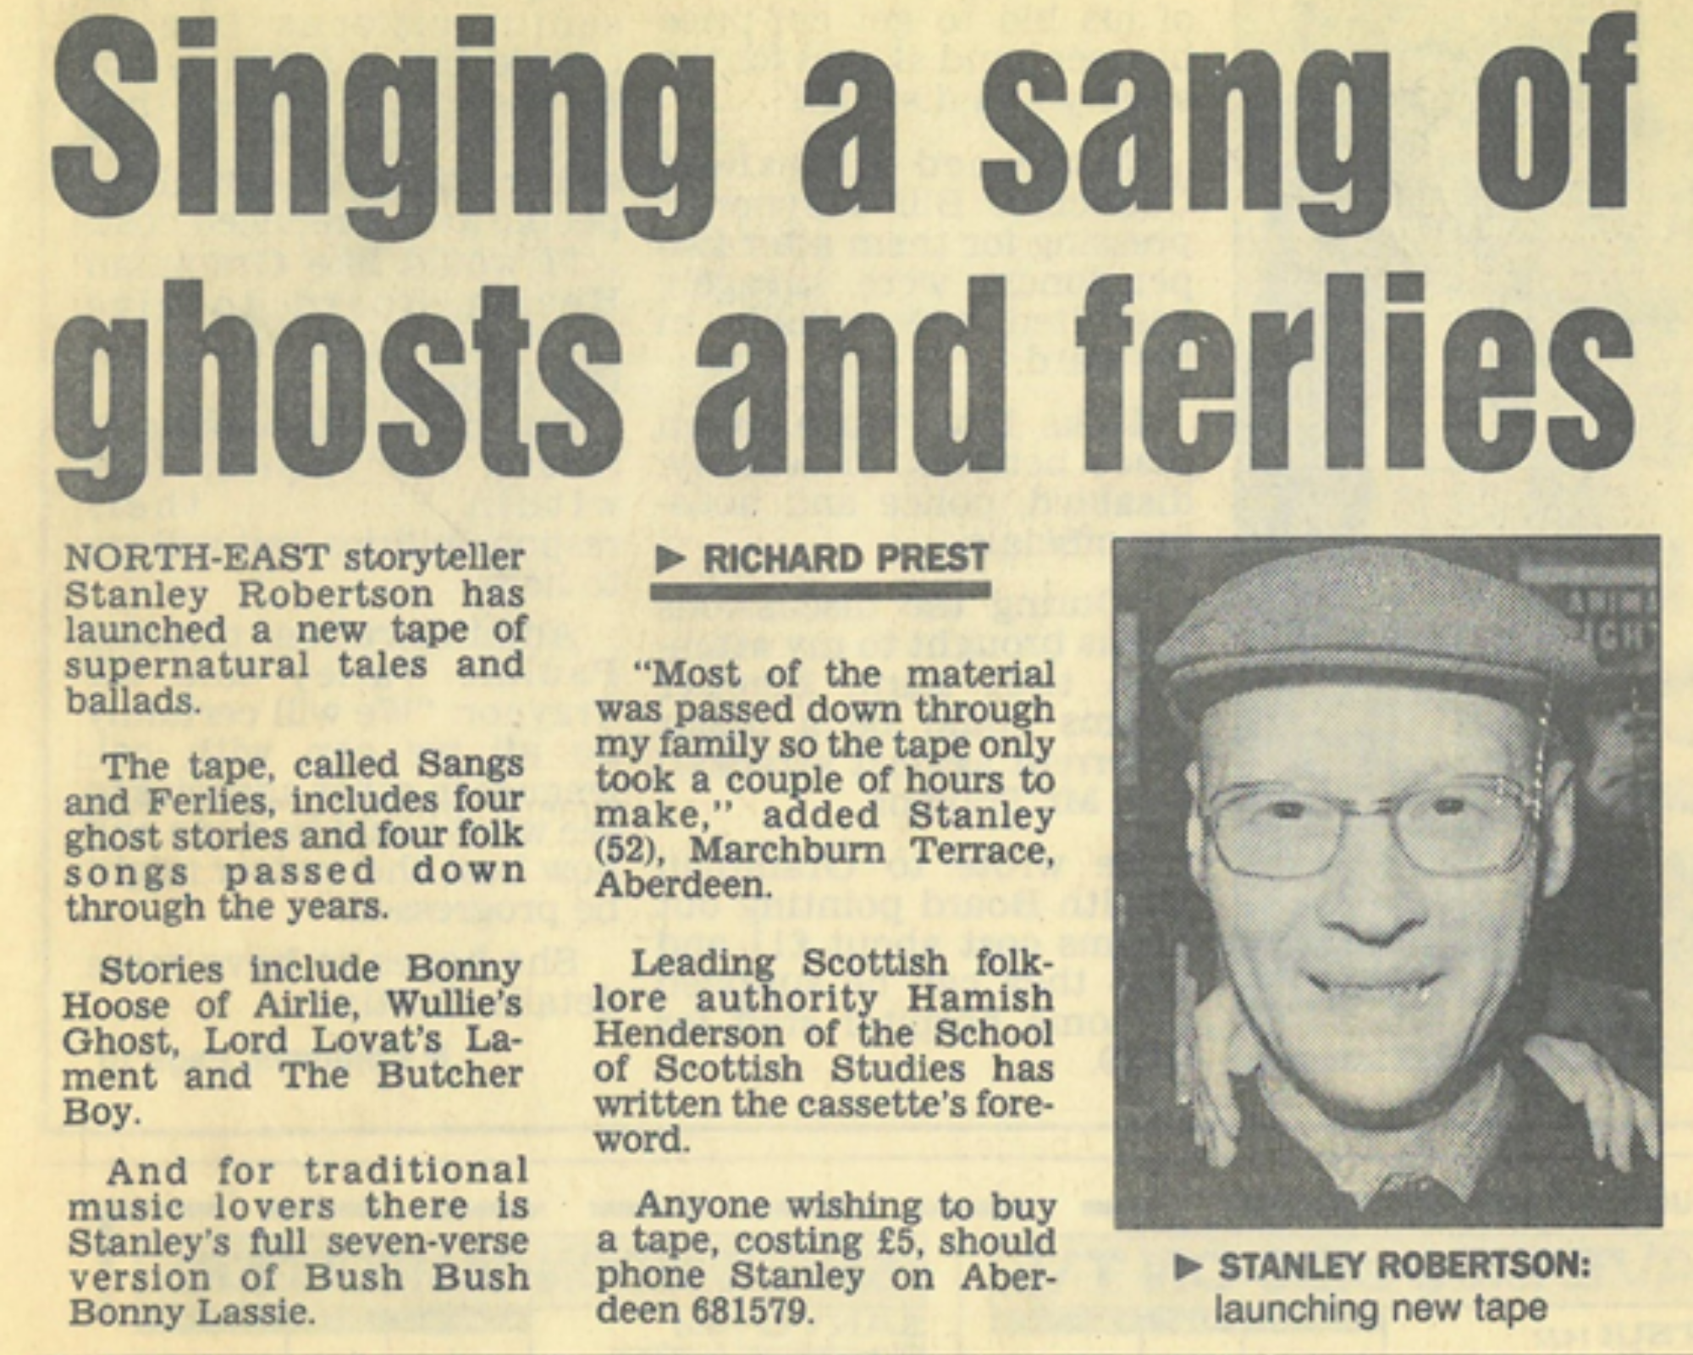

Email from Donald Smith. Director of the Scottish Storytelling Centre in Edinburgh. It was sent to all storytellers across Scotland and to many in other parts of the world too.

Mon 03/08/2009 15:17

Everyone will be sad to know that Stanley Robertson died yesterday at home in Aberdeen, Though recently frail, Stanley has been as active as ever with storytelling, his support for storytellers and his wonderful new book Reek Roun the Campfire.

His funeral is on Friday 7th August in Aberdeen, 12.15 for 12.30 pm, in the Church of Jesus Christ of the Latter Day Saints (the Mormon Church) in North Anderson Drive, AB15 6DD. All are welcome.

Stanley was a wise creative and good man who spoke to and for the soul of storytelling. He leaves a great inheritance for us all to live up to.

Donald Smith
The Scottish Storytelling Centre

Reproduced with permission

Email from Tony Robertson to storyteller Jackie Ross

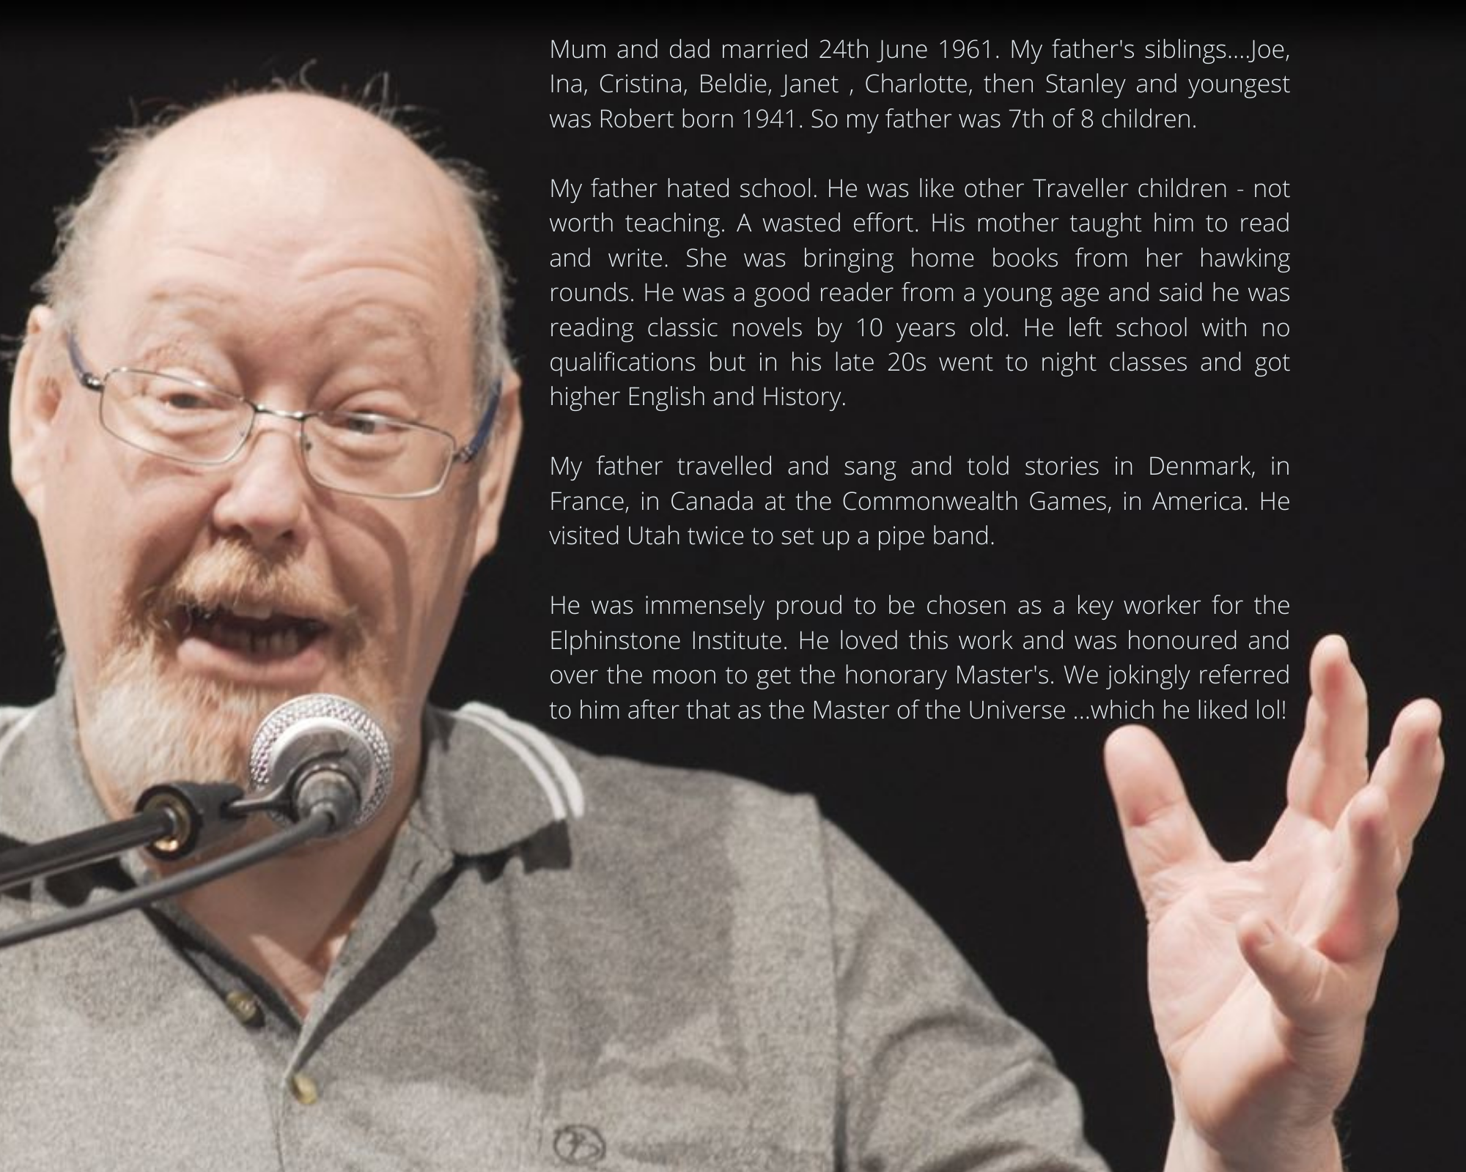

Reproduced with permission

