A history of the University of Aberdeen and its museums
  - Neil Curtis

The origin of the university’s museums
Prior to 1860 when they fused the form the University of Aberdeen, there were two independent universities in the city; King’s College, founded in 1495 near the cathedral, and Marischal College, founded in 1593 in what has become the city centre. Founded by Bishop Elphinstone to “produce the priests, the schoolmasters, the lawyers and the administrators that region and nation required”, King’s College attracted a number of gifts that were itemised in a 1542 inventory of King’s College. Although recording the possessions of a religious foundation rather than a museum, it records the description, provenance, and current location of items in a similar way to that of later museum collections. The Reformation later that century saw almost all dispersed or destroyed, with the only survivals being some books, charters, and one panel of a triptych which depicted Bishop Elphinstone. Although the North-East of Scotland was the region least affected by the ravages of the Reformation, with some remarkable survivals including the oak choir stalls of King’s College Chapel, the Calvinist attitudes of the reformed Church of Scotland were probably inimical to the creation of museum collections, unlike Italy where one of the most impressive museums was that of the Jesuit College in Rome. Instead, the colleges established impressive libraries, including the donation to Marischal College of the personal library of Thomas Reid (d.1624). Latin Secretary to King James VI.
Figure 1: One panel of a triptych depicting Bishop William Elphinstone.
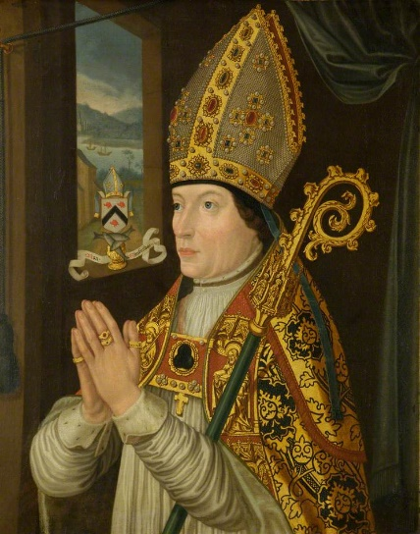
Through the eighteenth century, Enlightenment thinking took a strong hold in Aberdeen with, for example, James Beattie (1735-1803) and Thomas Reid (1710-96) both teaching in King’s College. It was in this context that material started to be assembled by members of staff to support their teaching, such as William Ogilvie who established a demonstration collection of coins, fossils and zoological specimens in King’s College from the 1760s and with some material being preserved in the college libraries in a way that we would today recognise as resembling a modern museum collection. The surviving records suggest that these collections were diverse, rather than being the result of disciplined, or disciplinary, collecting. Nonetheless, a room was opened as the college museum in 1786 in Marischal College, while the construction of new buildings in both colleges including purpose-built museum galleries. That in Marischal College opened in 1837 at the ceremonial heart of the institution, on the raised first floor next to college hall and library. The collections included material collected in North America, Polynesia, and Africa, catalogued alongside preserved animal specimens, geological specimens and Classical statutory, alongside manuscripts, rare books, and portraits.
Rather than being primarily a teaching or research resource, it can be argued that such a museum marked and amplified the status of the institution. There are three aspects to this. First, donations by college professors, graduates and local dignitaries emphasised the centrality of the colleges in elite social networks, emphasised by the recording of details of donors in the earliest listings of the collection. The troubled politics of the eighteenth century affected both colleges, as the claims of the Stuarts to the throne had many Jacobite adherents in the region. As a result, the defeat of the Jacobite Rising of 1715 saw the patron of Marischal College, the Earl Marischal, disinherited and many staff expelled from both colleges. Where loyalty to the Stuarts had previously been seen in the display of portraits of the Stuart monarchs, instead a large portrait of the Earl of Bute, prime minister to King George III was to take pride of place in the hall of Marischal College.
Second, as institutions that saw the importance of Classical learning as paramount, with the languages of teaching being Latin and Greek, the collection of Classical antiquities was important. A statue of Aesculapius in Marischal College, composed of an antique head and 18th century reconstruction of the body stands as a perfect synecdoche. Likewise, a rusty iron loop was acquired as supposedly part of the chariot of the Caledonian leader Calgacus, who was recorded by Tacitus as having been defeated at the battle of Mons Graupius in Scotland by the Roman army. A section of a later nineteenth century catalogue for “Roman-British Antiquities” shows the continuation of this important, though ironically all items there recorded can now be seen to be quite different origins, as does the creation of a large coin cabinet which includes many examples of Ancient Greek and Roman coins. It is also striking that in the later nineteenth century some of these coins, and a significant collection of Classical Greek pottery, were displayed in Marischal College’s library, rather than its museum, emphasising the continuing centrality of Classical texts to learning.
Third, the place of material that would have been seen as “primitive” had a part to play in this approach. Whether deriving from contemporary contact with non-European people, including items collected in the South Pacific, African or North America, or local antiquities from a barbaric past, such as a set of branks (scold’s bridle), these items were regarded as “Curiosities”. Most dramatic among these is a Greenlandic kayak which was found north of Aberdeen about 1720 with an Inuit man on board who died shortly afterwards. Initially displayed in King’s College Chapel, it was later transferred to the museum in Marischal College, with debate continuing as to whether he made his way across the Atlantic unaided or if he had been rescued or captured by a Scottish whaling ship. The display of such items would have helped to emphasise the international connections of the colleges, at the same time emphasising the intellectual distance between the people who made and used these things and the values of Christianity and Classical civilisation expounded by teaching in the colleges.

Scientific and imperial museums
The two colleges, each teaching a similar range of subjects, were fused into a single institution in 1860. This led to the loss of a number of staff, most famously James Clerk Maxwell, and the division of disciplines between the two buildings. The teaching of arts and divinity became focused on King’s College, while in Marischal College the teaching of science and medicine predominated. As a result, the two general college museums took on disciplinary characters with collections moved accordingly, so that King’s College became known as the “Archaeological Museum” by the 1880s, in which the display of Egyptian antiquities related well to both the history or writing and to Biblical history, while the museum in Marischal College was re-established as a natural history museum.
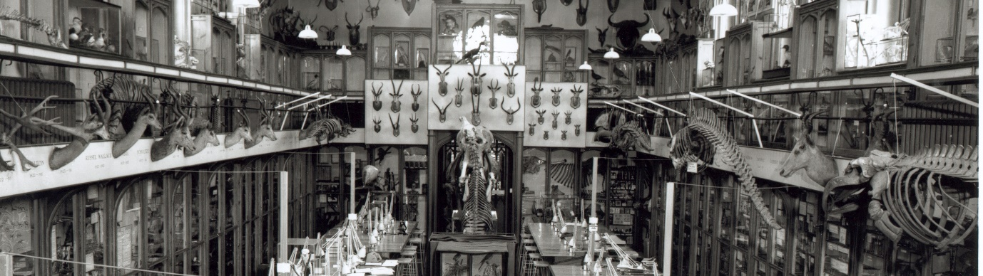
The growth of scientific disciplines in the nineteenth century saw collections become more important as teaching resources with a range of new departments and associated museums being established. By the end of the nineteenth century the facilities of Marischal College were acknowledged as inadequate for modern scientific purposes and a building project with government and private funding resulted in a major building extension which was opened by the King in 1906. Plans of the building show that disciplines such as geology, surgery, zoology, anatomy, and education each included a museum alongside laboratories and lecture theatres.
Figure 2: Natural history museum in Marischal College
As part of this scheme, a new library was built and the Professor of Anatomy, Robert Reid, was responsible for opening a new “Anthropological Museum” in the old library. This museum drew together the collections of the Archaeological Museum in King’s College, ancient Greek pots and coins that had been housed in the library, the Wilson Museum of Classical and Near Eastern archaeology, ethnographic material previously displayed in a small museum in the Anatomy Department, and other museum material from elsewhere in the university. Reid was also responsible for the Anatomy Museum on a lower floor of the college, resulting in a spatial metaphor dividing the study of the body from the study of culture. With the Anthropological Museum displaying material relating to archaeology and social anthropology, this complex clearly shows the conception of “three-field” anthropology that was dominant at the time and within which Reid operated.
The collections of the Anthropological Museum saw their most rapid growth in the early twentieth century as alumni who had served overseas as missionaries, soldiers, and colonial administrators donated their collections to the museum. Prime among these was Sir William MacGregor, son of a farm labourer from Aberdeenshire who studied medicine in the university. After being Medical Officer in Fiji, he went on the be governor in New Guinea, Nigeria, Newfoundland, and Queensland and donated his collections to show other students that there was “more to the world than Aberdeen and twal mile roon”. The displays and catalogues of the Anthropological Museum were arranged in an order that resembled a route around the world from Europe, through North Africa, Asia, the Americas, Polynesia, Melanesia, and Australia to Africa south of the Sahara. Metaphorically confirming the idea of the Western gaze as students were free to observe other cultures laid out in front of them, the displays also highlighted race as a structuring principle, with the ancient Egyptian collections placed adjacent to those of Europe, while those of Africa “South of the Sahara” were placed adjacent to Australian and New Guinea. The museum would therefore have had an active role in the teaching of medical students, normalising ideas of race encountered in both comparative anatomy and in the cultural collections before many of them went on to serve as medical officers in overseas colonies.

Becoming public museums
While the early twentieth century therefore saw very close links between academic disciplines and collections, this association weakened through the century with a lessening in the academic value of collections. Whiles some survived due to a continuing link between teaching, research, and collections (e.g Zoology and Geology), other museums subsequently disappeared entirely (e.g Education), while others were absorbed into other collections (e.g Surgery). Despite the dissolution of anthropology into three separate disciplines during the twentieth century, the curatorship of the Anthropological Museum continued to be held by anatomists until 1979. The combination of this lack of engagement with the developing disciplines of archaeology and anthropology, and the decreasing interest in material culture by these disciplines as they developed an interest in aspects such as language and social structure, therefore led to the Anthropological Museum becoming increasingly dissociated with teaching and research. Indeed, apart from research associated with the important collections of human remains that had been found in association with prehistoric pottery in Scotland (such as Beakers), there is little evidence of academic research making use of these collections during most of the century.
As the activities of the university’s museums came to more closely resemble those of other public museums, their role as the public face of the university became more significant. As a result, when Charles Hunt was appointed in 1979 as the university’s first professional curator, his main remit was the modernise the displays to make them more attractive to the visiting public. The gallery “About human being: about being human” use the collections to explore cross-cultural themes – such as initiation into adulthood, gift-giving, relationships with animals and attitudes to death – and was awarded the Scottish Museum of the Year Award in 1985. While clearly deriving from contemporary anthropological thinking and influencing ethnographic displays elsewhere, there were few links with the academic department in Aberdeen located 3km away in King’s College. Stronger links developed with museum professional bodies, such as the Scottish Museums Council and the Scottish Society of Museum Archaeologists, while the establishment of University Museums in Scotland demonstrated the increasing commonality of museum staff in different institutions as they saw their loyalties to the museum profession grow in place of a prime identification with an academic discipline in their home institutions.
The other gallery opened in 1990 as the “Encyclopaedia of the North-East” displaying archaeological and historical items form the region arranged in alphabetical order, designed to encourage visitors to reconsider ideas of classification. As the only exhibition about the culture and identity of the North-East, this gallery also reveals the role o the university’s museum as a regional museum in the absence of a civic museum. This role was also highlighted by the renaming of the Anthropological Museums as “Marischal Museum”, underscoring its local rather than academic identity, as well as its location in the city centre. As part of the Quincentenary of the University in 1995, “About human beings: About being human” was replaced by “Collecting the World” which traced the stories of some of the collectors, and so critiquing the history of colonial collecting.
Marischal Museum closed in 2008 as Marischal College was converted into the corporate headquarters of Aberdeen City Council. While part of the building is now used as the university’s museum collections centre, most public access is now through a programme of special exhibitions in venues in Old Aberdeen, currently in the Gallery in the Sir Duncan Rice Library.

