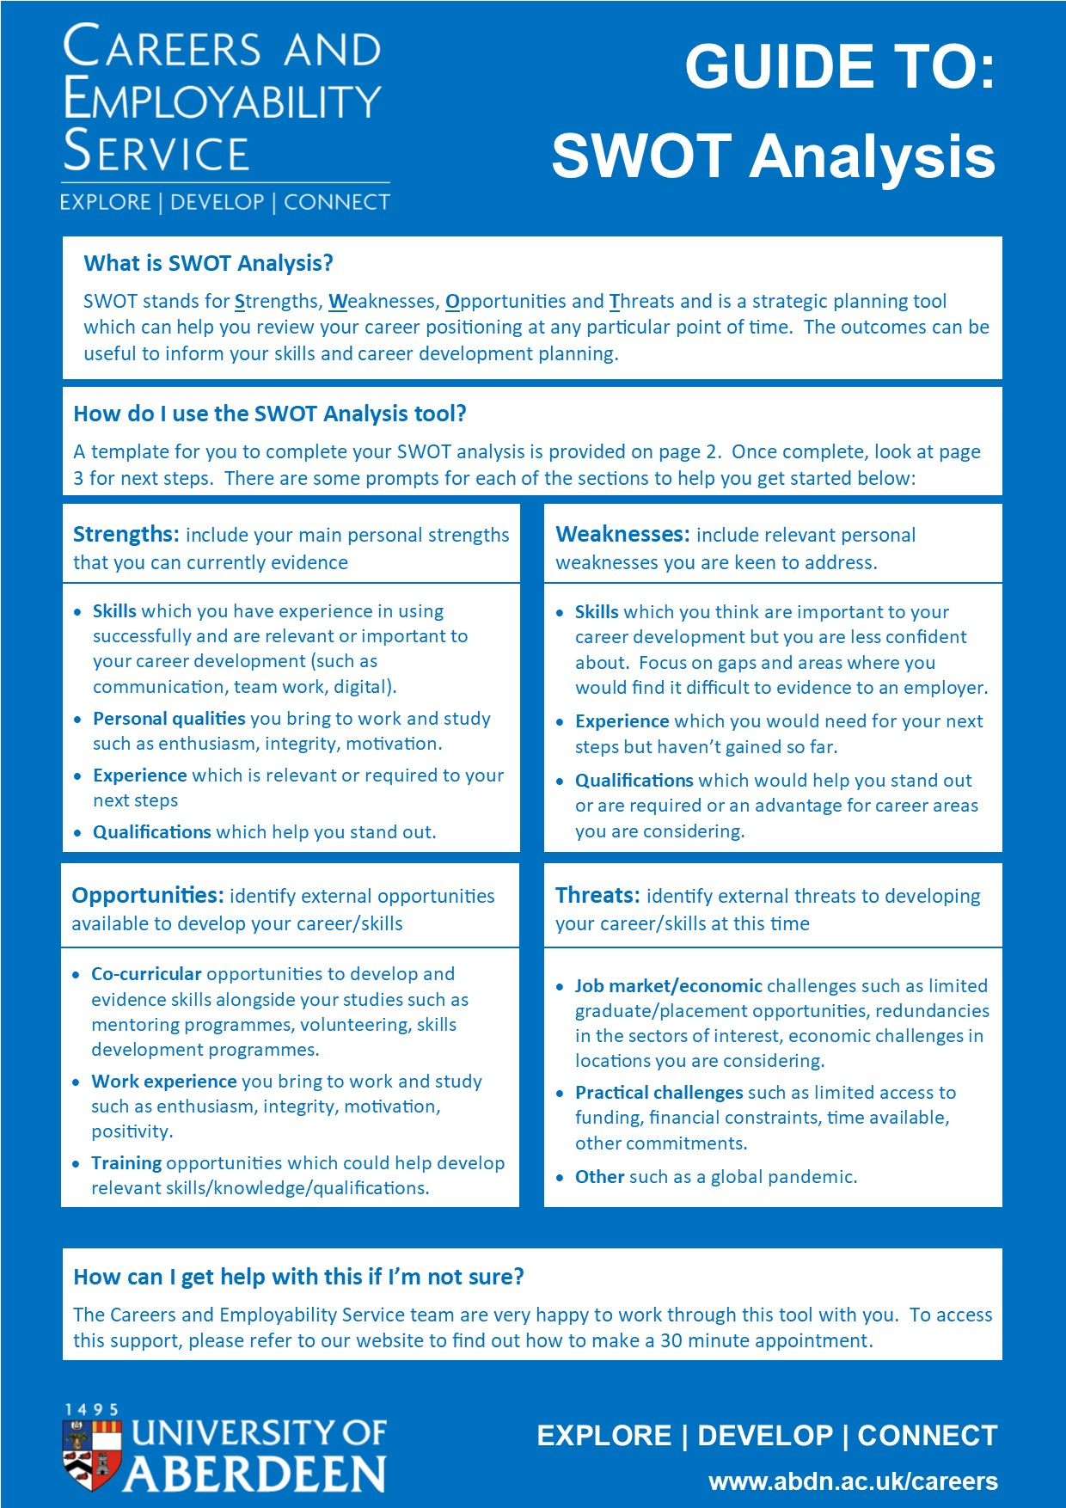
TO COMPLETE:
SWOT Analysis
Strengths: include your main personal strengths that you can currently evidence | Weaknesses: include relevant personal weaknesses you are keen to address.
Opportunities: identify external opportunities available to develop your career/skills | Threats: identify external threats to developing your career/skills at this time
