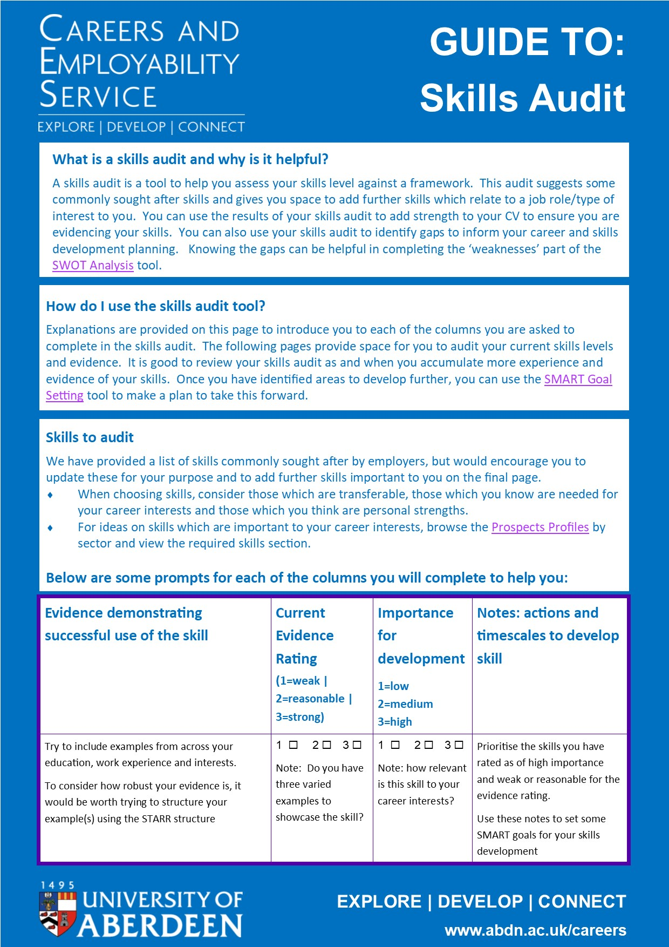

TO COMPLETE: Skills Audit Part 1

Skill | Evidence demonstrating successful use of the skill  (include examples from your education, work experience and interests) | Current Evidence Rating (1=weak | 2=reasonable | 3=strong) | Importance for development  1=low | 2=medium  3=high | Notes: actions and timescales to develop skill  (Add these to your SMART goal plans)
Communication | Click or tap here to enter text. | 1 ☐ 2 ☐ 3 ☐ | 1 ☐ 2 ☐ 3 ☐ | Click or tap here to enter text.
Leadership | Click or tap here to enter text. | 1 ☐ 2 ☐ 3 ☐ | 1 ☐ 2 ☐ 3 ☐ | Click or tap here to enter text.
Problem solving | Click or tap here to enter text. | 1 ☐ 2 ☐ 3 ☐ | 1 ☐ 2 ☐ 3 ☐ | Click or tap here to enter text.
Planning and organisation | Click or tap here to enter text. | 1 ☐ 2 ☐ 3 ☐ | 1 ☐ 2 ☐ 3 ☐ | Click or tap here to enter text.
Digital | Click or tap here to enter text. | 1 ☐ 2 ☐ 3 ☐ | 1 ☐ 2 ☐ 3 ☐ | Click or tap here to enter text.

TO COMPLETE: Skills Audit Part 2

Skill (add skills important to you) | Evidence demonstrating successful use of the skill  (include examples from your education, work experience and interests) | Current Evidence Rating (1=weak | 2=reasonable | 3=strong) | Importance for development  1=low | 2=medium  3=high | Notes: actions and timescales to develop skill  (Add these to your SMART goal plans)
Click or tap here to enter text. | Click or tap here to enter text. | 1 ☐ 2 ☐ 3 ☐ | 1 ☐ 2 ☐ 3 ☐ | Click or tap here to enter text.
Click or tap here to enter text. | Click or tap here to enter text. | 1 ☐ 2 ☐ 3 ☐ | 1 ☐ 2 ☐ 3 ☐ | Click or tap here to enter text.
Click or tap here to enter text. | Click or tap here to enter text. | 1 ☐ 2 ☐ 3 ☐ | 1 ☐ 2 ☐ 3 ☐ | Click or tap here to enter text.
Click or tap here to enter text. | Click or tap here to enter text. | 1 ☐ 2 ☐ 3 ☐ | 1 ☐ 2 ☐ 3 ☐ | Click or tap here to enter text.
Click or tap here to enter text. | Click or tap here to enter text. | 1 ☐ 2 ☐ 3 ☐ | 1 ☐ 2 ☐ 3 ☐ | Click or tap here to enter text.

