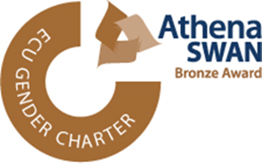**Public Engagement Update Form**

Where possible please complete all relevant areas.

*BEST ESTIMATES ARE ACCEPTABLE*

Event Title

Venue

Date & Time

Brief Description of Event (including target group: eg primary/secondary pupils, families or general public)

How many attendees? How many in each range? How many attendees were male and female?

male female

Children Adults

Your Name Your University Role

If you are happy to comment on your university grade:

Male or Female? Male Female Other

Are you a STEM ambassador?

Your role in the event (tick all that apply):

I was the main organiser/co-ordinator I was the main speaker/facilitator

I was one of the speakers/facilitators

If you were also the main organiser/facilitator:

Did other Staff Members Present? If so, who are they?

|  |  |  |  |
| --- | --- | --- | --- |
| Name | University Grade | Male/Female/Other | STEM Ambassador |
|  |  |  |  |
|  |  |  |  |
|  |  |  |  |

Were other Staff Members involved? If yes, how many: How many male and female?

male female other

Were UG students involved? If yes, how many: How many male and female?

male female other

Were PG students involved? If yes, how many: How many male and female?

male female other

Once completed please send to: iemdspublicengagement@abdn.ac.uk