‘How To’ Guide to SRS Degree Classification via Grade Point Average (GPA)
Undergraduate Honours programmes
[Updated May 2018]

These Degree Classification screens can only be used for students entering their Honours UG programme since September 2014; i.e. for students whose Honours components have been fully assessed using the Common Grading Scale (CGS).

NB: Academic Judgement and discretion should be used in deciding the final degree class at Examiners’ Meetings

Summary
This screen relates to the calculation of degree programme award and classification for Undergraduate programmes, as laid out in Appendix 1, and in the Code of Practice on Assessment (StaffNet http://www.abdn.ac.uk/staffnet/teaching/ug-entering-honours-201415-onwards-2922.php).
This guide addresses:
- Running the classification extract to extract the data, calculate the GPA, Median and Degree Award, and producing reports thereof;
- Amending individual student details in regard to courses that should/shouldn’t be included in GPA and Median calculations;
- Amending Degree Classifications of individual students, including borderline students, and students who would have received a higher award via the Grade Spectrum approach to classification;
- Confirming Degree Classifications - committing the results and producing the documentation to be signed by the Head of School and one other member of the examiners meeting before submission to Registry
It is strongly recommended that you read the whole document before trying to use the system, as the notes that follow the instructions are crucial to the operation and explain the logic behind the rules.

Contents
- Extracting and deriving the data required for degree classification Page 2
- Displaying details on screen Page 4
- Confirming / Changing degree classifications Page 6
- Including or Excluding courses from the GPA/ Median / Degree Classification Page 9
- Joint Degrees Page 10
- 5-year MA / BSc degrees (NOT integrated Master’s programmes) Page 12
- Study Abroad / Erasmus Page 13
- Discounted Periods of Study Page 14
- Direct Entrants Page 16
- Degree Classification Archive Page 17
Appendices
- Appendix 1: Award and Progression at Undergraduate Level
- Appendix 2: SCQF: Credit requirements for SCQF Compliance
- Appendix 3: Examples of reports
- Appendix 4: Mathematical example of how SRS calculates GPA/Median
- Appendix 5: Processing Exam results for Programmes not classified by SRS GPA/Median

- Extracting and deriving the data required for Degree Classification

Select Maintenance Screens, Departmental, Degree Classification:

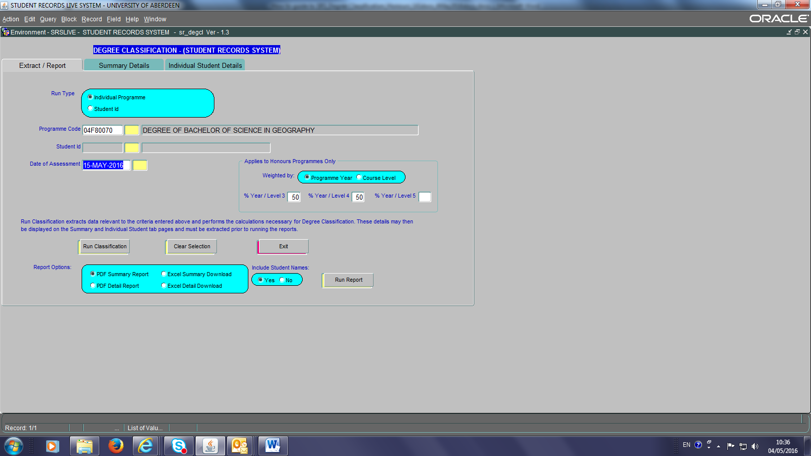

This page allows for the extract of data and for the running of reports. The extract of data may be carried out by:
- Individual Programme (the default setting) or
- Individual student ID number.

- Enter the details of the individual programme or student ID and the Date of Assessment e.g. 15-May-2016. Alternatively, click on the Yellow Buttons to receive options.

- Enter the criteria to be used to ‘weight’ the classification (i.e. course level or programme year) and the % weighting to be assigned [NB: default setting is programme year, 50:50 (or 33:33:34 for integrated Master’s)].

- Click on the Run Classification button – this will (i) run the extract that will retrieve details of any students who have a Programme Assessment status of ‘W’ (waiting), and (ii) check that grades are CGS grades and not CAS marks. If the latter, degree classifications can only be done via the Grade Spectrum and entered manually via Maintenance Screens, Departmental, Process Exam results for Programmes (see Appendix 5).

- When the data extract has been completed a message box will appear on the screen. Click OK.

Reports can then be obtained of the data extracted. There are 2 report options; a summary report (per cohort) and a detailed report (per student) both available as PDF or Excel download (see Appendix 3). All reports can be run with or without student names. All reports will identify at the top right hand side of each page the programme year or course level weighting conditions chosen.

- Select the report option(s) required and click Run Report. Options to print the reports will follow standard PDF or Excel protocol.

NB1: From 2016/17, for undergraduate students, if additional credits are at Level 3 or above, Schools will (i) have approved the extra credits and (ii) will have asked students to identify which of the 120 credits they wish to be included in their GPA calculation at the point at which the extra credits were chosen. Schools have to ‘untick’ the courses NOT included for GPA calculations (see section 4). If a student takes less that the standard number of credits but remains SCQF complaint, e.g. 180 credits for a 4 –year MA programme, the GPA calculation is determined on the basis of 180 level 3&4 credits only.

NB2: If a student has a level 3, 4 or 5 course against which a CAS grade is recorded, the student (i) cannot be classified via the GPA/Median method and (ii) will NOT appear in the degree classification programme list. Instead such a student can only have their degree classified by the Grade Spectrum and their result should be entered as in previous years, via the Maintenance Screens, Departmental, Process Exam results for Programmes (see Appendix 5).

NB3: This data reflects the state of the SRS when the extract was made. If any changes e.g. an awaited exam result for a student occurs, or changes are made to the courses included in the GPA/median calculation (section 4) then the extract would need to be re-run.

NB4: The extract can be run as many times as required for students whose data has not yet been confirmed (section 3.1).

NB5: If a student is missing from the list that you think should be there, please contact the Student Records Team on x 3580 or email studentrecords@abdn.ac.uk.

NB6: Only one person can run a particular programme, or Student ID at a time; if you attempt to extract data another user is working on, a warning message will appear:

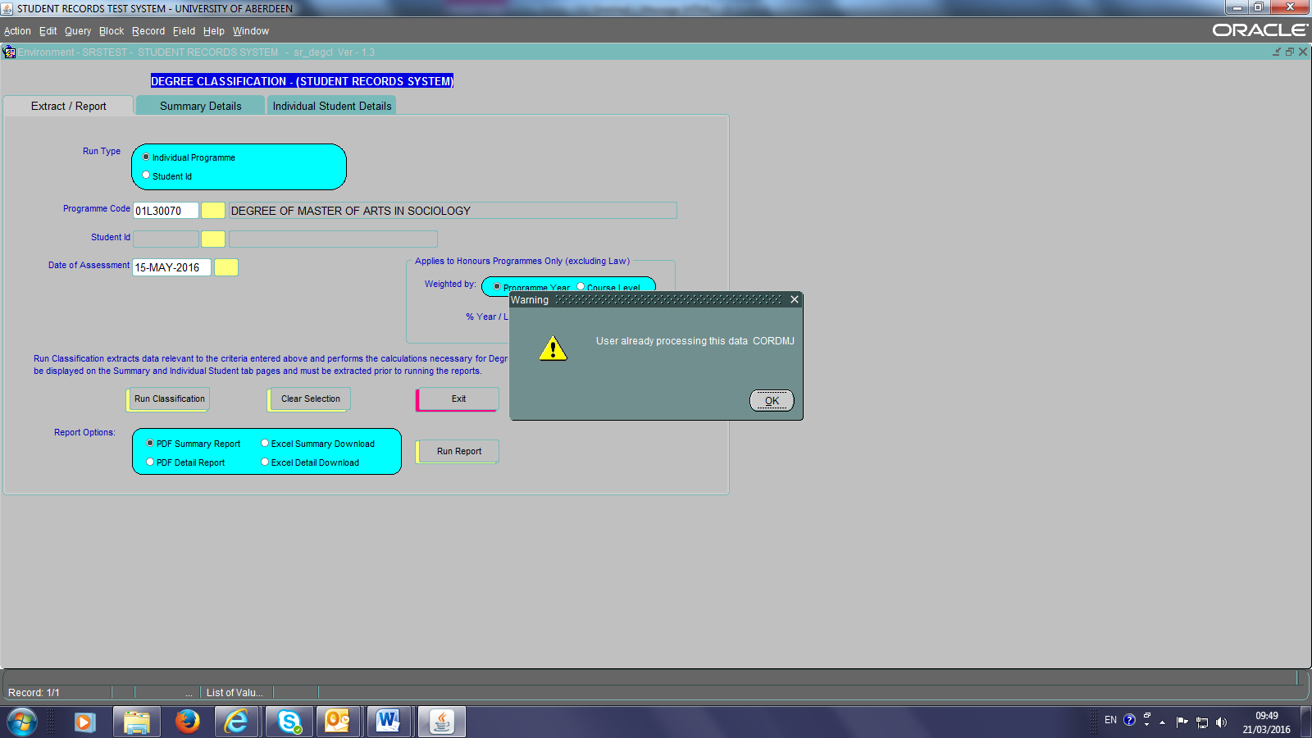

NB7: When exiting the screens please use the Exit button on the first tab page as this will clear down the data you have extracted in the session allowing another user, should they wish, to do a similar extract on that same day.

- Displaying the details on screen

2.1 The ‘Summary Details’ tab displays summary details of each student in the extracted data and reflects the information contained in the summary reports. This screen is where you will confirm the degree classification for each student via the ‘Confirm?’ box.
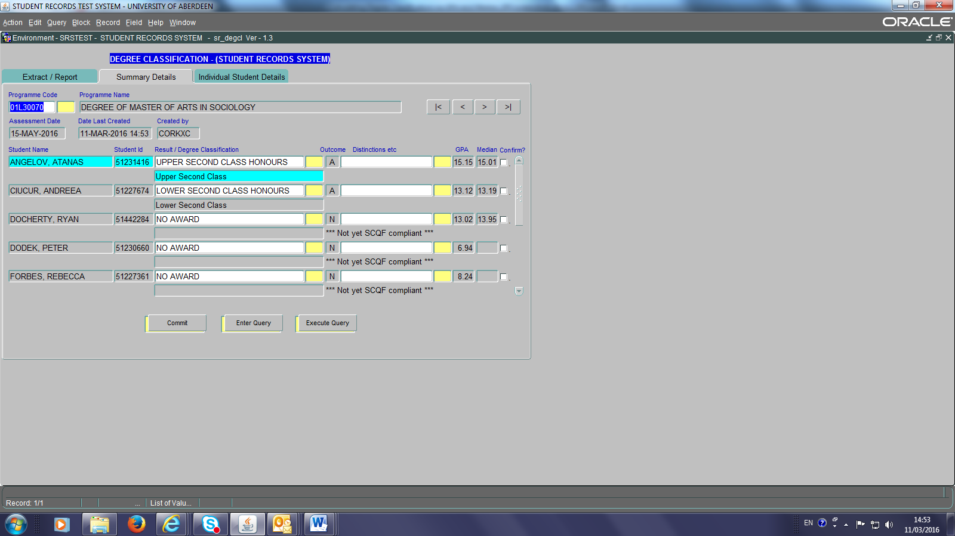

This tab displays each student, in alphabetical order, together with their calculated Degree Classification, GPA and Median. It also displays any significant points of note such as if the student is borderline, or still awaiting results, or has a discounted period of study, or took a period of study abroad/Erasmus. Importantly, if the student is not yet SCQF compliant in the number of credits s/he has achieved, the system will highlight this.
NB1: For students, where the Honours Award has not been achieved, NO AWARD will be detailed, for example if the student is not SCQF-compliant.

2.2.1 The ‘Individual Student Details’ tab allows for the full details for a student highlighted in turquoise on the summary details tab to be displayed:
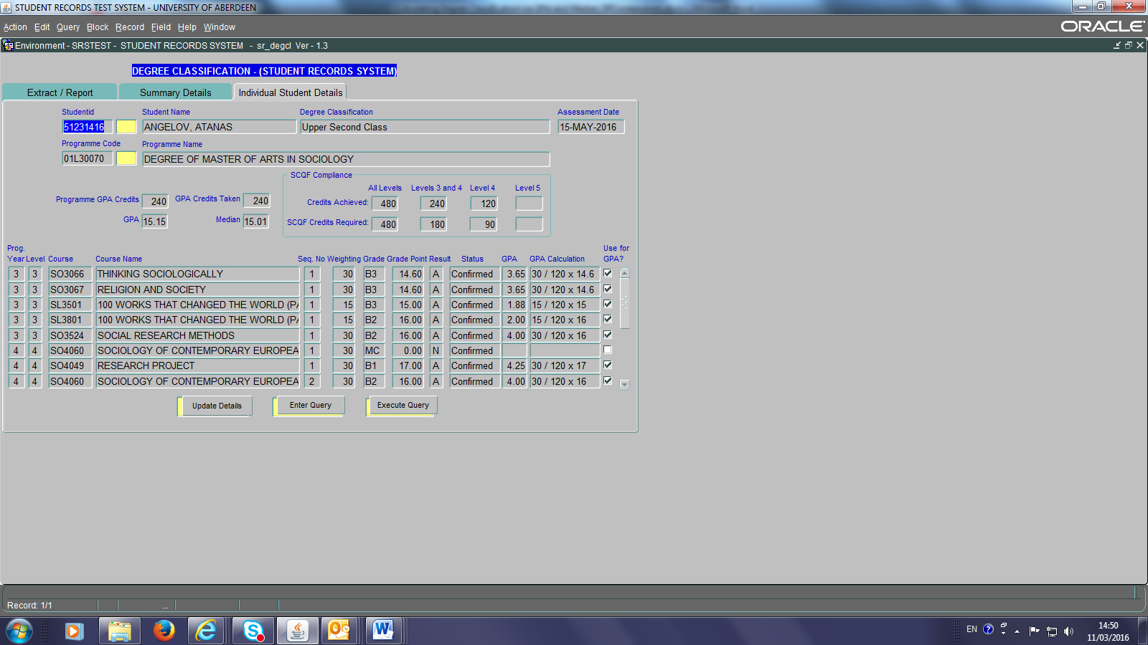
This screen reflects the information contained in the Individual Student Details. It also shows the calculation being performed to determine the GPA per course.

2.2.2 Capped Resit at 9.00/D3: From April 2018, successful resit grades following a fail will be capped at 9.00/D3 and used for degree classifications. For students entering level 4 or level 5 in AY 2017/18, resit grades from level 3 and level 4 will be capped at 9.00/D3 retrospectively.

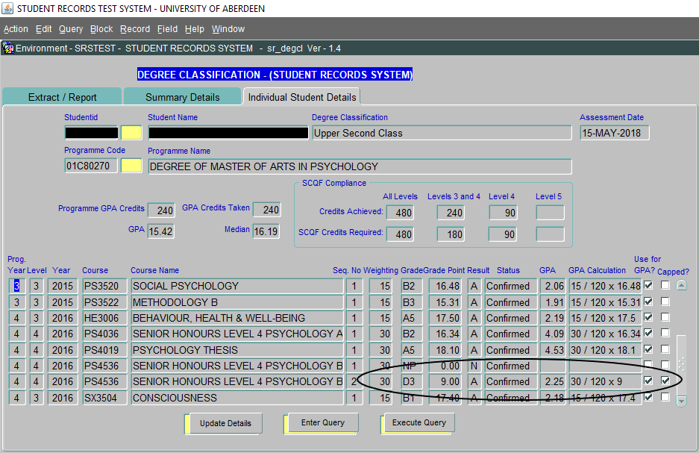

NB1 The student’s original resit result will be recorded in the Student Record System and will appear on the student’s transcript. The capping of a resit result is done by the system for degree classification calculations only.
NB2 A capped result will be highlighted in the ‘Individual Student Details’ screen by a tick in the ‘Capped?’ box.
NB3 A successful resit result of 8.50 to 8.99 (D3) will not be capped at 9.00.
NB4 For those students who have not resat a course that has not been achieved, the system will not select the failed course result for calculation of degree classification. If the failed grade should be included, the ‘Use for GPA?’ should be ticked and ‘Update Details’.
- Confirming the Degree Classification

3.1 This is undertaken using the Summary Details tab. For each student the GPA, Median and derived degree classification, based on the GPA only, will already be entered.

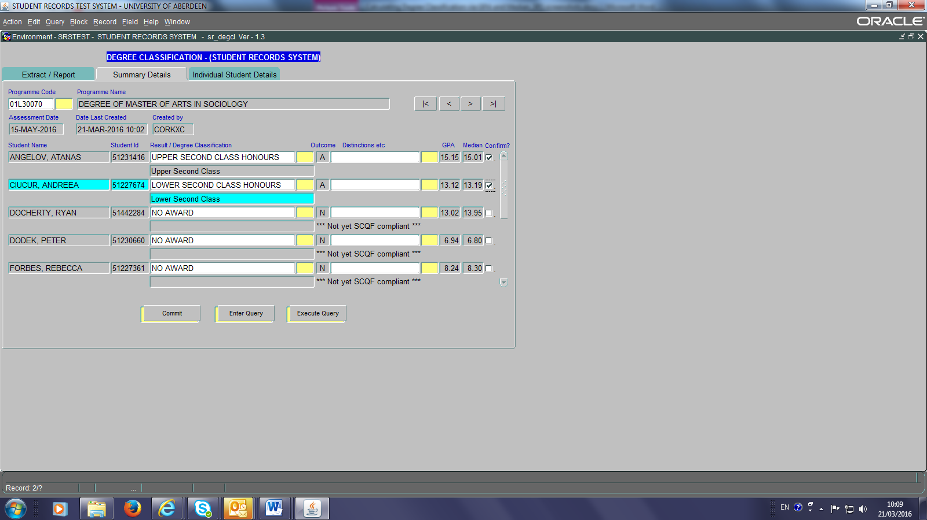

  - Changing the degree classification

    - Median Grade: If the Median Grade (either that calculated by the SRS, or the School-determined median for those Schools with 50:50 (33:33:34) weightings), is in a higher degree classification band than the GPA grade, and thus provides a higher degree classification, the student will receive the higher award and this screen must be changed manually.

    - Borderline cases will be clearly identified on the reports for discussion at examiners’ meetings. The GPA (and Median) values considered as borderline are detailed in Appendix 1. In borderline cases the SRS will always display the lower of the two options; e.g. if the student is awarded a lower second (2:2) but is borderline for an upper second (2:1), it is the 2:2 degree that is awarded in the summary tab.

    - Grade Spectrum: For 2014-2015 until 2017-2018 it has been agreed that students should be classified using both the GPA method and the ‘old’ Grade Spectrum approach, with the student receiving the higher of the award outcomes should differences occur. The grade spectrum classifications cannot be derived electronically by the SRS; Schools must do this manually as in previous years.

    - Academic Discretion: Academic Judgement and discretion should be used in deciding the final degree class at Examiners’ Meetings

In all cases where the degree classification award is amended, the rationale for the final degree class given must be clearly recorded in the minutes of examiners’ meetings.

If for any of the reasons identified above, a higher award is to be awarded this will need to be changed via clicking the Yellow Box (1st column) and choosing the Upper second class honours option before clicking the Confirm? tick box.

The 2nd column of yellow boxes can be used to enter distinctions / commendations etc as appropriate (e.g. Language degrees)
/overleaf
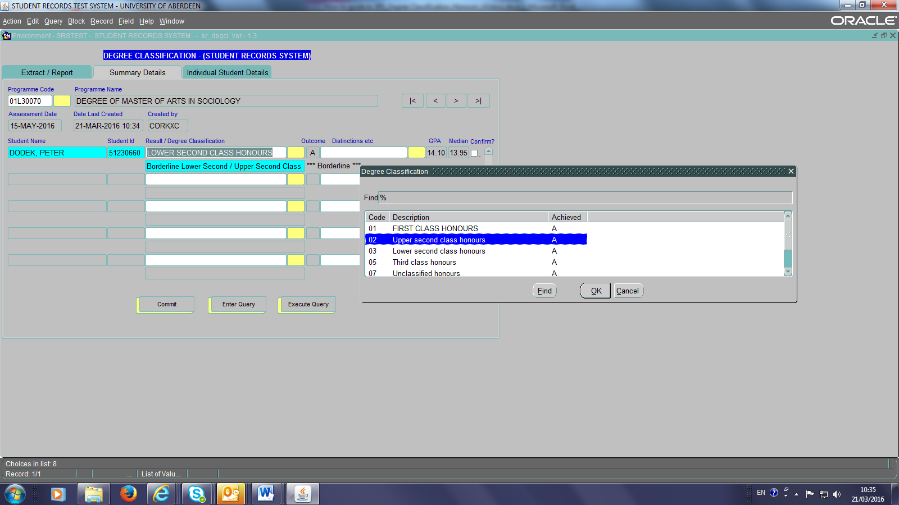

Confirming Awards:
Once the correct degree classification is displayed:
- Click the Confirm? tick box against each student and
- Click the Commit button.

This will (i) update the assessment data in the SRS to ‘provisional’ and (ii) automatically produce a confirmation ‘Examination Results’ report, which is to be signed by the Head of School and another member of the external examiners meeting before being faxed/taken to Registry:
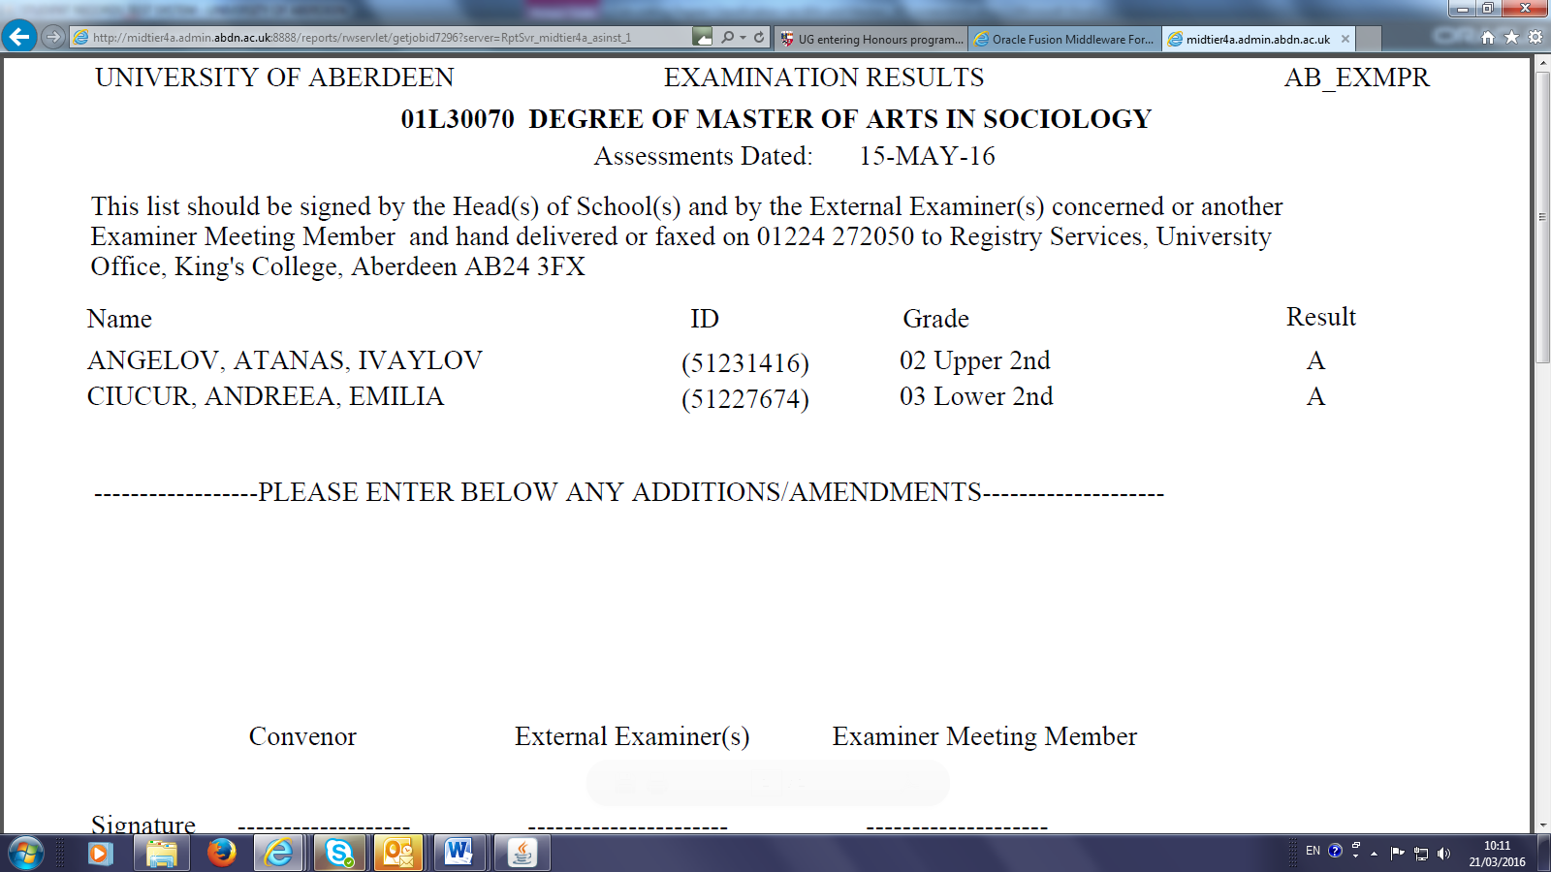

NB1: It may be the case that some students’ marks are not yet entered into the SRS. In such a case you can choose to confirm the degree classification in ‘batches’ by just committing the data for those students whose records are complete. An Examination Results sheet for each ‘batch’ would then be produced, but a complete list of results can then be printed using Reports, Departmental Reports, Print Copy of Programme Results.

NB2: Any students missing from the list should be written on the bottom of the ‘Examination Results’ report, together with details of their classification (Grade) and A for Achieved or N for Not Achieved (Result).

NB3: Any students not achieving the Honours award should have an N against their entry.

NB4: Provisional marks are not available to students and will not be visible in the Student Portal. Results will become visible to students via Student Portals the day after results have been returned to, and confirmed by, Registry following the final examiners meeting. Confirmation occurs after any changes on the signed Examination Results list have been made.

NB6: The GPA and Median (the SRS-calculated median) will both be displayed on the SRS via the General Enquiry screen (within the Study Aim History screen) and the GPA will also appear on the Student Record Card.

- Including / Excluding courses from the GPA/Median/Classification

4.1 It may be the case that courses which are not intended for inclusion within the GPA/Median calculations have been included by the SRS, e.g. ‘extra-credit’ courses taken by students from 2016/17, or zero-rated courses that do not have GPA weightings or UNS courses (unspecified credit). Assume, for example, the ‘Social Research Methods, SO3524’ course listed on the individual student screen below should not have been included:

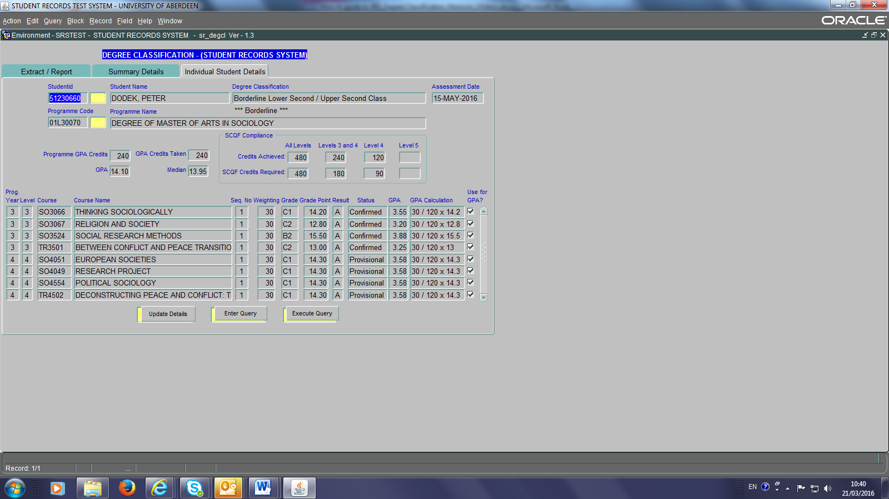
By (a) clicking the Use for GPA? tick box and then (b) clicking the Update Details button you can ‘un-tick’ the course and it will be excluded from the GPA and Median calculations:

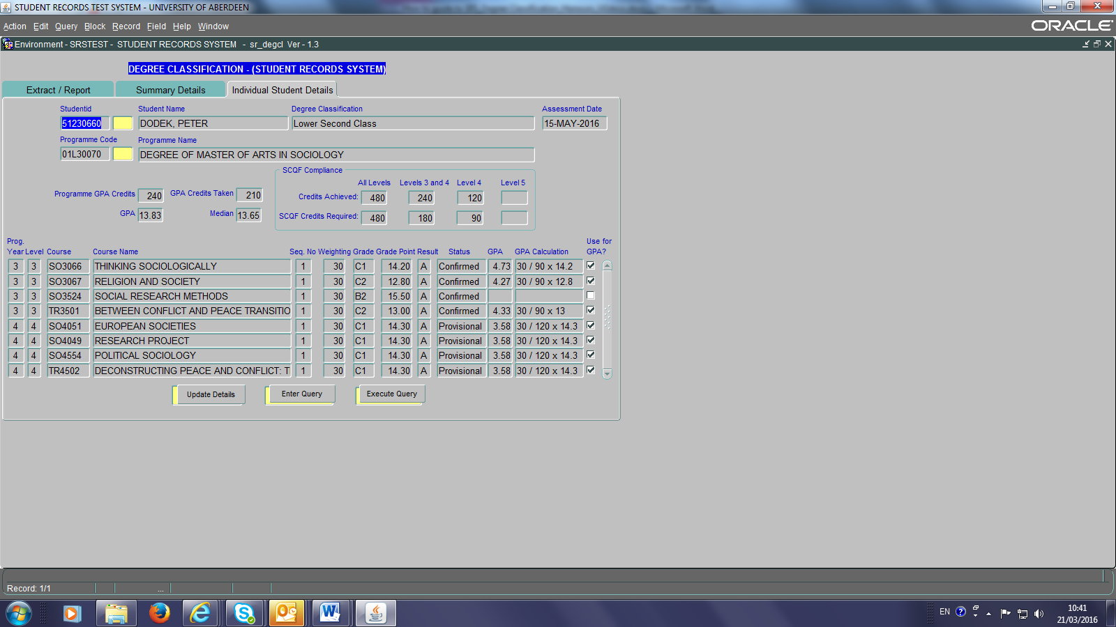

Removing this course from the calculations will amend the GPA, Median and, if appropriate, the degree classification. Similarly, any course that is, for whatever reason, not automatically ‘ticked’ in the SRS can be included in calculations by clicking the Use for GPA? to ‘tick’ the box, and then the Update Details button.
NB 1: When a course is ticked/unticked this is held in the SRS memory for future classification extracts.
NB 2: When a course is ticked or unticked for inclusion then it will be necessary to re-run the reports to receive the updated output.
NB 3: Ticking / unticking boxes have to be done for each individual student in the same situation.
- Joint Degrees

If both halves of the Joint degree apply the same programme year or course level weightings, then run the degree programme extract and confirm the classification results as usual, as per sections 1 and 3. If however, different programme year or course level weightings apply to each half of the degree, Schools must follow the procedures detailed below:

  - In the case of Joint honours degrees with different weightings, each discipline can use the SRS degree classification system to determine the degree classification for their half of the award. For example, the Degree of MA Economics-Mathematics detailed below. The Business School should firstly run the degree classification extract as usual, with the programme year or course level weightings as appropriate to their half of the degree:

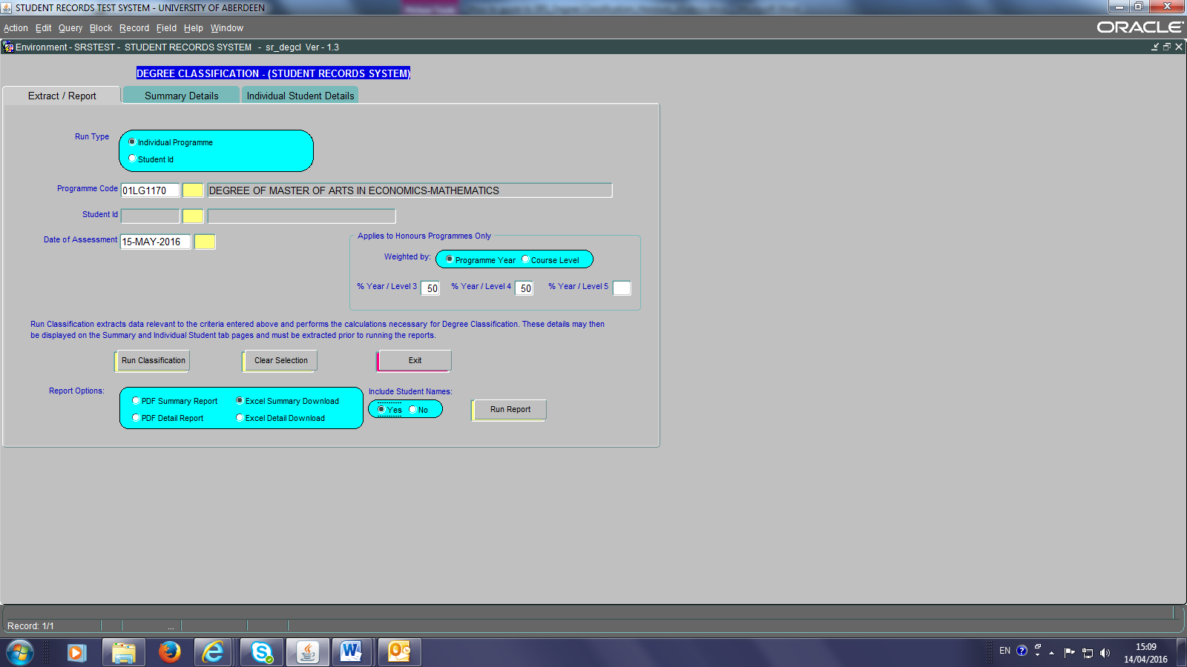

5.2 The Business School should bring up each students’ individual details on screen (click on Summary Screen tab, highlight student in question, click on Individual Student Details tab):

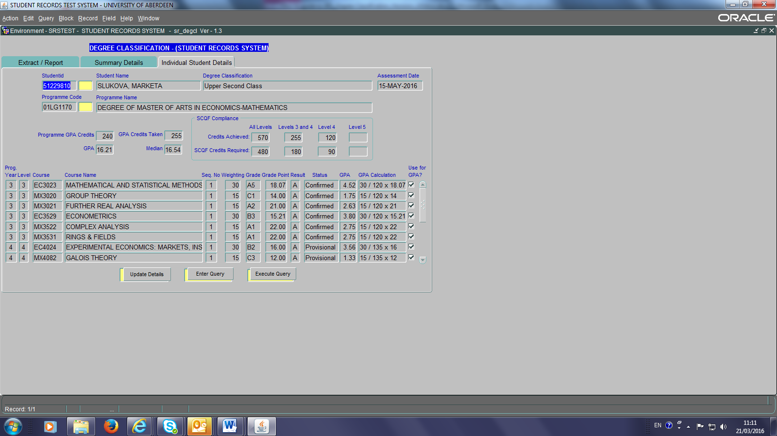

5.3 For each student the Business School should then untick the ‘Use for GPA?’ tick boxes for each of the MX Mathematics courses, and then click the Update Details button:
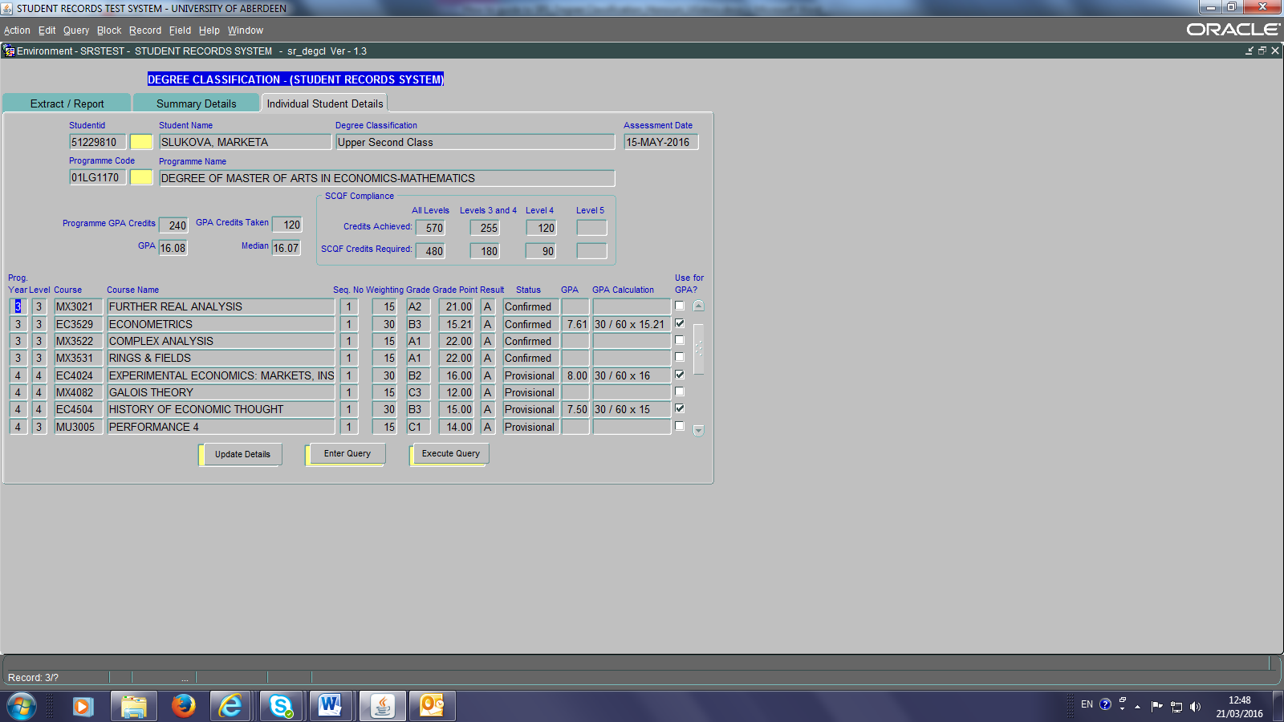

The updated GPA, Median and Degree Classification boxes will now show only those results pertinent to the Economics half of the overall joint degree.

  - The Business School would then re-run the report(s) to receive a print out of the updated degree classification.

  - Similarly, the School of Natural & Computing Sciences will run the degree classification according to the Mathematics programme year or course level weightings and untick the Economics courses instead of the Maths ones in order to generate the results pertinent to the Mathematics half of the overall joint degree.

  - The Schools of Business and Natural & Computing Sciences should then agree overall GPA, Median and Degree Classification to be awarded. This is simply by mathematical calculation – i.e. 50% of the Business School figure + 50% of the Mathematics figure for GPA and Median respectively. If the result is a borderline situation the Schools’ examination board(s) will make the final decision. Please ensure minutes of examiners’ meetings accurately record such discussions and the overall GPA, Median and degree class of Joint Awards.

  - The ‘parent’ School is then responsible for entering these details into the Student Record via Maintenance Screens, Departmental, Process Exam results for Programmes (see Appendix 5). Do NOT use the Degree Classification screens to try to enter this data.

In the event that a joint honours student has taken extra credit courses from a School or discipline that differs to either half of the degree, the extra credit course should be included in the degree calculations of the first named discipline of the degree programme title; in this instance Economics.
- 5-year MA/BSc Programmes (NOT 5-year integrated Masters)

Students on programmes such as the LLB Law and European Studies or MA Hispanic Studies can take a year of their studies abroad. For such programmes, Schools must remember to enter the weightings on the basis of year 4 and year 5 if weighting the programme by programme year:

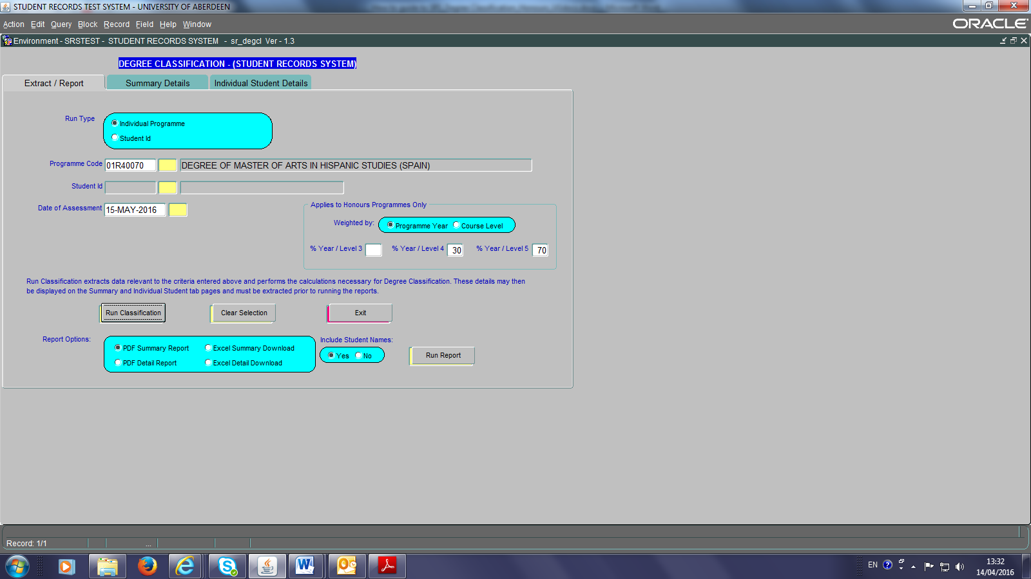
The SRS should be aware of all ‘residence abroad’ courses and know that they do not count towards GPA/Median classification:

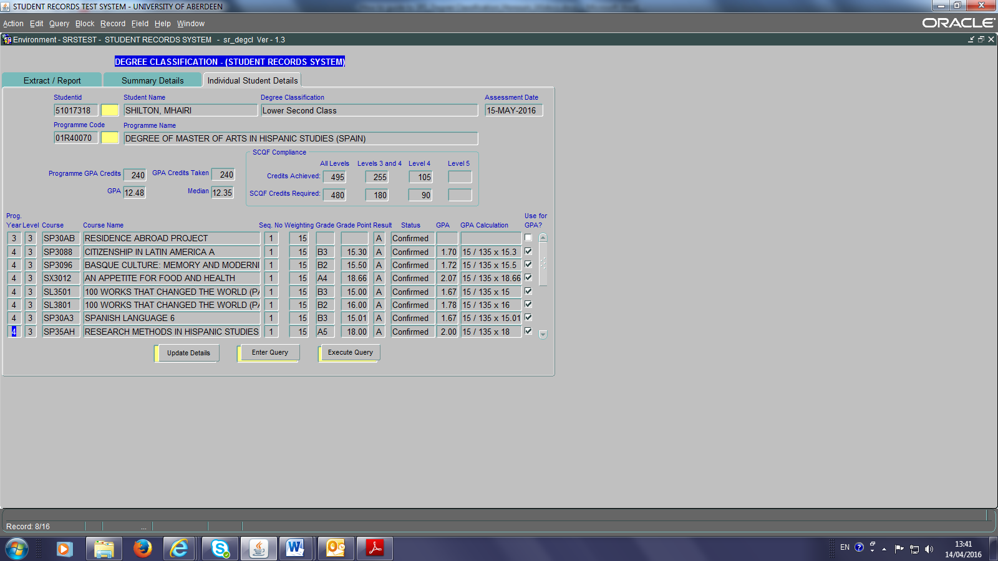

If however, a course has been included in the GPA/Median classification when it shouldn’t have been, the School can ‘untick’ the ‘Use for GPA’ box and click update (as per instructions in section 4).

- Study Abroad / Erasmus

7.1 As noted in the Code of Practice on Assessment, students who undertake to go abroad to study as part of Study Abroad or Erasmus programmes should not have the marks they earn whilst abroad counted towards classification; although the credits attained will count towards credit accumulation for SCQF purposes.

As such, for students in this category, their degrees will be classified on the basis of the credits they undertake at Aberdeen only.

Study Abroad courses are normally denoted by the prefix ZZ3 or ZZ4. Erasmus courses tend to be identified as ‘ERASMUS’.

7.2 Full year of study abroad

If a full year of study abroad was undertaken, with no other Aberdeen-based credits/courses taken during the year out, the degree classification will be determined on the basis of all honours credits taken in the honours year spent in Aberdeen. This means that any programme weightings entered by the School will be superseded by this rule. Hence, Schools should not need to deal with such students separately.

For example: As you can see in the screenshot below, and from the GPA course calculations in particular, the degree classification is based on the 120 credits taken at level 4 only.

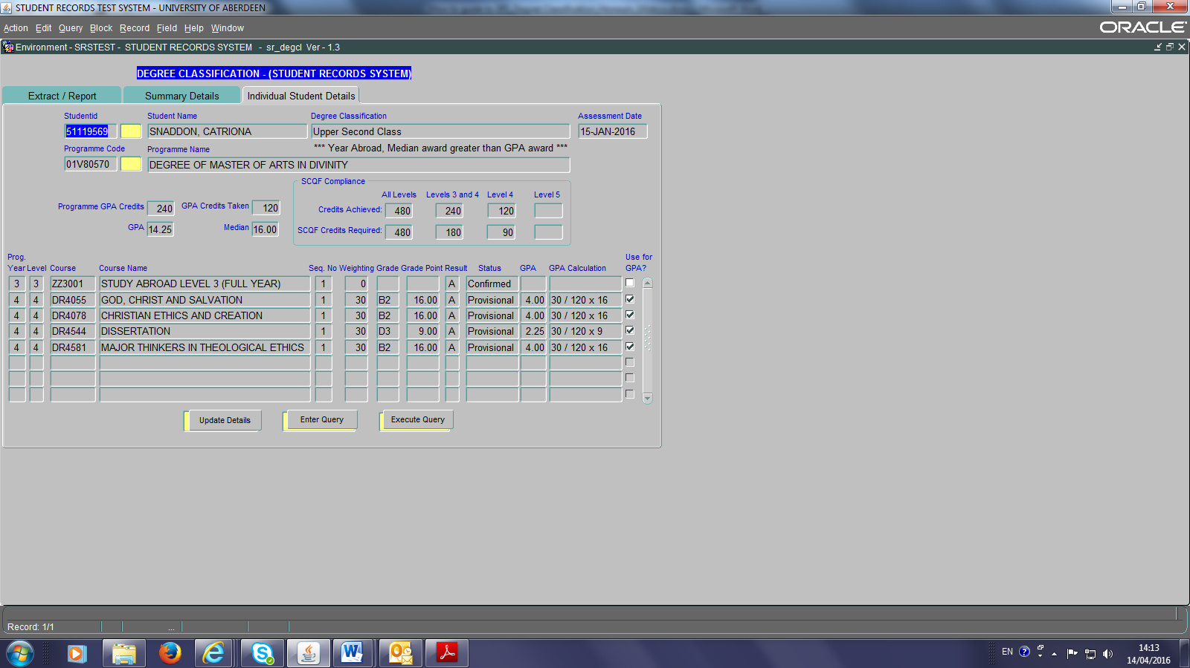

7.3 Part year of study abroad

If a part year of study abroad took place, OR additional honours courses were taken in the same period as a full year of study abroad, then the SRS will ignore the study abroad courses but all remaining courses will be subject to the programme weightings that the school originally chose. If the School is not happy with this outcome, then they must re-calculate the GPA/median manually or by ticking/unticking the ‘Use for GPA’ box as appropriate and enter the amended GPA, Median and Degree Classification manually (see Appendix 5).

For example: As you can see from the GPA calculations shown below the degree classification is based on the 90 credits taken in programme year 3 and the 120 credits at programme year 4.

P.T.O
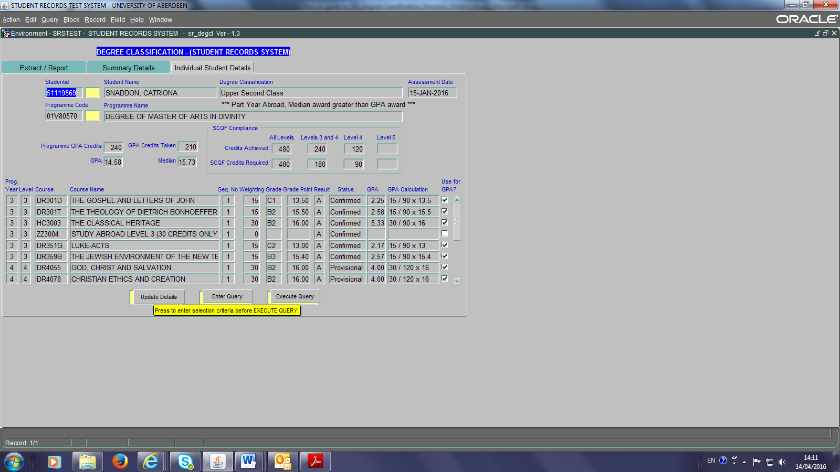

- Discounted Periods of Study

If a student has a discounted period of study, the SRS will recognise a discounted session(s) and whilst the degree classification system WILL display the discounted courses, these courses will NOT be included in the GPA/Median and degree classification.

For example: The following Politics and International Relations student had their 2013/14 year discounted. Assuming a classification weighting by programme year 50/50, you can see from the screenshot that:

- courses taken/passed/failed during the ‘discounted’ period are completely ignored,
- only the level 3 and 4 courses and grades taken outwith the ‘discounted’ period are included in GPA/Median and Degree Classification calculations, in accordance with programme year or course level weightings.

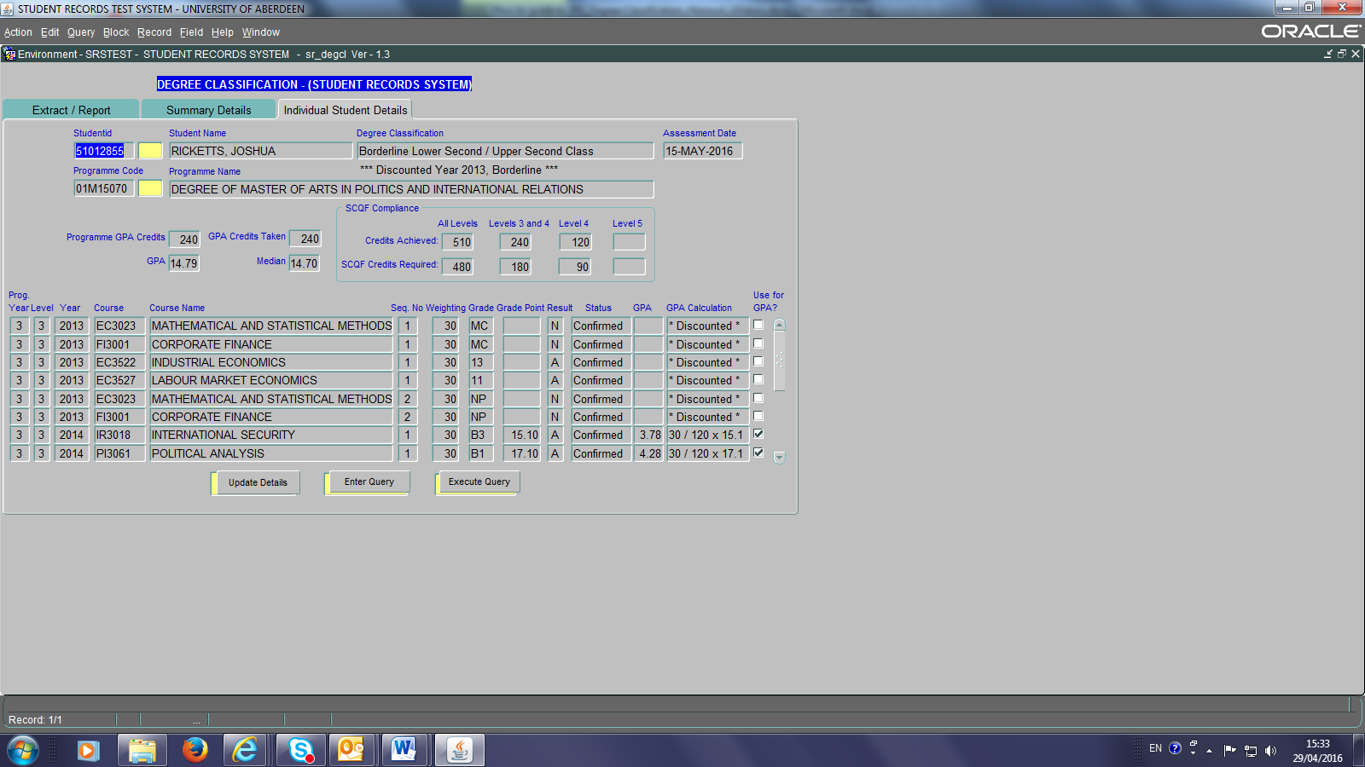

Note also, that a message highlighting the discounted period is given.

- Direct Entrants to programme year 4
If a student has entered directly into programme year 4 of study, the SRS will be aware of recognised credits from other institutions and display these as seen in the screenshot below:

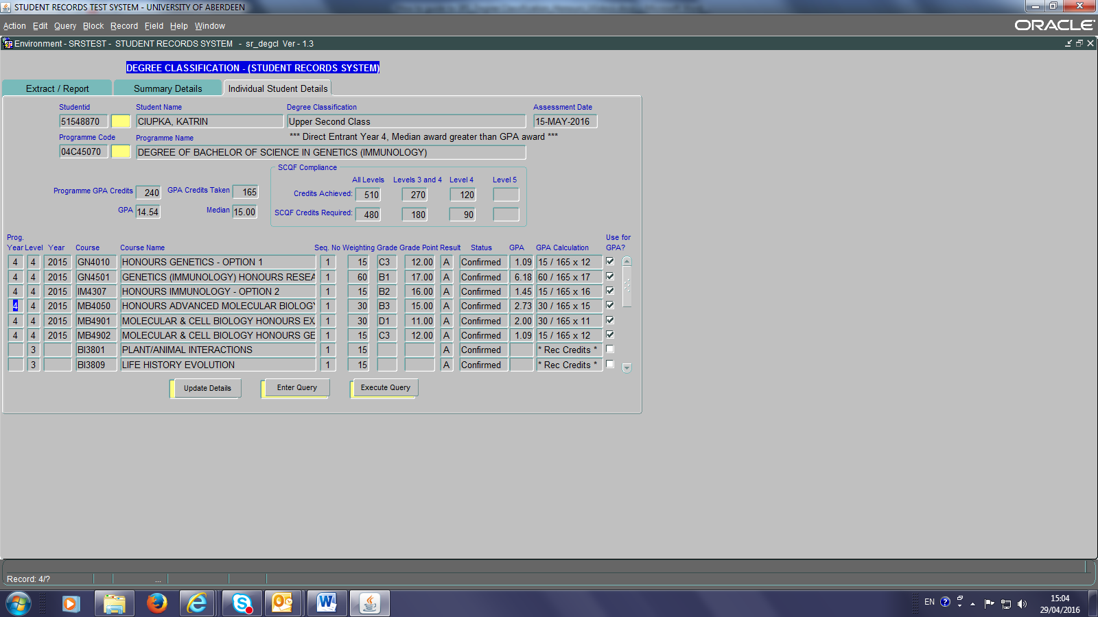

The degree classification process will overrule any programme or course level weightings entered for the cohort and calculate the GPA/Median and Degree Classification on the basis of all level 3 or level 4 courses taken during the student’s programme year 4.

NB1: Recognised credits are not included in the GPA calculation and are identified instead as ‘Rec Credits’; the ‘use for GPA’ box remains unticked.

NB2: The recognised credits are included in the overall credits achieved
NB3: A message highlighting that the student is a direct entrant is provided.

10. Degree Classification Archive
Select Maintenance Screens, Reports, Degree Classification Archive:
The Degree Classification Archive Screen keeps a record of all details pertaining to students in relation to their degree classification once their degree classification has been committed (section 3)

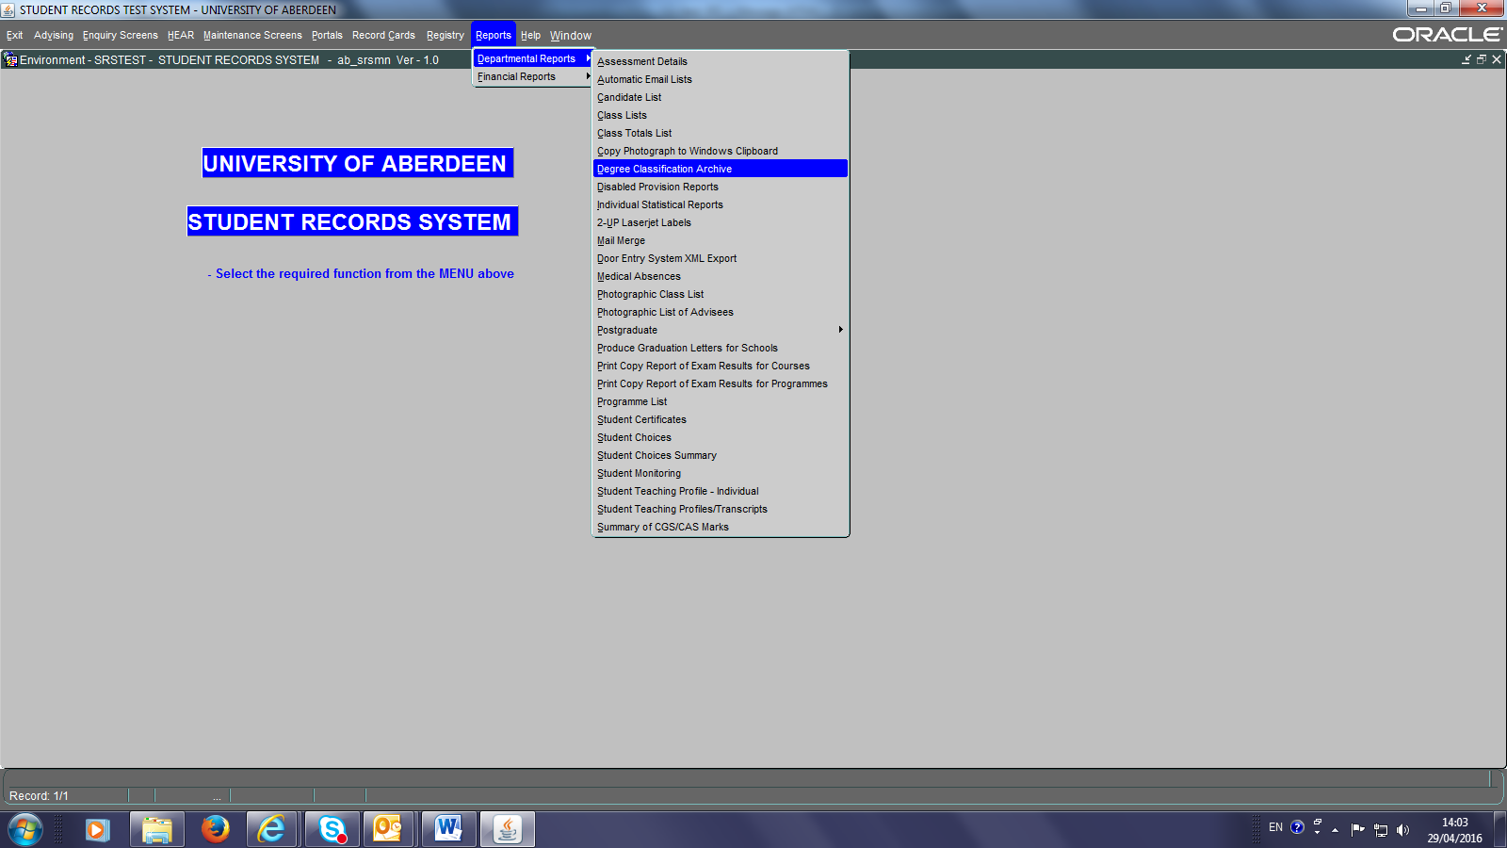

- To see the details for a cohort enter the degree programme code and click Execute Query.
- To see the details for an individual student, follow (a) and highlight the student you are querying and then click the Individual Student Details Tab.

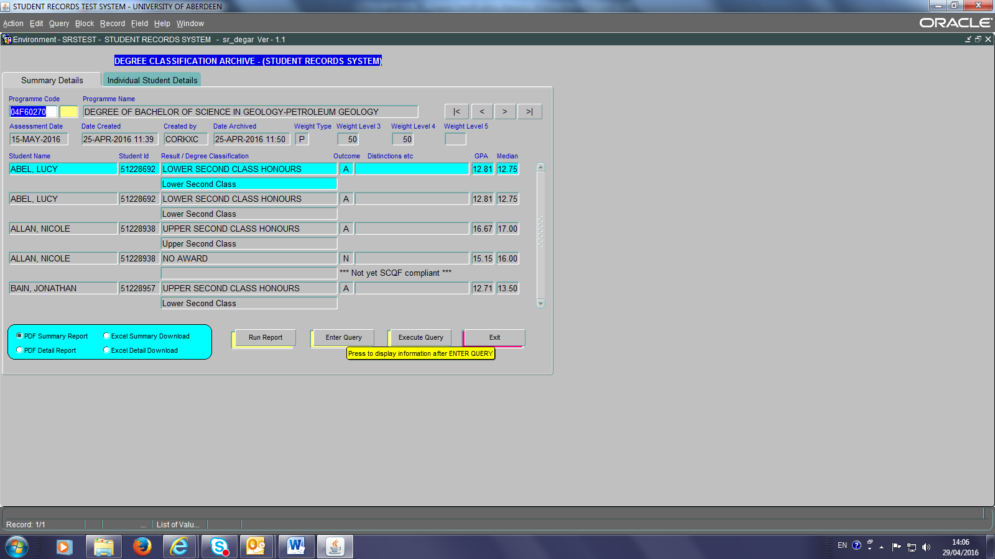
All information provided in the degree classification archive can be downloaded as PDF or Excel programme summary or individual student detailed reports (Appendix 3).

11. Appendices
Appendix 1 – Award of Undergraduate Honours degrees:
Grade Point Average | Degree Classification
18.0-22.0 | First Class
greater than 17.0, less than 18.0 | Borderline First / Upper Second Class
15.0 – 17.0 | Upper Second Class
greater than 14.0, less than 15.0 | Borderline Upper Second / Lower Second Class
12.0 – 14.0 | Lower Second Class
greater than 11.0, less than 12.0 | Borderline Lower Second / Third Class
9.0 - 11.0 | Third Class
greater than 8.0, less than 9.0 | Borderline Third Class / Fail
0 – 8.0 | Fail

Appendix 2 – SCQF: Credit Requirements for Compliance
 | Total | Levels 3+4 | Level 4 | Level 5
UG Hons | 480 | 180 | 90
Enhanced UG Master’s | 600 | 180 | 90 | 120
Intercalated degree Medicine | 480 | 180 | 90
PG Master’s degree | 180 |  |  | 150
PG Diploma | 120 |  |  | 90
PG Certificate | 60 |  |  | 40

Appendix 3 – Reports
- Summary PDF Report
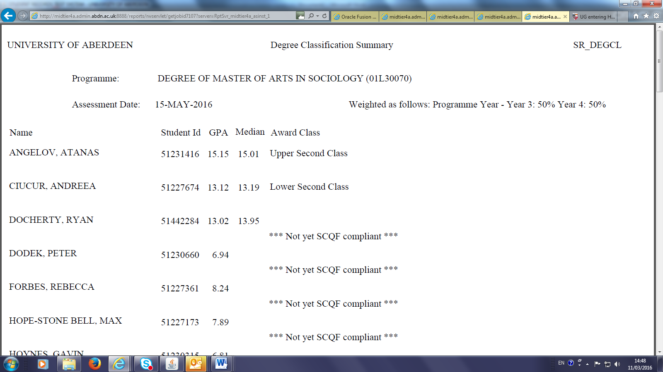

- Detailed PDF Report
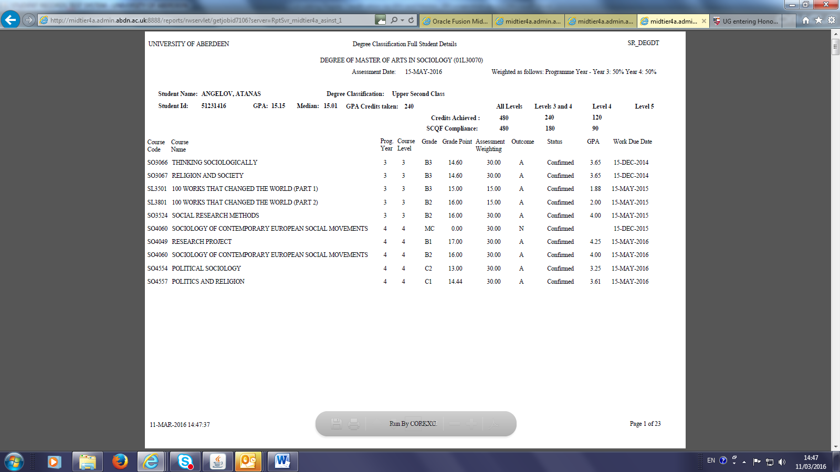

- Summary Excel download
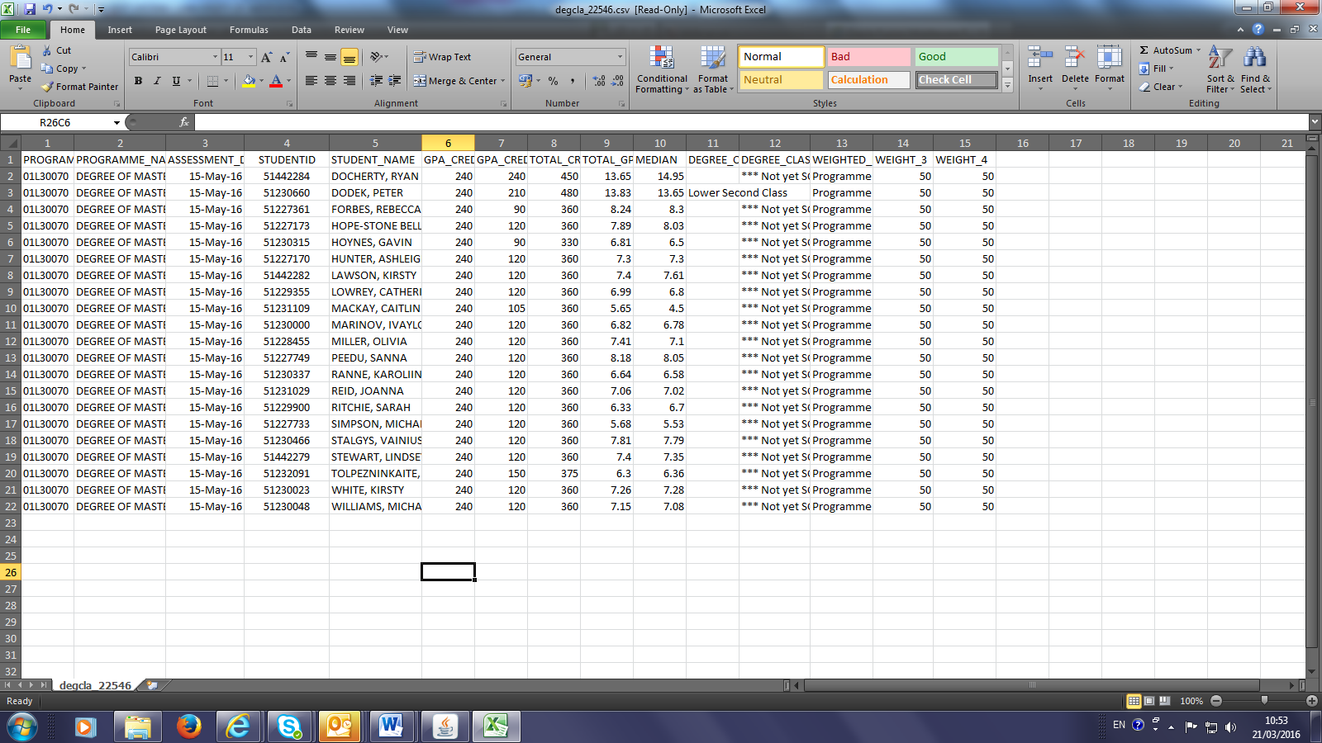
- Detail Excel download
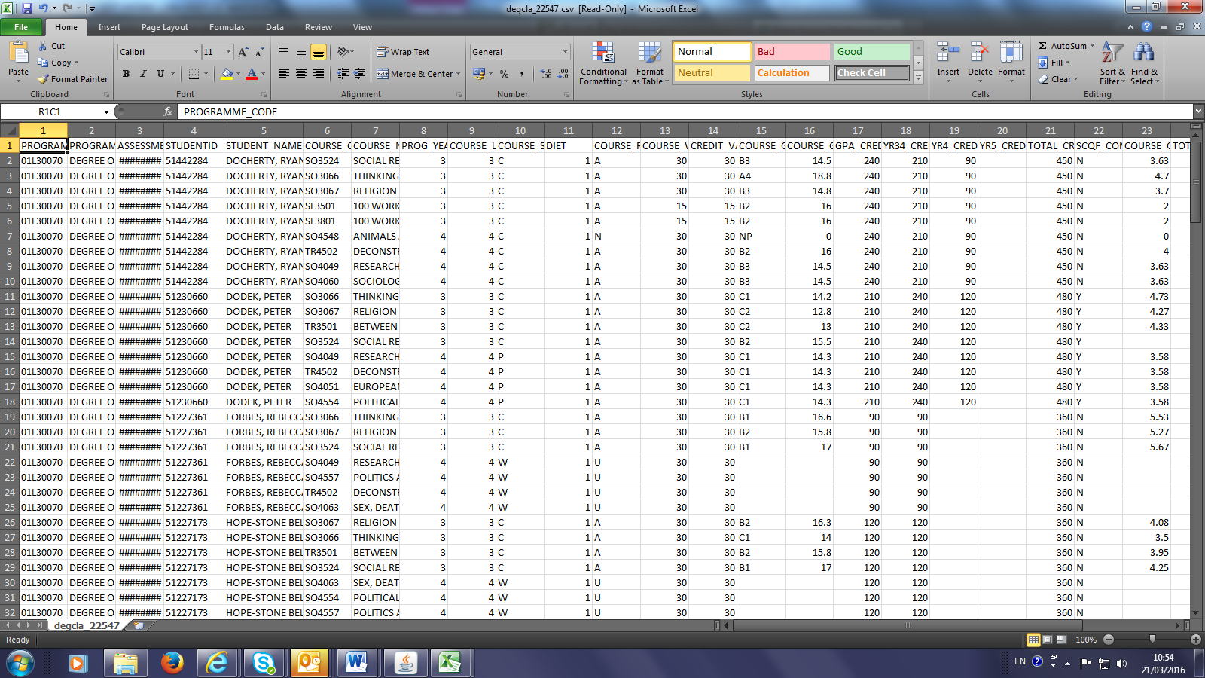

Appendix 4: Calculating Degree Classification via GPA and Median
From March 2017: Given the differential weighting used in UG degree classification with respect to programme year or course level in many Schools, the SRS’s Degree Classification tool calculates a weighted year average figure to use as a median. If Schools wish to calculate a straight median using all courses counting towards the degree classification they may choose to do so, however, this must be clearly minuted in the minutes of examiners’ meetings

NB: All Schools must continue to compare GPA against the median figure and, where this produces a degree classification higher than the SRS tool predicts, the SRS must be manually updated to reflect this (see section 3.2 of guidance notes).

- Identify all level 3 and 4 courses taken in honours years
- Establish the weightings for the award i.e. is degree classification based on differential weightings between (a) programme years, or (b) course level? And what is the weighting? E.g., 50:50, 30:70 etc
- Depending on step 2 above, Sum the total credit value for programme years 3 and 4 separately for course levels 3 and 4 separately
- Calculate the Grade Point Average (GPA) for each course [CGS * Course Credit Value/Total Credit value for that Year/level) depending on step 2 above
- Sum values to arrive at total GPA value for each programme year or course level
- Apply weightings from step 2 to step 5 and sum to derive overall GPA
- Calculate the Median – the middle CGS grade when all grades are arranged in order of value, weighted by credit value (i.e. a 30 credit course counts twice as much as a 15 credit course) and apply weightings from step 2 to step 5 and sum to derive overall Median
Example:
Step (1) Identify Courses: as detailed in table below (Note: two level 3 courses taken in prog year 4)
Step (2) Example based on a 30:70 weighting of level 3 to level 4 courses (not programme year)
 | Level 3 | Course | Grade | Grade Pt | Credits | Step (4)  Course GPA
 | 14/15 | CS3017 | D3 | 9 | 15 | 0.90 | i.e. 9*15/150
 | 14/15 | CS3024 | B3 | 15 | 30 | 3.00
 | 14/15 | CS3025 | B3 | 15 | 15 | 1.50
 | 14/15 | CS3026 | C2 | 13 | 15 | 1.30
 | 14/15 | CS3518 | A5 | 18 | 15 | 1.80
 | 14/15 | CS3524 | C1 | 14 | 15 | 1.40
 | 14/15 | CS3525 | B1 | 17 | 15 | 1.70
 | 15/16 | SX3009 | C1 | 14 | 15 | 1.40
 | 15/16 | SX3504 | B1 | 17 | 15 | 1.70
Step (3) |  | Total level 3 credits |  |  | 150
Step (5) |  | Level 3 GPA |  |  |  | 14.70
 | Level 4 | Course | Grade | Grade Pt | Credits | Course GPA
 | 15/16 | CS4025 | C1 | 14 | 15 | 2.33 | i.e. 14*15/90
 | 15/16 | CS4028 | D3 | 9 | 15 | 1.50
 | 15/16 | CS4040 | B3 | 15 | 15 | 2.50
 | 15/16 | CS4046 | B3 | 15 | 15 | 2.50
 | 15/16 | CS8888 | B2 | 16 | 30 | 5.33
Step (3) |  | Total level 4 credits |  |  | 90
Step (5) |  | Level 4 GPA |  |  |  | 14.16
/ continued overleaf
 | Assuming a 30/70 split between level 3 and 4
Step (6) | Level 3 GPA |  | 14.7 | *30% | 4.41
 | Level 4 GPA |  | 14.16 | *70% | 9.91
 | Final GPA |  |  |  | 14.32 | = borderline 2:2 / 2:1 classification
Step (7) | Also look at median (also weighted by credit)
 | Level 3 | 9, 13, 14, 14, 15, 15, 15, 17, 17,18 |  |  | median = 15 | *30% | 4.5
 | level 4 | 9, 14, 15,15, 16, 16 |  |  | median = 15 | *70% | 10.5
 |  |  |  |  |  |  | 15 | upper second
 | As Median > GPA, Median stands so classification is 2:1

Appendix 5: Processing Exam results for Programmes not classified by SRS GPA system
‘How To’ Guide to SRS
Process Exam Results for Programmes
Undergraduate programmes

These screens should only be used for:
(1) Non-Honours programmes,
(2) Joint Honours programmes,
(3) Students entering their Honours programme before September 2014; i.e. for students whose award can only be classified via the Grade Spectrum as their record contains CAS marks at level 3 and/or 4, and
(4) Schools with non-standard programmes whose degree classifications cannot be calculated automatically via the SRS.

Summary

This screen relates to the overall result of a programme of study and not to the individual course modules that make up the programme. This screen should only be used if the School cannot make use of the Degree Classification screens that automatically calculate GPA, Median and Degree Award.

Schools should enter their own Degree Programme results into the system. Ensure your entries are correct before committing the results. Mark any errors against the printed report; have it signed by the Head of School and another member of the examiners’ meeting. Then fax/take to the Student Records Team in Registry.

NB: it is strongly recommended that you commit every 20 or so entries to guarantee no loss of data. A complete list of results can be printed using Reports, Departmental Reports, Print Copy of Programme Results.
[For an explanation as to how Schools can download an excel spreadsheet of all the course marks per student per programme for GPA/Median calculation purposes, re-visit section 2 of this document: Extracting and Deriving the data required for Degree Classification.]

Processing Exam results for Programmes

Select Maintenance Screens, Departmental, Process Exam results for Programmes:
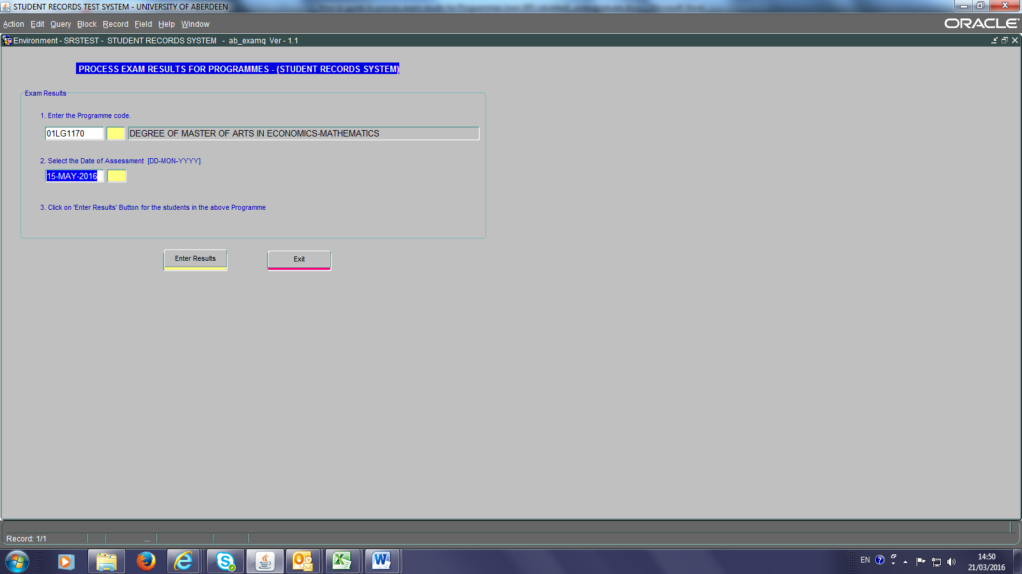

- Click on the text box beneath number 1. Enter a programme code or % and part of the code followed by %, and Click in the Yellow Box to receive a list of programmes to choose from. Click on the programme required and click on the OK button.
- Click the Yellow Box under Select the Date of Assessment and select the date of assessment e.g. 15-May-2016
- Click on the Enter Results button.

A list of students in alphabetical order and their Student ID numbers will be displayed:
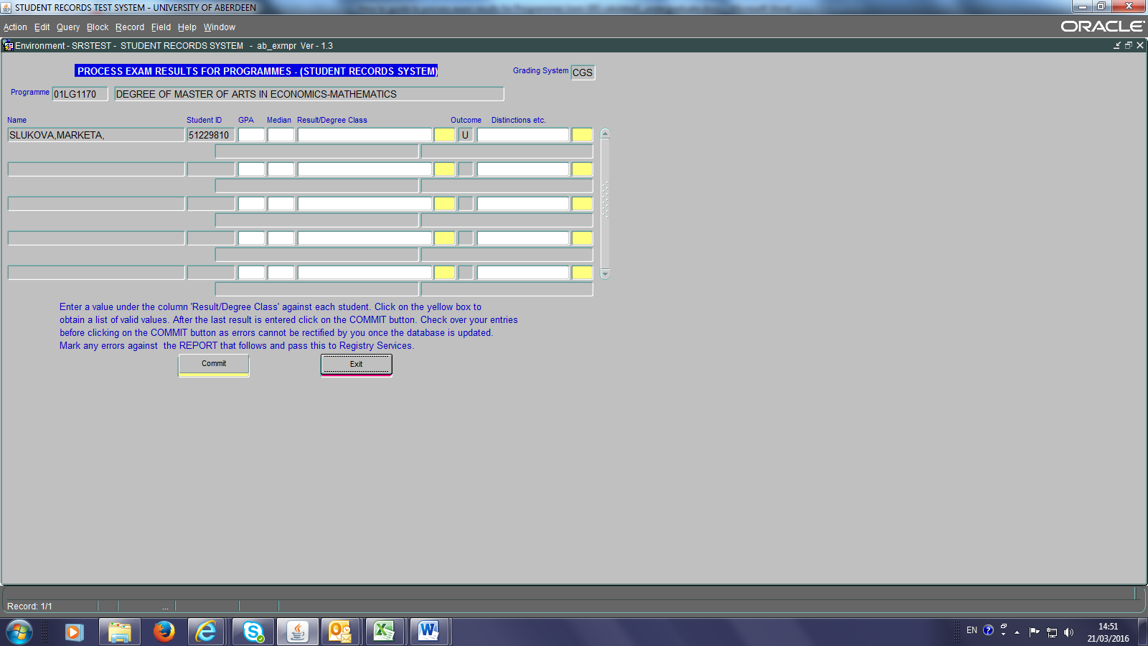

The Grading System at the top right of the screen indicates whether it is CAS or CGS. If it is CAS then the GPA and Median fields will be greyed out as these are not required for Grade Spectrum-only graded programmes. If the Grading System is CGS then the GPA and Median must be entered for those students who have been graded wholly using the CGS.

If there is a mix of students graded by both CGS and CAS systems then the grading system will show as CGS. In this case, the GPA and Median need be input only for those students graded using the CGS.

- Under the GPA and Median enter their results. In the SRS background the system will check to ensure SCQF compliance has been met, and each student’s Result/Degree Class will be automatically populated.

- The Yellow Box drop downs can be used to overwrite the automatic population of Result/Degree Class field if required, e.g. in the case of a Borderline result being returned.

- Click on the Commit button to save provisional marks to the database. The status bar will display ‘Transaction Complete: n records applied and saved’.

- When you click Commit acrobat reader opens with a report. Print out this Examinations Results list for the examiners meeting, mark on any errors or changes agreed at the meeting. The Head of School and another member of the examiners meeting should sign the print out before faxing/taking it to Registry.

- Click on the Exit button to return to the main menu.

NB1: If you have committed several times you will have to print out a complete list of results using Reports, Departmental Reports, Print Copy of Programme Results. Any students missing from the list should be written on the bottom of the printed list. Any students not achieving the Honours degree award should have an N against their entry.

NB2: Provisional marks are not available to students and will not be visible in the Student Portal. Results will become visible to students via Student Portals the day after results have been confirmed by Registry. Confirmation occurs after any changes on the signed Examination Results list have been made.

This step is NOT required for Intercalated BSc programmes - Intercalated BSc programmes go straight to step (c)
Senate agreed the principal that students will be classified according to the Honours classification system in place when the student embarked upon the honours part of their degree programme.
The parent School is the first named in the degree programme title. I.e. the parent School for the Degree Master of Arts in Economics and Mathematics will be the Business School as Economics is first named.
From March 2017: Given the differential weighting used in UG degree classification with respect to programme year or course level in many Schools, the SRS’s Degree Classification tool calculates a weighted year average figure to use as a median. If Schools wish to calculate a straight median using all courses counting towards the degree classification they may choose to do so, however, this must be clearly minuted in the minutes of examiners’ meetings. NB: All Schools must continue to compare GPA against the median figure and, where this produces a degree classification higher than the SRS tool predicts, the SRS must be manually updated to reflect this (see section 3.2 of guidance notes).

