December newsletter 2022- 2023

what has been happening in November.
The interns received World Host Training which is customer service based.
The interns are coming to the end of their first internship and looking forward to the second in the new year.
In preparation for Christmas, we have decorated the classroom and booked our Christmas lunch at the Brig of Don. The interns are coming to the end of their first internship and looking forward to the second in the new year.
They have been getting prepared for their next internship some have sent their applications and waiting to hear back, and some have had dates for their interviews, they are all very excited to see what their next internship entails, and we will keep you posted on each intern’s journey.
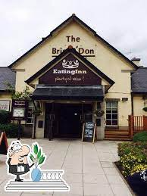
Since its Christmas soon we thought we would ask the interns what their favourite Christmas memory was or what they are looking forward to this year.

The past Christmas Present that I got was, my custom-built PC, from North East Peripherals, this was to allow me to do university work, as well as allow me to play some very high intense games, I love my pc and it has been amazing ever since I got it. Cameron
C
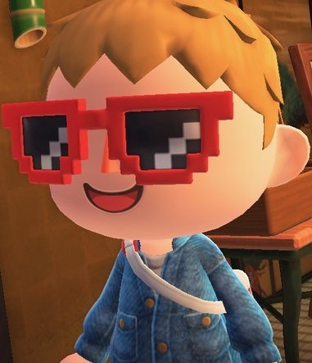

Every Christmas Eve it is a sort of tradition in our house that we watch the film Love Actually. Always goes down well and I also recently completed a 1000-piece Love Actually jigsaw. Its double sided so I can always come back and attempt the other side. Andrew

One of my favourite Christmas presents that was given was from my Grandparents. Before I tell you I just want to give you a heads up that it was a bit of a strange one. It was in fact an Elvis Presley outfit. As for my favourite Christmas film, I would have to say Polar Express, it’s a classic.
Greg

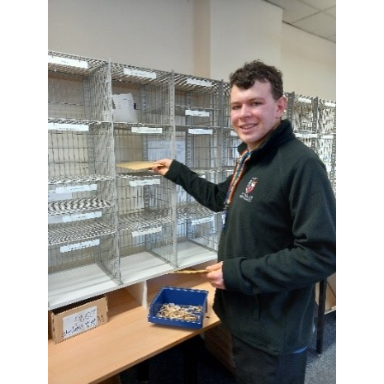
My favourite Christmas film is How the Grinch stole Christmas 2000 My favourite Christmas song is Snow is falling My favourite Christmas present is Hornby LNER A4 Sliver Link My favourite Christmas episode is Thomas’s Christmas party My favourite Christmas special is Bob the builder a Christmas to remember
Niall

My favourite Christmas song is Do They know it’s Christmas by Band Aid.
Ciaran

This year I am looking forward to spending time with extended family because we are all going out for a meal together, also I hope everyone enjoys the gifts I have bought them this year and I am happy that I'm spending time with more people this year.

Sionead

Hi, my name is Natalie, and my favourite Christmas movie is the Grinch, my favourite Christmas present from my childhood was a high school musical Tv

Hi I’m Carlisle

My Favourite Christmas Present of all time was my Nintendo 3DS.

Hello, my name is Jason Cobb.
A Christmas movie I have just recently seen is called Violent Night which I really liked.

One of our Christmas traditions is watching Home Alone 1 & 2 with the family.
Every Christmas I have a Chinese Takeaway.
Ryan

CHRISTMAS QUIZ
- What 3 gifts did the three Wise Men give baby Jesus?
- What was the name of the Angel that appeared to Mary to tell her that she was going to have a baby?
- How many ghosts appear in 'A Christmas Carol'?
- What year was the song 'Last Christmas' released?
- What is the highest grossing Christmas film of all time?
- Where was Jesus born?
- Which ballet is particularly popular during the Christmas season?
- What is the total number of legs in the 12 days of Christmas song?
- What city is most significant to Judaism, Islam, and Christianity?
- What is the name of the Christian season that lasts from the 27th of November until the 24th of December?
- Which Aberdeen tradition happens on boxing day?
A: Nippy Dipper
B: Barrel Rolling
C: Beach Football
D: Burning the Clocks

Christmas quiz answers

- Gold, Frankincense and Murr
- Gabriel
- 4 (Past, present, future and Jacob Marley)
- 1984
- The Grinch (2018)
- Bethlehem
- Nutcracker
- 808
- Jerusalem
- Advent
- A

Chocolate Dipped Candy canes

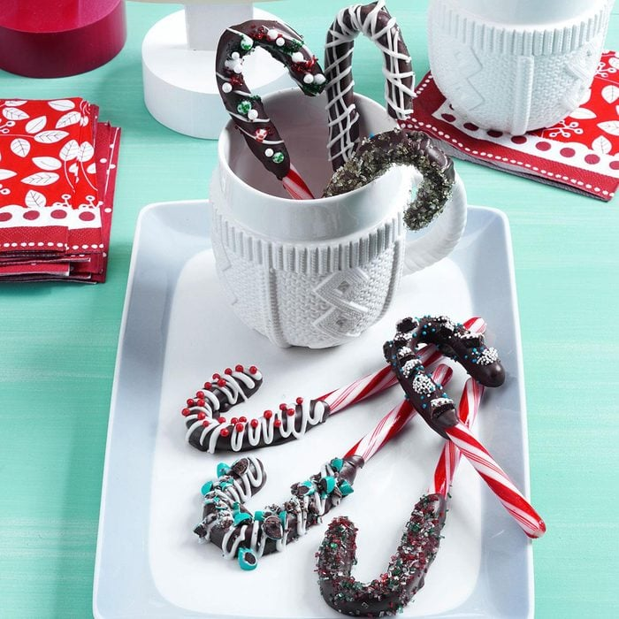

Ingredients
- 1 cup semisweet chocolate chips
- 12 candy canes (6 inches each)
- 3 ounces white baking chocolate, chopped
- Optional toppings: assorted coloured sugars or sprinkles and crushed candies

Directions
- In a microwave, melt chocolate chips; stir until smooth. Dip curved ends of candy canes in chocolate; allow excess to drip off. Place on waxed paper.
- In a microwave, melt white baking chocolate; stir until smooth. Drizzle over chocolate. Decorate with toppings if desired. Let stand until set.
- Use to stir servings of hot cocoa.
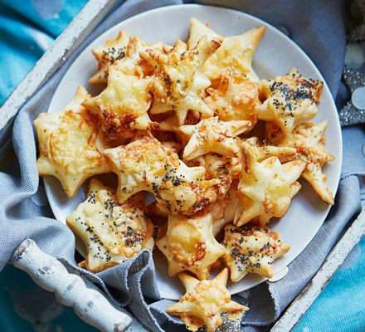
Cheese Stars

ingredients
- 320g puff pastry sheet
- mugful of grated cheese (we mixed 60g cheddar with 25g parmesan)
- flour, for dusting
- 2 tbsp milk
- toppings of your choice (optional) - we used poppy seeds, dried oregano, and sesame seeds

Method
- STEP 1 Unroll the pastry and sprinkle most of the cheese over one half of the sheet. Fold the pastry in half to cover the cheese and seal it in.

- STEP 2 Dust your rolling pin and work surface with a little flour and put your pastry sheet on it. Roll it out until doubled in size.

- STEP 3 Heat oven to 200C/180C fan/gas 6 and line two baking sheets with baking parchment.

- STEP 4 Using cookie cutters, cut the pastry into shapes, and put them on the prepared baking sheets. (Put the cutters on the dough close together so that less pastry is wasted. You can fold the trimmings back on themselves and re-roll to cut out more shapes.)

- STEP 5 Brush the shapes with milk and add a pinch of cheese and a sprinkling of your chosen topping,

- STEP 6 Bake in the oven for 10-12 mins or until risen and golden, then transfer to a serving plate. Will keep in an airtight container for 3 days.

