Undergraduate Medical Sciences
School of Medicine, Medical Sciences & Nutrition
SR3301 – Sports Psychology
Course Handbook 2023-2024
Contents

•
Course Summary
(3)

•
Course Aims & Learning
Outcomes

•
Course Teaching Staff

•
Assessments & Examinations

•
Class Representatives
(4)

•
Problems with Coursework

•
Course Reading List
(5)

•
Lecture Synopsis
(6)

•
Practical/Lab/Tutorial Work
(7)

•
University Policies

•
Academic Language & Skills
support
(8)

•
Medical Sciences Common

Grading Scale
(9)

•
Course Timetable SR3024: 2023-
2024

(10)

•
Campus and Floor Maps

Course Summary
This course aims to develop an understanding of the psychology of sport and exercise. As a relatively new discipline within psychology, current theories, research and practices will be presented as the framework within which this subject area continues to develop.
Course Co-ordinator: Dr Jenny Gregory (j.gregory@abdn.ac.uk); Telephone: 01224 437549 (though contact via email or Microsoft Teams is best) ;

Course Aims & Learning Outcomes
- Students will understand how a sports psychologist interacts with their clients and applies their learning.
- Students will be able to discuss the major theories and practices in Sports Psychology
- Students will be able to identify, understand and summarize relevant literature from the field and incorporate this into structured scientific writing, such as essays or abstracts.
- Students will be able to analyse data and apply their understanding of sport psychology to its interpretation.

Course Teaching Staff

Course Co-ordinator(s):
Dr Jenny Gregory (JG) j.gregory@abdn.ac.uk

Other Staff:
Dr Mirjam Brady-Van den Bos (MB) mirjam.brady@abdn.ac.uk
Professor Alison Jenkinson (AMJ) a.jenkinson@abdn.ac.uk
Mr Dan Sutton (DS) daniel.sutton@abdn.ac.uk
Dr Don Vasey (DV)

Assessments & Examinations
Students are expected to attend all lectures, laboratory classes and other elements of the course, and to complete all class exercises by the stated deadlines. It is imperative that any reasonable excuses for the late handing in of work are made to the course organisers before the deadline date. Otherwise, the work will not be marked and the class certificate, which is required to sit the examination, may be withheld. The minimum performance acceptable for the granting of a class certificate is evidence of engagement with at least 75% of the lecture classes, and presentation of all set course work.
There is no exam for this course. All grades will be determined by continuous assessment. Resit assessment will be based on a resit examination constituting 70% of the resit grade; the remaining 30% will come from previous continuous assessment. Your overall performance will be expressed as a grade awarded on the Common Grading Scale (CGS).

Continuous assessment - 100%
- Two multiple choice / short answer tests on lecture content (35% each, 70% total)
- Writing and literature search workshop tests (15%)
- Abstract writing, data analysis and engagement (15%)

Class Representatives

We value students’ opinions in regard to enhancing the quality of teaching and its delivery; therefore, in conjunction with the Students’ Association we support the Class Representative system.

In the School of Medicine, Medical Sciences & Nutrition we operate a system of course representatives, who are elected from within each course. Any student registered within a course that wishes to represent a given group of students can stand for election as a class representative. You will be informed when the elections for class representative will take place.

What will it involve?
It will involve speaking to your fellow students about the course you represent. This can include any comments that they may have. You will attend a Staff-Student Liaison Committee and you should represent the views and concerns of the students within this meeting. As a representative, you will also be able to contribute to the agenda. You will then feedback to the students after this meeting with any actions that are being taken.

Training
Training for class representatives will be run by the Students Association. Training will take place within each half-session. For more information about the Class representative system visit www.ausa.org.uk or email the VP Education & Employability vped@abdn.ac.uk . Class representatives are also eligible to undertake the STAR (Students Taking Active Roles) Award with further information about this co-curricular award being available at: www.abdn.ac.uk/careers.

Problems with Coursework

If students have difficulties with any part of the course that they cannot cope with, alone they should notify the course coordinator immediately. If the problem relates to the subject matter general, advice would be to contact the member of staff who is teaching that part of the course. Students with registered disabilities should contact the medical sciences office, (medsci@abdn.ac.uk) (based in the Polwarth Building, Foresterhill) to ensure that the appropriate facilities have been made available. Otherwise, you are strongly encouraged to contact any of the following as you see appropriate:

- Course student representatives
- Course co-ordinator
- Convenor of the Medical Sciences Staff/Student Liaison Committee (Professor Gordon McEwan)
- Personal Tutor
- Medical Sciences Disabilities Co-ordinator (Dr Derryck Shewan)

Most staff are based at Foresterhill and we strongly encourage the use of email or telephone the Medical Sciences Office. You may have a wasted journey travelling to Foresterhill only to find staff unavailable.

If a course has been completed and students are no longer on campus (i.e. work from second half session during the summer vacation), coursework will be kept until the end of Fresher’s Week, during the new academic year. After that point, unclaimed student work will be securely destroyed.

Course Reading List
SR3024 Reading List
Some literature and questionnaire tools will be provided on MyAberdeen. Additional reading is listed below.

Books:
Weinberg, R. & Gould, D. (2003/7) Foundations of Sport and Exercise Psychology (3rd/4th ed). Champaign, IL: Human Kinetics*
Cox, R.H. (1994/8). Sport psychology: Concepts and applications (3rd/4th ed). New York: McGraw Hill *
Hardy, L., Jones, G. & Gould, D. (1996). Understanding psychological preparation for sport. Chichester: John Wiley and Sons
Horn, T. S. (1992/2002). Advances in sport psychology (1st/2nd ed). Champaign, IL: Human Kinetics

* more recent editions of this book may also be available

Journals:
Journal of Sport and Exercise Psychology
Journal of Applied Sport Psychology
Journal of Sport Sciences
Psychology of Sport and Exercise
Useful Websites:
Association for the Advancement of Applied Sport Psychology www.aaasponline.org/index2.html
British Association of Sport and Exercise Sciences – www.bases.org.uk
British Psychological Society Division of Sport and Exercise - http://www.bps.org.uk/spex/
Sports Coach UK - www.sportscoachuk.org
Scottish Institute of Sport – www.sis.org.uk

Additional Resources:
Internet research databases e.g. PubMed (http://www.ncbi.nlm.nih.gov ) or Scopus (www.scopus.com ) Experiences of life e.g. own sport and exercise experiences.

Lecture Synopsis
Sport Psychology:

Topics presented by each lecturer are listed below:
Mirjam Brady-van den Bos (MB)
- Lecture 1
Stress and arousal
- Lecture 2
Sport psychology and injury
Don Vasey (DV)
- Introduction to Sport Psychology
- Approaches to Psychological Skills Training
- Professional practice
- Confidence and sport
- Stress and coping in sport
- Imagery and sport
- Motivation and commitment in sport
- Goal setting
- Health Behaviour change - which behaviours are important to health and wellbeing and why are they so hard to change?

Alison Jenkinson and Jenny Gregory will present topics focussed on literature and writing skills. Dan Sutton and Don Vasey will present a Q and A session on sports psychology from a coach’s perspective.

Practical/Tutorial Work
- Understanding how to find, consolidate and critically appraising relevant literature and write about it are key skills that will be assessed during the writing workshops.
- You will investigate key methods for assessing and changing your own behaviour (workshop) which will involve keeping a diary (3% for completion & engagement).

- You will perform some tasks linked to different goals in order to examine what makes a good goal, perform some data analysis and submit an abstract based on the results.

University Policies

Students are asked to make themselves familiar with the information on key education policies, available here. These policies are relevant to all students and will be useful to you throughout your studies. They contain important information and address issues such as what to do if you are absent, how to raise an appeal or a complaint and how the University will calculate your degree outcome.
These University wide education policies should be read in conjunction with this programme and/or course handbook, in which School specific policies are detailed. These policies are effective immediately, for the 2023/24 academic year. Further information can be found on the University’s Infohub webpage or by visiting the Infohub.

The information included in the institutional area for 2023-24 includes the following:
- Assessment
- Feedback
- Academic Integrity
- Absence
- Student Monitoring/ Class Certificates
- Late Submission of Work
- Student Discipline
- The co-curriculum
- Student Learning Service (SLS)
- Professional and Academic Development
- Graduate Attributes
- Email Use
- MyAberdeen
- Appeals and Complaints

Where to Find the Following Information:

C6/C7- University of Aberdeen Homepage > Students > Academic Life > Monitoring and Progress > Student
Monitoring (C6 & C7) https://www.abdn.ac.uk/students/academic-life/student-monitoring.php#panel5179

Absences- To report absences you should use the absence reporting system tool on Student Hub. Once you have successfully completed and sent the absence form you will get an email that your absence request
has been accepted. The link below can be used to log onto the Student Hub Website and from there you can record any absences you may have.

Log In - Student Hub (ahttps://www.abdn.ac.uk/studenthub/loginbdn.ac.uk)

Submitting an Appeal- University of Aberdeen Homepage > Students > Academic Life > Appeals and Complaints

https://www.abdn.ac.uk/students/academic-life/appeals-complaints-3380.php#panel2109

Academic Language & Skills support
For students whose first language is not English, the Language Centre offers support with Academic Writing and Communication Skills.
Academic Writing
- Responding to a writing task: Focusing on the question
- Organising your writing: within & between paragraphs
- Using sources to support your writing (including writing in your own words, and citing & referencing conventions)
- Using academic language
- Critical Thinking
- Proofreading & Editing

Academic Communication Skills
- Developing skills for effective communication in an academic context
- Promoting critical thinking and evaluation
- Giving opportunities to develop confidence in communicating in English
- Developing interactive competence: contributing and responding to seminar discussions
- Useful vocabulary and expressions for taking part in discussions

More information and how to book a place can be found here

Medical Sciences Common Grading Scale

Grade | Grade Point | % Mark | Category | Honours Class | Description
A1 | 22 | 90-100 | Excellent | First | - Outstanding ability and critical thought  - Evidence of extensive reading  - Superior understanding  •The best performance that can be expected from a student at this level
A2 | 21 | 85-89
A3 | 20 | 80-84
A4 | 19 | 75-79
A5 | 18 | 70-74
B1 | 17 | 67-69 | Very Good | Upper Second | - Able to argue logically and organise answers well  - Shows a thorough grasp of concepts • Good use of examples to illustrate points and justify arguments • Evidence of reading and wide appreciation of subject
B2 | 16 | 64-66
B3 | 15 | 60-63
C1 | 14 | 57-59 | Good | Lower Second | - Repetition of lecture notes without evidence of further appreciation of subject  - Lacking illustrative examples and originality  - Basic level of understanding
C2 | 13 | 54-56
C3 | 12 | 50-53
D1 | 11 | 47-49 | Pass | Third | - Limited ability to argue logically and organise answers  - Failure to develop or illustrate points • The minimum level of performance required for a student to be awarded a pass
D2 | 10 | 44-46
D3 | 9 | 40-43
E1 | 8 | 37-39 | Fail | Fail | - Weak presentation  - Tendency to irrelevance  - Some attempt at an answer but seriously lacking in content and/or ability  to organise thoughts
E2 | 7 | 34-36
E3 | 6 | 30-33
F1 | 5 | 26-29 | Clear Fail | Not used for Honours | • Contains major errors or misconceptions • Poor presentation
F2 | 4 | 21-25
F3 | 3 | 16-20
G1 | 2 | 11-15 | Clear  Fail/Abysmal |  | • Token or no submission
G2 | 1 | 1-10
G3 | 0 | 0

Course Timetable SR3301: 2023-2024

Date | Time | Place | Subject | Session | Staff
 |  |  | Week 13
Mon 23  Oct | 15:00-  16:00 | Zoology  ZB18 | Course Introduction, writing workshop 1 intro | Lecture /  Workshop | JSG
 |  |  | Behaviour diary task released | Online
Thu 26 Oct | 12:00-  13:00 | Meston  MT6 | Private self-study / group work | Group work/ Private study | JSG
Fri 27 Oct | 10:00-  12:00 | Auris  Lecture  Theatre | Introduction to Sports Psychology  Applying psychology to sport (professional practice) | Lecture | JSG & DV
 |  |  | Writing workshop 1 submission
 |  |  | Week 14
Mon 30  Oct | 10:00-12:00 | Science  Teaching  Hub 0.001 | Intro to practical / Quantitative (vs. qualitative) analysis/ review of workshop 1 | Lecture /  Workshop | JSG
 |  |  | Stress and injury lecture recordings released  Qualitative analysis recording released  Q & A submission opened | Online | HMM
Thu 2 Nov | 12:00-  13:00 | Meston  MT6 | Stress and injury | Tutorial | MB
Fri 3 Nov | 10:00-  12:00 | Auris  Lecture  Theatre | Confidence and stress | Lecture | DV and DS
 |  |  | Week 15
Tue 7 Nov | 15:00-  17:00 | Science  Teaching  Hub 0.001 | Practical & abstract / data analysis overview | Practical | JG
Weds 8
Nov
Thu 9  Nov | 12:00-  13:00 | Meston  MT6 | Coaching Q & A | Lecture/ online | DS and DV
 | 16:00 – 18:00 | Zoology  ZB18 | Writing Workshop 2 | Lecture /  Workshop | AJ
Fri 10 Nov | 10:00-  12:00 | Zoology  ZB18 | Imagery in Sport | Workshop | DV and DS
 |  |  | Week 16
Tues 14 Nov |  | Online | MCQ and short answer assessment 1
Thu 16  Nov | 15:00-  16:00 | Meston  MT6 | Data submission & stats analysis | Lecture /  Workshop | JG
 | 16:00 – 18:00 | Zoology  ZB18 | Writing Workshop | Lecture /  Workshop | AJ
Fri 17 Nov | 10:00-  12:00 | Auris  Lecture  Theatre | Motivation and goal setting | Lecture /  Workshop | DV & DS
 |  |  | Week 17
Tues 20  Nov |  |  | Abstract with data analysis submission due | online
Thu 22  Nov | 15:00-  16:00 | Meston  MT6 | Private study |  | JG
Fri 24 Nov | 10:00-  12:00 | Polwarth  1:143/144 | Behaviour diary workshop | Lecture /  Workshop | DV & JG

Staff

Dr Mirjam Brady-Van de Bos (MB)
Dr Jenny Gregory (JG)
Prof Alison Jenkinson (AMJ)
Dr Heather May Morgan (HMM)
Dr Christine Roberts (CR)
Mr Dan Sutton (DS)
Mr Don Vasey (DV)

Campus Maps - Foresterhill

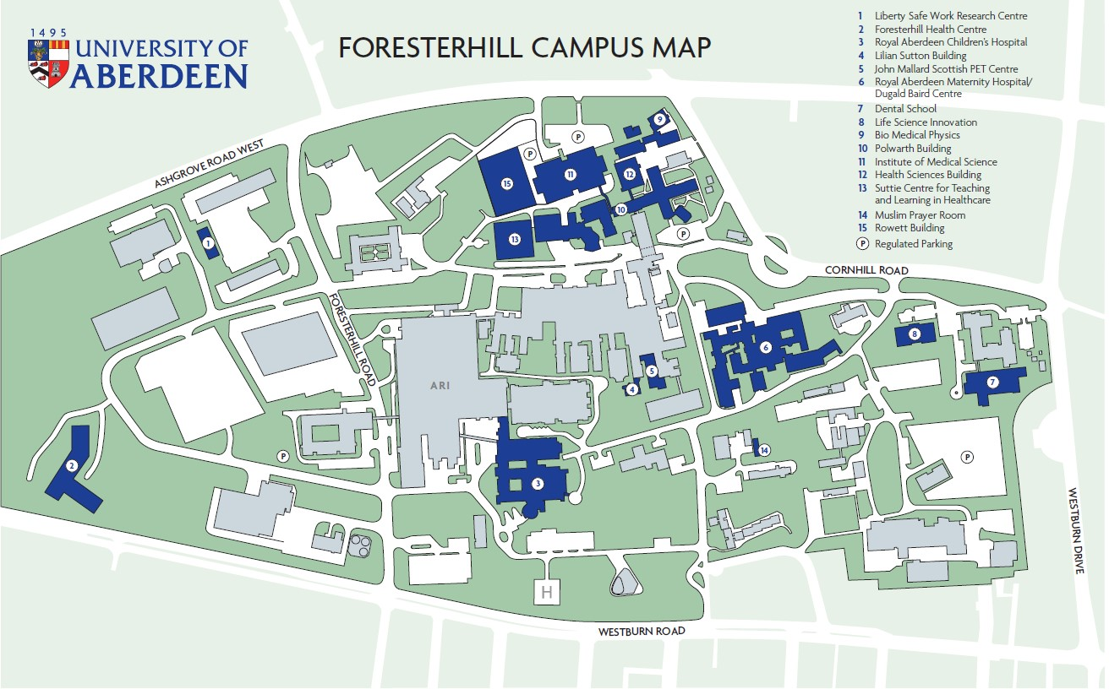

Polwarth Floor Plans

