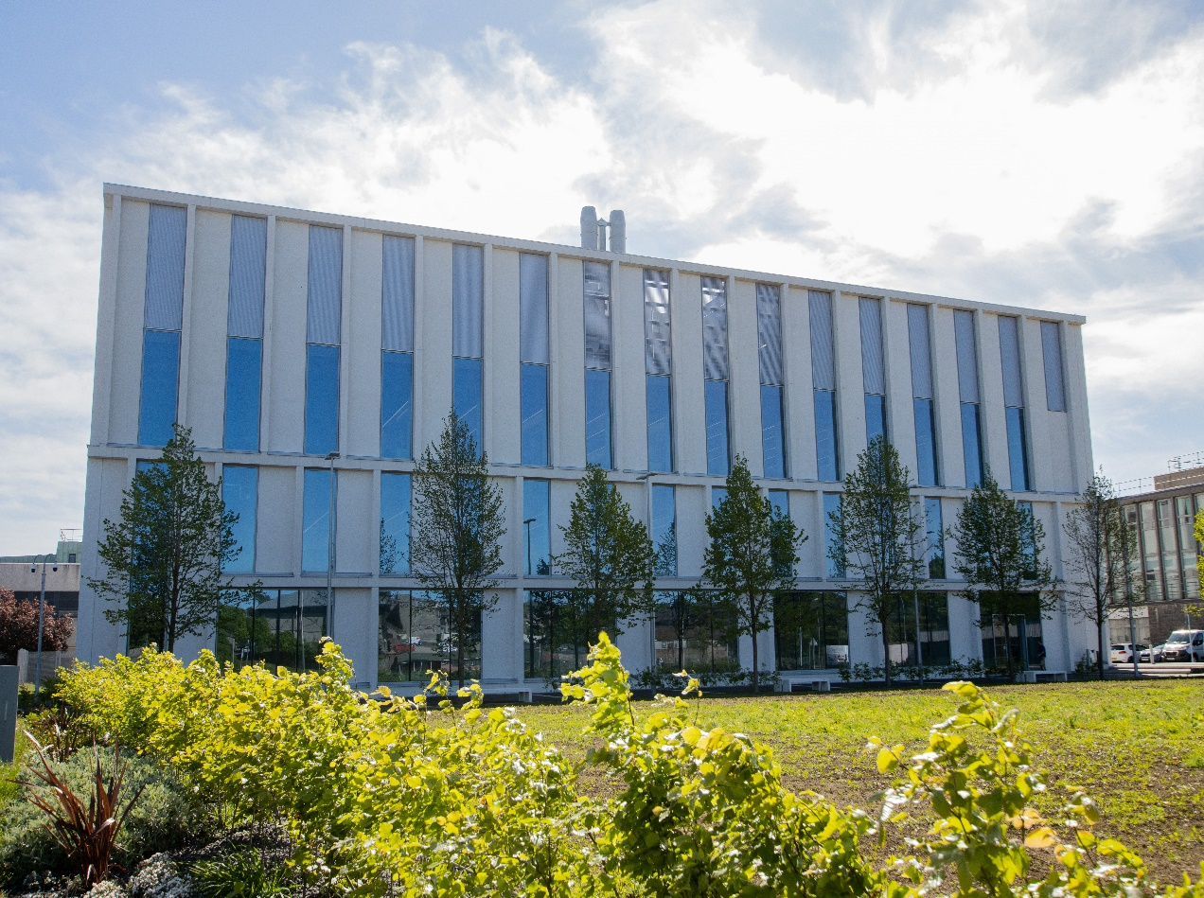
SR3509- Applied Practice in Sports Science 2
Course Handbook 2023-2024
Undergraduate Medical Sciences
School of Medicine, Medical Sciences & Nutrition
Contents

•
Course Summary
(3)

•
Course Aims & Learning
Outcomes

•
Course Teaching Staff

•
Assessments & Examinations

•
Class Representatives (4)

•
Problems with Coursework (5)

•
Course Reading List

•
Lecture Synopsis

•
Practical/Lab/Tutorial Work

•
University Policies (6)

•
Academic Language & Skills
support
(7)

•
Medical Sciences Common
Grading Scale
(8)

•
Course Timetable SR3009:
2023-2024
(9)

•
Campus and Floor Maps

Course Summary
For the sports science practitioner experience of working with both coaches and athletes in an applied setting is a key skill to understanding the challenges and rewards that are gained from this exposure. The course described in the coursebook provides an overview of the practices employed when interacting with coach and athlete to meet their demands, which could range for an assessment of force/power production, the implementation of novel training practice through to dietary advice and education. The course describes the process of professional conduct and ethics and confidentiality agreements, conducting a needs analysis for athlete to assess sports performance, training practice and/or nutritional status. The course incorporates a significant practical element and is assessed in two elements.

Course Co-ordinator:
Daniel Sutton (daniel.sutton@abdn.ac.uk)
Dr. Jenny Gregory (j.gregory@abdn.ac.uk)

Course Aims & Learning Outcomes
The learning outcomes of this course are:
- An understanding of the role of Sport Scientist in provision of Sport Science Support
- Adopt the professional attributes of the Sport Scientist, in relation to attitude, confidentiality and ethics
- To conduct a needs analysis for an athlete/coach/team and construct a plan to provide sport science to support.
- To demonstrate a program of sport sciences support and reflective analysis.

Course Teaching Staff
Course Coordinator(s):
Daniel Sutton (DS)
Jenny Gregory (JG)
Other Staff:
Don Vasey (CR)
Gillian Kerr (GK)

Assessments & Examinations
Students are expected to attend all lectures, tutorials, and presentation sessions and to complete all class exercises by stated deadlines. It is imperative that any reasonable excuses for the late handing in of work are made to the course organiser (Daniel Sutton) before the deadline date. Failure to do so will result in the work not being marked and the class certificate, which is required, may be withheld. The minimum performance acceptable for the granting of a class certificate is attendance at all practical sessions, and completion of all course assessments, both written and practical (OSPE).
The course is based on 100% continuous assessment (CA). 15% of the course assessment is based on conducting a needs analysis assessment to be completed by the end of week 3 of the course. Each student will complete poster presentation of their needs analysis and plan of their project that counts for the 25% of continuous assessment. Each student will submit a written report of the work they have completed with their chosen sport that describes the needs analysis, plan and outcome of their sport sciences support (60% of the CA). The overall report will be co-assessed by the academic staff and the coach (where applicable).
Common grading scale (CGS) grade: The overall performance of the student is expressed as a grade awarded on the common spine marking scale (see attached sheet).
The resit assessment for this course will be through a written assessment.

Class Representatives

We value students’ opinions in regard to enhancing the quality of teaching and its delivery; therefore, in conjunction with the Students’ Association we support the Class Representative system.

In the School of Medicine, Medical Sciences & Nutrition we operate a system of course representatives, who are elected from within each course. Any student registered within a course that wishes to represent a given group of students can stand for election as a class representative. You will be informed when the elections for class representative will take place.

What will it involve?
It will involve speaking to your fellow students about the course you represent. This can include any comments that they may have. You will attend a Staff-Student Liaison Committee and you should represent the views and concerns of the students within this meeting. As a representative, you will also be able to contribute to the agenda. You will then feedback to the students after this meeting with any actions that are being taken.

Training
Training for class representatives will be run by the Students Association. Training will take place within each half-session. For more information about the Class representative system visit www.ausa.org.uk or email the VP Education & Employability vped@abdn.ac.uk . Class representatives are also eligible to undertake the STAR (Students Taking Active Roles) Award with further information about this co-curricular award being available at: www.abdn.ac.uk/careers.

Problems with Coursework

If students have difficulties with any part of the course that they cannot cope with, alone they should notify the course coordinator immediately. If the problem relates to the subject matter general, advice would be to contact the member of staff who is teaching that part of the course. Students with registered disabilities should contact the medical sciences office, (medsci@abdn.ac.uk) (based in the Polwarth Building, Foresterhill) to ensure that the appropriate facilities have been made available. Otherwise, you are strongly encouraged to contact any of the following as you see appropriate:

- Course student representatives
- Course co-ordinator
- Convenor of the Medical Sciences Staff/Student Liaison Committee (Professor Gordon McEwan) • Personal Tutor
- Medical Sciences Disabilities Co-ordinator (Dr Derryck Shewan)

All staff are based at Foresterhill and we strongly encourage the use of email or telephone the Medical Sciences Office. You may have a wasted journey travelling to Foresterhill only to find staff unavailable.

If a course has been completed and students are no longer on campus (i.e. work from second half session during the summer vacation), coursework will be kept until the end of Fresher’s Week, during the new academic year. After that point, unclaimed student work will be securely destroyed.

Lecture Synopsis
Teaching will take place at the Old Aberdeen site and Aberdeen Sports Village (Aberdeen University Sports Pavillion) and at the Foresterhill campus. The course starts with tutorials that will cover the role of the Sport Scientist and process of building a working relationship with coach/athlete or team. Additional tutorials will be conducted to further discuss the role of the sport scientist and the ethical and confidentiality requirements of the applied sport scientist and as progress reports as you complete your placement. Electronic copies of the course material will be posted on MyAberdeen.
There will be 3 practical classes focusing on how to use video analysis, statistical analysis and creating athlete specific training programmes.

Practical/Lab/Tutorial Work
Practical/Lab Work
It is likely that the practical elements of this course will be conducted at either the Aberdeen Sports Village (athletics track/indoor sports area/aquatic centre), King’s Pavilion/Butchart or outdoor sports pitches as well as the Science Teaching Hub.

University Policies

Students are asked to make themselves familiar with the information on key education policies, available here. These policies are relevant to all students and will be useful to you throughout your studies. They contain important information and address issues such as what to do if you are absent, how to raise an appeal or a complaint and how the University will calculate your degree outcome.
These University wide education policies should be read in conjunction with this programme and/or course handbook, in which School specific policies are detailed. These policies are effective immediately, for the 2022/23 academic year. Further information can be found on the University’s Infohub webpage or by visiting the Infohub.

The information included in the institutional area for 2022-23 includes the following:
- Assessment
- Feedback
- Academic Integrity
- Absence
- Student Monitoring/ Class Certificates
- Late Submission of Work
- Student Discipline
- The co-curriculum
- Student Learning Service (SLS)
- Professional and Academic Development
- Graduate Attributes
- Email Use
- MyAberdeen
- Appeals and Complaints

Where to Find the Following Information:

C6/C7- University of Aberdeen Homepage > Students > Academic Life > Monitoring and Progress > Student
Monitoring (C6 & C7) https://www.abdn.ac.uk/students/academic-life/student-monitoring.php#panel5179

Absences- To report absences you should use the absence reporting system tool on Student Hub. Once you have successfully completed and sent the absence form you will get an email that your absence request has been accepted. The link below can be used to log onto the Student Hub Website and from there you can record any absences you may have.

Log In - Student Hub (ahttps://www.abdn.ac.uk/studenthub/loginbdn.ac.uk)

Submitting an Appeal- University of Aberdeen Homepage > Students > Academic Life > Appeals and Complaints

https://www.abdn.ac.uk/students/academic-life/appeals-complaints-3380.php#panel2109 Academic Language & Skills support
For students whose first language is not English, the Language Centre offers support with Academic Writing and Communication Skills.

Academic Writing
- Responding to a writing task: Focusing on the question
- Organising your writing: within & between paragraphs
- Using sources to support your writing (including writing in your own words, and citing & referencing conventions)
- Using academic language
- Critical Thinking
- Proofreading & Editing

Academic Communication Skills
- Developing skills for effective communication in an academic context
- Promoting critical thinking and evaluation
- Giving opportunities to develop confidence in communicating in English
- Developing interactive competence: contributing and responding to seminar discussions • Useful vocabulary and expressions for taking part in discussions

More information and how to book a place can be found here

Medical Sciences Common Grading Scale

Grade | Grade Point | % Mark | Category | Honours Class | Description
A1 | 22 | 90-100 | Excellent | First | • Outstanding ability and critical thought  • Evidence of extensive reading  • Superior understanding  •The best performance that can be expected from a student at this level
A2 | 21 | 85-89
A3 | 20 | 80-84
A4 | 19 | 75-79
A5 | 18 | 70-74
B1 | 17 | 67-69 | Very Good | Upper Second | • Able to argue logically and organise answers well  • Shows a thorough grasp of concepts  • Good use of examples to illustrate points and justify arguments  • Evidence of reading and wide appreciation of subject
B2 | 16 | 64-66
B3 | 15 | 60-63
C1 | 14 | 57-59 | Good | Lower Second | • Repetition of lecture notes without evidence of further appreciation of subject  • Lacking illustrative examples and originality  • Basic level of understanding
C2 | 13 | 54-56
C3 | 12 | 50-53
D1 | 11 | 47-49 | Pass | Third | • Limited ability to argue logically and organise answers  • Failure to develop or illustrate points  • The minimum level of performance required for a student to be awarded a pass
D2 | 10 | 44-46
D3 | 9 | 40-43
E1 | 8 | 37-39 | Fail | Fail | • Weak presentation  • Tendency to irrelevance  • Some attempt at an answer but seriously lacking in content and/or ability to organise thoughts
E2 | 7 | 34-36
E3 | 6 | 30-33
F1 | 5 | 26-29 | Clear Fail | Not used for Honours | • Contains major errors or misconceptions  • Poor presentation
F2 | 4 | 21-25
F3 | 3 | 16-20
G1 | 2 | 11-15 | Clear Fail/Abysmal |  | • Token or no submission
G2 | 1 | 1-10
G3 | 0 | 0

Course Timetable SR3009: 2023-2024

Date | Time | Place | Subject | Session | Staff
 |  |  | Week 26
Mon 22 Jan | 10:00 - 11:00 | Polwarth 1M:001 | Introduction to Course | Lecture | JG/DB
Tuesday 23 Jan
Wed 24 Jan |  | Online | Watch self-reflection recording and prepare questions | Private study / online | DV
Thu 25 Jan
Fri 26 Jan
 |  |  | Week 27
Mon 29 Jan | 10:00 - 11:00 | Polwarth 1M:001 | Self Reflection | Workshop | DB
Tue 30 Jan
Wed 31 Jan
Thu 1 Feb
Fri 2 Feb
 |  |  | Week 28
Mon 5 Feb | 10:00 - 11:00 | Polwarth 1M:001 | Athlete Progress checkup | Lecture | DS
 | 14:00 - 15:00 | Butchart Gymnasium | Introduction to Video Analysis | Practical | DS
Tue 6 Feb
Wed 7 Feb
Thu 8 Feb
Fri 9 Feb | 09:00 – 11:00 | Comp S84 Edward Wright | Video and data analysis methods | Workshop | JG/DS
 |  |  | Week 29
Mon 12 Feb | 10:00 - 11:00 | Polwarth 1M:001 | Needs analysis | Lecture | DS/DB
Tue 13 Feb
Wed 14 Feb
Thu 15 Feb | 16:00 | MyAberdeen | Coach/Athlete/Team Needs Analysis | Assessment | DS
Fri 16 Feb
 |  |  | Week 30
Mon 19 Feb | 10:00 - 11:00 | Polwarth 1M:001 | Creating training programmes | Lecture | DS
Tue 20 Feb
Wed 21 Feb
Thu 22 Feb
Fri 23 Feb | 09:00 - 11:00 | Butchart | Creating training programmes | Practical | DS
 |  |  | Week 31
Mon 26 Feb | 10:00 - 11:00 | Polwarth 1M:001 | Update on athlete sport plan | Lecture | DS
Tue 27 Feb
Wed 28 Feb
Thu 29 Feb
Fri 1 Mar
 |  |  | Week 32
Mon 4 Mar | 10:00 - 11:00 | Polwarth 1M:001 | Update on athlete sport plan  And intro to poster presentations | Lecture | DS/JG
Tue 5 Mar
Wed 6 Mar
Thu 7 Mar
Fri 8 Mar
 |  |  | Week 33
Mon 11 Mar | 10:00 - 12:00 | Polwarth 1M:001 | Poster Presentation Practice | Lecture | DS/JG/DB
Tue 12 Mar
Wed 13 Mar
Thu 14 Mar
Fri 15 Mar | 10:00 - 12:00 | Polwarth 1M:001 | Poster Presentation Assessment | Assessment | DS/JG/DB
 |  |  | Week 34
Mon 18 Mar | 10:00 - 11:00 | Polwarth 1M:001 | Report Writing | Lecture | DS/DB
Tue 19 Mar
Wed 20 Mar
Thu 21 Mar
Fri 22 Mar
 |  |  | Week 35
Mon 25 Mar
Tue 26 Mar
Wed 27 Mar
Thu 28 Mar
Fri 28 Mar | Deadline 16:00 | Myaberdeen | Final Report Submission | Assessment | DS/JG
 |  |  | End of Term

Staff

Mr Dan Sutton (DS), Medical Sciences (Course Coordinator)
Dr Derek Ball (DB), Medical Sciences
Dr Jenny Gregory (JG), Medical Sciences
Dr Christine Roberts (CR), Sports and Exercise Team
Ms Gillian Kerr (GK), Sports and Exercise Team
Mr Don Vasey (DV), External

Campus Maps - Foresterhill

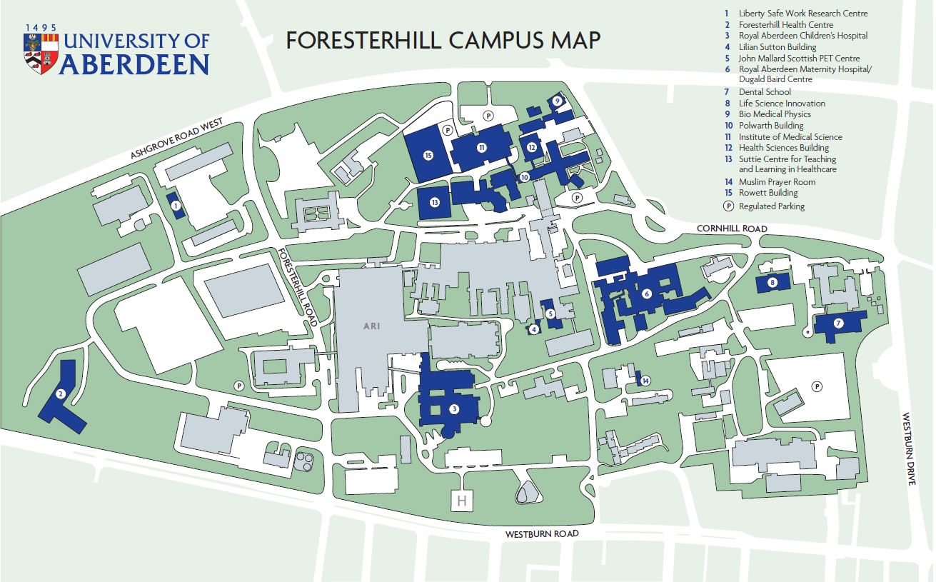
Figure 1

Polwarth

Floor Plans

Polwarth Floor Plans

