*SM2001- Foundation Skills for Life Sciences*

*Course Handbook 2023-2024*

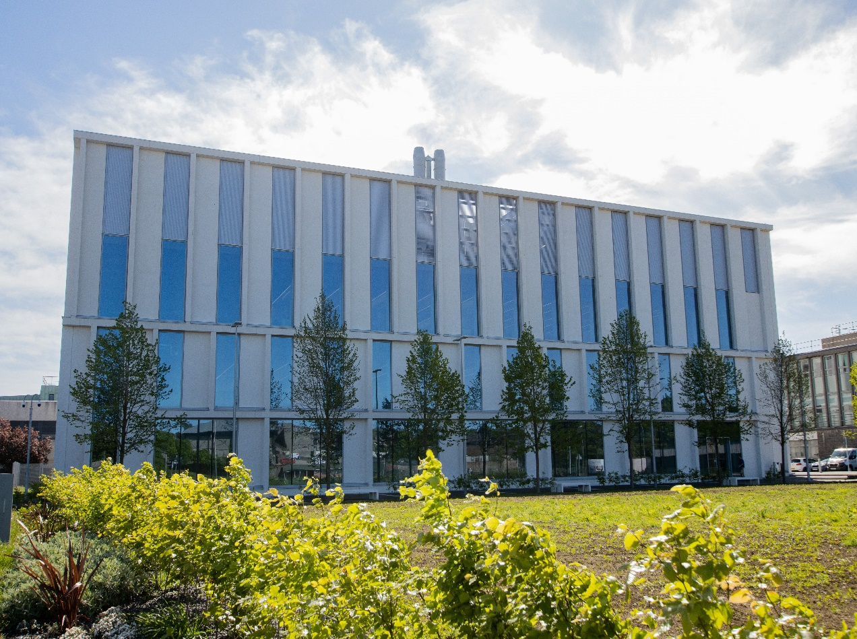

*Undergraduate Medical Sciences*

*School of Medicine, Medical Sciences & Nutrition*

**Contents**

* Course Summary (3)
* **Course Aims & Learning Outcomes**
* **Course Teaching Staff**(4)
* **Assessments & Examinations**
* **Class Representatives**
* **Problems with Coursework**(5)
* **Course Reading List**(6)
* **Lecture Synopsis**
* **Practical/Lab/Tutorial Work**(7)
* **University Policies**
* **Academic Language & Skills support**(8)
* **Medical Sciences Common Grading Scale**(9)
* **Course Timetable SM2001: 2023-2024**(10)
* Campus and Floor Maps

Course Summary

# This course focuses on developing core skills for medical scientists and will be required for all students with Medical Science degree intentions in the School of Medicine, Medical Sciences & Nutrition. The course consists of an Ombea (interactive) lecture starting at 10.00 am in the Science Teaching Hub (STH) followed by a 2-hour workshop in groups of around 3 on Wednesday mornings in University weeks 8, 10, 12, 14 and 16. Academic staff will be present for guidance and consultation. There will be opportunities for any students requiring extra help to receive it at the end of each Workshop or by arrangement with the course co-ordinator, including one-to-one or small group tuition. Once the workshops are finished, computer-based homework questions will be made available via MyAberdeen to be practised through self-study each week.

On Wednesdays in weeks 9, 11, 13, 15 and 17, students will be required to undertake individual assessments under timed conditions based on the practice questions. These will also take place in the STH.

Material in the workshops, practice questions and assignments have been contextualised to the major disciplines in the Medical Sciences.

Course Aims & Learning Outcomes

* To increase confidence and competence in numerical manipulations.
* To practice numerical and practical skills.
* To understand and interpret different ways of presenting scientific data.
* To understand simple statistical analysis and how to use it.
* To understand the basis of scientific investigation and the importance of hypothesis-driven enquiry.
* To understand the importance of using correct scientific English.
* To design and carry out a practical project.
* To develop transferable skills related to teamwork, time management, communication and information technology skills.

Course Teaching Staff

Course Co-ordinator:

Dr Derryck Shewan ((43)7381) ([d.shewan@abdn.ac.uk](mailto:d.shewan@abdn.ac.uk))

Other Staff:

School of Medicine, Medical Sciences & Nutrition Academic Contacts:

Prof Steve Tucker ([**s.j.tucker@abdn.ac.uk**](mailto:s.j.tucker@abdn.ac.uk)**)**

Dr Catriona Cunningham **(**[**c.cunningham@abdn.ac.uk**](mailto:c.cunningham@abdn.ac.uk)**)**

Prof Lynda Erskine **(**[**l.erskine@abdn.ac.uk**](mailto:l.erskine@abdn.ac.uk)**)**

Dr Silvia Mazzotta **(**[**silvia.mazzotta@abdn.ac.uk**](mailto:silvia.mazzotta@abdn.ac.uk)**)**

**Technical/Admin Support:**

Mr Nigel Graham, STH **(**[n.graham@abdn.ac.uk](mailto:n.graham@abdn.ac.uk)**)**

# 

Assessments & Examinations

Students are required to attend all lectures and workshops, practice the homework questions each week and complete all in-course assessments.

Assessment is derived from individual assignments (70%), exercises undertaken during the workshops (25%) and peer review of your colleagues’ performances in workshops (5%).

The overall performance of the student is expressed as a grade awarded on the Common Grading Scale (CGS).

You must pass all workshops and assessments in order to pass the course and so you will be given the opportunity to repeat any that you have missed or failed. If you miss a workshop or assessment due to illness or other reasons, you must contact your course co-ordinator (Dr Derryck Shewan, [**d.shewan@abdn.ac.uk**](mailto:d.shewan@abdn.ac.uk)) or course administrator (Mr Nigel Graham, [**n.graham@abdn.ac.uk**](mailto:n.graham@abdn.ac.uk)) immediately. It is your responsibility to be proactive in arranging to re-take missed or failed workshops or assessments. Any repeat assessment due to a failed first attempt will only be awarded a pass grade (D3 on the CGS, although you will be given feedback on the mark that you would have obtained, had it been your first attempt). If you cannot attend a workshop or assessment on the day, you must arrange to take it as soon as possible thereafter, so absences do not pile up. All work is expected to be complete by the end of the course. Thereafter, unless there are medical issues or other reasons of good cause, unfinished work will be regarded as a resit issue and you will need to apply, and pay, to finish the work and complete the course. As this is a compulsory course you cannot get your degree without passing it, nor can you substitute it with another 15 credit course. So please make sure you catch up with any absences as soon as you can and that you complete all work by December.

# Class Representatives

We value students’ opinions regarding enhancing the quality of teaching and its delivery; therefore, in conjunction with the Students’ Association, we support the Class Representative system.

In the School of Medicine, Medical Sciences & Nutrition we operate a system of course representatives, who are elected from within each course. Any student registered within a course that wishes to represent a given group of students can stand for election as a class representative. You will be informed when the elections for class representative will take place.

What will it involve?

It will involve speaking to your fellow students about the course you represent. This can include any comments that they may have. You will attend a Staff-Student Liaison Committee and you should represent the views and concerns of the students within this meeting. As a representative, you will also be able to contribute to the agenda. You will then give feedback to the students after this meeting with any actions that are being taken.

Training

Training for class representatives will be run by the Students Association. Training will take place within each half-session. For more information about the Class Representative system visit [www.ausa.org.uk](http://www.ausa.org.uk) or email the VP Education & Employability [vped@abdn.ac.uk](mailto:vped@abdn.ac.uk). Class Representatives are also eligible to undertake the STAR (Students Taking Active Roles) Award, with further information about this co-curricular award being available at: [www.abdn.ac.uk/careers](http://www.abdn.ac.uk/careers).

Problems with Coursework

If students have difficulties with any part of the course that they cannot cope with alone, they should notify the course co-ordinator immediately. If the problem relates to the subject matter in general, advice would be to contact the member of staff who is teaching that part of the course. Students with registered disabilities should contact the medical sciences office, ([medsci@abdn.ac.uk](mailto:medsci@abdn.ac.uk)) (based in the Polwarth Building, Foresterhill) to ensure that the appropriate facilities have been made available. Otherwise, you are strongly encouraged to contact any of the following as you see appropriate:

* Course student representatives
* Course co-ordinator
* Convenor of the Medical Sciences Staff/Student Liaison Committee (Dr Donna MacCallum)
* Personal Tutor
* Medical Sciences Disabilities Co-ordinator (Dr Derryck Shewan)

All staff are based at Foresterhill and we strongly encourage the use of email, or telephone the Medical Sciences Office. You may have a wasted journey travelling to Foresterhill only to find staff unavailable.

If a course has been completed and students are no longer on campus (i.e. work from second half session during the summer vacation), coursework will be kept until the end of Fresher’s Week, during the new academic year. After that point, unclaimed student work will be securely destroyed.

Course Reading List

There is no official course reading list, but Maths for Science complements some of the course content and is useful for further information and practice, and is held by the University Library in Old Aberdeen and the Medical School Library on the Foresterhill site. Further, contextual tuition is available through the “Interactive Support Materials” on the MyAberdeen SM2001 course site.

[Maths for Science](http://www.amazon.co.uk/Maths-Science-Sally-Jordan/dp/0199644969/ref=sr_1_1?s=books&ie=UTF8&qid=1409666916&sr=1-1&keywords=Maths+for+Science) **by Sally Jordan, Shelagh Ross and Pat Murphy**.

# 

Lecture Synopsis

**Ombea and Workshop Synopses**

Each workshop is preceded by an introductory lecture to set the scene. Staff will be on hand to help if you get stuck or confused. You will work through a set of related questions and complete answers using Lt. Marks will subsequently be shown in your personal MyAberdeen account.

**Workshop 1:**  **Introduction and Numerical Skills (University Week 8, Course Week 1)**

The first workshop covers the use of numerical analysis to solve relevant problems in the wide range of disciplines that embrace the medical sciences. It focuses on the importance of units and their conversion, understanding volumes, concentrations and spatial measurements, with an appreciation of scientific notation.

**Workshop 2:**  **Data Interpretation (Week 10, Course Week 3)**

Workshop 2 demonstrates the range of graphs that can be used to display data, specifically scatter plots, bar charts, histograms, line charts, pie charts, box plots etc. It illustrates how trends can be identified within data by describing correlation and the use of correlation coefficients. The workshop highlights the utility of logged axes when data contain outliers or is curvilinear. The concept of variation within datasets is introduced and how this can be illustrated in graphs using error bars.

**Workshop 3:**  **Data Collection and Statistical Analysis (Week 12, Course Week 5)**

This workshop provides an introductory guide to statistics and how to analyse scientific data. In this module, analysis of scientific data will be explained using introductory-level statistics. Building on an explanation of sampling and populations, the module will cover concepts such as how to express the centre point of a spread of data (measures of location: mean, median), how to express the spread of your data (standard deviation), how to calculate the confidence limits of a population, and how to carry out Student t-tests to compare two means from independent samples. The workshop will provide you with the ability to implement five useful statistical calculations and tests that you can employ to analyse a range of different biological data types, with the ability to interpret numerical and graphical statistical data.

**Workshop 4:**  **Experimental Design (Week 14, Course Week 7)**

This workshop will consider the design of experimental protocols to test scientific hypotheses. It will also address the necessity of appropriate control samples in experimental design to allow for confounding and nuisance variables and of appropriate replicates in experimental design, as well as an appreciation of correct sampling effort. This workshop will cover experimental bias and how to reduce this by randomisation of treatments and pairing/matching subjects, and examine the relationship between experimental design and correct statistical analysis.

**Workshop 5:**  **Reporting Scientific Data and Problem Solving (Week 16, Course Week 9)**

At the heart of science is problem solving. This workshop will involve interpreting complex data sets and working out what conclusions may be drawn from the information as it is presented. You will also be asked to write different types of reports appropriate to different situations.

# 

Workshop/Tutorial Work

The course co-ordinator is happy to make arrangements to meet students who are having problems with workshop or practice question concepts/questions in order to talk things through and provide clarification. Students who would like further tuition/explanation should contact the course co-ordinator. Repeat workshops/assessments must be arranged as soon as possible with the course administrator, Mr Nigel Graham ([n.graham@abdn.ac.uk](mailto:n.graham@abdn.ac.uk)) or the course co-ordinator, Dr Derryck Shewan ([d.shewan@abdn.ac.uk](mailto:d.shewan@abdn.ac.uk)).

University Policies

Students are asked to make themselves familiar with the information on key education policies, available [**here**](https://www.abdn.ac.uk/staffnet/teaching/key-education-policies-for-students-11809.php). These policies are relevant to all students and will be useful to you throughout your studies.  They contain important information and address issues such as what to do if you are absent, how to raise an appeal or a complaint and how the University will calculate your degree outcome.

These University wide education policies should be read in conjunction with this programme and/or course handbook, in which School specific policies are detailed. These policies are effective immediately, for the 2023/24 academic year. Further information can be found on the [**University’s Infohub webpage**](https://www.abdn.ac.uk/students/) or by visiting the Infohub.

The information included in the institutional area for 2023-24 includes the following:

* Assessment
* Feedback
* Academic Integrity
* Absence
* Student Monitoring/ Class Certificates
* Late Submission of Work
* Student Discipline
* The co-curriculum
* Student Learning Service (SLS)
* Professional and Academic Development
* Graduate Attributes
* Email Use
* MyAberdeen
* Appeals and Complaints

Where to Find the Following Information:

C6/C7 - University of Aberdeen Homepage > Students > Academic Life > Monitoring and Progress > Student Monitoring (C6 & C7)

https://www.abdn.ac.uk/students/academic-life/student-monitoring.php#panel5179

Absences- To report absences you should use the absence reporting system tool on Student Hub. Once you have successfully completed and sent the absence form you will get an email that your absence request has been accepted. The link below can be used to log onto the Student Hub Website and from there you can record any absences you may have.

[Log In - Student Hub (ahttps://www.abdn.ac.uk/studenthub/loginbdn.ac.uk)](https://www.abdn.ac.uk/studenthub/login)

Submitting an Appeal- University of Aberdeen Homepage > Students > Academic Life > Appeals and Complaints

https://www.abdn.ac.uk/students/academic-life/appeals-complaints-3380.php#panel2109

Academic Language & Skills support

For students whose first language is not English, the Language Centre offers support with Academic Writing and Communication Skills.

Academic Writing

* Responding to a writing task: focusing on the question
* Organising your writing: within & between paragraphs
* Using sources to support your writing (including writing in your own words, and

citing & referencing conventions)

* Using academic language
* Critical Thinking
* Proofreading & Editing

Academic Communication Skills

* Developing skills for effective communication in an academic context
* Promoting critical thinking and evaluation
* Giving opportunities to develop confidence in communicating in English
* Developing interactive competence: contributing and responding to seminar discussions
* Useful vocabulary and expressions for taking part in discussions

More information and how to book a place can be found here

Medical Sciences Common Grading Scale

|  |  |  |  |  |  |
| --- | --- | --- | --- | --- | --- |
| Grade | Grade Point | % Mark | Category | Honours Class | Description |
| A1 | 22 | 90-100 | Excellent | First | • Outstanding ability and critical thought • Evidence of extensive reading • Superior understanding •The best performance that can be expected from a student at this level |
|  |
| A2 | 21 | 85-89 |  |
|  |
| A3 | 20 | 80-84 |  |
|  |
| A4 | 19 | 75-79 |  |
|  |
| A5 | 18 | 70-74 |  |
|  |
| B1 | 17 | 67-69 | Very Good | Upper Second | • Able to argue logically and organise answers well  • Shows a thorough grasp of concepts  • Good use of examples to illustrate points and justify arguments  • Evidence of reading and wide appreciation of subject |  |
|  |
| B2 | 16 | 64-66 |  |
|  |
| B3 | 15 | 60-63 |  |
|  |
| C1 | 14 | 57-59 | Good | Lower Second | • Repetition of lecture notes without evidence of further appreciation of subject • Lacking illustrative examples and originality • Basic level of understanding |  |
|  |
| C2 | 13 | 54-56 |  |
|  |
| C3 | 12 | 50-53 |  |
|  |
| D1 | 11 | 47-49 | Pass | Third | • Limited ability to argue logically and organise answers • Failure to develop or illustrate points • The minimum level of performance required for a student to be awarded a pass |  |
|  |
| D2 | 10 | 44-46 |  |
|  |
| D3 | 9 | 40-43 |  |
|  |
| E1 | 8 | 37-39 | Fail | Fail | • Weak presentation • Tendency to irrelevance • Some attempt at an answer but seriously lacking in content and/or ability to organise thoughts |  |
|  |
| E2 | 7 | 34-36 |  |
|  |
| E3 | 6 | 30-33 |  |
|  |
| F1 | 5 | 26-29 | Clear Fail | Not used for Honours | • Contains major errors or misconceptions • Poor presentation |  |
|  |
| F2 | 4 | 21-25 |  |
|  |
| F3 | 3 | 16-20 |  |
|  |
| G1 | 2 | 11-15 | Clear Fail/Abysmal |  | • Token or no submission |  |
|  |
| G2 | 1 | 1-10 |  |
|  |
| G3 | 0 | 0 |  |
|  |

Course Timetable SM2001: 2023-2024

|  |  |  |  |  |  |
| --- | --- | --- | --- | --- | --- |
| Date | Time | Place | Subject | Session | Staff |
| Week 8 | | | | | |
| Mon 18 Sep |  |  |  |  |  |
| Tue 19 Sep |  |  |  |  |  |
| Wed 20 Sep | 10:00-13:00 | STH 1.001  STH 1.007 | Ombea Workshop on Numerical Skills | Workshop | DS / ST |
| Thu 21 Sep |  |  |  |  |  |
| Fri 22 Sep |  |  |  |  |  |
| Week 9 | | | | | |
| Mon 25 Sep |  |  |  |  |  |
| Tue 26 Sep |  |  |  |  |  |
| Wed 27 Sep | 10:00-11:30 | STH 1.001  STH 1.007 | Assessment on Numerical Skills | Assessment | DS / SM |
| Thu 28 Sep |  |  |  |  |  |
| Fri 29 Sep |  |  |  |  |  |
| Week 10 | | | | | |
| Mon 2 Oct |  |  |  |  |  |
| Tue 3 Oct |  |  |  |  |  |
| Wed 4 Oct | 10:00-13:00 | STH 1.001  STH 1.007 | Ombea Workshop on Data Interpretation | Workshop | DS / CC |
| Thu 5 Oct |  |  |  |  |  |
| Fri 6 Oct |  |  |  |  |  |
| Week 11 | | | | | |
| Mon 9 Oct |  |  |  |  |  |
| Tue 10 Oct |  |  |  |  |  |
| Wed 11 Oct | 10:00-11:30 | STH 1.001  STH 2:001 | Assessment on Data Interpretation | Assessment | DS / SM |
| Thu 12 Oct |  |  |  |  |  |
| Fri 13 Oct |  |  |  |  |  |
| Week 12 | | | | | |
| Mon 16 Oct |  |  |  |  |  |
| Tue 17 Oct |  |  |  |  |  |
| Wed 18 Oct | 10:00-13:00 | STH 1.001  STH 1.007 | Ombea Workshop on Data Collection and Statistical Analysis | Workshop | DS / LE |
| Thu 19 Oct |  |  |  |  |  |
| Fri 20 Oct |  |  |  |  |  |
| Week 13 | | | | | |
| Mon 23 Oct |  |  |  |  |  |
| Tue 24 Oct |  |  |  |  |  |
| Wed 25 Oct | 10:00-11:30 | STH 1.001  STH 1.007 | Assessment on Data Collection and Statistics | Assessment | DS / CC |
| Thu 26 Oct |  |  |  |  |  |
| Fri 27 Oct |  |  |  |  |  |
| Week 14 | | | | | |
| Mon 30 Oct |  |  |  |  |  |
| Tue 31 Oct |  |  |  |  |  |
| Wed 1 Nov | 10:00-13:00 | STH 1.001  STH 1.007 | Ombea Workshop on Experimental Design | Workshop | DS / CC |
| Thu 2 Nov |  |  |  |  |  |
| Fri 3 Nov |  |  |  |  |  |
| Week 15 | | | | | |
| Mon 6 Nov |  |  |  |  |  |
| Tue 7 Nov |  |  |  |  |  |
| Wed 8 Nov | 10:00-11:30 | STH 1.001  STH 1.007 | Assessment on Experimental Design | Assessment | DS / CC |
| Thu 9 Nov |  |  |  |  |  |
| Fri 10 Nov |  |  |  |  |  |
| Week 16 | | | | | |
| Mon 13 Nov |  |  |  |  |  |
| Tue 14 Nov |  |  |  |  |  |
| Wed 15 Nov | 10:00-13:00 | STH 1.001  STH 1.007 | Ombea Workshop on Reporting Scientific Data and Problem Solving | Workshop | DS / CC |
| Thu 16 Nov |  |  |  |  |  |
| Fri 17 Nov |  |  |  |  |  |
| Week 17 | | | | | |
| Mon 20 Nov |  |  |  |  |  |
| Tue 21 Nov |  |  |  |  |  |
| Wed 22 Nov | 10:00-11:30 | STH 1.001  STH 1.007 | Assessment on Reporting Scientific Data and Problem Solving | Assessment | DS / CC |
| Thu 23 Nov |  |  |  |  |  |
| Fri 24 Nov |  |  |  |  |  |
| Week 18 | | | | | |
| Mon 27 Nov |  |  |  |  |  |
| Tue 28 Nov |  |  |  |  |  |
| Wed 29 Nov | 09:00-17:00 | STH | Resit Workshops/Assessments | Assessment | NG / DS |
| Thu 30 Nov |  |  |  |  |  |
| Fri 1 Dec | 09:00-17:00 | STH | Resit Workshops/Assessments | Assessment | NG / DS |

Staff

|  |
| --- |
| Dr Derryck Shewan (Course Co-ordinator) (DS) |
| Dr Catriona Cunningham (CC) |
| Prof Steve Tucker (ST) |
| Dr Silvia Mazzotta (SM) |
| Prof Lynda Erskine (LE) |
| Mr Nigel Graham (NG) |

Campus Maps - Foresterhill



Polwarth Floor Plans

