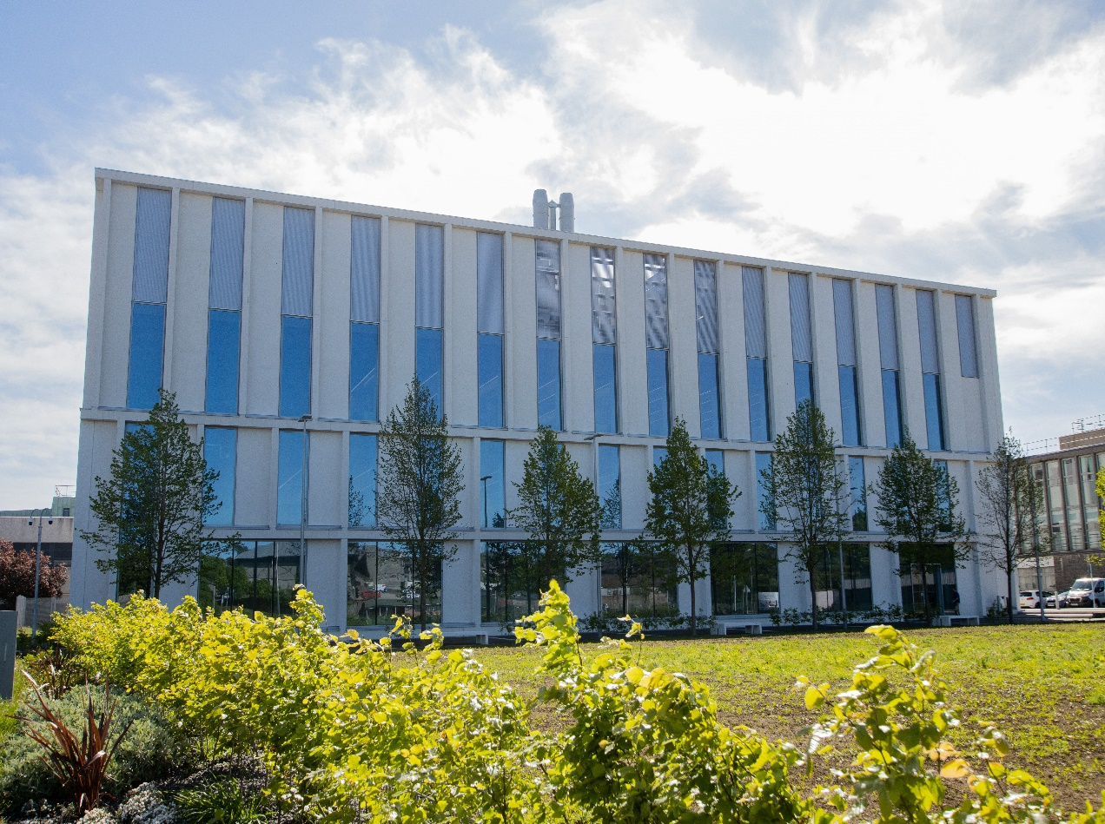

*PA4303- Current Topics in Pharmacological Research*

*Course Handbook 2023-2024*

*Undergraduate Medical Sciences*

*School of Medicine, Medical Sciences & Nutrition*

**Contents**

* Course Summary (3)
* **Course Aims & Learning Outcomes**
* **Course Teaching Staff**
* **Assessments & Examinations**
* **Class Representatives**(4)
* **Problems with Coursework**
* **Course Reading List**(5)
* **Lecture Synopsis**
* **Practical/Lab/Tutorial Work**(8)
* **University Policies**
* **Academic Language & Skills support**(9)
* **Medical Sciences Common Grading Scale**(11)
* **Course Timetable PA4303: 2023-2024**(12)
* Campus and Floor Maps

Course Summary

This course extends your previous knowledge in the area of drug mode of action, molecular targets and toxicology. The process of drug development will be examined from the importance of understanding the design and metabolic profile of drugs and their transport to covering molecular aspects of pre-clinical toxicology. This course provides focus on hot topics in pharmacology and toxicology, using specific examples from research at the University of Aberdeen and thus opens up new opportunities for employability in academia and the pharmaceutical industry.

Course Co-ordinator: Professor Steve Tucker (s.j.tucker@abdn.ac.uk)

Course Aims & Learning Outcomes

The course aims to develop an understanding of pharmacological targeting and molecular toxicology at an advanced level. The learning outcomes are:

* To develop advanced understanding of the processes surrounding pharmacological drug design and molecular targeting using specific examples
* To gain knowledge of drug-induced toxicity including organ specific toxicity, oxidative stress and the role of drug transport
* To develop knowledge of the processes involved in cell death including apoptosis, autophagy and necrosis
* To enhance understanding of the use of biomarkers in pharmacology and toxicology
* To develop advanced knowledge of molecular carcinogenesis (genotoxic and non-genotoxic)

Course Teaching Staff

Course Co-ordinator(s):

Professor S Tucker School of Medicine, Medical Sciences, Dentistry and Nutrition

Other Staff:

|  |
| --- |
| Prof J Barrow (JB), School of Medicine, Medical Sciences and Nutrition |
| Dr E Collie-Duguid (ECD), School of Medicine, Medical Sciences and Nutrition |
| Dr I Crane (IC), School of Medicine, Medical Sciences and Nutrition |
| Dr B De Fillipis, Dept of Pharmacy, University of Chieti, Italy |
| Dr R Lofthouse, Scottish Biologics Facility, University of Aberdeen |
| Dr P Marini (PM), School of Medicine, Medical Sciences and Nutrition |
| Prof IJ McEwan (IJM), School of Medicine, Medical Sciences and Nutrition |
| Dr L Penny, Scottish Biologics Facility, University of Aberdeen |
| Prof P Tucci, University of Foggia, Italy |
| Dr M Carlier (MC), School of Medicine, Medical Sciences and Nutrition |

Assessments & Examinations

Students are expected to access and study **ALL** lectures, drug design project classes and online materials, and to complete all exercises by the given deadlines. The minimum performance acceptable for the granting of a class certificate is evidence of engagement with, at least, 50% of the lectures and lab classes, and presentation of all set course work. Failure to achieve this may result in your class certificate being withheld.

The course assessment consists of:

1. Degree exam paper, answer 2 questions = 70% of the grade for this course
2. Continuous assessment: drug design practical project (20%), editorial (10%) = 30% of the grade for this course.

Past papers for PA4302 (previous code) and PA4303 are available on the Web.

In addition to the above assessed exercises, there will several formative tutorials throughout the course to support application of taught materials and also several weekly tasks designed to engage you with the course and your fellow students. You are required to participate with these and offer an ongoing active contribution to the virtual learning environment discussion board where appropriate.

Failing to regularly engage with the course content, discussion forum activities, live sessions and assessments will indicate non-engagement with the course, which will start the C6/C7 process.

The University of Aberdeen C6/C7 process is a monitoring system to identify students who may be experiencing difficulties with their studies and to ensure that students remain on track for their degree. For more information, click here: <https://www.abdn.ac.uk/students/academic-life/student-monitoring.php>.  If you receive a C6 you will be sent an email which details how to act to have the C6 removed from your record.  Failure to take any action will lead to the C6 becoming a C7 where you will lose access to your course.

It is important that you regularly check your University of Aberdeen email account as all correspondence and updates about your studies will be sent to this email address.

If you are struggling with this course, please make contact with the course coordinator as soon as possible so that we can provide appropriate support.

Problems with Coursework

If students have difficulties with any part of the course that they cannot cope with they should notify the course coordinator immediately. If the problem relates to the subject matter general, advice would be to contact the member of staff who is teaching that part of the course. Students with registered disabilities should contact the medical sciences office, ([medsci@abdn.ac.uk](mailto:medsci@abdn.ac.uk)) (based in the Polwarth Building, Foresterhill) to ensure that the appropriate facilities have been made available. Otherwise, you are strongly encouraged to contact any of the following as you see appropriate:

* Course student representatives
* Course co-ordinator
* Convenor of the Medical Sciences Staff/Student Liaison Committee (Professor Gordon McEwan)
* Personal Tutor
* Medical Sciences Disabilities Co-ordinator (Dr Derryck Shewan)

All staff are based at Foresterhill and we strongly encourage the use of email or telephone the Medical Sciences Office. You may have a wasted journey travelling to Foresterhill only to find staff unavailable.

# Class Representatives

We value students’ opinions in regard to enhancing the quality of teaching and its delivery; therefore, in conjunction with the Students’ Association we support the Class Representative system.

In the School of Medicine, Medical Sciences & Nutrition we operate a system of course representatives, who are elected from within each course. Any student registered within a course that wishes to represent a given group of students can stand for election as a class representative. You will be informed when the elections for class representative will take place.

What will it involve?

It will involve speaking to your fellow students about the course you represent. This can include any comments that they may have. You will attend a Staff-Student Liaison Committee and you should represent the views and concerns of the students within this meeting. As a representative, you will also be able to contribute to the agenda. You will then feedback to the students after this meeting with any actions that are being taken.

Training

Training for class representatives will be run by the Students Association. Training will take place within each half-session. For more information about the Class representative system visit [www.ausa.org.uk](http://www.ausa.org.uk) or email the VP Education & Employability [vped@abdn.ac.uk](mailto:vped@abdn.ac.uk) . Class representatives are also eligible to undertake the STAR (Students Taking Active Roles) Award with further information about this co-curricular award being available at: [www.abdn.ac.uk/careers](http://www.abdn.ac.uk/careers).

Problems with Coursework

If students have difficulties with any part of the course that they cannot cope with, alone they should notify the course coordinator immediately. If the problem relates to the subject matter general, advice would be to contact the member of staff who is teaching that part of the course. Students with registered disabilities should contact the medical sciences office, ([medsci@abdn.ac.uk](mailto:medsci@abdn.ac.uk)) (based in the Polwarth Building, Foresterhill) to ensure that the appropriate facilities have been made available. Otherwise, you are strongly encouraged to contact any of the following as you see appropriate:

* Course student representatives
* Course co-ordinator
* Convenor of the Medical Sciences Staff/Student Liaison Committee (Professor Gordon McEwan)
* Personal Tutor
* Medical Sciences Disabilities Co-ordinator (Dr Derryck Shewan)

All staff are based at Foresterhill and we strongly encourage the use of email or telephone the Medical Sciences Office. You may have a wasted journey travelling to Foresterhill only to find staff unavailable.

If a course has been completed and students are no longer on campus (i.e. work from second half session during the summer vacation), coursework will be kept until the end of Fresher’s Week, during the new academic year. After that point, unclaimed student work will be securely destroyed.

Course Reading List

**Books recommended (available through the University Library):**

Rang and Dale’s, Pharmacology 9th Edition

Pratt & Taylor Principles of Drug Action (Third edition). ISBN. 0443086761

Casarett & Doull’s Toxicology. (Fifth edition). ISBN. 0071054766.

In addition, Trends in Pharmacological Sciences and the British Journal of Pharmacology, will be very useful for reading around many topics relevant to the course. These are available online and through the University Library.

Lecture Synopsis

Introduction – Professor Steve Tucker

* Welcome to the course
* Introduction to assessments
* Teaching approaches

Pharmacology of cannabinoids – Dr Pietro Marini

* The endocannabinoid system
* Natural and synthetic ligands
* Use of cannabis in therapy
* Applied pharmacology: cannabinoid and cholinergic systems cross-talk

The chemistry of pharmacokinetics and pharmacodynamics – Professor Steve Tucker

* Synthetic chemistry and drug design
* Chemical groups that modify pharmacokinetics
* Chemical groups that modify pharmacodynamics

Chronotherapeutics – Professor Steve Tucker

* Circadian rhythm
* Influence of circadian rhythm on cancer initiation
* Influence of circadian rhythm on anticancer drug side effects / resistance
* Chronotherapy in cancer

Biomarkers - Dr Elaina Collie-Duguid

* Biomarkers in the management of human disease
* Types of biomarkers and their potential clinical utility
* Biomarkers in current clinical use

Biomarkers and where to find them – Dr Richie Lofthouse

* Biomarkers hold a wealth of information into the current physiological state of the body. However, they aren’t always easy to measure
* Newly developed technologies have the sensitivity required to investigate complex diseases with limits of detection in the attomolar range
* We will look at several of these new technologies and how they have revolutionised diagnostics for diseases such as Alzheimer’s and COVID-19

Quadruplex targeting – Professor John Barrow

* What are G-quadruplexes?
* G-quadruplex roles in gene regulation
* Current research in using quadruplexes as a drug target

Drug targeting in prostate cancer – Professor Iain McEwan

* Steroid Hormone Receptors: From basic biology to drug targets
* Androgen receptor-Structure and Function
* Prostate cancer
* Novel Small Molecule Inhibitors of receptor function

Contraceptive pharmacology – Professor Steve Tucker

* Endocrine regulation of female reproduction
* Pharmacology of the female hormonal contraception
* Endocrine regulation of male reproduction
* Pharmacology of the male hormonal contraception

Adverse effects of manipulating the immune system – Dr Lewis Penny

Although drugs that manipulate the immune system can be very effective treatments for many conditions from cancer to multiple sclerosis, their use, not surprisingly, can also have adverse effects. We will cover adverse effects through general immunomodulatory and immunosuppressive approaches but also case studies of toxicity that are specific to certain drug targets, disease indications and therapeutic modalities.

Drug targeting in breast cancer – Professor Steve Tucker

* Introduction to breast cancer
* Traditional targets (hormone receptors and growth factor receptors)
* Popeye domain containing (POPDC) proteins and breast cancer
* Targeting POPDC1

Psychedelic Medicine: current perspectives on therapy - Prof Paolo Tucci

* Classifications of psychedelic drugs and their mechanism of action.
* Current methodological designs, ethical strictures and clinical protocols on psychedelics drug and their use in humans.
* Treatment of some mental disorders with psychedelic-assisted treatments currently under investigation

Parasite infection pharmacology – Dr Molly Carlier

* Introduction to malaria; parasite life cycle and pathophysiology of disease.
* Current anti-malarial drugs, their mechanism of action and limitations.
* Adjunctive therapies targeting pathophysiological mechanisms currently under development.

Drug project/Editorial/Case study

Drug Design project (20% of final mark): Professor Steve Tucker

* examine target/drug structures and how these relate to pharmacological consequences
* develop an understanding of how to communicate with the public
* employ problem solving skills to design new synthetics for use on the target
* develop group and individual working skills

The project will involve small groups of students researching and selecting a drug target to focus upon and preparing individual short justification/explanation for their choice aimed at the public. Groups will then use molecular software to design a new synthetic drug with specific pharmacodynamic /pharmacokinetic properties enabled by its chemical structure. They will then prepare an audio embedded PowerPoint explaining their design.

Assessment: individual justification (10%); group new synthetic audio PowerPoint (10%)

Editorial (10% of final mark): Professor Steve Tucker

* condense complex information from scientific literature into clear and structured discursive writing
* to develop and explore a mature pharmacological theme considering all sides of the issue in a balanced and informed manner

The exercise will involve students being issued with a small number of research papers to read and interpret before writing a short editorial exploring the main themes linking the articles under exam conditions.

University Policies

Students are asked to make themselves familiar with the information on key education policies, available [here](https://www.abdn.ac.uk/staffnet/teaching/key-education-policies-for-students-11809.php). These policies are relevant to all students and will be useful to you throughout your studies.  They contain important information and address issues such as what to do if you are absent, how to raise an appeal or a complaint and how the University will calculate your degree outcome.

These University wide education policies should be read in conjunction with this programme and/or course handbook, in which School specific policies are detailed. These policies are effective immediately, for the 2023/24 academic year. Further information can be found on the [University’s Infohub webpage](https://www.abdn.ac.uk/students/) or by visiting the Infohub.

The information included in the institutional area for 2023-24 includes the following:

* Absence
* Appeals & Complaints
* Assessment
* Avoiding Plagiarism
* Communication
* Graduate Attributes
* MyAberdeen
* Student Learning Service (SLS)
* Student Monitoring/Class Certificates
* Student Discipline
* The Co-curriculum

Where to Find the Following Information:

C6/C7- University of Aberdeen Homepage > Students > Academic Life > Monitoring and Progress > Student Monitoriung (C6 & C7)

https://www.abdn.ac.uk/students/academic-life/student-monitoring.php#panel5179

Absences- To report absences you should use the absence reporting system tool on Student Hub. Once you have successfully completed and sent the absence form you will get an email that your absence request has been accepted. The link below can be used to log onto the Student Hub Website and from there you can record any absences you may have.

[Log In - Student Hub (ahttps://www.abdn.ac.uk/studenthub/loginbdn.ac.uk)](https://www.abdn.ac.uk/studenthub/login)

Submitting an Appeal- University of Aberdeen Homepage > Students > Academic Life > Appeals and Complaints

https://www.abdn.ac.uk/students/academic-life/appeals-complaints-3380.php#panel2109

Academic Language & Skills support

For students whose first language is not English, the Language Centre offers support with Academic Writing and Communication Skills.

Academic Writing

* Responding to a writing task: Focusing on the question
* Organising your writing: within & between paragraphs
* Using sources to support your writing (including writing in your own words, and

citing & referencing conventions)

* Using academic language
* Critical Thinking
* Proofreading & Editing

Academic Communication Skills

* Developing skills for effective communication in an academic context
* Promoting critical thinking and evaluation
* Giving opportunities to develop confidence in communicating in English
* Developing interactive competence: contributing and responding to seminar discussions
* Useful vocabulary and expressions for taking part in discussions

More information and how to book a place can be found here

Medical Sciences Common Grading Scale

|  |  |  |  |  |  |
| --- | --- | --- | --- | --- | --- |
| Grade | Grade Point | % Mark | Category | Honours Class | Description |
| A1 | 22 | 90-100 | Excellent | First | • Outstanding ability and critical thought • Evidence of extensive reading • Superior understanding •The best performance that can be expected from a student at this level |
|  |
| A2 | 21 | 85-89 |  |
|  |
| A3 | 20 | 80-84 |  |
|  |
| A4 | 19 | 75-79 |  |
|  |
| A5 | 18 | 70-74 |  |
|  |
| B1 | 17 | 67-69 | Very Good | Upper Second | • Able to argue logically and organise answers well  • Shows a thorough grasp of concepts  • Good use of examples to illustrate points and justify arguments  • Evidence of reading and wide appreciation of subject |  |
|  |
| B2 | 16 | 64-66 |  |
|  |
| B3 | 15 | 60-63 |  |
|  |
| C1 | 14 | 57-59 | Good | Lower Second | • Repetition of lecture notes without evidence of further appreciation of subject • Lacking illustrative examples and originality • Basic level of understanding |  |
|  |
| C2 | 13 | 54-56 |  |
|  |
| C3 | 12 | 50-53 |  |
|  |
| D1 | 11 | 47-49 | Pass | Third | • Limited ability to argue logically and organise answers • Failure to develop or illustrate points • The minimum level of performance required for a student to be awarded a pass |  |
|  |
| D2 | 10 | 44-46 |  |
|  |
| D3 | 9 | 40-43 |  |
|  |
| E1 | 8 | 37-39 | Fail | Fail | • Weak presentation • Tendency to irrelevance • Some attempt at an answer but seriously lacking in content and/or ability to organise thoughts |  |
|  |
| E2 | 7 | 34-36 |  |
|  |
| E3 | 6 | 30-33 |  |
|  |
| F1 | 5 | 26-29 | Clear Fail | Not used for Honours | • Contains major errors or misconceptions • Poor presentation |  |
|  |
| F2 | 4 | 21-25 |  |
|  |
| F3 | 3 | 16-20 |  |
|  |
| G1 | 2 | 11-15 | Clear Fail/Abysmal |  | • Token or no submission |  |
|  |
| G2 | 1 | 1-10 |  |
|  |
| G3 | 0 | 0 |  |
|  |

Course Timetable 23-24

|  |  |  |  |  |  |
| --- | --- | --- | --- | --- | --- |
| Date | Time | Place | Subject | Session Type | Staff |
| Week 13 | | | | | |
| Mon 23 Oct | 10:00-11:00 | 1:032/033 | Introduction to the course | Lecture | SJT |
| Wed 25 Oct | 11:00-12:00 | 1.032/033 | Drug design project: introduction | Lecture | SJT |
| Thu 26 Oct | 14:00-16:00 | 1.032/033 | Cannabinoid pharmacology | Lecture | PM |
| Fri 27 Oct | 10:00-13:00 | BMP WShop D2 | 3D modelling project | Practical | SJT |
| Week 14 | | | | | |
| Mon 30 Oct | 9:00-10:00 | 1:032/033 | The Chemistry of Pharmacokinetics and Pharmacodynamics | Lecture | SJT |
| 10:00-11:00 | 1:032/033 | Chronotherapeutics | Lecture | SJT |
| Wed 1 Nov | 11:00-12:00 | 1.032/033 |  | Lecture |  |
| ONLINE | ONLINE | Synthetic Chemistry | Lecture | BDF |
| Thu 2 Nov | 10:00-12:00 | 1M:003 | Quadraplex targeting | Lecture | JB |
| Fri 3 Nov | 10:00-11:30 | BMP WShop D2 | Biomarkers and Where to Find Them | Lecture | RL |
| 11:30-13:00 | BMP WShop D2 | Drug design project | Practical | SJT |
| Week 15 | | | | | |
| Mon 6 Nov | 10:00-12:00 | 1:032/033 | Parasite Infection Pharmacology 1 and 2 | Lecture | MC |
| Wed 8 Nov | 12:00-13:00 | 1.032/033 | Editorial introduction | Lecture | SJT |
| Thu 9 Nov | 11:00-12:00 | 1.032/033 | Drug targeting in prostate cancer  Please watch lecture recordings in advance – this is a tutorial | TUTORIAL | IJM |
| 14:00-16:00 | BMP WShop D2 | Drug design project (unstaffed) | Practical |  |
| Fri 10 Nov | 10:00-13:00 | BMP WShop D2 | Editorial | Assessment | SJT |
| Week 16 | | | | | |
| Mon 13 Nov | 10:00-12:00 | 1.032/033 | Biomarkers | Lecture | ECD |
| Thu 16 Nov | 11:00-12:00 | 1.032/033 | Adverse effects of manipulating the immune system | Lecture | LP |
| Fri 17 Nov | 11:00-13:00 | 1.032/033 | Drug targeting in breast cancer | Lecture | SJT |
| Week 17 | | | | | |
| Mon 20 Nov | 10:00-12:00 | 1.032/033 | Contraceptive pharmacology | Lecture | SJT |
| Thu 23 Nov | 11:00-13:00 | 1.032/033 | Psychedelic Medicine: Current Perspectives on Therapy | Lecture | PT |
| Fri 24 Nov | 10:00-13:00 | BMP  Wshop D2 | Coursework protected time (unstaffed) | Tutorial |  |

|  |
| --- |
| Prof SJ Tucker (SJT) Course Co-ordinator, School of Medicine, Medical Sciences and Nutrition |
| Prof J Barrow (JB), School of Medicine, Medical Sciences and Nutrition |
| Dr E Collie-Duguid (ECD), School of Medicine, Medical Sciences and Nutrition |
| Dr I Crane (IC), School of Medicine, Medical Sciences and Nutrition |
| Dr B De Fillipis, Dept of Pharmacy, University of Chieti, Italy |
| Dr R Lofthouse, Scottish Biologics Facility, University of Aberdeen |
| Dr P Marini (PM), School of Medicine, Medical Sciences and Nutrition |
| Prof IJ McEwan (IJM), School of Medicine, Medical Sciences and Nutrition |
| Dr L Penny, Scottish Biologics Facility, University of Aberdeen |
| Prof P Tucci, University of Foggia, Italy |
| Dr M Carlier (MC), School of Medicine, Medical Sciences and Nutrition |

Campus Maps - Foresterhill



Polwarth Floor Plans

