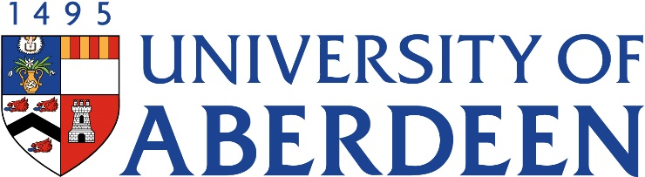

PA3004- Biochemical Pharmacology and Toxicology
Course Handbook 2023-2024

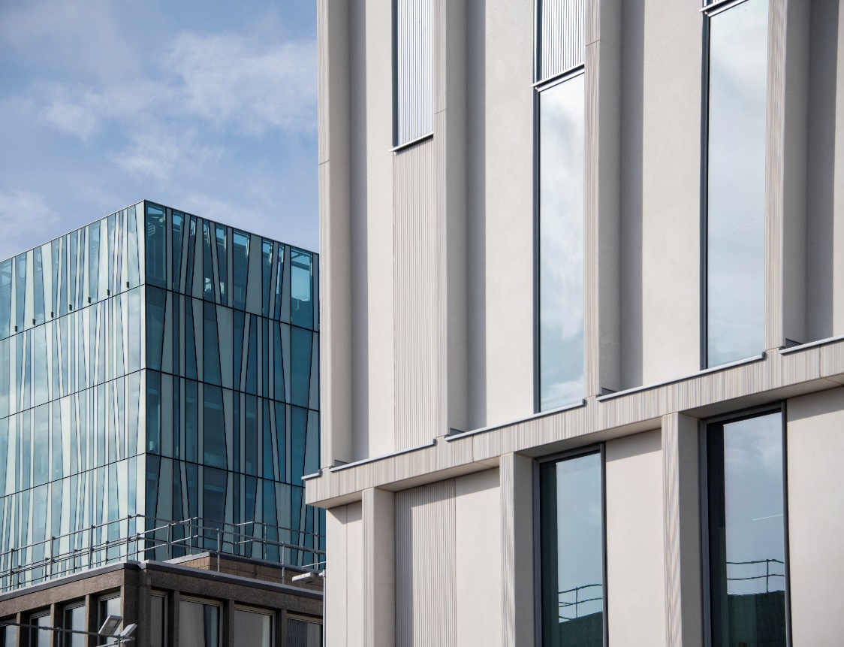
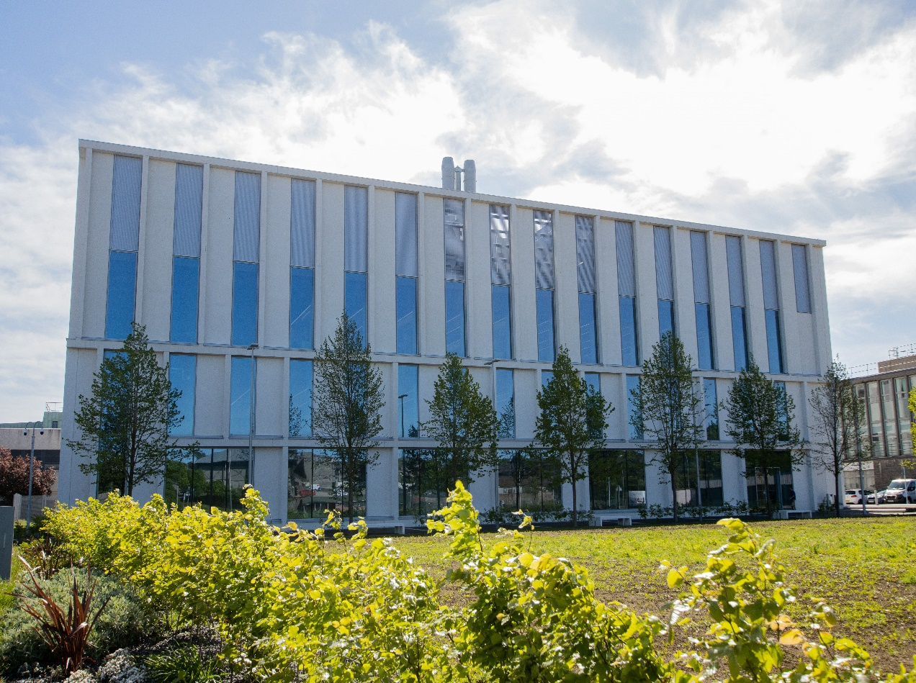
Undergraduate Medical Sciences
School of Medicine, Medical Sciences & Nutrition
Contents

- Course Summary (3)
- Course Aims & Learning Outcomes
- Course Teaching Staff
- Assessments & Examinations
- Class Representatives (4)
- Problems with Coursework
- Course Reading List (5)
- Lecture Synopsis
- Practical/Lab/Tutorial Work (8)
- University Policies (9)
- Academic Language & Skills support (10)
- Medical Sciences Common Grading Scale (12)
- Course Timetable PA3004: 2023-2024 (13)
- Campus and Floor Maps

Course Summary
This course examines aspects of the absorption, distribution, metabolism and excretion (ADME) of drugs and quantitative elements of pharmacokinetics. It also includes an introduction to toxicology, carcinogenesis, mutagenesis and the role of the immune system in a toxicological context. Finally, it explores many of the biochemical aspects associated with drugs that act on the renal and respiratory systems. Overall, it is a wide-ranging exploration of biochemical aspects of pharmacology and toxicology. The approach adopted in the course will be mechanism-based and will include problem solving and applied exercises to illustrate and reinforce the principles covered in the lectures.
Course Co-ordinator: Prof Steve Tucker (01224 437491; s.j.tucker@abdn.ac.uk )

Course Aims & Learning Outcomes

- To explore the principles of drug absorption, distribution, metabolism and excretion
- To examine pharmacokinetic modelling as a way of predicting drug behaviour in the body
- To introduce toxicology carcinogenesis, mutagenesis and organ specific toxicity
- To consider the role of the immune system in a toxicological context
- To investigate the renal and respiratory systems and their specific pharmacological manipulation.

Course Teaching Staff
Course Co-ordinator(s):
Prof S Tucker (ST)

Other Staff:
Prof G Nixon (GFN)
Prof D Scott (DS)
Prof H Wilson (HW)
Dr M Carlier (MC)

Assessments & Examinations

Students are expected to access and study ALL lectures, lab classes and online materials, and to complete all exercises by the given deadlines. The minimum performance acceptable for the granting of a class certificate is evidence of engagement with, at least, 50% of the lectures and lab classes, and presentation of all set course work. Failure to achieve this may result in your class certificate being withheld. The course assessment consists of:

- 30% assessed tutorials (1 x 10% - ADE; 2 x 10% pharmacokinetics)
- 20% practical report (drug metabolism practical)
- 10% online practical exercise (pharmacokinetic practical)
- 40% online test covering toxicology, renal and respiratory pharmacology

Resit assessment will be based on a completion of 2 timed essays selected from the course materials.
Your overall performance will be expressed as a grade awarded on the Common Grading Scale (CGS).

In addition to the above assessed exercises, there will several formative tutorials throughout the course to support application of taught materials and also several weekly tasks designed to engage you with the course and your fellow students. You are required to participate with these and offer an ongoing active contribution to the discussion board on MyAberdeen.
Failing to regularly engage with the course content, discussion forum activities, live sessions and assessments will indicate non-engagement with the course, which will start the C6/C7 process.
The University of Aberdeen C6/C7 process is a monitoring system to identify students who may be experiencing difficulties with their studies and to ensure that students remain on track for their degree. For more information, click here: https://www.abdn.ac.uk/students/academic-life/student-monitoring.php. If you receive a C6 you will be sent an email which details how to act to have the C6 removed from your record. Failure to take any action will lead to the C6 becoming a C7 where you will lose access to your course.
It is important that you regularly check your University of Aberdeen email account as all correspondence and updates about your studies will be sent to this email address.
If you are struggling with this course, please make contact with the course coordinator as soon as possible so that we can provide appropriate support.
Problems with Coursework
If students have difficulties with any part of the course that they cannot cope with they should notify the course coordinator immediately. If the problem relates to the subject matter general, advice would be to contact the member of staff who is teaching that part of the course. Students with registered disabilities should contact the medical sciences office, (medsci@abdn.ac.uk) (based in the Polwarth Building, Foresterhill) to ensure that the appropriate facilities have been made available. Otherwise, you are strongly encouraged to contact any of the following as you see appropriate:

- Course student representatives
- Course co-ordinator
- Convenor of the Medical Sciences Staff/Student Liaison Committee (Professor Gordon McEwan)
- Personal Tutor
- Medical Sciences Disabilities Co-ordinator (Dr Derryck Shewan)

All staff are based at Foresterhill and we strongly encourage the use of email or telephone the Medical Sciences Office. You may have a wasted journey travelling to Foresterhill only to find staff unavailable.

Class Representatives

We value students’ opinions in regard to enhancing the quality of teaching and its delivery; therefore, in conjunction with the Students’ Association we support the Class Representative system.

In the School of Medicine, Medical Sciences & Nutrition we operate a system of course representatives, who are elected from within each course. Any student registered within a course that wishes to represent a given group of students can stand for election as a class representative. You will be informed when the elections for class representative will take place.

What will it involve?
It will involve speaking to your fellow students about the course you represent. This can include any comments that they may have. You will attend a Staff-Student Liaison Committee and you should represent the views and concerns of the students within this meeting. As a representative, you will also be able to contribute to the agenda. You will then feedback to the students after this meeting with any actions that are being taken.

Training
Training for class representatives will be run by the Students Association. Training will take place within each half-session. For more information about the Class representative system visit www.ausa.org.uk or email the VP Education & Employability vped@abdn.ac.uk . Class representatives are also eligible to undertake the STAR (Students Taking Active Roles) Award with further information about this co-curricular award being available at: www.abdn.ac.uk/careers.

Course Reading List

Books recommended to support learning:
1. Rang & Dale; Pharmacology (ninth edition).
2. Gibson & Skett; Introduction to Drug Metabolism (third edition).
3. Hedaya; Basic Pharmacokinetics (second edition).
4. Birkett; Pharmacokinetics Made Easy.
5. Timbrell; Principles of Biochemical Toxicology (third edition).

Lecture Synopsis - lectures will be delivered face to face (unless otherwise indicated) and recordings provided afterwards for revision purposes. Students are expected to attend ALL lectures unless there are mitigating circumstances preventing them from doing so.
Lecture 1: Introduction to the course and what is biochemical pharmacology? - Professor S Tucker
Introduction to the course and the subject material that will be covered. There will also be an outline of the assessment criteria for the course, and the various exercises that constitute it. The lecture will finish with an introduction to what biochemical pharmacology is, how it will be explored through the course and why it is a key area of study.
Lecture 2-4: Absorption, distribution and excretion of drugs (ADE) - Professor S Tucker
Revision of pKa, partition coefficient, Henderson Hasselbach equation. Passage of drugs across membranes, diffusion, active transport, facilitated diffusion. Enteral administration, factors affecting absorption, including worked example. Non-parental routes of administration. Distribution of drugs, plasma protein binding, tissue reservoirs. Excretion of drugs in urine - tubular reabsorption, active secretion. Biliary secretion of drugs. Enterohepatic circulation.
Lecture 5: Pharmacokinetics: Introduction - Professor S Tucker
Introduction to the subject of pharmacokinetics. Advice on studying the subject and also definitions of the primary and secondary pharmacokinetic variables.
Lecture 5-6: Pharmacokinetics: Single dose IV kinetics - Professor S Tucker
The plasma concentration v time graph. Linear and semi-logarithmic plots, natural logarithms and exponential relationships. Zero order and first order processes. Calculating IV pharmacokinetic variables: plasma concentration at time 0, volume of distribution, elimination rate constant, elimination half time, clearance, AUC and the trapezoidal method.
Lecture 7: Pharmacokinetics: Single extravascular dose kinetics - Professor S Tucker
The phases of oral pharmacokinetics; absorption vs elimination. Calculating oral pharmacokinetic elimination parameters. The use of residuals to calculate kabs and absorption t1/2. Bioavailability (absolute and relative), bioequivalence and factors that influence these.
Lecture 8: Pharmacokinetics: IV infusion - Professor S Tucker
The concept of infusion and the zero order nature of the infusion rate (Ko). The balance between Ko and elimination determines equilibrium/steady state. Calculation of infusion parameters: steady state concentration, time to steady state, loading dose. The effect of changing these parameters in isolation. Post infusion data and how to determine elimination parameters from it.
Lecture 9: Pharmacokinetics: Renal clearance - Professor S Tucker
The concept of renal clearance and the different ways drugs can be handled by the renal system (filtration, secretion, reabsorption). Calculating renal clearance from urine and plasma sampling. Conclusions that can be drawn from renal parameters. Measurement of glomerular filtration rate (GFR) using creatinine handling data, and the relevance of this to renal clearance measures.
Lecture 10-11: Phase I metabolism (oxidation) - Professor S Tucker
Consequences and need for drug metabolism. Site of drug oxidation - liver (microsomes, mitochondria, cytosol). Microsomal oxidations - cytochrome P450-dependent oxidations, co-oxidation by PG synthetase, lipoxygenases. Non-microsomal oxidations - amine oxidases, alcohol and aldehyde oxidases, dehalogenation and purine oxidation. Enzymology - catalytic activity, co-factor requirements, substrate specificity, inhibitors. Relevance of drug oxidation to bioactivation and detoxification.
Lecture 12-13: Cytochrome P450 - Professor S Tucker
Catalytic cycle of cytochrome P450. Cytochrome P450 isozymes, mammalian isozymes, substrate specificity, implications for therapeutic effect and toxicity.
Lecture 14-15: Induction/inhibition of CYP450 - Professor S Tucker
Mechanisms of cytochrome P450 induction, receptor mediated (Ah, PXR, PPAR), species differences. Inhibition of cytochrome P450 by destruction of P450, formation of inactive complexes. Competition for active site of P450. Induction/inhibition of other drug metabolising enzymes.
Lecture 16: Phase II metabolism (conjugation) - Professor S Tucker
Role of phase II reactions in drug metabolism. Subcellular distribution of enzymes. Conjugation reactions - glucuronidation, sulphation, glutathione conjugation, acetylation, methylation, aminoacid conjugation. Enzymology - catalytic activity, co-factor requirements, substrate requirements, substrate specificity, inhibitors. Genetic polymorphisms - glucuronidation, acetylation. Glutathione transferases. Pharmacological and biological aspects of drug conjugation.
Lecture 17: Pharmacogenetics - Professor S Tucker
What is pharmacogenetics? What influence does genetic make-up have on drug metabolism and drug effects? Polymorphisms in the population. Case studies of aldehyde dehydrogenase, N-acetyl transferase and others. Polymorphic susceptibility based on endogenous role of enzymes.
Lecture 18: Phase III metabolism (transporters) - Dr M Carlier
An overview of the basics of transport including drugs and nutrients and the importance of transport in relation to ADME and drug metabolising processes.
Lecture 19-20: Immunity – a controlled Toxicity System I & II – Professor H Wilson
The immune system is a sophisticated toxic killing machine. These two teaching sessions will look at the role of the Immune system one of the main defence systems of the body. How the cells of the adaptive and innate immune systems interact and communicate to protect us.
The recognition of non-self or altered self by the immune system protects us form overwhelming infection and cancer.
Lecture 21: Immune mediated toxicity – Hypersensitivity - Professor H Wilson
The immune system is tuned to destroy pathogens and protect us from infection, however these immune responses can also cause injury to the host. When immune responses go wrong and there is excessive inflammation or undesirable reactions caused by the immune system (hypersensitivity), it can have very serious consequences. This lecture will look at the hypersensitivity reactions particularly those that may lead to allergy and autoimmunity pathologies.

Lecture 22-23: Respiratory pharmacology - Professor G Nixon
The concepts and material of the course will be examined in the context of the respiratory system with focus on airway diseases and their treatment e.g. asthma, COPD.
Lecture 24-25: Renal pharmacology - Professor D Scott
Renal Pharmacology I
This lecture will begin by briefly reviewing the major functions of the kidneys that are important for drug handling in the body and those that can be targeted to achieve therapeutic outcomes. We will then review the major class of drugs that affect renal function - the diuretics. Topics to be covered include: diuretics acting on the proximal tubule, loop diuretics, diuretics acting on the distal tubule (e.g. thiazides, aldosterone antagonists), osmotic diuretics.
Useful reading: Rang et al. (2007), 6th Ed., Chapter 24 The Kidney.
Renal Pharmacology II
This lecture will review agents that can increase or decrease urinary pH and drugs that can alter the excretion of organic molecules. We shall also examine the various drugs that are used to treat various renal conditions such as renal failure i.e. targeting problems such as hyperkalaemia and hyperphosphataemia, with a brief introduction to aspects of cardiovascular drugs that may also be of use in such situations. Finally, we shall review drugs used in urinary tract disorders i.e. agents that may aid urination or prevent incontinence.
Lecture 26: Carcinogenesis/mutagenesis - Dr M Carlier
Basic mechanisms of carcinogenesis and mutagenesis. The multistep process of carcinogenesis. Tests used to determine if a compound is either a carcinogen or a mutagen.
Lecture 27: Introduction to toxicology/In vivo/In vitro toxicology – Dr M Carlier
Introduction to toxicology and its importance relating to human health. The drug discovery/development process will be outlined, with reference to regulatory aspects of drug development. The advantages and disadvantages of using In vitro and in vivo models to investigate and demonstrate toxicological profiles of poisons and drugs will be discussed. How are these very different models used to explore toxicology of substances and drugs.

Tutorial/Practical Work

Formative Tutorials

These tutorials will involve completion of exercises and practice questions that do not count towards the final course mark, but are designed to reinforce and apply the materials covered in lectures. The format will vary with these sessions depending on the nature of the exercise. In some cases work will be required ahead of the class, in other cases exercises will be completed in the session working in small groups. Precise instructions will be communicated prior to the session through MyAberdeen. There may also be space to organise ad hoc tutorial sessions to cover specific areas of the course that students wish to explore or revisit in detail. Please contact the course coordinator to arrange such as session.
As these are integrated with other aspects of the course, they are compulsory and failure to complete these will deem you at risk of being withdrawn from the course.

There will also be space within these sessions and during specified times at the end of lectures to provide feedback on the course and its progress. This will allow changes and improvements to be made as the course runs to benefit the current class.

Practical Work

You are expected to participate in ALL practical sessions.

There are practical laboratory sessions intended to run face to face during the course running in 3 separate slots for different groups of students. You should choose a practical group (1-3) which correlates with those groups shown in the timetable at the back of this course guide. Swaps of practical groups are only possible if discussed with the course-coordinators as soon as possible after being assigned a practical group, but ideally should be avoided.

These practical sessions, will be based at the Science Teaching Hub on those dates and times shown in the timetable. Attendance will be taken at all practical classes. Practical guidance will be given at each practical class and information about the lab classes will be available on MyAberdeen prior to each class. Please ensure you read the instructions and complete any pre-session work ahead of the laboratory class.

A summary of the laboratory practicals are given below:

Pharmacokinetic model system practical:

This practical will use a model pharmacokinetic system to derive data for students to analyse and draw conclusions from. The session will be assessed through exercises made available for completion in MyAberdeen (10% of final mark).

In vitro drug metabolism practical
This investigates induction of rat cytochrome P450 (CYP450) enzymes by analysing the capacity for rat liver microsomal fractions to metabolise a fluorescent probe substrate (pentoxyresorufin). Kinetic analysis of control and induced CYP450 will be carried out and the practical assessed by submission of an individual report to MyAberdeen (20% of final course mark). The practical runs over 2 separate experimental sessions:

Session 1 - Measurement of specific pentoxyresorufin dealkylation by control and treated rat liver microsomes.
Session 2 - Use of a Lowry Assay to determine the protein content of microsomal samples used in session 1.

University Policies

Students are asked to make themselves familiar with the information on key education policies, available here. These policies are relevant to all students and will be useful to you throughout your studies. They contain important information and address issues such as what to do if you are absent, how to raise an appeal or a complaint and how the University will calculate your degree outcome.

These University wide education policies should be read in conjunction with this programme and/or course handbook, in which School specific policies are detailed. These policies are effective immediately, for the 2023/24 academic year. Further information can be found on the University’s Infohub webpage or by visiting the Infohub.

The information included in the institutional area for 2023-24 includes the following:

- Absence
- Appeals & Complaints
- Assessment
- Avoiding Plagiarism
- Communication
- Graduate Attributes
- MyAberdeen
- Student Learning Service (SLS)
- Student Monitoring/Class Certificates
- Student Discipline
- The Co-curriculum

Where to Find the Following Information:

C6/C7- University of Aberdeen Homepage > Students > Academic Life > Monitoring and Progress > Student Monitoriung (C6 & C7)
https://www.abdn.ac.uk/students/academic-life/student-monitoring.php#panel5179

Absences- To report absences you should use the absence reporting system tool on Student Hub. Once you have successfully completed and sent the absence form you will get an email that your absence request has been accepted. The link below can be used to log onto the Student Hub Website and from there you can record any absences you may have.

Log In - Student Hub (https://www.abdn.ac.uk/studenthub/loginbdn.ac.uk)

Submitting an Appeal- University of Aberdeen Homepage > Students > Academic Life > Appeals and Complaints
https://www.abdn.ac.uk/students/academic-life/appeals-complaints-3380.php#panel2109

Academic Language & Skills support
For students whose first language is not English, the Language Centre offers support with Academic Writing and Communication Skills.

Academic Writing
- Responding to a writing task: Focusing on the question
- Organising your writing: within & between paragraphs
- Using sources to support your writing (including writing in your own words, and
citing & referencing conventions)
- Using academic language
- Critical Thinking
- Proofreading & Editing

Academic Communication Skills
- Developing skills for effective communication in an academic context
- Promoting critical thinking and evaluation
- Giving opportunities to develop confidence in communicating in English
- Developing interactive competence: contributing and responding to seminar discussions
- Useful vocabulary and expressions for taking part in discussions

More information and how to book a place can be found here

Medical Sciences Common Grading Scale

Grade | Grade Point | % Mark | Category | Honours Class | Description
A1 | 22 | 90-100 | Excellent | First | • Outstanding ability and critical thought  • Evidence of extensive reading  • Superior understanding  •The best performance that can be expected from a student at this level
A2 | 21 | 85-89
A3 | 20 | 80-84
A4 | 19 | 75-79
A5 | 18 | 70-74
B1 | 17 | 67-69 | Very Good | Upper Second | • Able to argue logically and organise answers well  • Shows a thorough grasp of concepts  • Good use of examples to illustrate points and justify arguments  • Evidence of reading and wide appreciation of subject
B2 | 16 | 64-66
B3 | 15 | 60-63
C1 | 14 | 57-59 | Good | Lower Second | • Repetition of lecture notes without evidence of further appreciation of subject  • Lacking illustrative examples and originality  • Basic level of understanding
C2 | 13 | 54-56
C3 | 12 | 50-53
D1 | 11 | 47-49 | Pass | Third | • Limited ability to argue logically and organise answers  • Failure to develop or illustrate points  • The minimum level of performance required for a student to be awarded a pass
D2 | 10 | 44-46
D3 | 9 | 40-43
E1 | 8 | 37-39 | Fail | Fail | • Weak presentation  • Tendency to irrelevance  • Some attempt at an answer but seriously lacking in content and/or ability to organise thoughts
E2 | 7 | 34-36
E3 | 6 | 30-33
F1 | 5 | 26-29 | Clear Fail | Not used for Honours | • Contains major errors or misconceptions  • Poor presentation
F2 | 4 | 21-25
F3 | 3 | 16-20
G1 | 2 | 11-15 | Clear Fail/Abysmal |  | • Token or no submission
G2 | 1 | 1-10
G3 | 0 | 0

Course Timetable PA3004: 2023-2024
Date | Time | Place | Subject | Session | Staff
Week 8
Mon 18 Sep
Tue 19 Sep | 14:00-15:00 | St Marys 105 | Introduction to course | Lecture | SJT
 | 15:00-16:00 | St Marys 105 | ADE 1 | Lecture | SJT
Wed 20 Sep
Thu 21 Sep
Fri 22 Sep
Week 9
Mon 25 Sep | 14:00-15:00 | St Marys G3 | ADE 2 | Lecture | SJT
Tue 26 Sep | 14:00-16:00 | FN111 | ADE Tutorial | Tutorial | SJT
Wed 27 Sep
Thu 28 Sep
Fri 29 Sep | 14:00-15:00 | NK14 | Pharmacokinetics I - Introduction | Lecture | SJT
 | 15:00-16:00 | NK14 | Pharmacokinetics II - Single dose IV kinetics | Lecture | SJT
Week 10
Mon 2 Oct | 14:00-15:00 | St Marys G3 | Pharmacokinetics III - Single extravascular dose kinetics | Lecture | SJT
Tue 3 Oct | 09:00-10:00 | NK14 | Pharmacokinetics IV - IV infusion and renal clearance | Lecture | SJT
Wed 4 Oct
Thu 5 Oct
Fri 6 Oct
Week 11
Mon 9 Oct | 14:00-15:00 | St Marys G3 | Pharmacokinetics V - Multiple dose kinetics | Lecture | SJT
Tue 10 Oct | 09:00-10:00 | NK14 | PK Summary | Lecture | SJT
Wed 11 Oct
Thu 12 Oct
Fri 13 Oct | 15:00-16:00 | NK14 | Phase I Metabolism (oxidation) | Lecture | SJT
Week 12
Mon 16 Oct | 14:00-15:00 | St Marys G3 | Cytochrome P450 | Lecture | SJT
Tue 17 Oct | 10:00-13:00 | 0.004 benches 15-18 | Practical 1: Modelling Pharmacokinetics | Practical | SJT
 | 14:00-16:00 | FN111 | PK tutorial | Tutorial | SJT
Wed 18 Oct
Thu 19 Oct
Fri 20 Oct | 14:00-15:00 | NK14 | Induction/inhibition of CYP450 | Lecture | SJT
Week 13
Mon 23 Oct | 14:00-15:00 | St Marys G3 | Phase II Metabolism (conjugation) | Lecture | SJT
Tue 24 Oct | 09:00-10:00 | NK14 | Pharmacogenomics | Lecture | SJT
Wed 25 Oct
Thu 26 Oct
Fri 27 Oct
Week 14
Mon 30 Oct | 14:00-15:00 | St Marys G3 | Introduction to In Vitro Metabolism practical | Lecture | SJT
Tue 31 Oct
Wed 1 Nov
Thu 2 Nov
Fri 3 Nov | 14:00-15:00 | NK14 | Metabolism tutorial | Tutorial | SJT
 | 15:00-16:00 | NK14 | Transporters | Lecture | MC
Week 15
Mon 6 Nov
Tue 7 Nov | 10:00-13:00 | 0.004 benches 15-18 | Practical 2– in vitro metabolism Part A | Practical | SJT
Wed 8 Nov
Thu 9 Nov
Fri 10 Nov | 14:00-15:00 | NK14 | Immunity: a controlled toxicity system I | Lecture | HW
Week 16
Mon 13 Nov | 14:00-15:00 | St Marys G3 | Immunity: a controlled toxicity system II | Lecture | HW
Tue 14 Nov | 09:00-10:00 | NK14 | Immune mediated toxicity –Hypersensitivity | Lecture | HW
 | 10:00-13:00 | 0.004 benches 15-18 | Practical 2 – in vitro metabolism Part B | Practical | SJT
Wed 15 Nov
Thu 16 Nov
Fri 17 Nov | 14:00-15:00 | NK14 | Special topic 1: Respiratory pharmacology I | Lecture | GFN
Week 17
Mon 20 Nov
Tue 21 Nov | 09:00-10:00 | NK14 | Special topic 1: Respiratory pharmacology II | Lecture | GFN
Wed 22 Nov
Thu 23 Nov
Fri 24 Nov | 14:00-15:00 | NK14 | Target organ toxicity | Lecture | SJT
 | 15:00-16:00 | NK14 | Tutorial | Tutorial | SJT
Week 18
Mon 27 Nov | 14:00-15:00 | St Marys G3 | Special topic 2: Renal pharmacology I | Lecture | DS
Tue 28 Nov | 09:00-10:00 | NK14 | Introduction to toxicology/in vivo/in vitro toxicity | Lecture | MC
Wed 29 Nov
Thu 30 Nov
Fri 1 Dec | 14:00-15:00 | NK14 | Mutagenesis/carcinogenesis | Lecture | MC
 | 15:00-16:00 | NK14 | Special topic 2: Renal pharmacology II | Lecture | DS

Staff

Professor S Tucker (SJT) Course Co-ordinator
Professor GF Nixon (GFN)
Professor Derek Scott (DS)
Professor H Wilson (HW)
Dr M Carlier (MC)

Campus Maps - Foresterhill

Polwarth Floor Plans

