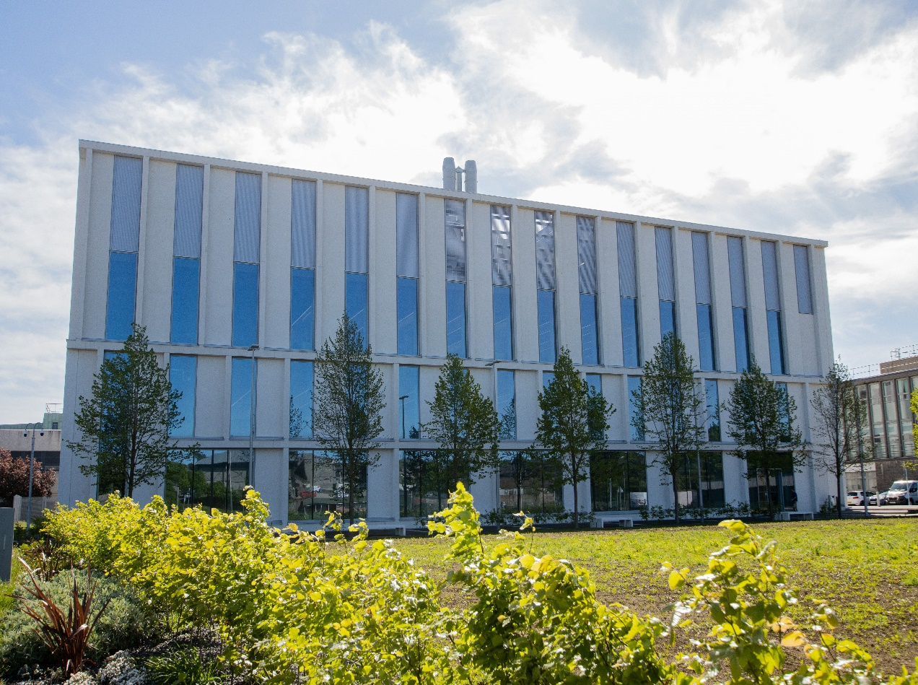

*IM3502- Applied Immunology: Human Health*

*Course Handbook 2023-2024*

*Undergraduate Medical Sciences*

*School of Medicine, Medical Sciences & Nutrition*

**Contents**

* Course Summary (3)
* **Course Aims & Learning Outcomes**
* **Course Teaching Staff**(4)
* **Assessments & Examinations**(5)
* **Class Representatives**
* **Problems with Coursework**(6)
* **Course Reading List**
* **Lecture Synopses**(7)
* **Practical/Lab/Tutorial Work**
* **University Policies**
* **Academic Language & Skills support**(8)
* **Medical Sciences Common Grading Scale**(9)
* **Course Timetable IM3502: 2023-202****4** (10)
* Campus and Floor Maps

Course Summary

This course runs in parallel with IM3501 and will take the fundamental knowledge that you learn there and show how it applies in human health and disease. However, the course is also designed to be standalone and will utilise the immunology knowledge you have gained previously. If you are taking IM3502 but not IM3501 please do ask if you need additional help.

The course investigates how the various mechanisms of innate and adaptive immunity interact to protect against human disease and how immune dysfunction may cause disease. Immune responses to pathogens (viruses, bacteria, fungi and parasites): organ transplantation; immune-biology of cancer; blood groups; development of vaccines and antibody-based therapies are covered. Practical work will reinforce this knowledge as well as teaching immunological and generic laboratory techniques and a range of transferable skills.

# Course Aims & Learning Outcomes

Aims

1. To develop and extend knowledge of how cellular and molecular components of the immune system act together to protect against human disease and how their dysfunction may cause disease.
2. To further develop practical laboratory skills of use in a general laboratory as well as those more specific to immunology.
3. To further develop and practice a range of transferable skills including data analysis, poster preparation, presentation skills and critical literature analysis.

Learning Outcomes

Students should be able to synthesize and apply their knowledge of specific cellular and molecular components of the immune system to predict how they interact to defend against infection and how their dysfunction or imbalance may lead to disease.

This should include:

* the innate immune system and cells such as dendritic cells, neutrophils, macrophages, NK cells
* the adaptive immune system including T cell subsets, B cells and antibodies
* the role of other immune system components such as cytokines, complement factors, acute phase proteins
* an understanding of how and why autoimmune disease develops
* the significance of MHC in normal functioning of the immune system and in transplantation

Students should be able to use general laboratory and team working skills, data analysis, software applications and literature research to investigate a scientific hypothesis, critically analyse results and create a report or a poster presentation.

# Course Teaching Staff

Course Co-ordinator(s):

Dr Isabel Crane (IJC) [i.j.crane@abdn.ac.uk](mailto:i.j.crane@abdn.ac.uk)

Other Staff:

Dr Patrick Cao (PC) [**h.cao@abdn.ac.uk**](mailto:h.cao@abdn.ac.uk)

Dr Indrani Mukhopadhya (IM) [indrani.mukhopadhya@abdn.ac.uk](mailto:indrani.mukhopadhya@abdn.ac.uk)

Dr Donna MacCallum (DMC) [**d.m.maccallum@abdn.ac.uk**](mailto:d.m.maccallum@abdn.ac.uk)

Dr Candice Quin (CQ) candice.quin@abdn.ac.uk

Dr Frank Ward (FW) [**f.j.ward@abdn.ac.uk**](mailto:f.j.ward@abdn.ac.uk)

Dr Virtu Solano (VS) [**mariavirtudes.solanocollado@abdn.ac.uk**](mailto:mariavirtudes.solanocollado@abdn.ac.uk)

Dr Tara Sutherland (TS) tara.sutherland@abdn.ac.uk

In-person teaching

Please note that we aim for all lectures and tutorials to be in-person on campus. Highlighted in green on the timetable is the practical material which you should study before the class.

The live in-person lectures will have full recordings which have captions and powerpoint files, available online on MyAberdeen, so that you can go over them later, as well, at your leisure. These are likely to have been recorded in advance to improve quality and may be in shorter sections and may include questions which aim to help you consider the material in more depth. Because the full captioned, recorded lectures have been prepared in advance for you, the in-person sessions may not be identical and may focus on certain aspects of the lectures to help with understanding but use the online recordings as the definitive version for revision.

Assessments & Examinations

Assessment

There will be a 40% continuous assessment component to this module based upon 2 assignments which have equal weighting.

Examination

There will be a written examination at the end of the course (60%). It will consist of a choice of two questions selected from a total of four.

IM3502 is a 15 credit course and to achieve these credits you should put in 150 hours of study including attending lectures, practical classes, completing assignments, reading and revising. Students are expected to attend all lectures, laboratory classes and to complete all class exercises by stated deadlines.

The degree examination is held in May, with the re-sit examination in July. The previous continuous assessment mark will be carried over for the re-sit. If you fail the practical continuous assessment component of the course, you will be required to resubmit this or complete alternative work and this will be capped at CGS mark D3.

# Class Representatives

We value students’ opinions in regard to enhancing the quality of teaching and its delivery; therefore, in conjunction with the Students’ Association we support the Class Representative system.

In the School of Medicine, Medical Sciences & Nutrition we operate a system of course representatives, who are elected from within each course. Any student registered within a course that wishes to represent a given group of students can stand for election as a class representative. You will be informed when the elections for class representative will take place.

What will it involve?

It will involve speaking to your fellow students about the course you represent. This can include any comments that they may have. You will attend a Staff-Student Liaison Committee and you should represent the views and concerns of the students within this meeting. As a representative, you will also be able to contribute to the agenda. You will then feedback to the students after this meeting with any actions that are being taken.

Training

Training for class representatives will be run by the Students Association. Training will take place within each half-session. For more information about the Class representative system visit [www.ausa.org.uk](http://www.ausa.org.uk) or email the VP Education & Employability [vped@abdn.ac.uk](mailto:vped@abdn.ac.uk) . Class representatives are also eligible to undertake the STAR (Students Taking Active Roles) Award with further information about this co-curricular award being available at: [www.abdn.ac.uk/careers](http://www.abdn.ac.uk/careers).

Problems with Coursework

If students have difficulties with any part of the course that they cannot cope with alone, they should notify the course coordinator immediately. If the problem relates to the subject matter general advice would be to contact the member of staff who is teaching that part of the course. Students with registered disabilities should contact the medical sciences office, ([medsci@abdn.ac.uk](mailto:medsci@abdn.ac.uk)) (based in the Polwarth Building, Foresterhill) to ensure that the appropriate facilities have been made available. Otherwise, you are strongly encouraged to contact any of the following as you see appropriate:

* Course student representatives
* Course co-ordinator
* Convenor of the Medical Sciences Staff/Student Liaison Committee
* Personal Tutor
* Medical Sciences Disabilities Co-ordinator (Dr Derryck Shewan)

All staff are based at Foresterhill and we strongly encourage the use of email or telephone the Medical Sciences Office. You may have a wasted journey travelling to Foresterhill only to find staff unavailable.

If a course has been completed and students are no longer on campus (i.e. work from second half session during the summer vacation), coursework will be kept until the end of Fresher’s Week, during the new academic year. After that point, unclaimed student work will be securely destroyed.

# Course Reading List

Cellular and Molecular Immunology by A.K. Abbas, A.H. Lichtman and S. Pillai (10th Edition) W.B. Saunders Co. (ISBN: 9780323757485)

This textbook provides a lot of information relevant to this course and many of the lectures will use the material in this book. You will also find the 9th edition available second hand and in the library. The 9th edition is also available via Leganto online (10th edition is not available online yet).

Where appropriate you will also be directed to specific reading material.

If you do not plan to do Immunology at level 4 there is also a simpler version of the Abbas textbook, Basic Immunology by A.K. Abbas, A.H. Lichtman and S. Pillai (Sixth Edition) W.B. Saunders Co. (**ISBN:** 9780323549431)

[**Janeway's Immunobiology**](http://www.amazon.co.uk/Janeways-Immunobiology-Ken-Murphy/dp/0815341237/ref=sr_1_1?ie=UTF8&qid=1292246371&sr=1-1) by Murphy et al., 8th or 9th Edition may also be helpful.

# 

Lecture Synopses

These are available on MyAberdeen.

Practical/Lab/Tutorial Work

The course contains two practical elements, with a marked assignment (P1 and P2). Each marked assignment is given equal weight.

Deadlines for submitting the two assignments are shown on the timetable at the end of this handbook. The assignment must be submitted online by 4.30 pm on that day.

Late submissions without a negotiated extension or a justifiable reason will have CGS grades deducted as shown in the Assessment Handbook e.g. if work is awarded a CGS grade of B1, and the work is four days late, the final mark will be B2. After seven days, the work is marked at a maximum of D3, and after 10 days it will be recorded as zero (G3).

University Policies

Students are asked to make themselves familiar with the information on key education policies, available [here](https://www.abdn.ac.uk/staffnet/teaching/key-education-policies-for-students-11809.php). These policies are relevant to all students and will be useful to you throughout your studies.  They contain important information and address issues such as what to do if you are absent, how to raise an appeal or a complaint and how the University will calculate your degree outcome.

These University wide education policies should be read in conjunction with this programme and/or course handbook, in which School specific policies are detailed. These policies are effective immediately, for the 2023/24 academic year. Further information can be found on the [University’s Infohub webpage](https://www.abdn.ac.uk/students/) or by visiting the Infohub.

The information included in the institutional area for 2023-24 includes the following:

* Assessment
* Feedback
* Academic Integrity
* Absence
* Student Monitoring/ Class Certificates
* Late Submission of Work
* Student Discipline
* The co-curriculum
* Student Learning Service (SLS)
* Professional and Academic Development
* Graduate Attributes
* Email Use
* MyAberdeen
* Appeals and Complaints

Where to Find the Following Information:

C6/C7- University of Aberdeen Homepage > Students > Academic Life > Monitoring and Progress > Student Monitoring (C6 & C7)

https://www.abdn.ac.uk/students/academic-life/student-monitoring.php#panel5179

Absences- To report absences you should use the absence reporting system tool on Student Hub. Once you have successfully completed and sent the absence form you will get an email that your absence request has been accepted. The link below can be used to log onto the Student Hub Website and from there you can record any absences you may have.

[Log In - Student Hub (ahttps://www.abdn.ac.uk/studenthub/loginbdn.ac.uk)](https://www.abdn.ac.uk/studenthub/login)

Submitting an Appeal- University of Aberdeen Homepage > Students > Academic Life > Appeals and Complaints

https://www.abdn.ac.uk/students/academic-life/appeals-complaints-3380.php#panel2109

Academic Language & Skills support

For students whose first language is not English, the Language Centre offers support with Academic Writing and Communication Skills.

Academic Writing

* Responding to a writing task: Focusing on the question
* Organising your writing: within & between paragraphs
* Using sources to support your writing (including writing in your own words, and

citing & referencing conventions)

* Using academic language
* Critical Thinking
* Proofreading & Editing

Academic Communication Skills

* Developing skills for effective communication in an academic context
* Promoting critical thinking and evaluation
* Giving opportunities to develop confidence in communicating in English
* Developing interactive competence: contributing and responding to seminar discussions
* Useful vocabulary and expressions for taking part in discussions

More information and how to book a place can be found here

Medical Sciences Common Grading Scale

|  |  |  |  |  |  |
| --- | --- | --- | --- | --- | --- |
| Grade | Grade Point | % Mark | Category | Honours Class | Description |
| A1 | 22 | 90-100 | Excellent | First | • Outstanding ability and critical thought • Evidence of extensive reading • Superior understanding •The best performance that can be expected from a student at this level |
|  |
| A2 | 21 | 85-89 |  |
|  |
| A3 | 20 | 80-84 |  |
|  |
| A4 | 19 | 75-79 |  |
|  |
| A5 | 18 | 70-74 |  |
|  |
| B1 | 17 | 67-69 | Very Good | Upper Second | • Able to argue logically and organise answers well  • Shows a thorough grasp of concepts  • Good use of examples to illustrate points and justify arguments  • Evidence of reading and wide appreciation of subject |  |
|  |
| B2 | 16 | 64-66 |  |
|  |
| B3 | 15 | 60-63 |  |
|  |
| C1 | 14 | 57-59 | Good | Lower Second | • Repetition of lecture notes without evidence of further appreciation of subject • Lacking illustrative examples and originality • Basic level of understanding |  |
|  |
| C2 | 13 | 54-56 |  |
|  |
| C3 | 12 | 50-53 |  |
|  |
| D1 | 11 | 47-49 | Pass | Third | • Limited ability to argue logically and organise answers • Failure to develop or illustrate points • The minimum level of performance required for a student to be awarded a pass |  |
|  |
| D2 | 10 | 44-46 |  |
|  |
| D3 | 9 | 40-43 |  |
|  |
| E1 | 8 | 37-39 | Fail | Fail | • Weak presentation • Tendency to irrelevance • Some attempt at an answer but seriously lacking in content and/or ability to organise thoughts |  |
|  |
| E2 | 7 | 34-36 |  |
|  |
| E3 | 6 | 30-33 |  |
|  |
| F1 | 5 | 26-29 | Clear Fail | Not used for Honours | • Contains major errors or misconceptions • Poor presentation |  |
|  |
| F2 | 4 | 21-25 |  |
|  |
| F3 | 3 | 16-20 |  |
|  |
| G1 | 2 | 11-15 | Clear Fail/Abysmal |  | • Token or no submission |  |
|  |
| G2 | 1 | 1-10 |  |
|  |
| G3 | 0 | 0 |  |
|  |

Course Timetable IM3502: 2023-2024

|  |  |  |  |  |  |
| --- | --- | --- | --- | --- | --- |
| Day | Time | Place | Subject | Session | Staff |
| Week 26 | | | | | |
| Mon 22 Jan | 14:00-15:00 | 1M:001 | L 1: Introduction; Immunity and immune disease | Lecture | IC |
| Tue 23 Jan | 10:00-12:00 | CR2 | P 1: Scientific literature. Poster exercise introduction | Practical | IC/CQ |
| Wed 24 Jan | 10:00-11:00 | D2 workshop | L 2: Inflammation | Lecture | IC |
| Thu 25 Jan |  |  |  |  |  |
| Fri 26 Jan | 15:00-16:00 | 1M:001 | L 3: Immune response to bacteria | Lecture | VS |
| Week 27 | | | | | |
| Mon 29 Jan | 14:00-15:00 | 1M:001 | L 4: Immune response to viruses | Lecture | VS |
|  |  | MyAbd | P 1 in advance: Macrophage function – please listen to recorded introduction and read the associated handbook |  | CQ/IC |
| Tue 30 Jan | 10:00-13:00 | STH 1.007 | P 2: Macrophage function | Practical | CQ/IC |
| Wed 31 Jan | 10:00-11:00 | D2 workshop | L 5: Immune response to parasites | Lecture | VS |
| Thu 1 Feb |  |  |  |  |  |
| Fri 2 Feb | 14:00-15:00 | 1M:003 | L 6: Response to fungal infection | Lecture | DMC |
| Week 28 | | | | | |
| Mon 5 Feb | 15:00-17:00 | 1M:001 | L 7: Antigens, antibodies and blood groups | Lecture and case study | PC |
| 17:00 |  | Deadline for submitting assignment 1 | N/A |  |
| Tue 6 Feb | 11:00-13:00 | CR2 | Poster preparation | Workshop | IC |
| Wed 7 Feb | 10:00-11:00 | D2 workshop | L 8: Antigens and tumours | Lecture | IC |
| Thu 8 Feb |  |  |  |  |  |
| Fri 9 Feb | 15:00-16:00 | 1M:001 | L 9: Antigens and gut immunology | Lecture | IM |
| Week 29 | | | | | |
| Mon 12 Feb | 14:00-15:00 | 1M:001 | L 10: Antigens and transplantation | Lecture | CQ |
| Tue 13 Feb | 10:00-12:00 | 1M:003 | T1: SARS-CoV-2 and the Immune Response | Tutorial | VS |
| Wed 14 Feb | 10:00-11:00 | D2 workshop | L 11: Hypersensitivity 1 | Lecture | TS |
| 17:00 |  | Deadline for submitting poster | N/A |  |
| Thu 15 Feb |  |  |  |  |  |
| Fri 16 Feb | 15:00-16:00 | 1M:001 | L 12: Hypersensitivity 2 | Lecture | TS |
| Week 30 | | | | | |
| Mon 19 Feb | 14:00-15:00 | 1M:001 | L13 Autoimmune disease | Lecture | TS |
| Tue 20 Feb | 10:00-12:00 | D2 workshop | P2: Poster presentations | Practical | IC/CQ |
| Wed 21 Feb | 10:00-11:00 | D2 workshop | L 14: Antibody therapy | Lecture | CQ |
| Thu 22 Feb |  |  |  |  |  |
| Fri 23 Feb | 15:00-16:00 | 1M:001 | L 15: Vaccines | Lecture | FW |

Staff:

Dr Virtu Solano (VS);

Dr Isabel Crane (IC);

Dr Donna MacCallum (DMC);

Dr Frank Ward (FW);

Dr Patrick Cao (PC);

Dr Tara Sutherland (TS);

Dr Candice Quin (CQ);

Dr Indrani Mukhopadhya (IM)

Venues

1M:001; 1M:003. – Polwarth Building, Foresterhill

D2 Workshop – Biomedical Physics Building, Foresterhill

CR2 – Computer Room 2, Polwarth Building, Foresterhill

STH Science Teaching Hub, Old Aberdeen

Campus Maps - Foresterhill



Polwarth Floor Plans

