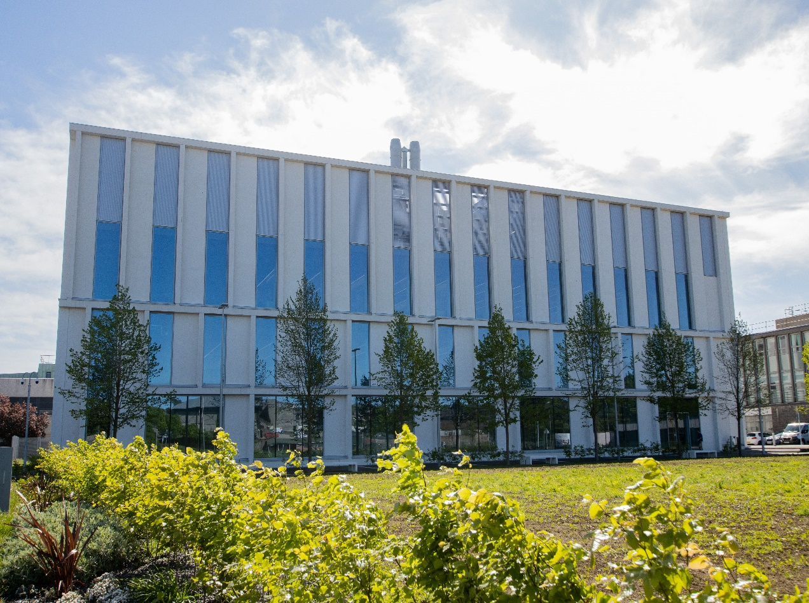

*BT4506- Advanced Bio-Business*

*Course Handbook 2023-2024*

*Undergraduate Medical Sciences*

*School of Medicine, Medical Sciences & Nutrition*

**Contents**

* Course Summary
* **Course Aims & Learning Outcomes**
* **Course Teaching Staff**
* **Assessments** **(5)**
* **Class Representatives**
* **Problems with Coursework**
* **Course Reading List**
* **Lecture Synopsis**
* **Practical/Lab/Tutorial Work**
* **University Policies**
* **Academic Language & Skills support**
* **Medical Sciences Common Grading Scale**
* **Course Timetable BT4506: 2023-2024** **(11)**
* Campus and Floor Maps

Course Aims & Learning Outcomes

Welcome to a fully-revised Advanced Biobusiness. I am genuinely delighted to be able to deliver what I believe will be by far the best course we have ever been fortunate enough to be able to run. This year we will have a mixture of extensive background content, to provide the foundations and framework for your virtual companies; alongside a number of expert external speakers providing first-hand examples of how it can be done (a prize-winning elevator pitch and a fresh returnee from the toughest bio-business boot camp in the world); a local-but-global superstar who is about as inspirational an example as exists; one of our own larger than life superstars; an expert in the hard-core finance (chortle…enjoy!); er, and me…well, you probably won’t find anyone more enthusiastic about the topic!

Last year, the teams completely blew me away with what they came up with and their ability to work out both the smallest details and the toughest concepts, and seriously impressed the Dragons with the breadth and depth of their knowledge about the ventures they had created. This year I’m expecting even better. Hope you enjoy the course as much as I expect to enjoy delivering it.

Course Summary

* “The inventor turns money into innovation, but the [bio]entrepreneur turns [biomedical] innovation into money” (Unknown source)

In the world of biomedicine and biotechnology, it is the individual who sees opportunities where others see challenges who drives innovation…and goes on to change the world

When *you* make that discovery or invention, will *you* be prepared to seize the opportunity and change the world?

In the world of biomedicine and biotechnology, it is the small, nimble, dynamic, entrepreneurial companies who drive innovation…and go on to change the world

When *you* go to work for that dynamic start-up company, will *you* have the right mindset and skills to ensure that the product reaches the patient or the customer?

This course will aim to bring out the “bioentrepreneur” in you and allow you to develop a “prepared mind” for when that stroke of genius comes your way.

This course will build on the work of the previous two courses and challenge students to develop their own virtual bio-business. Graduates with an understanding of the exploitation and commercialisation of scientific ideas are the next generation of people who will solve the great challenges of our time: from food security and clean energy to cures for dementia and cancer. The entrepreneur is responsible for making dreams into a reality – from starting up dynamic new companies that change the way industries operate, to simply ensuring that blue sky ideas reach their full potential and benefit humanity [you can “just” cure cancer if you like – there is no rule that says you have become rich and famous too, if that really doesn’t appeal!].

Previously, we have focussed primarily on the scientific and technical aspects, this year we will start to think more about some aspects that many scientists regard as peripheral, secondary or just plain uninteresting:

Q: “What is the single necessary and sufficient condition for a business?

Hint: It is not a product, a technology, a customer need, a business plan, a vision, a strong team, a CEO, money, investors, competitive advantage, or company values (not that these aren’t important…)

A: The single necessary and sufficient condition for a business is a paying customer”

Course Aims & Learning Outcomes

The main aim is to have fun and to enjoy the experience of “growing” as a group of creative, dynamic, free-thinking go-getters, who provide each other with support, encouragement and inspiration in a collective journey towards becoming a bioentrepreneur. There is no rule that says you cannot all get a top grade!

1. This year, working in teams, you will complete the development of “your” idea and explore all the aspects of a business that will develop it to reach a viable product or a commercial exit.
2. In addition to the topics covered in previous years, we will introduce or go into greater depth on issues such as finance and funding, building a persona of your customer, competitive advantage of your product, realistic expectations for your company and product (e.g. how much is it *really* worth and how much will it *really* cost to reach a suitable endpoint?), market research and marketing, and the central importance of the customer rather than the science
3. The requirement to have a strong market pull and not just technology push

This course will challenge students to think about the nature of research when driven by commercial outcomes. Many of the future recruitment opportunities for students with medical science skills may involve roles in biobusiness development rather than exclusively research at the bench. Graduates with subject expertise, combined with an ability to see and understand the “bigger picture”, are in great demand for the dynamic small and medium companies that provide employment for over 60% of the UK workforce – as well as being valuable members of the multi-disciplinary teams in big pharma and biotech. This course hopes to enable our students to be at a competitive advantage when seeking such career opportunities when compared to those students that only have a traditional scientific background.

Course Teaching Staff

Course Coordinator(s):

Dr Iain Greig: [i.greig@abdn.ac.uk](mailto:i.greig@abdn.ac.uk)

* Dr Deborah O’Neil – CEO Novabiotics
* Prof Andy Porter – Director Scottish Biologics Facility
* Dr William Jackson – Deputy Dean of the University of Aberdeen Business School and Head of the Department of Accountancy, Finance and Real Estate
* Dr Soumya Palliyil – School Enterprise and Innovation Champion
* Dr Heather Morgan – Dean for Enterprise and Innovation

Assessments & Examinations

**Course Assignments**

There are 3 assignments in the course:

**Assessment 1: Hand in 23rd February 2024**

**A Company Sketch**

Short answers to specific questions you will be given. These will set the scene for your company and will cover aspects such as: the market, the market need, the customer, the business model, the competition and the competitive advantage. This should feed directly into your company profile and presentation.

**Assessment 2: Hand in 11th March 2024**

**Intellectual Property for your venture**

In this assignment your group will provide the outline for a patent to cover your invention. It must be vaguely realistic (so, no process for achieving immortality, as per one of the patents in the lecture) but again can have some jumps in reality (e.g. you have successfully engineered your organism to do X or Y).

Working in your team. Each of you will be responsible for one section (after discussion / with help from the rest of the group). Your final submission will say who wrote each section and you must all agree that this was indeed the case. While you will be marked as a group, you must all contribute and you must all submit a copy of the document.

Your submission must cover:

1. The Title (this must be appropriately descriptive) and the Abstract.
2. The Background to the Invention: what is the technical problem and how does your invention solve this problem
3. Prior Art: what was done previously that relates to this invention - what is the nearest "prior art"
4. Inventiveness: how is your invention not obvious? What is "surprising and unexpected" about your invention?
5. Technical Data: what data would your patent contain to convince the examiner that you were "in possession" of the invention at the time of filing (i.e. you had actually done what you said). What data would be required to prove to the examiner that your invention does what you say and solves the problem you have described above? (i.e. if your drug will treat a disease, you clearly will not have human data and, at an early stage, are likely to have only in vitro data...but what might this be?)

**Assessment 3: 25th March 2024**

**Company Presentation (as per Dragon’s Den)**

* 25 min presentation plus around 10 min questions
* You are an SME Biotech/Biomed company
* You are less than 5 years old
* You can be in any biotech/biomedical space
* Feel free to make up science (within reason – one *deus ex machina* is perfectly acceptable!)
* Role play (CEO, CFO, CSO, CBO, COO etc). You may need to take on a couple of roles
* All to present

The course will be assessed by continuous assessment (100%). All assignments will be marked on the common grading scale (CGS, copy attached).

**Continuous Assessment**

• One company brief 30%; one presentation 40%; one Patent Summary 30%.

# Class Representatives

We value students’ opinions in regard to enhancing the quality of teaching and its delivery; therefore, in conjunction with the Students’ Association we support the Class Representative system.

In the School of Medicine, Medical Sciences & Nutrition we operate a system of course representatives, who are elected from within each course. Any student registered within a course that wishes to represent a given group of students can stand for election as a class representative. You will be informed when the elections for class representative will take place.

What will it involve?

It will involve speaking to your fellow students about the course you represent and, ideally, setting up some sort of social media outlet by which you can all communicate. This can include any comments that they may have. You will attend a Staff-Student Liaison Committee and you should represent the views and concerns of the students within this meeting. As a representative, you will also be able to contribute to the agenda. You will then feedback to the students after this meeting with any actions that are being taken.

It will also involve meeting with your counterparts in 2nd and 3rd year to discuss ways in which the three year-groups can be mutually supporting and build a community of like-minded individuals, such that entrepreneurship is “in the air”.

Finally, if required, it may involve identifying the requirement, and an appropriate time, for setting up additional sessions with staff to cover any material you feel either has not been covered or warrants more in-depth coverage.

Training

Training for class representatives will be run by the Students Association. Training will take place within each half-session. For more information about the Class representative system visit [www.ausa.org.uk](http://www.ausa.org.uk) or email the VP Education & Employability [vped@abdn.ac.uk](mailto:vped@abdn.ac.uk) . Class representatives are also eligible to undertake the STAR (Students Taking Active Roles) Award with further information about this co-curricular award being available at: [www.abdn.ac.uk/careers](http://www.abdn.ac.uk/careers).

Problems with Coursework

If students have difficulties with any part of the course that they cannot cope with, alone they should please please please notify the course coordinator immediately. If the problem relates to the subject matter general, advice would be to contact the member of staff who is teaching that part of the course. Students with registered disabilities should contact the medical sciences office, ([medsci@abdn.ac.uk](mailto:medsci@abdn.ac.uk)) (based in the Polwarth Building, Foresterhill) to ensure that the appropriate facilities have been made available. Otherwise, you are strongly encouraged to contact any of the following as you see appropriate:

* Course student representatives
* Course co-ordinator
* Convenor of the Medical Sciences Staff/Student Liaison Committee (Professor Gordon McEwan)
* Personal Tutor
* Medical Sciences Disabilities Co-ordinator (Dr Derryck Shewan)

# Course Reading List

* [**So you want to be a student entrepreneur?** | N**ature Biotechnology**](https://www.nature.com/articles/nbt.3778/#:~:text=%20So%20you%20want%20to%20be%20a%20student,from%20investors%20and%20organizations%20that%20they...%20More%20) **(click to access article!)**

# [**How to start a life science company**: a comprehensive guide for first-time entrepreneurs - University of Aberdeen (exlibrisgroup.com)](https://abdn.primo.exlibrisgroup.com/discovery/fulldisplay?docid=alma9918135635305941&context=L&vid=44ABE_INST:44ABE_VU1&lang=en&search_scope=MyInst_and_CI&adaptor=Local%20Search%20Engine&tab=Everything&query=any,contains,how%20to%20start%20a%20life%20science&offset=0) [click on link to access details]

* [**The Edison of Medicine (hbr.org)**](https://hbr.org/2017/03/the-edison-of-medicine) (click on link to access article)
* [**Biotechnology Entrepreneurship:** Craig Shimasaki](https://www.elsevier.com/books/biotechnology-entrepreneurship/shimasaki/978-0-12-815585-1) [click on link to see Amazon page]. An [older edition is available free online: What is Biotechnology Entrepreneurship? - ScienceDirect](https://www.sciencedirect.com/science/article/pii/B978012404730300004X) [click on link to access PDFs]. It is quite advanced but you may find it interesting to leaf through.
* [Disciplined Entrepreneurship: 24 Steps to a Successful Startup eBook : Aulet, Bill: Amazon.co.uk: Books](https://www.amazon.co.uk/Disciplined-Entrepreneurship-Steps-Successful-Startup-ebook/dp/B00DQ97TWO/ref=tmm_kin_swatch_0?_encoding=UTF8&qid=1660823511&sr=8-1). Why should *this one* be more worthy than all the other takes? Well, they use it at MIT – so what? – well apparently the value of their spin-outs is equivalent to the GDP of the 9th largest economy in the world…just sayin’.

Practical/Lab/Tutorial Work

There is no practical work for this course.

University Policies

Students are asked to make themselves familiar with the information on key education policies, available [here](https://www.abdn.ac.uk/staffnet/teaching/key-education-policies-for-students-11809.php). These policies are relevant to all students and will be useful to you throughout your studies.  They contain important information and address issues such as what to do if you are absent, how to raise an appeal or a complaint and how the University will calculate your degree outcome.

These University wide education policies should be read in conjunction with this programme and/or course handbook, in which School specific policies are detailed. These policies are effective immediately, for the 2023/24 academic year. Further information can be found on the [University’s Infohub webpage](https://www.abdn.ac.uk/students/) or by visiting the Infohub.

Where to Find the Following Information:

C6/C7- University of Aberdeen Homepage > Students > Academic Life > Monitoring and Progress > Student Monitoriung (C6 & C7)

https://www.abdn.ac.uk/students/academic-life/student-monitoring.php#panel5179

Absences- To report absences you should use the absence reporting system tool on Student Hub. Once you have successfully completed and sent the absence form you will get an email that your absence request has been accepted. The link below can be used to log onto the Student Hub Website and from there you can record any absences you may have.

[Log In - Student Hub (ahttps://www.abdn.ac.uk/studenthub/loginbdn.ac.uk)](https://www.abdn.ac.uk/studenthub/login)

Submitting an Appeal- University of Aberdeen Homepage > Students > Academic Life > Appeals and Complaints

https://www.abdn.ac.uk/students/academic-life/appeals-complaints-3380.php#panel2109

Academic Language & Skills support

For students whose first language is not English, the Language Centre offers support with Academic Writing and Communication Skills.

Academic Writing

* Responding to a writing task: Focusing on the question
* Organising your writing: within & between paragraphs
* Using sources to support your writing (including writing in your own words, and

citing & referencing conventions)

* Using academic language
* Critical Thinking
* Proofreading & Editing

Academic Communication Skills

* Developing skills for effective communication in an academic context
* Promoting critical thinking and evaluation
* Giving opportunities to develop confidence in communicating in English
* Developing interactive competence: contributing and responding to seminar discussions
* Useful vocabulary and expressions for taking part in discussions

More information and how to book a place can be found here

Medical Sciences Common Grading Scale

|  |  |  |  |  |  |
| --- | --- | --- | --- | --- | --- |
| Grade | Grade Point | % Mark | Category | Honours Class | Description |
| A1 | 22 | 90-100 | Excellent | First | • Outstanding ability and critical thought • Evidence of extensive reading • Superior understanding •The best performance that can be expected from a student at this level |
|  |
| A2 | 21 | 85-89 |  |
|  |
| A3 | 20 | 80-84 |  |
|  |
| A4 | 19 | 75-79 |  |
|  |
| A5 | 18 | 70-74 |  |
|  |
| B1 | 17 | 67-69 | Very Good | Upper Second | • Able to argue logically and organise answers well  • Shows a thorough grasp of concepts  • Good use of examples to illustrate points and justify arguments  • Evidence of reading and wide appreciation of subject |  |
|  |
| B2 | 16 | 64-66 |  |
|  |
| B3 | 15 | 60-63 |  |
|  |
| C1 | 14 | 57-59 | Good | Lower Second | • Repetition of lecture notes without evidence of further appreciation of subject • Lacking illustrative examples and originality • Basic level of understanding |  |
|  |
| C2 | 13 | 54-56 |  |
|  |
| C3 | 12 | 50-53 |  |
|  |
| D1 | 11 | 47-49 | Pass | Third | • Limited ability to argue logically and organise answers • Failure to develop or illustrate points • The minimum level of performance required for a student to be awarded a pass |  |
|  |
| D2 | 10 | 44-46 |  |
|  |
| D3 | 9 | 40-43 |  |
|  |
| E1 | 8 | 37-39 | Fail | Fail | • Weak presentation • Tendency to irrelevance • Some attempt at an answer but seriously lacking in content and/or ability to organise thoughts |  |
|  |
| E2 | 7 | 34-36 |  |
|  |
| E3 | 6 | 30-33 |  |
|  |
| F1 | 5 | 26-29 | Clear Fail | Not used for Honours | • Contains major errors or misconceptions • Poor presentation |  |
|  |
| F2 | 4 | 21-25 |  |
|  |
| F3 | 3 | 16-20 |  |
|  |
| G1 | 2 | 11-15 | Clear Fail/Abysmal |  | • Token or no submission |  |
|  |
| G2 | 1 | 1-10 |  |
|  |
| G3 | 0 | 0 |  |
|  |

Course Timetable BT4506: 2023-2024

|  |  |  |  |  |  |
| --- | --- | --- | --- | --- | --- |
| Date | Time | Room | Title | Session | Staff |
| Week 26 | | | | | |
| Fri 26 Jan | 14:00-16:00 | BMP LT | Introduction to the Course and Assessments | Lecture | Dr Iain Greig |
| Week 27 | | | | | |
| Mon 29 Jan |  | Recording | Examples of ideas and inventions for your venture | Lecture | Dr Iain Greig |
| Thu 1 Feb | 10:00-12:00 | 1:039/040 | (Almost) everything you ever wanted to know about a start-up journey | Lecture | Dr Iain Greig |
| Fri 2 Feb | 15:00-17:00 | 1:032/033 | The Customer and the Market | Lecture | Dr Iain Greig |
| Week 28 | | | | | |
| TBA |  | Online | Sessions with each team as required |  | Dr Iain Greig |
| Thu 8 Feb | 10:00-12:00 | 1:039/040 | Company Start-up | Workshop | Prof Andy Porter |
| Week 29 | | | | | |
| TBA |  | Online | Sessions with each team as required |  | Dr Iain Greig |
| Mon 12 Feb |  | Recording | Advanced Intellectual Property | Lecture | Dr Iain Greig |
| Thu 15 Feb | 10:00-11:00 | 1:039/040 | Example of a prize-winning pitch | Workshop | Dr Soumya Palliyil |
| 11:00-12:00 | 1:039/040 | Example of a virtual company from the world’s toughest bio bootcamp | Workshop | Dr Heather Morgan |
| Week 30 | | | | | |
| TBA |  | Online | Sessions with each team as required |  | Dr Iain Greig |
| Thu 22 Feb | 10:00-12:00 | 1:039/040 | Financials | Workshop | Dr William Jackson |
| Fri 23 Feb |  |  | Customer and Market Brief Due | Assessment |  |
| Week 31 | | | | | |
| Mon 26 Feb |  | Recording | Everything (else) you ever wanted to know about a start-up journey | Lecture | Dr Iain Greig (away seeking investment) |
| Thu 29 Feb | 10:00-12:00 | 1:039/040 | Room available for groups to meet | Group session |  |
| Week 32 | | | | | |
| TBA |  | Online | Sessions with each team as required |  | Dr Iain Greig |
| Thu 7 Mar | 10:00-12:00 | 1:039/040 | A Global-but-local superstar  comes to town! | Workshop | Dr Deborah O’Neil |
| Week 33 | | | | | |
| Mon 11 Mar |  |  | Patent Outline Due | Assessment |  |
| Thu 14 Mar | 10:00-12:00 | 1:039/040 | Advice and Practice | Group session | Dr Iain Greig and invited experts |
| Week 34 | | | | | |
| Thu 21 Mar | 10:00-12:00 | 1:039/040 | Final Advice and Practice | Group session | Dr Iain Greig |
| Week 35 | | | | | |
| Mon 25 Mar | 14:00-18:00 | 1:039/040 | Dragons Den Presentation | Presentation | Invited Experts |

Staff and Guest Speakers

* Dr Iain Greig - Course Coordinator
* Dr Deborah O’Neil – CEO NovaBiotics
* Prof Andy Porter – Director Scottish Biologics Facility and serial entrepreneur
* Dr William Jackson – Deputy Dean of the University of Aberdeen Business School and Head of the Department of Accountancy, Finance and Real Estate
* Dr Soumya Palliyil – School Enterprise and Innovation Champion
* Dr Heather Morgan – Dean for Enterprise and Innovation

Campus Maps - Foresterhill



Polwarth Floor Plans

