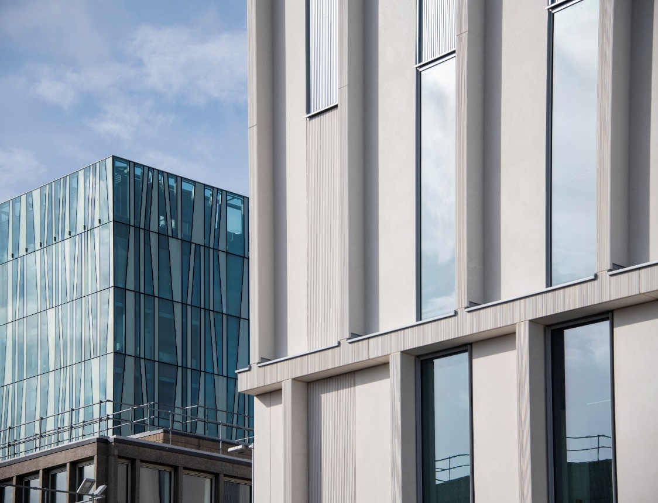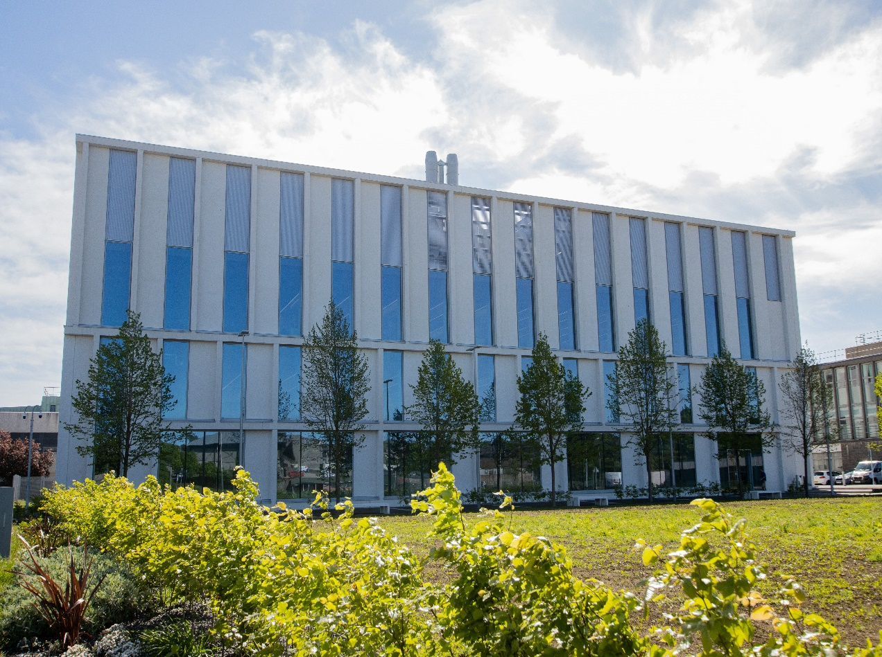

*BM4010- Advanced Molecules, Membranes & Cells (Stem Cells & Regeneration)*

*Course Handbook 2023-2024*

*Undergraduate Medical Sciences*

*School of Medicine, Medical Sciences & Nutrition*

Contents

* Course Summary –(3)
* Course Aims & Learning Outcomes
* Course Teaching Staff
* Assessments & Examinations – (4)
* Class Representatives
* Problems with Coursework – (5)
* Course Reading List
* Lecture/ Course Content Synopsis –(6)
* Tutorials, Practical Workbook and Other Coursework –(9)
* University Policies –(10)
* Academic Language & Skills support –(11)
* Medical Sciences Common Grading Scale –(13)
* Course Timetable BM4010: 2023-2024 –(14)
* Campus and Floor Maps

# Course Summary

This course provides core material for students to gain an understanding of professional biomedical research at the molecular, cellular and systems levels. It contains a series of lectures on Stem Cells and Regeneration that are an essential component of the Degree Programme for students undertaking degrees in Human Embryology and Developmental Biology, BMS (Developmental Biology) and BMS (Anatomy). The course provides a much more detailed insight into research methods and recent findings with detailed presentations of current research topics from individual academic staff of Medical Sciences. The course consists of 3-5 lectures per week. The course will be examined in a 3 hour written examination and by continuous assessment, which will comprise of one viva, and a practical report.

# Course Aims & Learning Outcomes

1. To provide detailed core knowledge of techniques used in the study of aspects of molecular and cellular bioscience, stem cells and developmental biology.

2. To relate recent research findings and discuss current trends and controversies in key research areas.

3. To provide a description of research work and bring the students close to the borders of our current understanding of several fields of biomedical science, including stem cell technology, tissue regeneration, and neuronal growth and development.

# 

Course Teaching Staff

Course Co-ordinator(s):

Prof Martin Collinson (m.collinson@abdn.ac.uk)

Other Lecturing Staff:

Prof J Barrow (JB), School of Medicine, Medical Sciences and Nutrition

Professor P Fowler (PF), School of Medicine, Medical Sciences and Nutrition

Professor P McCaffery (PMc), School of Medicine, Medical Sciences and Nutrition

Prof D Scott (DSc), School of Medicine, Medical Sciences and Nutrition

Dr D Shewan (DS), School of Medicine, Medical Sciences and Nutrition

Prof Cosimo De Bari (CDB), School of Medicine, Medical Sciences and Nutrition

Dr Ann Rajnicek (AMR), School of Medicine, Medical Sciences and Nutrition

Dr Annesha Sil (AS), School of Medicine, Medical Sciences and Nutrition

# Assessments & Examinations

a) Continuous assessment - 30% of the total assessment will be based on the practical report in October-November (20%) and the viva on a research paper in November (10%). Practical assignments and viva topics will be distributed in late September to early October.

b) Examination - This will take place in the summer diet, April/May. It will take the form of an essay-based examination, which will comprise 70% of the assessment for BM4010. The format will be a three-hour paper with a choice of 3 questions from a total of 8. The examination paper will be divided into two sections: A consisting of 3 questions and B consisting of 5 questions. Only one question from section A and two questions from section B are to be attempted. All assessments (continuous and examined) will be made using the Medical Sciences Common Grade Scheme (copy attached).

c) Satisfactory performance - Students are expected to work on all elements of the course and to complete all class exercises. The minimum performance acceptable is engagement with 80% of the course.

**The completion of all course work is an absolute requirement for your degree. You cannot pass the course if there is an assessment uncompleted.**

# Class Representatives

We value students’ opinions in regard to enhancing the quality of teaching and its delivery; therefore, in conjunction with the Students’ Association we support the Class Representative system.

In the School of Medicine, Medical Sciences & Nutrition we operate a system of course representatives, who are elected from within each course. Any student registered within a course that wishes to represent a given group of students can stand for election as a class representative. You will be informed when the elections for class representative will take place.

What will it involve?

It will involve speaking to your fellow students about the course you represent. This can include any comments that they may have. You will attend a Staff-Student Liaison Committee and you should represent the views and concerns of the students within this meeting. As a representative, you will also be able to contribute to the agenda. You will then feedback to the students after this meeting with any actions that are being taken.

Training

Training for class representatives will be run by the Students Association. Training will take place within each half-session. For more information about the Class representative system visit [www.ausa.org.uk](http://www.ausa.org.uk) or email the VP Education & Employability [vped@abdn.ac.uk](mailto:vped@abdn.ac.uk) . Class representatives are also eligible to undertake the STAR (Students Taking Active Roles) Award with further information about this co-curricular award being available at: [www.abdn.ac.uk/careers](http://www.abdn.ac.uk/careers).

Problems with Coursework

If students have difficulties with any part of the course that they cannot cope with, alone they should notify the course coordinator immediately. If the problem relates to the subject matter general, advice would be to contact the member of staff who is teaching that part of the course. Students with registered disabilities should contact the medical sciences office, ([medsci@abdn.ac.uk](mailto:medsci@abdn.ac.uk)) (based in the Polwarth Building, Foresterhill) to ensure that the appropriate facilities have been made available. Otherwise, you are strongly encouraged to contact any of the following as you see appropriate:

* Course student representatives
* Course co-ordinator
* Convenor of the Medical Sciences Staff/Student Liaison Committee (Professor Gordon McEwan)
* Personal Tutor
* Medical Sciences Disabilities Co-ordinator (Dr Derryck Shewan)

All staff are based at Foresterhill and we strongly encourage the use of email or telephone the Medical Sciences Office. You may have a wasted journey travelling to Foresterhill only to find staff unavailable.

If a course has been completed and students are no longer on campus (i.e. work from second half session during the summer vacation), coursework will be kept until the end of Fresher’s Week, during the new academic year. After that point, unclaimed student work will be securely destroyed.

# 

# Course Reading List

The lecturer responsible for each section of the course will provide a reference list which will enable students to follow up topics of particular interest. The core text for Human Embryology and Developmental Biology Honours year courses is Gilbert SF, 2010. Developmental Biology (9th edition) (Sinauer: Sunderland. Mass. USA).

# 

Lecture Synopsis

**Lecture 1:**  **Discussion of Honours Projects - Dr D Shewan**

**Lecture 2:** **Introduction to Course - Professor M Collinson**

**Lecture 3:**  **Searching databases and internet resources – Ms M Bickerton**

**Lectures 4-10: Genetic manipulation technology - Professor M Collinson**

Seven lectures on the generation and use of genetic modified animals and the application of these technologies for biomedical research and medicine. Starting by visiting the concept of pluripotency – the ability of pluripotent stem cells to contribute to any tissue of the body - we describe the discovery of embryonic stem cells, central to 30 years of gene knockouts. We discuss methods of getting DNA – transgenes – into animal cells by injection, electroporation or through the use of viruses. Classical mutagenesis techniques such as homologous recombination of targeting vector DNA into ES cells are covered, and transgenic animals produced by injection of DNA into fertilised oocytes to study gene function and regulation. Dolly and her sheepy friends get a new lecture to themselves. We will study Cre-lox targeted mutagenesis of mice – to knock genes out only in particular tissues or at particular times of life, and gene ‘knock-ins’. Genome editing techniques including CRISPR/Cas9 technology, Zinc finger nucleases and TALENs will be described, before going full circle to the discovery of induced pluripotent stem (iPS) cells and their use as a potentially ethical source of human ES-like cells for gene therapy.

**Lecture 11: Citing referencing and plagiarism - Prof D Scott**

**Lectures 12-14: Genomic and Proteomic technologies - Dr John Barrow**

Genomics and proteomics are relatively new fields that are largely only possible with the advent of high-powered computer technology.  They are shaping the way we can test and measure global changes in cells, tissues and whole organisms.  These lectures will focus on recent research in both of these fields, highlighting key advances and changes to our understanding that have been brought about.  Key examples and reading material will also be highlighted as the lectures progress.

**Lectures 15-17 Axon Guidance - Dr Derryck Shewan**

The growth cone: the motile tip of an axon that senses its environment and responds to it. How detection of extracellular signals leads to re-organisation of the axonal cytoskeleton. The physical, chemical and electrical characteristics of guidance signals underlying developmental axon growth to target tissues.

Attractive and repulsive axon guidance cues combine to ensure accurate pathfinding. Axons and their molecular environments change during development: consequences for nerve regeneration after injury. Examples of recent research will illustrate the rapid progress being made in understanding the molecular nature of nerve growth and repair.

The retinotectal projection. The accurate transmission of information from the eye to the brain is achieved because axons from neighbouring neurons in the retina map to neighbouring positions in the optic tectum. The molecular mechanisms underlying this amazing precision are discussed.

Lecture 18: Animal Models of Alzheimer’s disease – Dr A Sil

The first of two GM animal lectures by current lab-based research fellows. Examples of transgenic methods used to create murine models of Alzheimer’s Disease and other dementias will be presented. General over-expression lines will be compared with regional- and cell-type specific knock-in models, and viral gene delivery in cell culture systems. Translational approaches such as PET imaging and EEG will be discussed, and the use of models for drug discovery will be briefly explored.

**Lecture 19: Statistics – Prof D Scott**

**Lectures 20-24: Endocrine Signalling and Reproductive Biology**

**Profs Peter McCaffery and Paul Fowler**

Endocrine signalling through nuclear receptors. Background to endocrinology, definitions, hormone production, methods of hormone transport in the body. Types and mechanisms of action of hormone receptors. Outline of male and female reproductive organs, with special emphasis on reproductive endocrine glands. Hormones with reproductive roles and functions. Contrast between male and female endocrine cycles. The hypothalamo-pituitary-gonad axis. The principles of endocrine feedback, as illustrated by the control of the female ovarian cycle. The role of signal transduction and endogenous timekeepers in regulating reproductive endocrine cycles. The course will end with a brief overview of comparative reproductive endocrinology, focusing on specialised reproductive adaptations of various mammalian species.

**Lecture 25-27: Stem Cell Tutorial/ Tissue Stem Cells and Regeneration – Professor M Collinson**

The concept of stem cell is rooted in classic developmental biology experiments, which have shown that the cell nucleus contains the instructions for creating form and shape of the embryo. How do we know that stem cells exist? We will define what a stem cell is and what the hallmarks of stem cells are. We will introduce concepts of totipotency, pluripotency, self-renewal and differentiation, which are associated with stem cells. But we will also discuss the idea that cancer is closely associated with embryonic and adult stem cells. The lectures will address current and future challenges for stem cell technology. Human regenerative therapy requires human stem cells, but the ethical consideration preclude many of the experimental options that are available in model animal systems. These lectures looks at other sources of human stem cells, in particular those that can be isolated from the umbilicus, which is a source of haematopoietic and mesenchymal stem cells*.* We will use the eye as an example of the role of adult stem cells in maintaining tissues.

**Lectures 28-29: Neural stem cells and neurogenesis - P McCaffery**

Until the early 1990s, dogma held that new neurons could not be generated in the adult brain – you were born with a fixed number at birth and it was only downhill from then on. It is now understood that certain regions of the brain have a slow turnover of neurons – in those regions new neurons are born, while others die, throughout your life. These regions of the brain are the hippocampus, hypothalamus and a region close to the lateral ventricles known as the subventricular zone. Much research has been devoted to the understanding of why neurogenesis occurs, and this process is believed to be involved in regulation of learning and memory in the hippocampus and control of energy balance in the hypothalamus. The possibility exists as well that the slow rate of neurogenesis could be artificially accelerated after brain injury to repair damage. This lecture will discuss these functions together with the signalling systems controlling neurogenesis.

**Lectures 30-31:** **Stem Cells in Skeletal Regenerative Medicine - Professor C De Bari**

These lectures describe the molecular basis of skeletal regeneration and repair and discuss roles and strategies for stem cells in these processes.

**Lecture 32: Planaria and Stem Cells - Dr A Rajnicek**

Flatworms, Planaria, have astounded biologists for over a hundred years for their ability to regenerate after being cut into fragments or after prolonged periods of starvation. In large part this is because of retention, in the adult, of a population of stem cells, neoblasts. This lecture will review the roles and activities of neoblasts in Planarian regeneration, as we try to understand principles and molecular pathways that could inform strategies for human stem cell-based therapies.

**Lectures 33-36: Human Embryo Manipulation, Gene and Stem Cell Therapy - Professor M Collinson**

The one cell embryo is the supreme stem cell. This lecture describes techniques for the manipulation in vitro of early human embryos, IVF, the technical issues and potential for early embryo screening in human clinical science. Examples of cutting-edge strategies for effecting human gene therapy and the use of stem cells for curing disease will be described. How do we make genome editing safe for humans?

Continuous assessment

Each student will carry out two tasks as part of their coursework. You will be assessed on both of these tasks and the marks will be combined to form 30% of your final mark for this course. The examination paper in the summer will carry the other 70% of the total.

Work handed in after the deadlines without good cause **will** be penalised according to the assessment handbook. If you have problems with this work please contact Professor Martin Collinson ([m.collinson@abdn.ac.uk](mailto:m.collinson@abdn.ac.uk)).

**Tasks:**

1. ***Practical Report (for 20% of the final mark):***

You will be assigned to a small group practical in an IMS/Polwarth Lab on either 3, 10 or 17 October. You will perform an experiment in a working research lab and write up a report in form of a short paper.

Whether you do an in person or virtual practical, the report is in the same format and will be marked at the same level.

The Practical Report should be typed (Font 11 pt), using the third person (e.g. "Patch pipettes were used...") and outline the laboratory session with an abstract, introduction, methods, results and discussion sections.

• Title Page: Give student’s name and student no., practical title and the supervisor’s name.

• Abstract: Max 200 words. Remember this is an executive summary describing the purpose of the study, what you did, what happened and what you concluded. In theory, someone should be able to read this and get the important information without having to read the rest of the report.

• Introduction: Outline the background to the work and briefly describe the objectives.

• Methods: Give basic details of what you have measured and how this was done. Also state what data analysis was carried out, if any.

• Results: Present your data in a logical order and include images, graphs and/or original traces of your data, with appropriate legends. Remember the results section is more than just figures or tables. It tells the story of what experiments you did and why, and what happened, so should contain a significant amount of text.

• Discussion: Give a brief interpretation of your results and describe what would be interesting to investigate next in the context of this laboratory session.

• Include a list of references used (usually 5-15 references).

• **THE WORD LIMIT is 2000 (including the abstract, but not reference list, tables, figures and figure legends).**

• Practical assignments will be due for submission 3 weeks after your practical session.

1. *Viva (for 10% of the course mark)*

You will be assigned a research paper to read, several weeks in advance of the viva. At the viva slot, a staff member will question you on your understanding of the paper, its rationale, data, and conclusions. Vivas will be held on 21 November.

University Policies

Students are asked to make themselves familiar with the information on key education policies, available [**here**](https://www.abdn.ac.uk/staffnet/teaching/key-education-policies-for-students-11809.php). These policies are relevant to all students and will be useful to you throughout your studies.  They contain important information and address issues such as what to do if you are absent, how to raise an appeal or a complaint and how the University will calculate your degree outcome.

These University wide education policies should be read in conjunction with this programme and/or course handbook, in which School specific policies are detailed. These policies are effective immediately, for the 2023/24 academic year. Further information can be found on the [**University’s Infohub webpage**](https://www.abdn.ac.uk/students/) or by visiting the Infohub.

The information included in the institutional area for 2023-24 includes the following:

* Assessment
* Feedback
* Academic Integrity
* Absence
* Student Monitoring/ Class Certificates
* Late Submission of Work
* Student Discipline
* The co-curriculum
* Student Learning Service (SLS)
* Professional and Academic Development
* Graduate Attributes
* Email Use
* MyAberdeen
* Appeals and Complaints

Where to Find the Following Information:

C6/C7- University of Aberdeen Homepage > Students > Academic Life > Monitoring and Progress > Student Monitoriung (C6 & C7)

https://www.abdn.ac.uk/students/academic-life/student-monitoring.php#panel5179

Absences- To report absences you should use the absence reporting system tool on Student Hub. Once you have successfully completed and sent the absence form you will get an email that your absence request has been accepted. The link below can be used to log onto the Student Hub Website and from there you can record any absences you may have.

[Log In - Student Hub (ahttps://www.abdn.ac.uk/studenthub/loginbdn.ac.uk)](https://www.abdn.ac.uk/studenthub/login)

Submitting an Appeal- University of Aberdeen Homepage > Students > Academic Life > Appeals and Complaints

https://www.abdn.ac.uk/students/academic-life/appeals-complaints-3380.php#panel2109

Academic Language & Skills support

For students whose first language is not English, the Language Centre offers support with Academic Writing and Communication Skills.

Academic Writing

* Responding to a writing task: Focusing on the question
* Organising your writing: within & between paragraphs
* Using sources to support your writing (including writing in your own words, and

citing & referencing conventions)

* Using academic language
* Critical Thinking
* Proofreading & Editing

Academic Communication Skills

* Developing skills for effective communication in an academic context
* Promoting critical thinking and evaluation
* Giving opportunities to develop confidence in communicating in English
* Developing interactive competence: contributing and responding to seminar discussions
* Useful vocabulary and expressions for taking part in discussions

More information and how to book a place can be found here

Medical Sciences Common Grading Scale

|  |  |  |  |  |  |
| --- | --- | --- | --- | --- | --- |
| Grade | Grade Point | % Mark | Category | Honours Class | Description |
| A1 | 22 | 90-100 | Excellent | First | • Outstanding ability and critical thought • Evidence of extensive reading • Superior understanding •The best performance that can be expected from a student at this level |
|  |
| A2 | 21 | 85-89 |  |
|  |
| A3 | 20 | 80-84 |  |
|  |
| A4 | 19 | 75-79 |  |
|  |
| A5 | 18 | 70-74 |  |
|  |
| B1 | 17 | 67-69 | Very Good | Upper Second | • Able to argue logically and organise answers well  • Shows a thorough grasp of concepts  • Good use of examples to illustrate points and justify arguments  • Evidence of reading and wide appreciation of subject |  |
|  |
| B2 | 16 | 64-66 |  |
|  |
| B3 | 15 | 60-63 |  |
|  |
| C1 | 14 | 57-59 | Good | Lower Second | • Repetition of lecture notes without evidence of further appreciation of subject • Lacking illustrative examples and originality • Basic level of understanding |  |
|  |
| C2 | 13 | 54-56 |  |
|  |
| C3 | 12 | 50-53 |  |
|  |
| D1 | 11 | 47-49 | Pass | Third | • Limited ability to argue logically and organise answers • Failure to develop or illustrate points • The minimum level of performance required for a student to be awarded a pass |  |
|  |
| D2 | 10 | 44-46 |  |
|  |
| D3 | 9 | 40-43 |  |
|  |
| E1 | 8 | 37-39 | Fail | Fail | • Weak presentation • Tendency to irrelevance • Some attempt at an answer but seriously lacking in content and/or ability to organise thoughts |  |
|  |
| E2 | 7 | 34-36 |  |
|  |
| E3 | 6 | 30-33 |  |
|  |
| F1 | 5 | 26-29 | Clear Fail | Not used for Honours | • Contains major errors or misconceptions • Poor presentation |  |
|  |
| F2 | 4 | 21-25 |  |
|  |
| F3 | 3 | 16-20 |  |
|  |
| G1 | 2 | 11-15 | Clear Fail/Abysmal |  | • Token or no submission |  |
|  |
| G2 | 1 | 1-10 |  |
|  |
| G3 | 0 | 0 |  |
|  |

Course Timetable BM4010: 2023-2024

* Times are UK Time and show the timings of live sessions (either via MyAberdeen or on campus)
* Suttie Lecture Theatre 012 (Sut) and will be used, with Polwarth 1:039/40, 1M:001 and 2.054. CR2 is Computer Room 2 (Polwarth)

Timetable Key:

|  |
| --- |
| Green = Recorded classes in MyAberdeen |
| Blue = Live classes delivered in person or as a live session in MyAberdeen |
| Yellow = Assessments |
| Grey = No scheduled classes for BM4010 on these days |

|  |  |  |  |  |  |
| --- | --- | --- | --- | --- | --- |
| Date | Time | Place | Subject | Session | Staff |
| Week 8 | | | | | |
| Mon 18 Sep | 16.00-17.00 | Sut 012 | Honours Project Introduction | Lecture | DS |
| Tue 19 Sep | 10.00-11.00 | Sut 012 | Course Introduction | Lecture | MC |
| 11.00-12.00 | Sut 012 | Genetic manipulation technology 1 | Lecture | MC |
| Wed 20 Sep |  |  |  |  |  |
| Thu 21 Sep |  |  |  |  |  |
| Fri 22 Sep | 13.00-14.00 | Sut 012 | Genetic manipulation technology 2 | Tutorial | MC |
| 16:00-17:00 | Sut 012 | Searching databases Ovid and internet resources | Tutorial | MBi |
| Week 9 | | | | | |
| Mon 25 Sep | 14.00-15.00 | Sut 012 | Genetic manipulation technology 3 | Lecture | MC |
| 15.00-16.00 | Sut 012 | Genetic manipulation technology 4 | Lecture | MC |
| Tue 26 Sep | 09.00-11.00 | CR2 | Databases & internet resources- search practical (Optional – sign up on 22 Sep) GRP A | Tutorial | MBi |
| 11.00-13:00 | CR2 | Databases & internet resources- search practical (Optional – sign up on 22 Sep) GRB B | Tutorial | MBi |
| Wed 27 Sep | 10:00-11:00 | Sut 012 | Citing, Referencing and Plagiarism | Lecture | DSc |
| Thu 28 Sep |  |  |  |  |  |
| Fri 29 Sep | 14.00-15.00 | Sut 012 | Genetic manipulation technology 5 | Lecture | MC |
| 15.00-16.00 | Sut 012 | Genetic manipulation technology 6 | Lecture | MC |
| Week 10 | | | | | |
| Mon 2 Oct | 14.00-15.00 | Sut 012 | Genetic manipulation technology 7 | Lecture | MC |
| 15.00-16.00 | Sut 012 | Practical Prep – introduction to report writing | Tutorial | MC |
| Tue 3 Oct | 10.00-16.00 | IMS Labs | Practical (Group A) | Practical | IMS staff |
| Wed 4 Oct | 10.00-11.00 | Sut 012 | Genomic and Proteomic Analysis 1 | Lecture | JB |
| Thu 5 Oct |  |  |  |  |  |
| Fri 6 Oct | 14.00-15.00 | Sut 012 | Genomic and Proteomic Analysis 2 | Lecture | JB |
| 15.00-16.00 | Sut 012 | Genomic and Proteomic Analysis 3 | Lecture | JB |
| Week 11 | | | | | |
| Mon 9 Oct | 14.00-15.00 | Sut 012 | Axonal guidance 1 | Lecture | DS |
| 15.00-16.00 | Sut 012 | Axonal guidance 2 | Lecture | DS |
| Tue 10 Oct | 10.00-16.00 | IMS Labs | Practical (Group B) | Practical | IMS staff |
| Wed 11 Oct |  |  |  |  |  |
| Thu 12 Oct |  |  |  |  |  |
| Fri 13 Oct | 14.00-15.00 | Sut 012 | Axonal guidance 3 | Lecture | DS |
| 15:00-16.00 | Sut 012 | Animal Models of Alzheimer’s Disease | Lecture | AS |
| Week 12 | | | | | |
| Mon 16 Oct | 14.00-15.00 | Sut 012 | Endocrine Signalling and Reproductive Biology 1 | Lecture | PMcC |
| 15.00-16.00 | Sut 012 | Endocrine Signalling and Reproductive Biology 2 | Lecture | PMcC |
| Tue 17 Oct | 10:00-16:00 | IMS Labs | Practical (Group C) | Practical | IMS staff |
| Wed 18 Oct |  |  |  |  |  |
| Thu 19 Oct |  |  |  |  |  |
| Fri 20 Oct | 13.00-14.00 | Sut 012 | Statistics | Lecture | DSc |
| Week 13 | | | | | |
| Mon 23 Oct | 14.00-15.00 | Sut 012 | Endocrine Signalling and Reproductive Biology 3 | Lecture | PF |
| 15.00-16.00 | Sut 012 | Endocrine Signalling and Reproductive Biology 4 | Lecture | PF |
| Tue 24 Oct |  |  |  |  |  |
| Wed 25 Oct | 10:00-11:00 | Sut 012 | Careers Service Presentation | Tutorial | RG |
| Thu 26 Oct |  |  |  |  |  |
| Fri 27 Oct |  |  |  |  |  |
| Week 14 | | | | | |
| Mon 30 Oct |  |  |  |  |  |
| Tue 31 Oct | 9.00 – 10.00 | Sut 012 | Endocrine Signalling and Reproductive Biology 5 | Lecture | PF |
| Wed 1 Nov |  |  |  |  |  |
| Thu 2 Nov |  |  |  |  |  |
| Fri 3 Nov | 13:00-14:00 | MyAb | Tutorial – Viva prep | Tutorial | MC |
| 15.00-16.00 | 1M:001 | Stem Cells Tutorial | Tutorial | MC |
| Week 15 | | | | | |
| Mon 6 Nov | 14.00-15.00 | 1:039/40 | Tissue Stem Cells and Regeneration 1 | Lecture | MC |
| 15.00-16.00 | 1:039/40 | Tissue Stem Cells and Regeneration 2 | Lecture | MC |
| Tue 7 Nov |  |  |  |  |  |
| Wed 8 Nov |  |  |  |  |  |
| Thu 9 Nov |  |  |  |  |  |
| Fri 10 Nov | 14:00-15:00 | 1:039/40 | Neural stem cells and neurogenesis 1 | Lecture | PMcC |
| 15.00-16.00 | 1:039/40 | Neural stem cells and neurogenesis 2 | Lecture | PMcC |
| Week 16 | | | | | |
| Mon 13 Nov | 14.00-15.00 | 1:039/40 | Stem cells in skeletal regenerative medicine 1 | Lecture | CDB |
| 15.00-16.00 | 1:039/40 | Stem cells in skeletal regenerative medicine 2 | Lecture | CDB |
| Tue 14 Nov |  |  |  |  |  |
| Wed 15 Nov | 10.00-11.00 | 1M:001 | Spare slot | Lecture |  |
| Thu 16 Nov |  |  |  |  |  |
| Fri 17 Nov | 13:00-14:00 | 1M:001 | Planaria – Stem Cells and Regeneration | Lecture | AMR |
| Week 17 | | | | | |
| Mon 20 Nov | 14.00-15.00 | Sut 012 | Human Gene and Stem Cell Therapy 1 | Lecture | MC |
| Tue 21 Nov | 09.00-15.00 | IMS Offices | Viva examination | Viva | IMS staff |
| Wed 22 Nov | 09:00-10:00 | Sut 012 | Human Gene and Stem Cell Therapy 2 | Lecture | MC |
|  | 10:00-11:00 | Sut 012 | Human Gene and Stem Cell Therapy 3 | Lecture | MC |
| Thu 23 Nov |  |  |  |  |  |
| Fri 24 Nov | 14:00-15:00 | 1:039/40 | Spare slot |  |  |
| 15.00-16.00 | 1:039/40 | Spare slot |  |  |
| 16:00-17:00 | 2.054 | Human Gene and Stem Cell Therapy 4 | Lecture | MC |

Staff

|  |
| --- |
| Prof M. Collinson (MC) (Co-ordinator) |
| Dr John Barrow (JB) |
| Prof Gordon McEwan (GMcE) |
| Dr G.S. Bewick (GSB) |
| Prof P. Fowler (PFow) |
| Prof P. McCaffery (PMcC) |
| Dr Ann Rajnicek (AMR) |
| Prof. D. Scott (DSc) |
| Dr D. Shewan (DS) |
| Ms R Gibson (RG) |
| Dr Nicola Mutch (NMu) |
| Prof Mirela Delibegovic (MD) |
| Dr Wenlong Huang (WH) |
| Prof Graeme Nixon (GFN) |
| Dr Nimesh Mody (NMo) |
| Prof Bettina Platt (BP) |
| Dr Sergio Dall’angelo (SDA) |
| Dr Steve Tucker (ST) |
| Dr Catriona Cunningham (CC) |
| Prof Iain Gibson (IG) |
| Ms Melanie Bickerton (MBi) |
| Dr Pablo Martinez de Morentin (PMM) |
| Dr Flora Groening (FG) |
| Prof Simon Parson (SP) |
| Dr Annesha Sil (AS) |
| Dr Claire Whyte (CW) |
| Prof Gordon McEwan (GMcE) |
| Prof Cosimo de Bari (CDB) |

Campus Maps - Foresterhill



Polwarth Floor Plans

