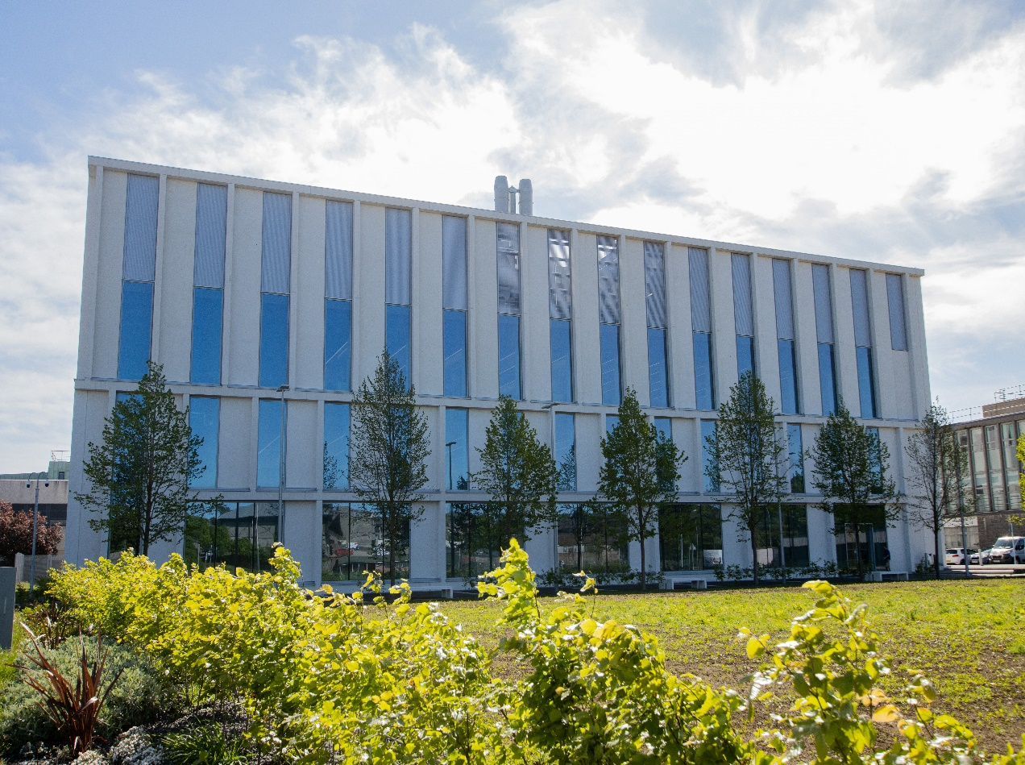

*BM2009- Human Anatomy A*

*Course Handbook 2023-2024*

*Undergraduate Medical Sciences*

*School of Medicine, Medical Sciences & Nutrition*

**Contents**

* Course Summary –(3)
* **Course Aims & Learning Outcomes**
* **Course Teaching Staff** **­**
* **Assessments & Examinations**–(4)
* **Class Representatives**–(5)
* **Problems with Coursework**
* **Course Reading List**–(6)
* Anatomy on the Web
* **Lecture Synopsis**
* Talks/Tutorials/Practicals –(7)
* **University Policies**
* **Academic Language & Skills support**–(8)
* **Medical Sciences Common Grading Scale** –(10)
* **Course Timetable BM2009: 2023-2024**–(11)
* Campus and Floor Maps

Course Summary

BM2009 is restricted to students registered for the BSc in Biomedical Sciences. BM2009 is an anatomy course that explores gross anatomy and functions of the human body.

The course will consist of:

1. An introductory lecture and live session

2. Recorded and live short talks

3. Weekly practical classes

4. Five in-course assessments, the first formative, the remaining four summative

All students on this course must comply with The Anatomy Act 1984 as amended by The Human Tissue (Scotland) Act 2006 and its regulations. Other local rules for practical work involving embalmed human specimens will be provided during the course. Students must familiarise themselves with the particular policies relating to health, safety and confidentiality when working within the Anatomy Facility. Information on these will be provided at the beginning of the course.

Course Aims & Learning Outcomes

Name and describe, in standard terms, anatomical planes and relations and the gross anatomical components of the human body and explain their functions.

* Demonstrate the location and main components of functional systems in the regions of the body.
* Identify anatomical structures in cadaveric specimens and demonstrate their spatial relationships.
* Explain the functional and clinical significance of key anatomical structures.
* Begin to identify the spectrum of usual variation of normal human structure and function and how this relates to abnormality.
* Demonstrate the two-dimensional projection of structures on radiographic images.
* Develop time-management skills and the skills for self-directed learning.
* Develop problem-solving and IT skills.

As far as the BM2009 course is concerned, the above objectives refer to the following regions of the body: back, upper and lower limbs, thorax and abdomen. The BM2509 course, in Semester 2, covers the pelvis and perineum, head, neck and brain. Please refer to the BM2009 Workbook for the specific learning outcomes for each body region.

Course Teaching Staff

Course Co-ordinator:

Dr Flora Gröning, [**f.groening@abdn.ac.uk**](mailto:f.groening@abdn.ac.uk)

Please use the Discussion Board on the course homepage on MyAberdeen and the practical classes to ask questions about the course content. For any personal or private queries, contact the course co-ordinator via email or approach them at the end of a practical class.

Course Administrator:

Ms Agnieszka (Aggie) Kruk-Omenzetter (Anatomy Administrator),

Email: [**a.kruk-omenzetter@abdn.ac.uk**](mailto:a.kruk-omenzetter@abdn.ac.uk)

Other Teaching Staff:

Mr David Chorn, [**d.j.chorn@abdn.ac.uk**](mailto:d.j.chorn@abdn.ac.uk)

Dr Premnath Ballal, [**p.ballal@abdn.ac.uk**](mailto:p.ballal@abdn.ac.uk)

Dr Shahida Shahana, s.shahana@abdn.ac.uk

Dr Bahgat Sami, [**bahgat.sami@abdn.ac.uk**](mailto:bahgat.sami@abdn.ac.uk)

Prof Simon H Parson, [**simon.parson@abdn.ac.uk**](mailto:simon.parson@abdn.ac.uk)

In addition, postgraduate demonstrators and PAL tutors will often be available to assist during practical classes.

Assessments

Students will be required to pass the whole course – i.e. a total composite mark, based on the continuous summative assessment components as specified below, of 9 or above on the University of Aberdeen common grading scale (CGS) will give 15 credits. Students should assess their own progress by self-testing their attainment of the learning objectives and by realistically interpreting the results of formative assessments and online quizzes.

**Upper Limb summative assessment – 25%**

**Lower Limb summative assessment – 25%**

**Thorax summative assessment – 25%**

Abdomen summative assessment – 25%

(Continuous assessment: 100% of total assessment)

All four continuous assessments will be **in-person assessments** in the Anatomy facilities. They will include MCQ questions as well as ‘spotter’ questions which will ask you about a labelled structure in a specimen. Your course coordinator will provide further details during the course induction and via the FAQ on the course homepage on MyAberdeen.

Students who attain an overall mark for the course of 8 or less on the CAS will fail the course. A resit diet will be held in July.

Class certificates will be valid for two years and permit a total of three attempts at the required assessment within that two-year period i.e. the first attempt plus up to two resits.

# 

Class Representatives

We value students’ opinions in regard to enhancing the quality of teaching and its delivery; therefore, in conjunction with the Students’ Association we support the Class Representative system.

In the School of Medicine, Medical Sciences & Nutrition we operate a system of course representatives, who are elected from within each course. Any student registered within a course that wishes to represent a given group of students can stand for election as a class representative. You will be informed when the elections for class representative will take place.

What will it involve?

It will involve speaking to your fellow students about the course you represent. This can include any comments that they may have. You will attend a Staff-Student Liaison Committee and you should represent the views and concerns of the students within this meeting. As a representative, you will also be able to contribute to the agenda. You will then feedback to the students after this meeting with any actions that are being taken.

Training

Training for class representatives will be run by the Students Association. Training will take place within each half-session. For more information about the Class representative system visit [www.ausa.org.uk](http://www.ausa.org.uk) or email the VP Education & Employability [vped@abdn.ac.uk](mailto:vped@abdn.ac.uk) . Class representatives are also eligible to undertake the STAR (Students Taking Active Roles) Award with further information about this co-curricular award being available at: [www.abdn.ac.uk/careers](http://www.abdn.ac.uk/careers).

Problems with Coursework

If students have difficulties with any part of the course that they cannot cope with, alone they should notify the course coordinator immediately. If the problem relates to the subject matter general, advice would be to contact the member of staff who is teaching that part of the course. Students with registered disabilities should contact the medical sciences office, ([medsci@abdn.ac.uk](mailto:medsci@abdn.ac.uk)) (based in the Polwarth Building, Foresterhill) to ensure that the appropriate facilities have been made available. Otherwise, you are strongly encouraged to contact any of the following as you see appropriate:

* Course student representatives
* Course co-ordinator
* Convenor of the Medical Sciences Staff/Student Liaison Committee (Professor Gordon McEwan)
* Personal Tutor
* Medical Sciences Disabilities Co-ordinator (Dr Derryck Shewan)

All staff are based at Foresterhill and we strongly encourage the use of email or telephone. You may have a wasted journey travelling to Foresterhill only to find staff unavailable.

If a course has been completed and students are no longer on campus (i.e. work from second half session during the summer vacation), coursework will be kept until the end of Fresher’s Week, during the new academic year. After that point, unclaimed student work will be securely destroyed.

Course Reading List

Textbooks – The purchase of an anatomy textbook is considered essential for all students. The following book is recommended:

‘***Moore’s Essential Clinical Anatomy***’ by Anne M.R. Agur and Arthur F. Dalley, 6th edition, 2019 published by Wolters Kluwer. ISBN 9781975114435 (*older editions are also fine!*)

**N.B. Reading the recommended textbook, or similar texts, is an integral part of your study of anatomy!**

Written material and diagrams in classes are similar to what you will find in your recommended text.

A small collection of books is available for students’ use in Anatomy Teaching areas. These books must not be removed from Anatomy.

Anatomy on the Web

The following online resources are available on the course website on MyAberdeen:

* **Toolkit videos** on “How to make the most of Anatomy practical classes” and “Top tips for successful Anatomy revision” (also available under: [**https://www.abdn.ac.uk/toolkit/services/anatomy/**](https://www.abdn.ac.uk/toolkit/services/anatomy/))
* **Acland’s Video Atlas** of Human Anatomy
* **Anatomy.tv** (available through the generosity of the Roland Sutton Academic Trust)
* **Weekly quizzes**

Please note that Acland’s Video Atlas and Anatomy.tv are commercial packages that have not been specifically designed for your course. Much of the material covered in these packages is presented in greater depth than you are expected to know for the course assessment.

Lecture Synopsis

This course does not use traditional lectures as part of its teaching, except where specific material must be covered in greater detail (e.g. the Anatomy Act lecture at the very start of the course). Instead of full-length lectures, there will be shorter talks as described in the following section of this handbook.

Talks/Live Q&A Sessions/Practicals

**Talks**

Talks (<45 minutes) will explain areas of difficulty or interest in each region of the body. All talks will be recorded with Panopto and uploaded to the course homepage on MyAberdeen so that you can access them at any time. Please note that views of the videos will be tracked to monitor student engagement throughout the course.

**Practicals**

There will be practical classes each week. These sessions are compulsory (attendance will be monitored!) and you will be expected to make an active contribution and make the most of the human cadaveric specimens provided during these sessions. Therefore, you are expected to be prepared for each session, which means that you have worked through the respective section of your workbook. Please find the dates and times for these practical classes in the timetable at the end of this handbook.

University Policies

Students are asked to make themselves familiar with the information on key education policies, available [here](https://www.abdn.ac.uk/staffnet/teaching/key-education-policies-for-students-11809.php). These policies are relevant to all students and will be useful to you throughout your studies.  They contain important information and address issues such as what to do if you are absent, how to raise an appeal or a complaint and how the University will calculate your degree outcome.

These University wide education policies should be read in conjunction with this programme and/or course handbook, in which School specific policies are detailed. These policies are effective immediately, for the 2023/24 academic year. Further information can be found on the [University’s Infohub webpage](https://www.abdn.ac.uk/students/) or by visiting the Infohub.

The information included in the institutional area for 2023-24 includes the following:

* Assessment
* Feedback
* Academic Integrity
* Absence
* Student Monitoring/ Class Certificates
* Late Submission of Work
* Student Discipline
* The co-curriculum
* Student Learning Service (SLS)
* Professional and Academic Development
* Graduate Attributes
* Email Use
* MyAberdeen
* Appeals and Complaints

Where to Find the Following Information:

C6/C7- University of Aberdeen Homepage > Students > Academic Life > Monitoring and Progress > Student Monitoring (C6 & C7)

https://www.abdn.ac.uk/students/academic-life/student-monitoring.php#panel5179

Absences- To report absences you should use the absence reporting system tool on Student Hub. Once you have successfully completed and sent the absence form you will get an email that your absence request has been accepted. The link below can be used to log onto the Student Hub Website and from there you can record any absences you may have.

[Log In - Student Hub (ahttps://www.abdn.ac.uk/studenthub/loginbdn.ac.uk)](https://www.abdn.ac.uk/studenthub/login)

Submitting an Appeal- University of Aberdeen Homepage > Students > Academic Life > Appeals and Complaints

https://www.abdn.ac.uk/students/academic-life/appeals-complaints-3380.php#panel2109

Academic Language & Skills support

For students whose first language is not English, the Language Centre offers support with Academic Writing and Communication Skills.

Academic Writing

* Responding to a writing task: Focusing on the question
* Organising your writing: within & between paragraphs
* Using sources to support your writing (including writing in your own words, and

citing & referencing conventions)

* Using academic language
* Critical Thinking
* Proofreading & Editing

Academic Communication Skills

* Developing skills for effective communication in an academic context
* Promoting critical thinking and evaluation
* Giving opportunities to develop confidence in communicating in English
* Developing interactive competence: contributing and responding to seminar discussions
* Useful vocabulary and expressions for taking part in discussions

More information and how to book a place can be found here

Medical Sciences Common Grading Scale

|  |  |  |  |  |  |
| --- | --- | --- | --- | --- | --- |
| Grade | Grade Point | % Mark | Category | Honours Class | Description |
| A1 | 22 | 90-100 | Excellent | First | • Outstanding ability and critical thought • Evidence of extensive reading • Superior understanding •The best performance that can be expected from a student at this level |
|  |
| A2 | 21 | 85-89 |  |
|  |
| A3 | 20 | 80-84 |  |
|  |
| A4 | 19 | 75-79 |  |
|  |
| A5 | 18 | 70-74 |  |
|  |
| B1 | 17 | 67-69 | Very Good | Upper Second | • Able to argue logically and organise answers well  • Shows a thorough grasp of concepts  • Good use of examples to illustrate points and justify arguments  • Evidence of reading and wide appreciation of subject |  |
|  |
| B2 | 16 | 64-66 |  |
|  |
| B3 | 15 | 60-63 |  |
|  |
| C1 | 14 | 57-59 | Good | Lower Second | • Repetition of lecture notes without evidence of further appreciation of subject • Lacking illustrative examples and originality • Basic level of understanding |  |
|  |
| C2 | 13 | 54-56 |  |
|  |
| C3 | 12 | 50-53 |  |
|  |
| D1 | 11 | 47-49 | Pass | Third | • Limited ability to argue logically and organise answers • Failure to develop or illustrate points • The minimum level of performance required for a student to be awarded a pass |  |
|  |
| D2 | 10 | 44-46 |  |
|  |
| D3 | 9 | 40-43 |  |
|  |
| E1 | 8 | 37-39 | Fail | Fail | • Weak presentation • Tendency to irrelevance • Some attempt at an answer but seriously lacking in content and/or ability to organise thoughts |  |
|  |
| E2 | 7 | 34-36 |  |
|  |
| E3 | 6 | 30-33 |  |
|  |
| F1 | 5 | 26-29 | Clear Fail | Not used for Honours | • Contains major errors or misconceptions • Poor presentation |  |
|  |
| F2 | 4 | 21-25 |  |
|  |
| F3 | 3 | 16-20 |  |
|  |
| G1 | 2 | 11-15 | Clear Fail/Abysmal |  | • Token or no submission |  |
|  |
| G2 | 1 | 1-10 |  |
|  |
| G3 | 0 | 0 |  |
|  |

Course Timetable BM2009 – 2023-2024

|  |  |  |  |  |  |
| --- | --- | --- | --- | --- | --- |
| Date | Time | Place | Subject | Session | Staff |
| Week 8 | | | | | |
| Mon 18 Sep |  |  |  |  |  |
| Tue 19 Sep |  |  |  |  |  |
| Wed 20 Sep |  |  |  |  |  |
| Thu 21 Sep | 15:30-16:00 | 1:032/033 | Anatomy Act lecture | Lecture | SP, FG |
|  | 16:00-17:00 | Anatomy Facility | Course induction and tour | Practical | FG |
| Fri 22 Sep |  |  |  |  |  |
| Week 9 | | | | | |
| Mon 25 Sep |  |  |  |  |  |
| Tue 26 Sep | 10:00-11:00 | Suttie Lecture Theatre | Introduction to Anatomy | Lecture | FG |
|  | 11:00-13:00 | Anatomy Facility | Introduction to Anatomy | Practical | FG, MM |
| Wed 27 Sep |  |  |  |  |  |
| Thu 28 Sep | 15:30-17:00 | Anatomy Facility | Bones & Joints | Practical | FG, MM |
| Fri 29 Sep |  |  |  |  |  |
| Week 10 | | | | | |
| Mon 2 Oct |  |  |  |  |  |
| Tue 3 Oct | 10:00-11:00 | Suttie Lecture Theatre | Muscles & Nerves | Lecture | FG |
|  | 11:00-13:00 | Anatomy Facility | Muscles & Nerves | Practical | FG, MM |
| Wed 4 Oct |  |  |  |  |  |
| Thu 5 Oct | 15:30-17:00 | Anatomy Facility | Back | Practical | FG, MM |
| Fri 6 Oct |  |  |  |  |  |
| Week 11 | | | | | |
| Mon 9 Oct |  |  |  |  |  |
| Tue 10 Oct | 10:00-11:00 | Suttie Lecture Theatre | Upper Limb 1 & 2 | Lecture | FG |
| 11:00-12:00 | Anatomy Facility | Formative Assessment: Introduction & Back | Test | FG |
| 12:00-13:00 | Anatomy Facility | Upper Limb 1 | Practical | FG, MM |
| Wed 11 Oct |  |  |  |  |  |
| Thu 12 Oct | 15:30-17:00 | Anatomy Facility | Upper Limb 2 | Practical | FG, MM |
| Fri 13 Oct |  |  |  |  |  |
| Week 12 | | | | | |
| Mon 16 Oct |  |  |  |  |  |
| Tue 17 Oct | 10:00-11:00 | Suttie Lecture Theatre | Upper Limb 3 & 4 | Lecture | FG |
|  | 11:00-13:00 | Anatomy Facility | Upper Limb 3 | Practical | FG, MM |
| Wed 18 Oct |  |  |  |  |  |
| Thu 19 Oct | 15:30-17:00 | Anatomy Facility | Upper Limb 4 & Revision | Practical | FG, MM |
| Fri 20 Oct |  |  |  |  |  |
| Week 13 | | | | | |
| Mon 23 Oct |  |  |  |  |  |
| Tue 24 Oct | 10:00-11:00 | Anatomy Facility | Summative Assessment: Upper Limb | Test | FG |
| 11:00-13:00 | Anatomy Facility | Lower Limb 1 | Practical | FG, MM |
| Wed 25 Oct |  |  |  |  |  |
| Thu 26 Oct | 15:30-17:00 | Anatomy Facility | Lower limb 2 | Practical | FG, MM |
| Fri 27 Oct |  |  |  |  |  |
|  |  |  |  |  |  |
| Week 14 | | | | | |
| Mon 30 Oct |  |  |  |  |  |
| Tue 31 Oct | 10:00-13:00 | Anatomy Facility | Lower Limb 3 | Practical | FG, MM |
| Wed 1 Nov |  |  |  |  |  |
| Thu 2 Nov | 15:30-17:00 | Anatomy Facility | Lower Limb 4 & Revision | Practical | FG, MM |
| Fri 3 Nov |  |  |  |  |  |
| Week 15 | | | | | |
| Mon 6 Nov |  |  |  |  |  |
| Tue 7 Nov | 10:00-11:00 | Suttie Lecture Theatre | Lower Limb Q&A & Thorax | Lecture | FG |
| 11:00-12:00 | Anatomy Facility | Summative Assessment: Lower Limb | Test | FG |
| 12:00-13:00 | Anatomy Facility | Thorax 1 | Practical | FG, MM |
| Wed 8 Nov |  |  |  |  |  |
| Thu 9 Nov | 15:30-17:00 | Anatomy Facility | Thorax 2 | Practical | FG, MM |
| Fri 10 Nov |  |  |  |  |  |
| Week 16 | | | | | |
| Mon 13 Nov |  |  |  |  |  |
| Tue 14 Nov | 10:00-11:00 | Suttie Lecture Theatre | Thorax Q&A & Thorax 3 | Lecture | FG |
|  | 11:00-13:00 | Anatomy Facility | Thorax 3 & Revision | Practical | FG, MM |
| Wed 15 Nov |  |  |  |  |  |
| Thu 16 Nov | 15:30-17:00 | Anatomy Facility | Summative Assessment: Thorax | Test | FG |
| Fri 17 Nov |  |  |  |  |  |
| Week 17 | | | | | |
| Mon 20 Nov |  |  |  |  |  |
| Tue 21 Nov | 10:00-11:00 | Suttie Lecture Theatre | Abdomen | Lecture | FG |
|  | 11:00-13:00 | Anatomy Facility | Abdomen 1 & 2 | Practical | FG, MM |
| Wed 22 Nov |  |  |  |  |  |
| Thu 23 Nov | 15:30-17:00 | Anatomy Facility | Abdomen 3 & Revision | Practical | FG, PB, MM |
| Fri 24 Nov |  |  |  |  |  |
| Week 18 – NO TEACHING | | | | | |
| Mon 27 Nov |  |  |  |  |  |
| Tue 28 Nov |  |  |  |  |  |
| Wed 29 Nov |  |  |  |  |  |
| Thu 30 Nov | 15:30-17:00 | Anatomy Facility | Summative Assessment: Abdomen | Test |  |
| Fri 1 Dec |  |  |  |  |  |

Staff

|  |
| --- |
| Dr Flora Gröning (FG), Course Co-ordinator |
| Miss Michaela (Misha) Matejova (MM) |
| Mr David Chorn (DC) |
| Dr Prem Ballal (PB) |
| Dr Bahgat Sami (BS) |
| Prof. Simon Parson (SP) |

Campus Maps - Foresterhill



Polwarth Floor Plans

