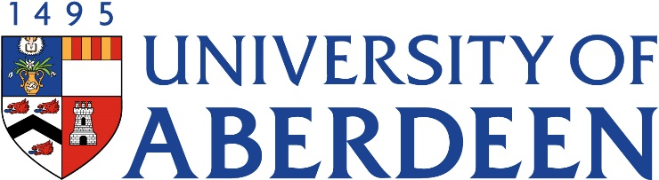
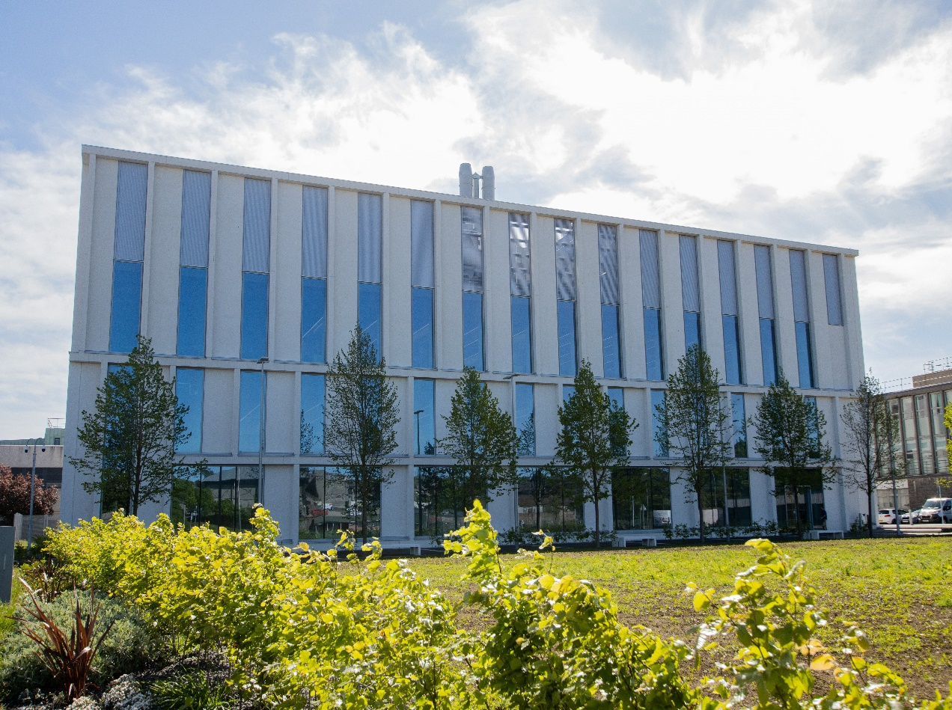

AN3301 – Human Embryonic Development
Course Handbook 2023-2024
Undergraduate Medical Sciences
School of Medicine, Medical Sciences & Nutrition

Contents

- Course Summary – (3)
- Course Aims & Learning Outcomes – (3)
- Course Teaching Staff – (3)
- Assessments & Examinations – (4)
- Class Representatives – (5)
- Problems with Coursework – (5)
- Course Reading List – (6)
- Lecture/ Course Content Synopsis – (6)
- Workshop/Tutorial – (9)
- University Policies – (9)
- Academic Language & Skills support – (10)
- Medical Sciences Common Grading Scale – (11)
- Course Timetable AN3301: 2023-2024 – (12)
- Campus and Floor Maps – (13)

Course Summary
Focusing on human development, this course will examine the question of how a single fertilised cell develops into a fully functioning organism with a complex, highly patterned body structure. The course will begin with an overview of embryonic and foetal development, the major signalling systems sculpting normal development, and causes of birth differences. The structural changes underlying the development of each of the major tissues and organs of the body will be discussed in turn, and the genes and signalling pathways involved will be introduced briefly.
The course consists of a mixture of lectures, tutorials, a workshop, a group oral presentation on a specific aspect of altered development and completion of other course work.
The course is assessed by continuous assessment (50%) and written exam (50%).

Course Aims and Learning Outcomes
1. Provide a broad understanding of the major structural changes underlying the development of the mature body form from an initial single cell.
2. Describe the early stages in the development of the body plan, and the major developmental events defining the embryonic and foetal periods.
3. Explore how specific tissues and organs develop, and the timescale and progression of events, including processes that may continue after birth.
4. Explain the major causes of birth differences, including teratogenic agents, and their effects.

Course Teaching Staff
Course Co-ordinator:
LE – Professor Lynda Erskine, l.erskine@abdn.ac.uk
Other Staff:
CDB – Professor Cosimo de Bari, c.debari@abdn.ac.uk
JMC – Professor Martin Collinson, m.collinson@abdn.ac.uk
SM – Dr Silvia Mazzotta, silvia.mazzotta@abdn.ac.uk
NV – Professor Neil Vargesson, n.vargesson@abdn.ac.uk

Assessments and Examinations
Students are expected to attend all lectures, attend and actively engage in the workshops, presentation session and tutorials, and to complete all assignments by the stated deadlines. The minimum acceptable performance is attendance of 70% of the lectures/tutorials, attendance at the workshop and presentations and submission of all set course work, written and oral.
Assessment is derived from:
Continuous assessment: 50% of the total marks, consisting of:
- MCQs throughout the course – 20%
- A group oral presentation on a selected aspect of altered development – 20%
- Workshop write up – 10%
Written exam: 50% of the total marks
Topics for the oral presentations will be selected during the 1st week of the course. Preparation time has been included throughout the course.
Key assessment information and dates:
Oral presentations – at the start of the course groups will be assigned a 10 min slot for their presentation. The presentations will take place on Tuesday 14th November (10:00-13:00). Everyone is expected to attend these presentations.
Workshop - write up to be submitted on the day (Tuesday 21st November). Attendance and active engagement at the workshop is compulsory.
MCQs:
Set 1 released Monday 6th November 09:00, deadline for everyone to have completed Friday 10th November 17:00 (once start the assessment you will have 90 min to complete).
Set 2 released Friday 24th November 09:00, deadline for everyone to have completed Friday 1st December 17:00 (once start the assessment you will have 90 min to complete).
Written Exam – released Monday 4th December 09:00, deadline for everyone to have completed Friday 8th December 17:00 (once open the assessment link you will have 2.5 hrs to complete and submit).
Resit assessment will be based on resitting the exam and/or resubmission of any failed or missing in course assessments as relevant.

Your overall performance will be expressed as a grade awarded on the Common Grading Scale (CGS).

Class Representatives

We value students’ opinions in regard to enhancing the quality of teaching and its delivery; therefore, in conjunction with the Students’ Association we support the Class Representative system.

In the School of Medicine, Medical Sciences & Nutrition we operate a system of course representatives, who are elected from within each course. Any student registered within a course that wishes to represent a given group of students can stand for election as a class representative. You will be informed when the elections for class representative will take place.

What will it involve?
It will involve speaking to your fellow students about the course you represent. This can include any comments that they may have. You will attend a Staff-Student Liaison Committee and you should represent the views and concerns of the students within this meeting. As a representative, you will also be able to contribute to the agenda. You will then feedback to the students after this meeting with any actions that are being taken.

Training
Training for class representatives will be run by the Students Association. Training will take place within each half-session. For more information about the Class representative system visit www.ausa.org.uk or email the VP Education & Employability vped@abdn.ac.uk . Class representatives are also eligible to undertake the STAR (Students Taking Active Roles) Award with further information about this co-curricular award being available at: www.abdn.ac.uk/careers.

Problems with Coursework

If students have difficulties with any part of the course that they cannot cope with alone they should notify the course coordinator immediately. If the problem relates to the subject matter in general, advice would be to contact the member of staff who is teaching that part of the course. Students with registered disabilities should contact the medical sciences office, (medsci@abdn.ac.uk) (based in the Polwarth Building, Foresterhill) to ensure that the appropriate facilities have been made available. Otherwise, you are strongly encouraged to contact any of the following as you see appropriate:

- Course student representatives
- Course co-ordinator
- Convenor of the Medical Sciences Staff/Student Liaison Committee
- Personal Tutor
- Medical Sciences Disabilities Co-ordinator (Dr Derryck Shewan)

All staff are based at Foresterhill and we strongly encourage the use of email or telephone. You may have a wasted journey travelling to Foresterhill only to find staff unavailable.

If a course has been completed and students are no longer on campus (i.e. work from second half session during the summer vacation), coursework will be kept until the end of Fresher’s Week, during the new academic year. After that point, unclaimed student work will be securely destroyed.

Course Reading List
Langman’s Medical Embryology., Lippincott, Williams &Wilkin
Moore KL. Persaud TVN. The developing human: clinically oriented embryology. Saunders/Elsevier.
[Related text book: Moore KL, Persuad TVN. Before we are born: essentials of embryology and birth defects]
Additional, specific references, may be provided by individual members of the teaching staff

Lecture Synopsis
Lecture 1: Embryonic development – Professor Neil Vargesson
This lecture will examine the early events in embryonic development. Topics that will be covered include, fertilisation and the pre-implantation stages of development, implantation, formation of the bilaminar germ disc, formation of the trilaminar germ disc, and origins of the ectoderm, mesoderm, endoderm and their functions.
Lecture 2: The foetal Period; Teratogens – Professor Neil Vargesson
Following on from embryonic development, this lecture will cover pattern formation, organogenesis, formation of the placenta, growth and foetal milestones. The main causes and risk factors for birth differences also will be discussed.
Lecture 3: Signalling systems in development – Professor Martin Collinson
In order to understand human embryology, we need to understand how cells talk to each other. Despite the incredible complexity of embryonic development, most developmental processes are controlled by a few, highly conserved families of signalling molecules. This lecture will introduce the major players, including the fibroblast growth factors (FGFs), wingless-family proteins (Wnts), bone morphogenetic proteins (BMPs) and Hedgehog-family ligands (Hh).
Lecture 4: Head and neck development – Professor Lynda Erskine
This lecture will consider the structural development of the head and neck. Major players in this process are the pharyngeal (branchial) arches. The composition of the pharyngeal arches and the various structures derived from them will be described. The development of the face from mesenchyme surrounding the mouth, the separation of the oral and nasal cavities through formation of the palate and the development of the skull (cranium) will also be covered.
Lecture 5: Respiratory system development – Professor Lynda Erskine
Breathing is essential to life, and a major cause of neonatal lethality in premature infants is under development of the lungs. This lecture will describe the development of the thoracic and abdominal cavities, the formation of the lung buds from the foregut, the development of the trachea, oesophagus, larynx and bronchi, and the maturation of the lungs. Variances of respiratory system development will also be introduced.
Lecture 6: Digestive system development - Professor Lynda Erskine
This lecture covers the development of the major derivatives of the foregut (e.g. stomach, liver, pancreas), midgut (most of the intestines) and hindgut (distal part of the colon and anorectal canal). Variances of gut development will be introduced briefly.
Lecture 7: Bone development – Professor Cosimo de Bari
This lecture explores the processes of cellular condensation that lead to the formation of cartilage and bone. Processes of intramembranous and endochondral ossification will be studied, and the genetic and cellular pathways that lead to the formation and maintenance of bone. We will all fall off a wall and break a bone at some point in our lives – this lecture will briefly describe the process of bone repair with hints of bone tissue engineering.
Lecture 8: Nervous system development – Professor Lynda Erskine
The nervous system is arguably the most complex tissue in our body, composed of billions of cells connected together in a very precise fashion. Normal nervous system development is essential for making us who we are and defining all of our interactions with the world around us. This lecture will introduce the development of the central nervous system (brain and spinal cord) from the neural tube, and generation of the different neuronal and glial cell types. Neural tube variations, such as spina bifida as well as other brain differences will be discussed. The formation of the ventricular system and the development of major brain regions will be described briefly. The development of the peripheral nervous system from neural crest cells and cranial placodes also will be considered.
Lecture 9: Integumentary system development – Professor Neil Vargesson
The integumentary system protects the body from various kinds of damage, including water loss or abrasion from outside. The system comprises the skin and its appendages. This lecture will discuss the development of the epidermis, dermis, and role of neural crest cells in skin development. Formation of nails, hair, sebaceous and sweat glands will be discussed. In addition, we also will look at the development of the teeth.
Lecture 10: Urinary system development – Professor Neil Vargesson
This lecture will begin by examining the relationship between the development of the urinary and reproductive systems. The development of the kidneys via a series of successively more complex excretory organs, the pronephros, mesonephros and metanephros will be described. The development of bladder and the renal tubules, collecting ducts and resulting structure of the kidneys also will be discussed.
Lecture 11: Genital system development - Professor Neil Vargesson
This lecture will describe the development of the male and female reproductive systems. Topics that will be covered include formation of the testis, formation of the excretory ducts, descent of the testis, the female genital tract, ovarian development, the development of the uterine tubes, uterus and vagina. Urinary-genital variations also will be considered.
Lecture 12: Eye and ear development – Professor Lynda Erskine
Vision and hearing are two of our most precious senses. This lecture will look at the development of the anatomical structures important for these senses - the eye and ear. Topics that will be discussed include:
Eye development: Development of the optic vesicle, lens induction and development, cellular differentiation in the retina, development of the other structures of the eye (iris, ciliary body, sclera, choroid and vitreous), development of the eye lids, eye variations.
Ear Development: Development of the external, middle and inner ear. Deafness and external ear differences will be introduced.
Lecture 13: Cardiovascular system development – Dr Silvia Mazzota
The cardiovascular system is the first functional organ system to develop in the human embryo, and cardiovascular function is from then on required continuously throughout life. The heart also is one of the most complex organs to develop and, as a consequence, congenital heart differences account for approximately a quarter of all human congenital variations.
This lecture focuses on introducing the normal development of the cardiovascular system; its origin in the lateral plate mesoderm, the formation of the linear heart tube and the major arteries and veins connected to the heart, the morphogenesis of the linear heart tube into a four-chambered heart, and the changes at birth that give rise to separate systemic and pulmonary circulation.
Lecture 14: Somite and Muscle development - Professor Martin Collinson
Many tissues in the body have their origins in the somites, balls of mesodermal tissue that form on either side of the developing body axis, and are the clearest physical evidence that we are segmented animals. The development of somites is one of the most spectacular examples of how dynamic changes in gene expression control morphogenesis, and this lecture will describe this process. The somites also give rise to muscles of the axis, body wall and limbs, and the dynamic processes of cell specification, migration and muscle block formation will be explained.
Lecture 15: Limb development – Professor Neil Vargesson
Although vertebrate limbs take many different shapes and functions, for walking, flight, swimming and manipulation, the basic growth and patterning of the pentadactyl limb has a very uniform and well-studied basis, which will be covered in this lecture. The origins of the limb bud and the two-way interaction between the apical ectodermal ridge and the underlying limb mesenchyme will be studied. The genes and signalling pathways that make forelimbs different from hindlimbs, arms different from hands, and fingers from thumbs also will be discussed.

Workshop/Tutorial Work
Participation and active engagement in the workshop is compulsory.
Handouts detailing the work to be carried out in the workshop will be posted on MyAberdeen.
The tutorial in week 17 (24th November) will focus on preparation for the written exam and student feedback on the course.

University Policies

Students are asked to make themselves familiar with the information on key education policies, available here. These policies are relevant to all students and will be useful to you throughout your studies. They contain important information and address issues such as what to do if you are absent, how to raise an appeal or a complaint and how the University will calculate your degree outcome.
These University wide education policies should be read in conjunction with this programme and/or course handbook, in which School specific policies are detailed. These policies are effective immediately, for the 2023/24 academic year. Further information can be found on the University’s Infohub webpage or by visiting the Infohub.

The information included in the institutional area for 2023-24 includes the following:
- Assessment
- Feedback
- Academic Integrity
- Absence
- Student Monitoring/ Class Certificates
- Late Submission of Work
- Student Discipline
- The co-curriculum
- Student Learning Service (SLS)
- Professional and Academic Development
- Graduate Attributes
- Email Use
- MyAberdeen
- Appeals and Complaints

Academic Language & Skills support
For students whose first language is not English, the Language Centre offers support with Academic Writing and Communication Skills.

Academic Writing
- Responding to a writing task: Focusing on the question
- Organising your writing: within & between paragraphs
- Using sources to support your writing (including writing in your own words, and
citing & referencing conventions)
- Using academic language
- Critical Thinking
- Proofreading & Editing

Academic Communication Skills
- Developing skills for effective communication in an academic context
- Promoting critical thinking and evaluation
- Giving opportunities to develop confidence in communicating in English
- Developing interactive competence: contributing and responding to seminar discussions
- Useful vocabulary and expressions for taking part in discussions

More information and how to book a place can be found here

Medical Sciences Common Grading Scale

Grade | Grade Point | % Mark | Category | Honours Class | Description
A1 | 22 | 90-100 | Excellent | First | • Outstanding ability and critical thought  • Evidence of extensive reading  • Superior understanding  •The best performance that can be expected from a student at this level
A2 | 21 | 85-89
A3 | 20 | 80-84
A4 | 19 | 75-79
A5 | 18 | 70-74
B1 | 17 | 67-69 | Very Good | Upper Second | • Able to argue logically and organise answers well  • Shows a thorough grasp of concepts  • Good use of examples to illustrate points and justify arguments  • Evidence of reading and wide appreciation of subject
B2 | 16 | 64-66
B3 | 15 | 60-63
C1 | 14 | 57-59 | Good | Lower Second | • Repetition of lecture notes without evidence of further appreciation of subject  • Lacking illustrative examples and originality  • Basic level of understanding
C2 | 13 | 54-56
C3 | 12 | 50-53
D1 | 11 | 47-49 | Pass | Third | • Limited ability to argue logically and organise answers  • Failure to develop or illustrate points  • The minimum level of performance required for a student to be awarded a pass
D2 | 10 | 44-46
D3 | 9 | 40-43
E1 | 8 | 37-39 | Fail | Fail | • Weak presentation  • Tendency to irrelevance  • Some attempt at an answer but seriously lacking in content and/or ability to organise thoughts
E2 | 7 | 34-36
E3 | 6 | 30-33
F1 | 5 | 26-29 | Clear Fail | Not used for Honours | • Contains major errors or misconceptions  • Poor presentation
F2 | 4 | 21-25
F3 | 3 | 16-20
G1 | 2 | 11-15 | Clear Fail/Abysmal |  | • Token or no submission
G2 | 1 | 1-10
G3 | 0 | 0

Course Timetable AN3301: 2023-2024
Date | Time | Place | Subject | Session Type | Staff
Week 13
Mon 23rd Oct | 15:00-16:00 | ZB03 | Introduction; Embryonic Development | Lecture | LE/NV
 | 16:00-17:00 | ZB03 | The Foetal Period/Teratogens | Lecture | NV
Tues 24th Oct | 14:00-15:00 | ZB03 | Signalling Systems | Lecture | JMC
 | 15:00-16:00 | ZB03 | Presentation Topic Selection | Tutorial | LE
Fri 27th Oct | 14:00-15:00 | ZB03 | Head and Neck | Lecture | LE
Week 14
Mon 30th Oct | 15:00-16:00 | ZB03 | Respiratory System | Lecture | LE
 | 16:00-17:00 | ZB03 | Digestive System | Lecture | LE
Fri 3rd Nov | 14:00-15:00 | NK3 | Bone | Lecture | CDB
Week 15
Mon 6th Nov | 15:00-16:00 | ZB03 | Nervous system | Lecture | LE
Mon 6th Nov | 09:00 |  | MCQ Set 1 Released
Tues 7th Nov | 12:00-13:00 | ZB03 | Integumentary System | Lecture | NV
 | 14:00-15:00 | ZB03 | Urinary System | Lecture | NV
 | 15:00-16:00 | ZB03 | Genital System | Lecture | NV
Fri 10th Nov | 14:00-15:00 | NK3 | Eye and Ear | Lecture | LE
Fri 10th Nov | 17:00 |  | Deadline Completion MCQ Set 1
Week 16
Mon 13th Nov | 14:00-15:00 | ZB03 | Cardiovascular system | Lecture | LE
Tues 14th Nov | 10:00-13:00 | ZB03 | Assessed Group Presentations | Presentations | LE/NV
Fri 17th Nov | 14:00-15:00 | NK3 | Somite and Muscle | Lecture | JMC
Week 17
Tues 21st Nov | 10:00-16:00 | ZB03 | Workshop – Comparative Embryology | Workshop | LE
Thur 23rd Nov | 12:00-13:00 | ZB03 | Limb | Lecture | NV
Fri 24th Nov | 14:00-15:00 | NK3 | Feedback/Exam prep | Tutorial | LE
Fri 24th Nov | 09:00 |  | MCQ Set 2 Released
Week 18
Fri 1st Dec | 17:00 |  | Deadline Completion MCQ Set 2

Week 19
Mon 4th Dec | 09:00 |  | Final Assessment released
Fri 8th Dec | 17:00 |  | Deadline Submission Final Assessment

MCQs – once start assessment you will have 90 min to complete
Final assessment – once open assessment link you will have 2.5hrs to complete and submit.

Staff

CDB – Professor Cosimo de Bari
JMC – Professor Martin Collinson
LE – Professor Lynda Erskine (Course co-ordinator)
SM – Dr Silvia Mazzotta
NV – Professor Neil Vargesson

Venues

ZB03 – Zoology Building, Old Aberdeen
NK3 – New King’s Old Aberdeen

