Summer School Leaders 2105

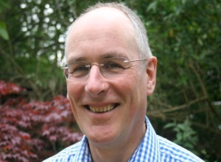

**Canon Nick Cuthbert** is the founder of Riverside Church in Birmingham where they have lived and ministered for 43 years. Nick is an author of several books including ‘How to survive and thrive as a church leader.’ He is a teacher and evangelist, a lay canon and a leader of Lead Academy.

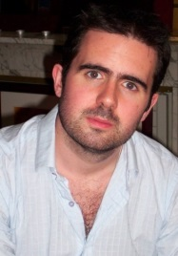**Professor Tom Greggs** is Professor of Historical and Doctrinal Theology at the University of Aberdeen and Honorary Professor of Theology at St Mellitus College, London; he was previously Professor of Systematic Theology at the University of Chester. A graduate of the Universities of Oxford and Cambridge, Tom is Methodist Representative to the Faith and Order Committee of the World Council of Churches. An internationally regarded preacher and teacher, Tom is the former Secretary of Society for the Study of Theology, and has served as co-chair of the Scriptural Reasoning Panel at the American Academy of Religion.

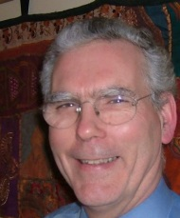

**Rev Peter Neilson** has retired recently from his role as a freelance mission consultant after 40 years of ministry within the Church of Scotland. He had a range of roles from parish ministry in Glasgow and Edinburgh to national roles in mission.

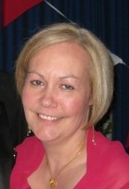**Rev Alison Wilkinson** is a Methodist Minister in Hartlepool; previously she served at a growing church on the edge of Durham City for twelve years. She mentors probationer ministers in their ongoing academic and professional development for the Darlington District. For several years she has taught in the Wesley Study Centre Ministerial Training, St Johns College, University of Durham, and on the Fresh Expression's Mission Shaped Ministry Course. Her ongoing PhD research is in Leadership, Discipleship and Gender.

[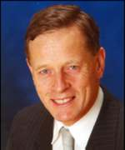](http://www.google.co.uk/url?sa=i&rct=j&q=&esrc=s&frm=1&source=images&cd=&cad=rja&uact=8&ved=0CAcQjRw&url=http://news.bbc.co.uk/2/hi/uk_news/scotland/976097.stm&ei=oznrVJ72KcSxaZOHgOAD&bvm=bv.86475890,d.d2s&psig=AFQjCNE8z4_h1fmZLqKTVHtpXL94dg5SSQ&ust=1424788245534298)

**Very Rev John Miller** was Parish Minister at Castlemilk East Parish Church, Glasgow for 37 years with one year as Moderator of the General Assembly of the Church of Scotland. He retired from his parish duties in July 2007, but in retirement went to work temporarily for the Church in Zimbabwe. Miller Primary School in Castlemilk was named after him and his wife.