Diploma in Professional Legal Practice

Guidance note for applicants 2024/25

The Diploma in Legal Practice (Diploma) is the postgraduate stage of the route to qualification as a solicitor in Scotland. This guidance is designed for students who are thinking about applying for the
2024/25 course. At the Law Society of Scotland, we encourage all prospective applicants to carefully consider their position before embarking upon the course, particularly in relation to funding arrangements and the traineeship job market.

This guidance note will cover:

Diploma providers

Differences between providers
Spaces per course and criteria for admission
Course fees

Application process
Please note that for 2024/25 entry each provider will provide their own individual application process. We advise to read each of these processes thoroughly before applying.

Considerations before applying

Diploma validity
Funding and extra financial support for Diploma students
The traineeship employment market
Fitness and properness
Special considerations for international students

Diploma providers

In session 2024/25 there are six Diploma providers. Here's who they are and how many places they
have available, both full-time and part time:

Provider | Full time places 2024/25 | Part time places 2024/25
University of Aberdeen | 110 | NA
University of Dundee | 80 |  | 4
University of Edinburgh | 144 combined
University of Glasgow | 204 12
Robert Gordon University |  | 95 combined*
University of Strathclyde | Approx 200 | Approx 16

*Inclusive of online places

We advise that students who are considering both full-time and part-time options speak directly to the Diploma providers of their choice, prior to completing the application form. There are significant differences between providers in terms of course structures, teaching timetables and fee schedules, so it's important to be absolutely clear on all of these factors beforehand.

Full-time courses take approximately one academic year, whereas part-time courses are usually spread over two academic years.

Competition and criteria for admission
In session 2023/24, demand from applicants exceeded the number of spaces available on the course, meaning unfortunately some applicants were unsuccessful in securing a place on the 2023/24 Diploma course. In 2023/24:

700 (approx) spaces on courses were available

1,852 (approx) students applied for a place on the course
*this figure may include duplicate applications as applicants could apply to up to two Diploma providers for 23/24 entry therefore, the exact figure could be slightly lower*

Admissions processes are set by the individual Diploma providers. For students on the LLB that started on or after 2011, the main criterion for admission to the Diploma is based on results in the subjects which map to the foundation outcomes required by the Law Society of Scotland.
Please note that Diploma providers have discretion to take into account additional factors to determine how places are allocated. Please contact providers for specific admissions queries as for the 2024-25 admission they are each adopting different admissions policies.
Differences between providers Each Diploma course has different structures, modules and electives and will vary in terms of your course options and timetables.

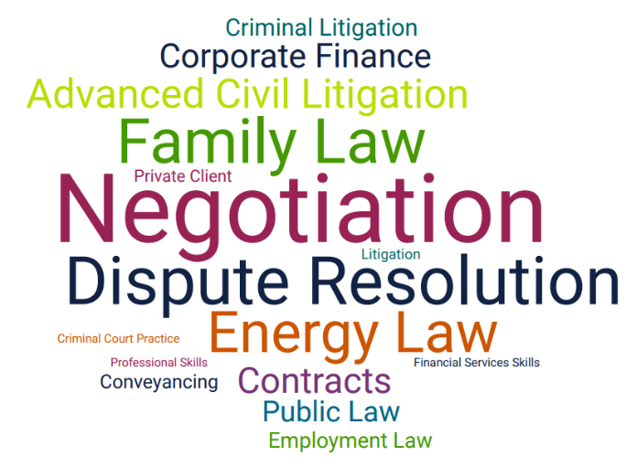

This year for the second time, applicants can apply to up to two Diploma providers. We really recommend taking the time
to research different universities offering the Diploma before making your application.
really recommend taking time to research the

Visit our Virtual Diploma Fair to compare the

different providers in more detail.

Fees

The fees for the Diploma are set annually by each Diploma provider, not the Law Society of Scotland. These course fees and additional costs are set out below.

Each university has their own arrangement for the payment of fees. Visit our Virtual Diploma Fair or contact the universities directly to find out more about your options.

Diploma provider |  | Full-time fees | Part-time fees*
University of Aberdeen |  | £9400 | N/A
University of Dundee |  | £10,000 £10,000
University of Edinburgh |  | £10,735 | £10,735
University of Glasgow |  | £11,130 £11,130
Robert Gordon University |  | £8,250 | £8,250
University of Strathclyde |  | £10,800 £10,800

*part-time fees can usually be split over the 2 years of study and are potentially subject to an annual increase in year 2.

When completing a Diploma application, you will be entitled to apply to up to two Diploma providers. This will give students a greater chance of securing a place on the Diploma and we advise using this opportunity to apply to two providers and not limiting your chances by applying to just one provider. As you are not guaranteed to be offered a place with the provider you choose, it's essential you consider alternative providers.

Application forms can be found on Diploma providers websites. You must apply separately to each Diploma provider (i.e you will make one or two separate applications). You may receive offers from either or both Diploma providers, regardless of preference. However, please note that Diploma providers will take your preference into account when making offers.

Please note, some Diploma providers will require you to also complete an online application
form. Information can be found on the initial application. See application form for more information.

Application period for 2024/25 session

8 March: Applications for the Diploma open
10 May: Applications for the Diploma close
Acceptances must be made by 12 noon on the relevant acceptance deadline below.

Round 1 offers

9 July: Round 1 offers to be made to successful applicants
17 July: Deadline for acceptance of Round 1 offers
Should you receive more than one offer from one of your chosen Diploma providers, you must accept only one offer and decline the others. Failure to do so could result in your offers being withdrawn.

Round 2 offers

For applicants that have not been successful in Round 1, you will fall into the round two offers. Here, Diploma providers that have available space on their course may offer you a place.
24 July: Round 2 offers will be intimated to remaining applicants
29 July: Deadline for acceptance of Round 2 offers

Round 3 offers

For applicants that have not been successful in Round 2, you will fall into the round three offers. Here, Diploma providers that have available space on their course may offer you a place.
5 August: Round 3 offers will be intimated to remaining applicants
7 August: Deadline for acceptance of Round 3 offers

Please note that Diploma providers will set individual, bespoke deadlines for any subsequent rounds (e.g. Round Four onwards).

Diploma validity
The LLB does not have a period of validity, but the Diploma does. A valid Diploma is required in order for a trainee to commence a training contract.

The Diploma is valid for five years from 31 December the year it is awarded and you must start a traineeship before that date
e.g. if the Diploma is awarded in June 2025, it will be valid until 31 December 2030

As a prospective Diploma student, you are encouraged to consider Diploma validity alongside the
fact that the traineeship market is very competitive. You may find you are still looking for a traineeship after graduating.

More information, including the standard application form, can be found by searching 'Diploma validity' on our website.

Funding and extra financial support for Diploma students

Student Awards Agency Scotland (SAAS) loans
As of 18 January 2024, for the 2024/25 session, a loan entitlement of up to £11,500 for all full-time, Scottish domiciled postgraduate students is available from SAAS. For more information we encourage you to contact SAAS directly.

up to £7,000

Tuition fee loan
up to £4,500

Living cost loan (non-income assessed)

Our understanding is for both the tuition fee and living cost loan, repayment will commence once the student has graduated, is in employment and is earning above the student loan repayment threshold, currently at £27,660. Please visit www.saas.gov.uk for more information.

Additional sources of funding
In addition to SAAS funding, eligible postgraduates may be able to access additional sources of funding. These include:
- University Discretionary Funds
- Disabled Students' Allowance (DSA)
- Local bursaries
Search 'funding your education' on our website for more information about these funds.

The traineeship employment market

We encourage you to research and understand your position in the traineeship market before committing to the course. Traineeships are very competitive, and students are not guaranteed to be successful in securing a role.

Every year we produce trainee statistics so you can understand the broad picture. Here are some of the headlines from 2022/23:

An average of 87% of Diploma students secured a traineeship

Based on a 3-year average of our annual figures. This represents an increase from 86% last year.

753 traineeships commenced

this represents a 2% decrease compared to 2021/22.

11% of traineeships were in-house

this shows an increase from 10% from the previous year.

32% of traineeships started at firms with 1-5 partners

With 32% commenced at firms with 31+ partners

Training contracts started in 2022/23 by local authority area
Local authority area | Training contracts
Edinburgh | 272
Glasgow | 265
Aberdeen | 52
Dundee | 38
Fife | 22
Highland | 12
South Lanarkshire | 11
West Lothian | 10
Perth and Kinross | 9
South Ayrshire | 9
Dumfries and Galloway | 5
England and Wales | 5
Falkirk | 5
Renfrewshire | 5
Aberdeenshire | 4
North Lanarkshire | 4
Moray | 4
Scottish Borders | 4
Angus | 3
Inverclyde | 3
East Ayrshire | 2
East Dunbartonshire | 2
East Lothian | 2
Na h-Eileanan Siar | 2
North Ayrshire | 2
West Dunbartonshire | 2
Argyll and Bute | 1
Midlothian | 1
Orkney | 1
Stirling | 1
Clackmannanshire | 0
East Renfrewshire | 0
Shetland | 0

£22,550 is the recommended rate for 1st year trainee salaries

For 2nd year trainees, the recommended salary rises to £26,125. Recommended rates are reviewed annually with any increase in effect from the 1 June of that year.
As a minimum, all trainees must be paid at least the Living Wage as set by the Living
Wage Foundation.

Fitness and properness

A person cannot be admitted as a solicitor unless they are deemed to be a 'fit and proper person to be a solicitor'. Any person who practices as a solicitor in Scotland must be competent to do so and should not pose a risk to their clients, the public or other members of the profession.

Fitness and properness will be addressed for the first time when prospective trainees apply for an entrance certificate, which you must be granted to enter into a training contract. The Law Society will have regard to a number of factors including, but not limited to:
- Criminal convictions
- Bankruptcy/ Trust deeds
- Plagiarism

For more information, see the fit and proper guidance on our website. We advise that if you have any particular concerns, you get in touch with Louise Bradley at the Law Society on 0131 476
8105 (louisebradley@lawscot.org.uk)to discuss your circumstances.

Special considerations for international students

Overseas students studying with the intention of securing employment thereafter in Scotland or elsewhere in the UK are advised to make enquiries that they can satisfy any visa requirements.

The traineeship constitutes a period of work, rather than study, so students need to be aware of the change in their requirements prior to qualifying. For students that currently hold/ have held a Tier 4 visa for studying, when they undertake the traineeship and then work as a solicitor, they will need to apply for a Tier 2 visa.

If this affects you, please visit the UK Government's website for further information,

Need more advice or information?

Contact Careers@lawscot.org.uk ; or Visit our Virtual Diploma Fair

