The Global South Law Research Network, School of Law, University of Aberdeen

Inaugural Event and Colloquium

Exploring The Nexus Between Energy, Food Security and Climate Change in Africa

KEYNOTE ADDRESSES
John Paterson Professor of Law and Co-Founder, Aberdeen University Centre for Energy Law

Jennie MacDiarmid Professor of Sustainable Nutrition & Health and Director of Interdisciplinary Challenge, Health, Nutrition & Well-being, University of Aberdeen

Date: Monday, July 24, 2023
Time: 9.30 – 15.30
Venue: King’s College Building (KCF7) and Online

FUNDED BY:
University of Aberdeen Grants Academy, Internal Pump Prime Fund
SUPPORTED BY:
University of Aberdeen Research Future Fund
University of Aberdeen Interdisciplinary Challenges
Aberdeen University Centre for Energy Law (AUCEL)
Aberdeen University Centre for Commercial Law (CCL)
African Natural Resources Law Network (ANREL)
Aberdeen Nigerian Research Group
Flora IP

PROGRAMME

9.00 - 9.30 Arrival and Tea/Coffee
9:30 - 9:50 Welcome Remarks (School of Law)
9:50 - 10:05 Opening Keynote
John Paterson (Professor of Law and Co-Founder, Aberdeen University Centre for Energy Law)
10:05 - 10:15 Framing the Nexus Challenge
Sadiq Igomu Okoh (CEO, Carbon Free African Network)
10:15 - 10:25 Q & A
10:25 - 11:05 Theme I - Energy Crises and Just Transition in Africa
Panel Chair Eddy Wifa, Law Lecturer, University of Aberdeen
Panellists
Stefanie Busch Energy, Mining and Environmental Law Specialist & Senior Associate, ENSAfrica, Namibia
Topic: Exploring Namibia as a case study for green hydrogen production, and the lessons which the Southern African Development Community (SADC) can draw from this experience in developing a green hydrogen hub and green industrial revolution within the region
Charles Aholu Energy & Environmental Law Lecturer, Nottingham Law School
Topic: Energy Neo-Colonialism in the Era of the Global Energy Transition: Implications for Food Security In Africa.
Samuel Dike Energy and Comparative Environmental Law Professor, Rivers State University, Port Harcourt
Topic: Securing Access to Energy Resources under the Pseudo-Deregulated Downstream Sector of the Petroleum Industry and the impact on Food Security in Nigeria
11:05 - 11:15 Break

11:15 -11:55 Theme II - Food Systems: Towards Resilience & Sustainability in Africa
Panel Chair Titilayo Adebola, Law Lecturer, University of Aberdeen
Panellists
Gbolagade Ayoola Founder & President, Farm and Infrastructure Foundation (FIF)
Nigeria
Topic: Rethinking Africa's Food Policy in Terms of Rights

Gloria Otieno Genetic Resources & Food Security Policy Expert, Alliance of Bioversity International and The International Centre for Tropical Agriculture (CIAT)
Topic: Agrobiodiversity, Climate Change and Food security: What are the Nexus and Policy Issues?

Justify G Shava Head, Southern African Development Community (SADC), Plant Genetic Resources Centre (SPGRC)
Topic: Farmer variety recognition and preservation of the critical crop diversity in Southern Africa: A Catch 22 scenario.
11:55 - 13:10 Lunch Break/Poster Presentation by UoA Doctoral Researchers
13:10 - 13:15 Colloquium Photo
13:15 -13:25 Address from Greg Gordon, Head of School of Law, University of Aberdeen
13.25 - 14:05 Theme III – Governing Climate Change to Protect Africa’s Prosperity
Panel Chair Tomi Enibukun, Law Lecturer, University of Aberdeen
Panellists
Fayokemi Olorundami Senior Lecturer, Nottingham Law School
Topic: Climate Change Litigation: Assessing the Predisposition of Nigeria’s Judiciary Towards Encouraging Climate Action
Eghosa Ekhator Senior Lecturer, University of Derby
Topic: Multinational Corporations and Climate Action in Africa
Pedi Obani Associate Professor, School of Law, University of Bradford
Topic: Human Rights Perspectives on the Energy, Food Security, Climate Change nexus in Nigeria
14:05 - 14.25 Theme IV - Experiences from Europe and Latin America
Panel Chair Mitchel Lennan, Law Lecturer, University of Aberdeen
Panellists
Gloria Alvarez Senior Lecturer, School of Law, University of Aberdeen
Topic: Indigenous and Local Communities as Actors of International Investment Treaty Law and Practice

Thomas Muinzer Reader, School of Law, University of Aberdeen

Topic: The Concept of the Just Energy Transition in the European Union and Beyond

Daria Shapovalova Senior Lecturer, School of Law, University of Aberdeen

Topic: Just Transition and Energy in Scotland: Challenges and Opportunities

14:25 - 14:55 Policy Recommendations led by Titilayo Adebola

14:55 - 15:05 Closing Keynote

Jennie MacDiarmid (Professor of Sustainable Nutrition & Health and Director of interdisciplinary challenge Health, Nutrition & Well-being, University of Aberdeen)

15:05 - 15:15 Closing Remarks
Eddy Wifa Law Lecturer, University of Aberdeen

Speakers

John Paterson

Professor Paterson is Chair in Law at the University of Aberdeen. He is a member of the Aberdeen University Centre for Energy Law and directs Aberdeen’s involvement in the North Sea Energy Law Programme. His research has covered systems theory, the regulation of risk, governance in the EU, corporate governance and energy law. He has been involved in a number of international projects both in research and teaching. He has provided specialist training in oil and gas law and corporate governance for the corporate sector, expert advice in international arbitration, and consultancy to international organisations. He is series editor (together with Professor Julian Webb) of the Law, Science and Society series published by Routledge-Cavendish. He is co-editor of Oil and Gas Law in the UK: Current Practice and Emerging Trends (3rd ed., 2 vols, 2018).

Dr Sadiq Igomu Okoh

Dr Sadiq Austine Igomu Okoh is a very skilled and experienced environmental policy analyst with over 30 years of experience in environmental decision-making and policy formulation. He equally has expert experience in the field of climate change, energy policy, green economy/climate governance and sustainable development. He has five books to his name with 31 academic in reputable journals. He is an avid clean energy advocate and in recognition of his contribution to climate governance, UNECA/ACPC added him to its roster of climate change experts in Africa. Dr Okoh is the founder of Carbon Free Africa Network, an NGO dedicated to eradicating Africa’s adverse carbon footprint through closing the knowledge gap on low carbon development.

Dr Eddy Wifa

Dr. Wifa is an Energy Law Lecturer at the University of Aberdeen. He has contributed to teaching a range of both on-campus and distance-learning courses like Petroleum Resource Governance, Energy Law, Oil and Gas Contracting, Oil and Gas Enterprise Management, Ocean and Society, Decommissioning of Offshore Installations (Regulatory and Commercial Aspects), Low Carbon Energy Transition (Renewable Energy Law) and Alternative Methods to Dispute Resolution. His research interests include, risk governance, petroleum and natural resource governance, regulatory theories in high-major risk industries, decommissioning and clean energy regulation. He is a member of the Nigerian Bar Association and Society of Legal Scholars. He also is an Associate Fellow of the Higher Education Academy and the Director of the African Natural Resource and Energy Law Network (ANRELN). He is the Editorial Assistant, African Journal of International Energy and Environmental Law, Reviewer, Journal of African Law as well as Director, Aberdeen Nigeria Research Group.
Stefanie Busch

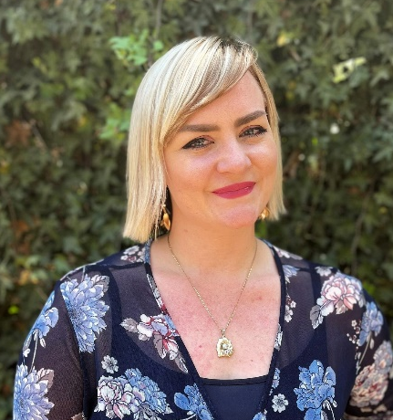
Stefanie Busch is a practicing attorney at Africa’s largest law Firm, ENSafrica and practices in Namibia. She specialises in energy, mining and environmental law as well as project development and general commercial work. Stefanie’s experience includes advising numerous international clients in respect of their entry into Namibian renewable energy (specifically, green hydrogen) market. Stefanie is currently undertaking an Advanced Masters in Energy Law offered by the North Sea Energy Law Partnership, consisting of a partnership between the University of Groningen, University of Oslo, University of Aberdeen and University of Copenhagen.
Stefanie has also been invited to speak to the Parliamentary Standing Committee of Natural Resources of the Namibian Parliament, to discuss the green hydrogen legislative framework and make recommendations as to how the policies and laws regulating green hydrogen in Namibia should be structured.

Dr Charles Aholu
Okechukwu Aholu is a Lecturer at Nottingham Law School, where he teaches Public Law, Land Law, Tort Law and Law in Action for law undergraduate suits. In this role, he facilitates learning for the different modules and help undergraduates build the confidence to tackle legal questions and acquire research skills necessary for higher legal education. He is also an experienced Nigerian qualified lawyer and an environmental law specialist.

Prof Samuel Chisa Dike

Prof S C.Dike is currently the Deputy Dean of the Faculty of Law, Rivers State University, Nigeria. He is a professor of Energy and Comparative Environmental Law with more than sixteen (16) years’ experience. He is the Founder and President of the Association of Environmental Lawyers of Nigeria; a member of Energy Institute UK and Nigerian Bar Association, Port Harcourt. He has well over one hundred publication locally and internationally and the Managing Editor of the bespoke Journal of international Energy and Environmental Law. His publications can be accessed at researchgate.net.

Dr Titilayo Adebola

Dr Titilayo Adebola is the Theme Coordinator for Intellectual Property Law and Associate Director of the Centre for Commercial Law at the University of Aberdeen School of Law. As an interdisciplinary scholar in international intellectual property law and international economic law with specialist interests in food, agriculture, environment and technology, Dr Adebola has delivered lectures in Africa, Asia, Europe and North America. She is a Fellow of the Higher Education Academy.
Dr Adebola is the President of the African International Economic Law Network and a Senior Advisor to the United Nations Special Rapporteur on the Right to Food. She is an Editor on Afronomicslaw.org, the leading resource on international economic law as it relates to Africa and the Global South, a Collaborator on Open AIR African Innovation Research, a network committed to uncovering new insights about access to knowledge and the Founding Editor of Flora IP, an innovative resource on food, agriculture and intellectual property.

Prof Gbolagade Ayoola

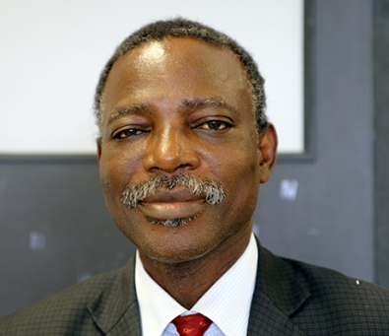
Professor Gbolagade Babalola Ayoola is a Professor of Agricultural Economics and Policy. He is also the founder/president of Farm and Infrastructures Foundation, which is an organization for promoting policy best practices in agriculture and rural development. He is also the promoter of the Right to Food Bill at the National Assembly, Nigeria informed by his belief that the natural right of people to be free from hunger is sacrosanct.

Dr Gloria Otieno

Dr Gloria Otieno is a policy expert and researcher particularly working on policy issues related to building resilient seed systems in times of climate change, specifically access and benefit sharing, seed policies, gender in seed systems, farmers’ rights and its nexus with food security.

She has 12 years of progressively responsible experience in multi-sectoral approach to planning, management and implementation of projects and programs in 11 Sub-Saharan

African countries spanning four regions. She also has a strong analytical background in research design, data analysis and evidence based policy analysis including grassroots policy implementation and macro-level policy development. Dr Otieno is currently a specialist with Alliance of Bioversity International and International Centre for Tropical Agriculture (CIAT).

Dr Justify Gotami Shava

Dr Justify Gotami Shava is the Head of the Southern African Development Community (SADC) Plant Genetic Resources Centre (SPGRC) based in Lusaka, Republic of Zambia. A plant breeder by profession, he was the founding President of the Zimbabwe Plant Breeders Association (ZPBA). Justify was plant breeder at the Tobacco Research Board of Zimbabwe (TRB) for eight (8) years and developed many varieties of tobacco and Katambora Rhodes grass currently grown in Zimbabwe and beyond in addition to maintaining tobacco germplasm. He was a lecturer in the Crop Science Department at the University of Zimbabwe and taught at the Women’s University in Africa (WUA) and the Zimbabwe Open University (ZOU).

Dr Tomi Eni-ibukun

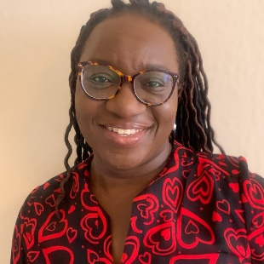
Tomi is a lecturer in energy and environmental law at the University of Aberdeen, specializing in climate change, low-carbon development, and sustainable energy. Her research focuses on the policies, laws and mechanisms being used globally to address these issues. However, she engages with a wide range of environmental law issues, including sustainable chemicals management, environmental justice, and environmental implementation and enforcement.

Dr Fayokemi Olorundami

Dr Fayokemi Olorundami is a Senior Lecturer at the Nottingham Law School. Kemi teaches and leads numerous modules on the LLM programme including International Environmental and Climate Change Law and International Energy Transition Law and Regulation. On the LL.B, Kemi teaches Applied Legal Knowledge, and on the PGDL, Tort Law. She is also a fellow of the UK Higher Education Academy.

Dr Pedi Obani

Dr Pedi Obani has worked in the higher education sector since 2012, collaborating extensively with academics in Nigeria, South Africa, Canada, the Netherlands and the United Kingdom, among others. She is experienced in leading both on campus and distance learning programmes, as well as teaching a range of undergraduate and postgraduate modules. Before starting her academic career, Pedi qualified as a Barrister and Solicitor of the Supreme Court of Nigeria and was active in private law practice. Pedi's research interests revolve around inclusive development and sustainability, including the interactions between law and climate change, governance of water and other natural resources, and gender issues.

Dr Eghosa Ekhator

Dr Eghosa Ekhator is a senior lecturer in law at the University of Derby, United Kingdom. His main research areas include International Environmental Law, African International Legal History, and Natural Resources Governance. Eghosa has published extensively on his research areas and his academic papers have been cited by a plethora of organisations and international agencies including the United Nations Refugee Agency, the Swiss Refugee Council, and the United Kingdom Parliament's International Trade Committee's inquiry - UK trade approach towards developing countries.

Dr Mitchell Lennan

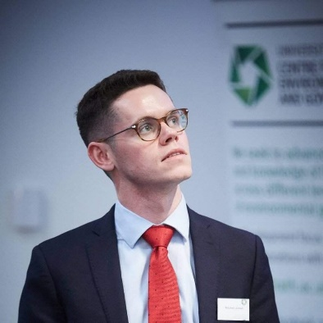
Mitchell is a Lecturer in Environmental Law at the University of Aberdeen. His research interests revolve around the ocean, where he explores the intersections of International Law of the Sea, Climate, Biodiversity, Human Rights, and Trade Law. He is specifically interested in the international regulation of fisheries and other marine resources in the face of climate change. He is also interested in the World Trade Organization's recently adopted Agreement on Fisheries Subsidies. As a UKRI GCRF One Ocean Hub member, Mitchell undertakes collaborative inter- and transdisciplinary research on various ocean law and governance issues and has contributed to several consultancies for the United Nations Environment Programme, the Food and Agriculture Organization of the United Nations, the Secretariat for the Convention on Biological Diversity, national governments, and non-governmental organisations.
Dr Gloria Alvarez

Gloria is an international academic on international dispute resolution, energy and investment law. She has in-depth knowledge of commercial law in civil and common law systems, acts as legal expert and independent arbitrator (ICC, ICSID and LCIA experience). She worked as in-house lawyer in a multinational company and arbitration case manager in an arbitral institution. Her academic work spans in the areas of international economic law, climate and social justice. She has held prestigious academic posts at the Shanghai University of Finance, Queen Mary University of London, Max Planck Institute (Luxemburg), Lauterpacht Centre (University of Cambridge) and a Research Associate at UKERC (EPSRC Grant). Gloria has published numerous leading books.
Dr Thomas Muinzer

Dr Thomas L Muinzer is a Reader at the School of Law, University of Aberdeen. His academic research focuses most pointedly on the Low Carbon Transition, with particular reference to climate law and governance and issues around decarbonisation of the energy sector. He has subsidiary and intersecting interests in the sphere of constitutional law, human rights protections, and the safe and responsible governance of energy and the environment. He has written the first monograph on the world’s first example of national framework climate legislation, the UK’s pioneering Climate Change Act: Climate and Energy Governance for the UK Low Carbon Transition: The Climate Change Act 2008 (Palgrave: UK, 2018). He is also the contributing editor to the first comprehensive book-length study of climate change regimes as they begin to emerge around the world: National Climate Change Acts: The Emergence, Form and Nature of National Framework Climate Legislation (Hart, 2020).

Dr Daria Shapovalova

Daria is a senior lecturer in energy law. She is the co-director of the Aberdeen University Centre for Energy Law and coordinator of the University's Just Transitions Lab. Daria coordinates the Energy LLM theme and leads courses on energy and environmental law. Daria's main research interests are in energy, environmental law and human rights. Her current research is on the climate change and energy law with a focus on just transition. Daria has published extensively on Arctic governance, regulation of petroleum production, and climate change law. Daria is a Fellow of the Higher Education Academy. She is a member of the UK Environmental Law Association, World Commission of Environmental Law, and International Law Association.

