Workshop Title: Renewable Energy Technology: Future, Opportunity, and Challenges for the UK and Turkey

UK coordinator: Dr. Khaled Ahmed

Turkey coordinator: Prof. Ilhami Colak
Discipline: Energy
Dates and venue: 4-7 April 2016, Gelisim University Campus, Istanbul, Turkey.

As part of the Newton-Katip Celebi Fund, the British Council and the TÜBITAK (The Scientific and Technological Research Council of Turkey) have launched a new five-year programme to encourage international research collaboration between ambitious researchers from the UK and eighteen countries around the world.

Newton-Katip Celebi Fund Researcher Links Programme provides opportunities for early career researchers from the UK and internationally to interact, learn from each other and explore opportunities for building long-lasting research collaborations.

As part of this programme, a ‘call to action’ was issued in April 2015 for leading researchers to propose themes for bilateral workshops to be held in one of these countries which will bring together early career researchers to discuss their research and start to build international relationships.

Successful applicant organisations from the UK and Turkey are now recruiting early career researchers and welcome applications to attend the above workshop.

The workshops will provide a unique opportunity for sharing research expertise and networking. During the workshops early career researchers will have the opportunity to present their research in the form of a short oral presentation and discuss this with established researchers from the UK and partner countries. There will be a focus on building up links for future collaborations and participants selected on the basis of their research potential and ability to build longer term links.

The British Council and TUBITAK will cover the costs related to the participation to the workshop, including: travel (both international and local), accommodation and meals. Costs for the visa will be covered; however participants will be responsible for making all the necessary arrangements. Although this cost will not be covered by the British Council, participants are encouraged to purchase an adequate travel and medical insurance. The British Council accepts no responsibility for any problems which may occur when the participants are in-country.

Application and Deadline:
The full application below must be completed and submitted by the 5th February 2016 to: khaled@abdn.ac.uk and icolak@gelisim.edu.tr

Eligibility Criteria:
- Applications must be submitted using the Researcher Links application form.
- Application must be submitted before the above deadline.
- Participants must be early career researchers: Early Career Researchers are defined as holding a PhD and having up to 10 years post-PhD research experience. They are equivalent to the ‘Recognised Researcher’ and sometimes ‘Experienced Researcher’ categories in the EU framework for researchers’ careers. http://ec.europa.eu/euraxess/pdf/research_policies/Towards_a_European_Framework_for_Research_Careers_final.pdf. Leading Researchers as defined by the EU Framework for researchers careers are research group leaders who are internationally recognised in their field.
- Participants must have a research or academic position (a permanent post, research contract, or fellowship etc.) at a recognised research institution either in the UK or in Turkey.

Quality Assessment
- Experience and relevance of the applicant’s research area to the workshop.
- Motivation and contribution to the aims of the workshop.
- Description of the long term impact expected through the participation in the workshop.
- Ability to disseminate workshop’s outcomes.

Selection Procedure:
- Eligibility check.
- Quality assessment.

Notification of results:
Applicants will be notified by email 1 month prior to the workshop.

Equal Opportunities
The British Council is committed to equal opportunities and diversity in all its activities and this includes the avoidance of any bias in the assessment of applications due to gender, disability, racial or ethnic origin, sexual orientation, or religious belief. Participants’ selection undertaken by workshop organisers must not contravene this policy. Extra support to enable participation of early career researchers with special needs will be given.

Please see the link below for detail on British Council policies that relate to your work- adherence to these policies are British Council Requirements http://www.britishcouncil.org/new/about-us/jobs/folder_jobs/register-as-a-consultant/policies-for-consultants-and-associates/. Please refer to brand guidelines as directed by the British Council office in the country where you will be delivering your workshop.

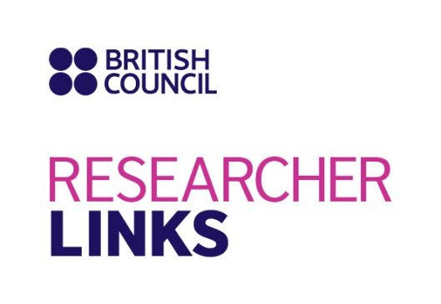

Application Form

1. Applicant
Name and title
Gender (to monitor statistic participation – this will not be considered during assessment)
Position and institution
Postal address
Email
Phone number
Brief CV (academic career, publications, markers of esteem, and any other relevant information) – no more than ½ page of A4

Abstract - Please give a summary of your area of research

3. Please describe your motivation to attend the workshop and how the workshop matches your professional development needs
4. Please describe the expected impact of your participation to the workshop on your personal and professional development, including your ability to work on an international level

5. Please indicate how you will disseminate the outcomes of the workshops and the new knowledge/skills you have acquired

6. Workshops will take place in English as standard. Please indicate your ability to work and communicate in English (Note, translators may be provided if necessary)
Native speaker |  | Good
Excellent |  | Need support

7. Please use this space to give any additional information that you feel is relevant for the application.

