**DYNAMIC MODEL OF ROCK IMPACTS**

M Wiercigroch, O Ajibose, E Pavlovskaia, Gy Károlyi, J Wojewoda, A.R.Akisanya

*Centre for Applied Dynamics Research, School of Engineering, University of Aberdeen, AB24 3UE,*

*Aberdeen, Scotland, UK, m.wiercigroch@abdn.ac.uk*

**ABSTRACT**

Previous theoretical and experimental investigations [1]–[5] have tested the behaviour of high frequency vibro-impact drilling systems using a bilinear elasto-plastic model for the force-deformation characteristics of rocks (see Fig. 1a). There, the resistive force was proportional to the deformation of the rock before the yield stress was reached. Then a perfectly plastic behaviour set in: at constant force the deformation of the rock simply followed the movement of the drill-bit. Experimental evidence shows, however, that this kind of force-displacement relations cannot accurately describe the behaviour of rock materials under impact, because the deformations and the stresses can far exceed the yield limit. In this paper a new contact force model is proposed for rocks under impacts.



Figure 1: Schematics of the previous and the new vibro-impact drilling models. (a) The previous bilinear model, where the slider exerts a constant force *FR* when the load acting on it exceeds this value. (b) The new model with the nonlinear contact force model (c) showing the resistive force-deformation diagram: during the loading period of the impact the force is proportional to the square of the displacement, during unloading it follows Hertz’s law.

The dynamic model of a vibro-impact system incorporating the new model of the contact force is shown in Fig. 1b. In Figs. 1a and b, the drill-bit is modelled by a mass *M* driven by a combination of a static and a dynamic force *F* = *FS +FD* cos(Ωt). Here *FS* is the static force, *FD* is the amplitude of the dynamic force, and Ω is the angular frequency of the dynamic load component. While the drill-bit of mass *M* is not in contact, its dynamics can be described by:

 (1)

where *xM* is the displacement of the drill head, and *xT*,  *xB* or *xS*  are the displacements of the slider. As soon as the drill-bit contacts the rock, the resistive force *FR* also starts to act on the mass. In our new contact force model, as shown in Fig. 1b, during the loading stage (*M* >0) of the contact, the resistive force is proportional to the square of the displacement: *FR* = *a* (*xS* – *xS,prev* )2 , where *a*  is a material constant, and  *xS,prev* is the position of the slider reached during the previous impact. When the velocity of the progressing mass drops to zero(*M* ≤ 0 ) we assume that the elastic part of the deformation is regained, hence the resistive force is Hertzian: *FR* = *d*(*xS* – *xR* )3/2, where *xR* = *xS*,max – ( *FR,max* /*d*) is the remaining deformation after unloading, *xS*,max is the maximum displacement during progress, *FR,max* is the corresponding maximum resistive force, and *d* is a material constant. Hence the dynamics can be described by the following equations during impact:

 (2)

where *G* is the initial gap between the drill-bit and the rock.

We identify chaotic and regular motion of the drill bit, depending on the parameter settings. Figure 2a presents typical time histories of the progression for several values of the static force. One can observe that the progression is higher when the motion is periodic. In Fig. 2b a chaotic attractor is shown, the irregular behaviour implies that the drill head impacts the rock with non-optimal velocity, slowing down the progress. The state of the system can be different after each period of the driving force, and it is characterised by different points in the phase space.

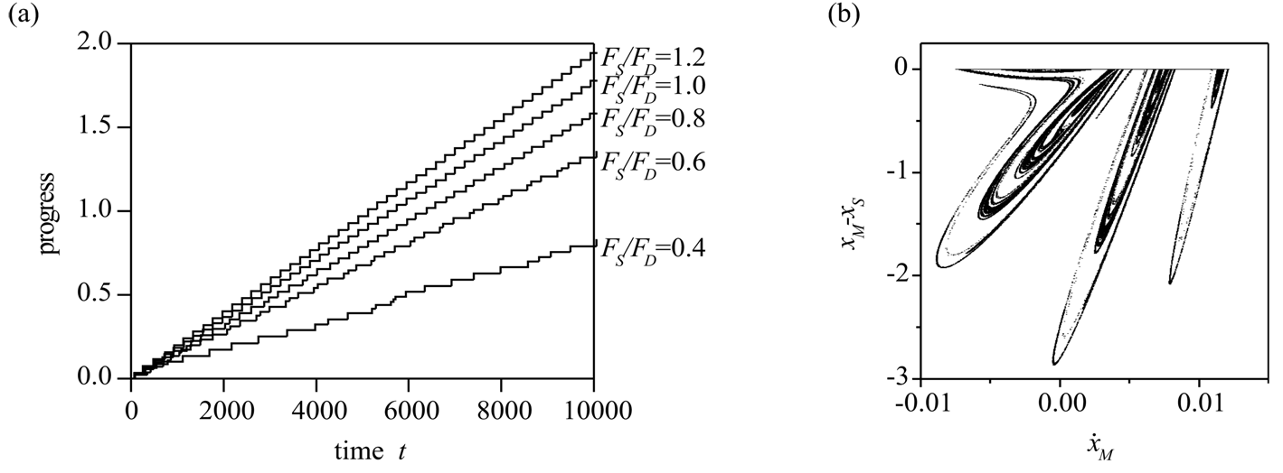

Figure 2: (a) Progression (remaining displacement of the slider) for several values of the static force FS. The parameters used are *FD* = 10 ×10-5, Ω=0.03, *G* =0.3, *M* =1, *a=1*, *d=1* (all values are non-dimensional). (b) Chaotic attractor, the Poincaré map shows the state of the system after each periods of the dynamic force in the phase space consisting of the velocity *M* of the drill-bit and the distance *xM* - *xS* of the mass from the slider. The static force is *FS* = 4 ×10-5, the other parameters are the same as those used for (a).

To have an overview of when the motion of the drill-bit is chaotic and when it is periodic, the bifurcation diagram was also constructed for several parameter values. Two examples are shown in Fig. 3.

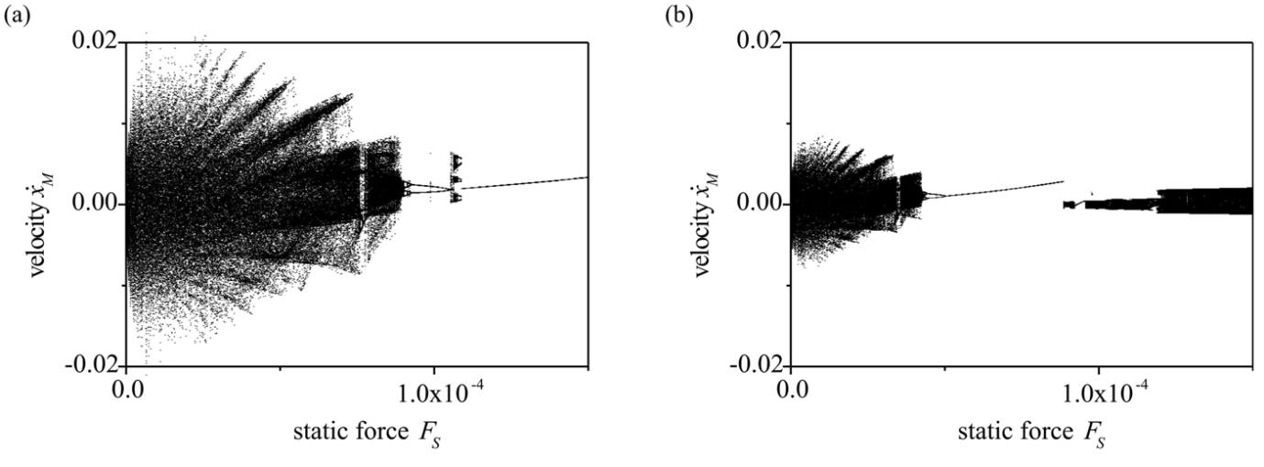

Figure 3: Bifurcation diagrams for different dynamic forces, (a) *FD* = 5 ×10-5, (b) *FD* = 12 ×10-5 . The other parameters are the same as those used in Fig. 2.

**References**

[1] M.Wiercigroch, R.D. Nielson, M.A. Player: Material removal rate prediction for ultrasonic drilling of hard materials using an impact oscillator approach. *Physics Letters A* **259** (1999) 91–96.

[2] E.E. Pavlovskaia, M. Wiercigroch, C. Grebogi: Modelling of an impact oscillator with a drift. *Physical Review E* **64** (2001) 056224.

[3] E.E. Pavlovskaia, M.Wiercigroch: Modelling of vibro-impact system driven by beat frequency. *International Journal of Mechanical Sciences* **45** (2003) 623–641.

[4] M. Wiercigroch, J. Wojewoda, A.M. Krivstov: Dynamics of ultrasonic percussive drilling of hard rocks. *Journal of Sound and Vibration* **280** (2005) 739–757.

[5] E.E. Pavlovskaia, M. Wiercigroch: Low dimensional maps for piecewise smooth oscillators. *Journal of Sound and Vibration* **305** (2007) 750–771.