Exhibit 7 – TMSA Storytelling Trophy
This trophy was made in honour of Stanley Robertson. What does that tell you about what people thought of him?
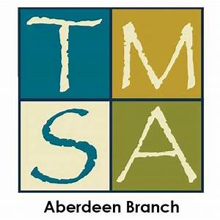
Grampian Association of Storytellers – Stanley Robertson Prize for Storytelling
This trophy is presented to the best adult storyteller at the Aberdeen TMSA (Traditional Music and Song Association of Scotland) Traditional Competition each March.

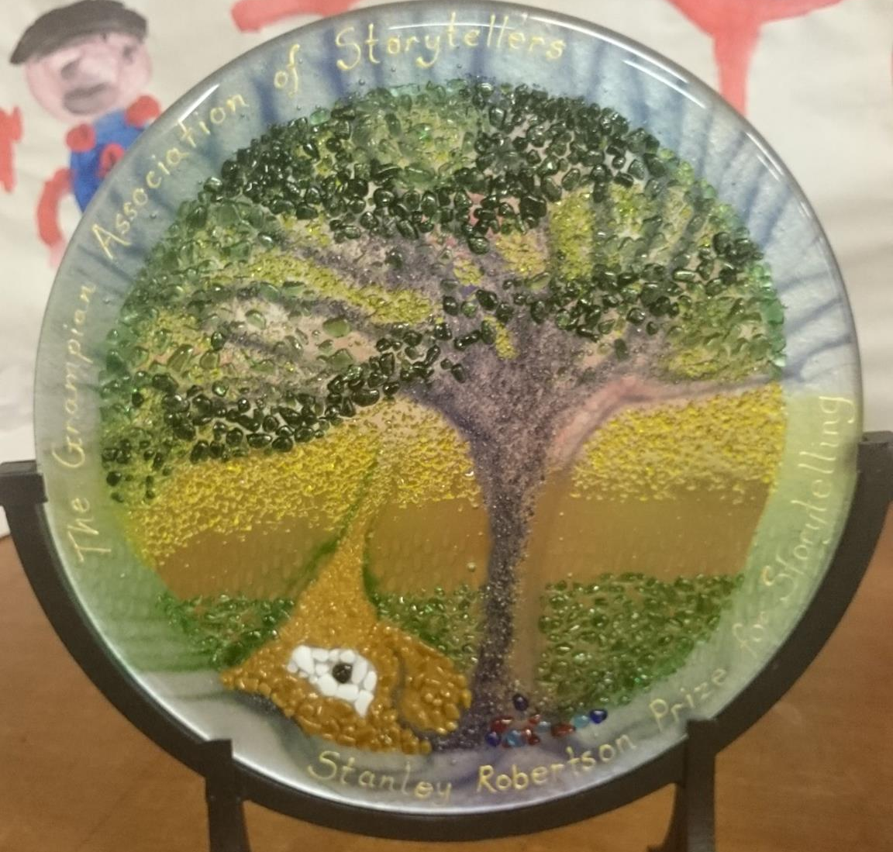

It shows 'Auld Croovie' – an old oak tree near the Lumphanan camp site where Stanley stayed as a boy. Stanley told a story about Auld Croovie – it was one of his favourites.

Exhibit 8 – Adverts for Commemorative Events
Look at these events which were held to remember Stanley. What does that tell you about what people thought of him?
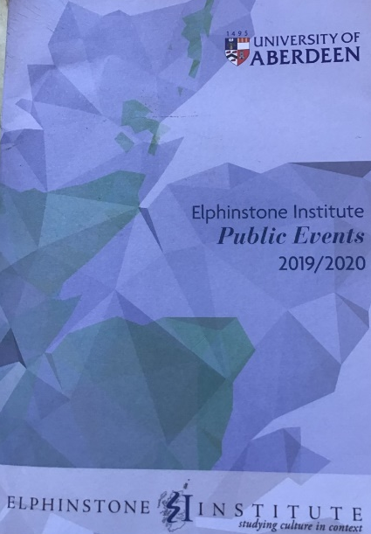

Exhibit 9 – Testimonials from Storytellers

Read the following comments from various different storytellers. What does that tell you about what people thought of Stanley Robertson?
For years I had heard of Stanley Robertson from afar, with a respect and reverence for who and what he represented. It was in 2000 that I met him, during a day at Drum Castle where he was telling the story of the Lady of Drum. From that day I was fortunate enough to meet him often and learn many, many stories and songs from him.
Grace Banks, Singer and Storyteller
He [Stanley] had the ability to transport you to another world, to another place. And [with] his ballads, he had that feeling of authenticity about the whole nature of Scottish traditional culture. Along with Sheila Stewart, he was the greatest living exponent of it.
Vic Smith, Folk Club Organiser
Stanley inspired me to become a storyteller. When I read his book 'Exodus to Alford', especially the story of Jack and the Skinny Coo, I knew I wanted to tell stories. I was then lucky enough to meet Stanley and have the chance to learn about storytelling from him. I guess you could call him my storytelling idol!
Jackie Ross, Storyteller

