Exhibit 1 – Obituary
Read the following obituary from The Guardian Newspaper. An obituary is written when a famous person dies, and it tells us about their life. What does that tell you about the importance of Stanley Robertson?

Members of the Traveller community in Scotland have been vociferous guardians of oral culture: folk songs, ballads and stories. The singer and settled Traveller Jeannie Robertson, who died in 1975, was described by the American folklorist Alan Lomax as "a monumental figure in 20th-century folksong". Among the small number of singers to whom Jeannie taught the songs directly was her nephew Stanley Robertson, who has died of a heart attack aged 69. Although he never achieved the fame of his aunt, Stanley was nevertheless a highly skilled singer, with a seemingly unlimited repertoire, and a storyteller with a prodigious memory.

Stanley was the son of William and Elizabeth. By the time he was born, the family had settled in Aberdeen, although they continued the "summer walking", when Travellers took to the road and worked in seasonal agricultural trades. The annual exodus to Alford in north-east Scotland (which inspired the title of one of Stanley's books) to work in the flax fields allowed the family to escape from the prejudice then common among the city's residents.

Stanley left school at 14 and spent almost all of his working life as a fish gutter on the quayside at Aberdeen, where he frequently entertained his colleagues with stories and songs. He also played the bagpipes in the Territorial Army's pipe band.
His maternal grandfather, Joseph McDonald, provided further inspiration for Stanley's storytelling. His fairy-tales and tales of wonder, legends, religious and supernatural stories were first published in Exodus to Alford (1988), followed quickly by Nyakim's Windows (1989), two volumes of Fish-Hooses (1991), The Land of No Death (1993) and Ghosties and Ghoulies (1994). His final collection of stories, Reek Roon a Camp Fire, was published earlier this year. He told his tales in schools and was invited to storytelling festivals in Britain and the US. Some of his stories could last up to an hour, yet he told them with confidence, never faltering or forgetting the detail.

Stanley's storytelling inspired his playwriting, including The Burkers and Scruffie Uggie, written for children. The Edinburgh Theatre Workshop performed his Jack and the Land of Dreams in 2000.

He is survived by his wife, Johnann, and children Robert, Anthony, Clifford, Dale, Gabrielle and Nicole, who all continue to sing and tell the family stories.

• William Stanley Robertson, folk singer and storyteller, born 8 June 1940; died 2 August 2009

Edited from webpage:
https://www.theguardian.com/music/2009/oct/07/stanley-robertson-obituary

Exhibit 2 – Research Papers
Look at the following photos of various research papers that mention Stanley and his work. These research papers are written by people who have studied Stanley's work and life to learn more about people and storytelling and singing.
What does that tell you about the importance of Stanley Robertson?

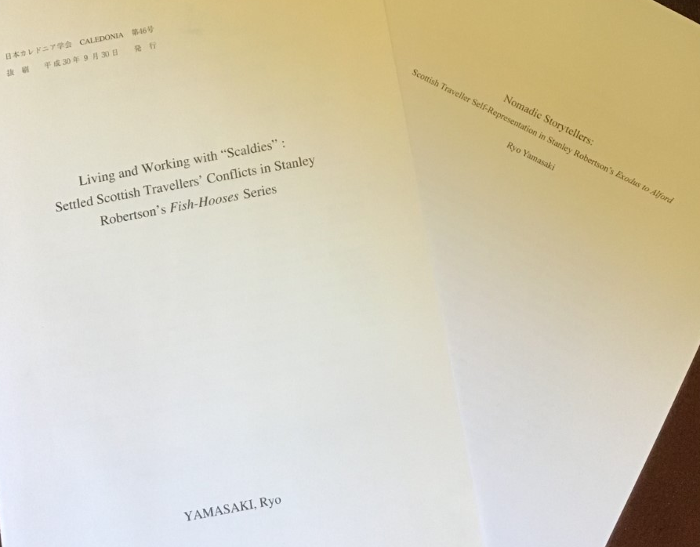

Exhibit 3 – Listings on Archive Site
Tobar an Dualchais was created so that people can listen to important recordings of stories, songs and talk about traditions. Can you find where it says that Stanley Robertson has 379 recordings on this website?
What does that tell you about the importance of Stanley Robertson?

