UNIVERSITY OF ABERDEEN

PURE - REF2014 MODULE - GUIDANCE NOTE

NOMINATING RESEARCH OUTPUTS FOR POTENTIAL REF2014 SUBMISSION IN PURE

Summary

The University will be using the new REF2014 Module in Pure to coordinate and submit the output element of the REF2014 submission.

In order to do so, we need all research active staff to upload details of all research outputs that they have produced since 1 January 2008 (the start of the REF2014 assessment period) onto Pure. This will enable us to see what outputs are available for each researcher for possible selection for REF. Researchers also have the opportunity to indicate which outputs they think the University should consider when preparing its submission to REF2014.

Please note, that researchers can nominate more than four research outputs for consideration to REF2014 via the REF2014 module in Pure, although only a maximum of four outputs will be submitted (less if there are individual staff circumstances). Nominating outputs does not mean that the University will use these outputs in the submission, or that a researcher will be included in the final submission.

Decisions on selection of staff for the REF2014 exercise will be made in due course.

Uploading Research Outputs into Pure

For a reminder on how to upload research outputs in to Pure (or for those who have never done this), instructions are available in the Pure guidance document “Adding New Content”, accessed via the following page: http://www.abdn.ac.uk/staff/pure

Proposing Research Outputs for REF2014

Once your record has been updated, you can indicate which outputs you think should be considered for REF2014. In order to do this, please:

- Log in to your Pure account via www.abdn.ac.uk/staff/pure
- On your homepage, please select “Propose outputs for REF2014” from the row of headings located underneath your personal information at the top of the screen. Please see the screenshot on the next page for an example of a personal profile.

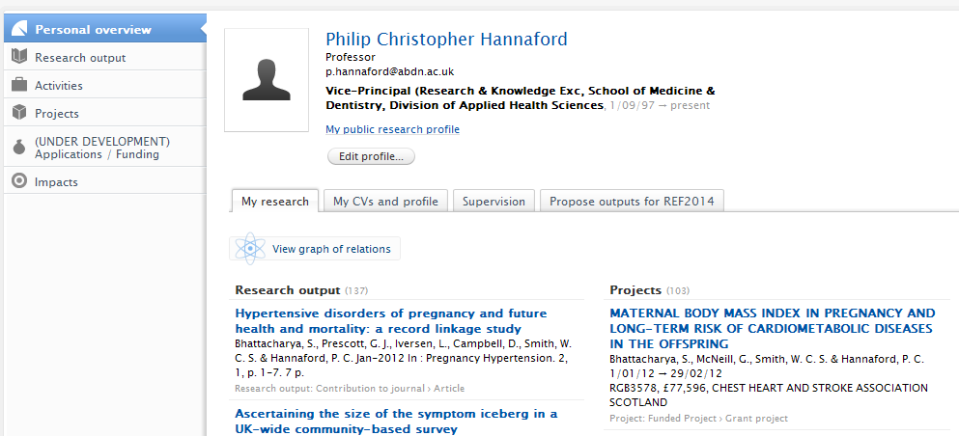

Once you have selected “Propose outputs for REF2014), the following screen (please see screenshot on the next page) then lists all research outputs that you have recorded in Pure during the REF2014 submission period (i.e. since 1 January 2008). Underneath each research output, you will see a tick-box for “Proposed for REF2014”. In order to select the outputs you wish to put forward for REF2014 submission, please:

- Left click and select the “Proposed for REF2014” tick-box, underneath the chosen output.
- This will open a text-box which enables you to provide information about why you think the output should be considered. The text-box states:

“Give your reason for proposing this output:
Please consider if it is interdisciplinary research? Should it be cross-referred to another UoA? Do you judge this output to be double-weighted? Please justify why.”

- Please provide any information that you feel would be helpful when considering your submission.
- Once you have selected your outputs, please click ‘SAVE’ at the bottom of the screen.
- Please note, you can also “rank” the selected outputs in order of preference, from 1 to 5 (1 being most favoured / strongest). You may rank up to 5 outputs (though only a maximum of 4 outputs will be used in the submission). You can choose to ignore this feature.
- PLEASE ENSURE YOU CLICK ‘SAVE’ OR ALL SELECTIONS WILL BE LOST WHEN YOU LEAVE THE SCREEN.

