UNIVERSITY OF ABERDEEN

PURE - PUBLIC RESEARCH PROFILE

OVERVIEW AND GUIDELINES

Making Content from Pure Available Publicly

Pure Public Research Profile Overview

The institutional Research Information System, Pure, includes a “Public Research Profile” facility which externally displays content stored in Pure via a web interface, in a way similar to staff web-pages. Every Pure user within the institution has their own Public Research Profile page which, once live, will sync and display content externally, directly from their individual Pure account.

The University will launch the Pure Public Research Profile facility on 30 March 2012.

The information displayed by the Public Research Profile, directly from your Pure account, will include: basic personal details, selected research outputs, and research activities. However, individual users will have the editorial authority to determine which content in their account they would like to display in their Public Research Profile, meaning, for example, users can choose which research outputs they would (or would not) like to display.

The institutional Pure Research Profile Homepage will look like this to an external viewer:

UNIVERISTY PUBLIC RESEARCH PROFILE - HOMEPAGE
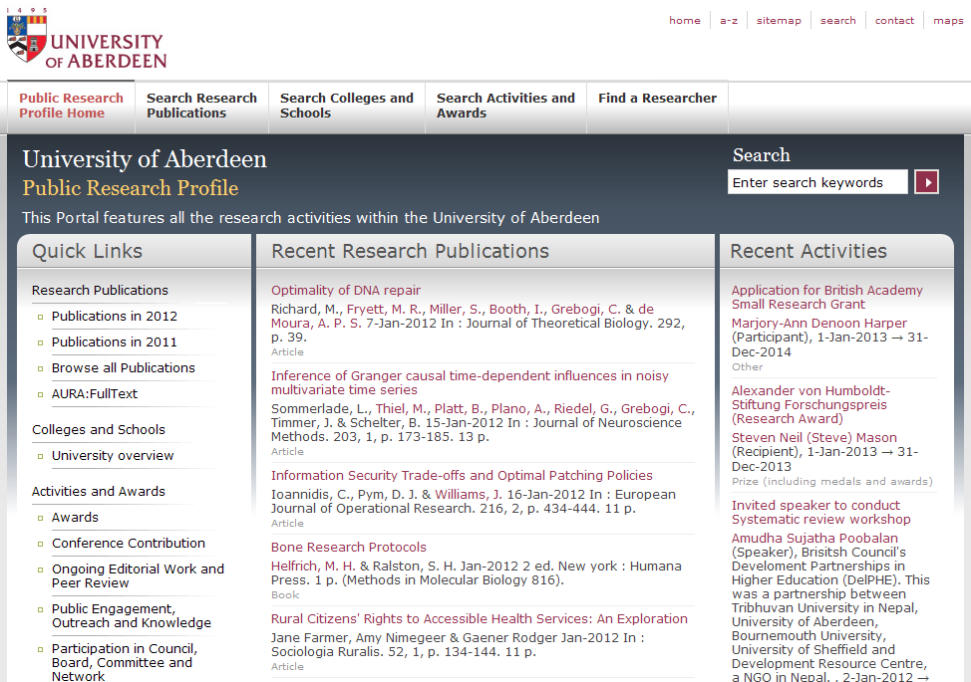

An individual user’s Public Research Profile page will look like this:

INDIVIDUAL USER’S PUBLIC RESEARCH PROFILE
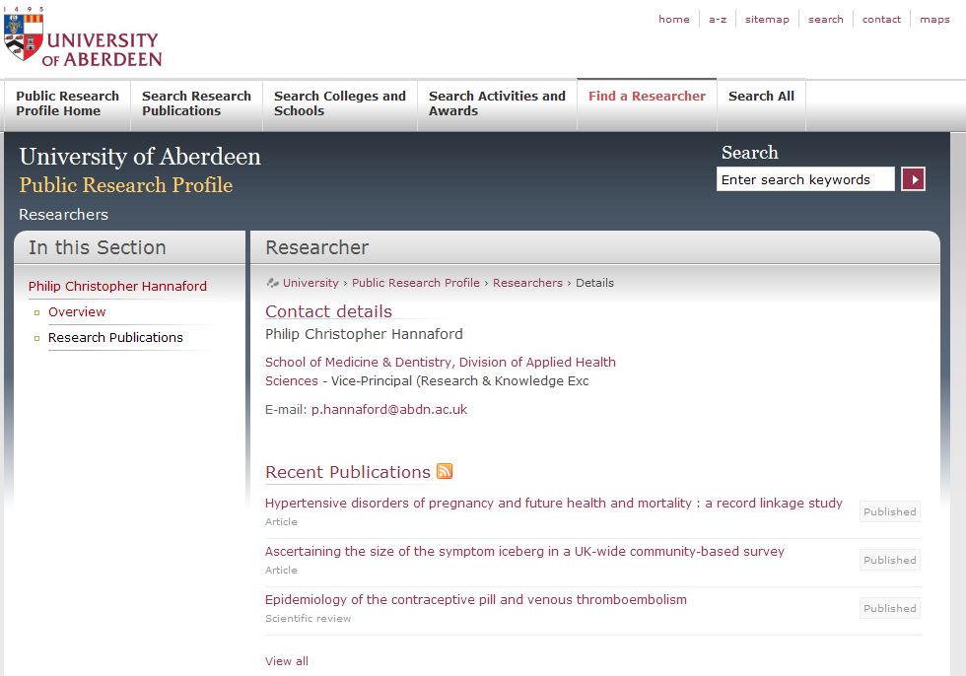

Launching the Pure Public Research Profile - Key Points

It is the University’s intention to launch the Pure Public Research Profile on 30 March 2012.

There are a number of advantages to using the Public Research Profile (described below); however, there are also a number of important issues to consider when making content from Pure available via the Public Research Profile. There are also specific steps each individual user must take before the Public Research Profile goes live (such as selecting which research outputs they would / would not like to display via the Public Research Profile). Please read through the Q and A’s below for the relevant information:

Why make content from Pure available externally?

- The information displayed in the Public Research Profile will be useful to researchers visiting the University web pages to search for an individual researchers publications. It will also be accessible to potential research students, taught postgraduates, undergraduates, business and the media.
- The Pure Public Research Profile makes full-text available by linking directly to files on AURA.
- It will also make content available through Google and similar search engines.

What content from Pure won’t be displayed in the Pure Public Research Profile?

- Under current settings, Projects and Impact(s), as listed in any individuals Pure profile, are blocked from the Public Research Profile, regardless of the visibility setting in Pure. No personal or contractual information is ever passed to the Public Research Profile.

How do I control the data going to the Pure Public Research Profile from my Pure profile?

- Content displayed in the Pure Public Research Profile from Pure (i.e. its ‘visibility’) is controlled by individual users in Pure; a selection box in each research output template allows items to be marked as “Public” (making it available to external visitors), “Campus” (which restricts access to users within a specific IP range), “Backend” (i.e. requires a University log-in / available to internal viewers only), or ‘Confidential’ (restricting access to associated users and editors).

- The responsibility for the visibility option selected in Pure rests with the individual user. To access the visibility selection box (screenshot below), an individual must open their research record entry in Pure (double click on the selected research output), and scroll down towards the foot of the page, where they will find Visibility settings. They can then change accordingly. To make an entry in Pure visible to the outside world via the Public Research Profile, users must select the “Public” option; to stop an output from appearing on the Public Research Profile, users should change the visibility setting to “Backend - restricted to Pure users”.

- Please ensure you click SAVE before exiting the screen or any changes will be lost

PURE VISIBILITY SETTINGS
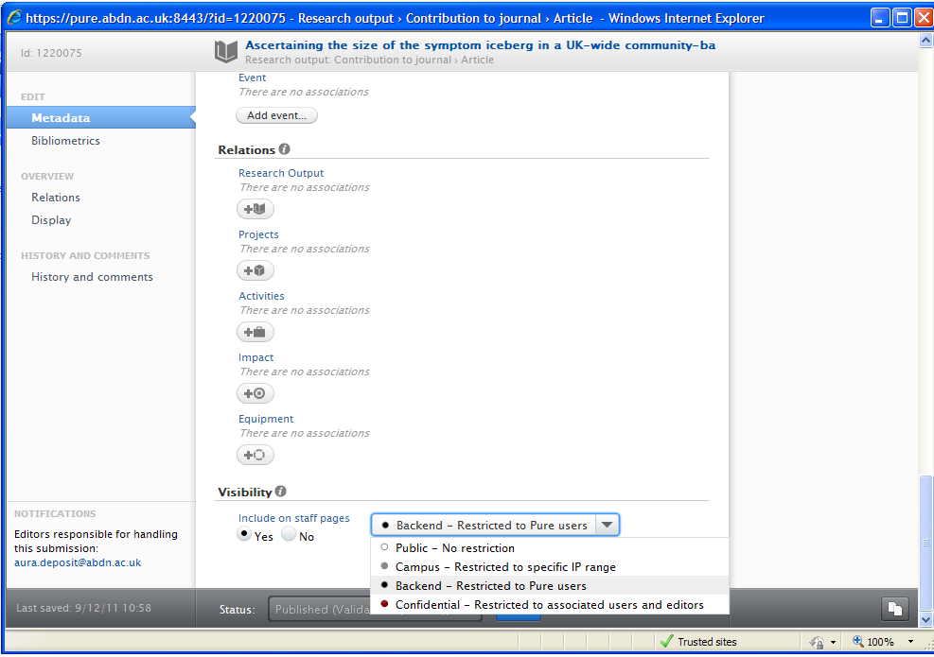

What should I do before the Pure Public Research Profile is launched?

- Check all existing content in Pure to make sure that the appropriate Visibility setting is selected, noting that:

  - Most content in Pure is normally set by default to Public (meaning publicly available) unless you physically change the Visibility setting – as explained above, this requires action on your part. When content is set by default to Public it will be available via the Public Research Profile to external visitors.

  - Basic information (but no personal details) from your Pure Profile will also go through to the Public Research Profile, unless you change it to Backend - Restricted to Pure Users.

  - When you create a new Research Output, the Visibility is automatically set to Public. You have to take action if you wish to change it.

NOTE that any items set to ‘in Preparation’ will never go through to the Public Research Profile, irrespective of the Visibility setting.

  - When you create a new Activity, the Visibility is automatically set to Public. You have to take action to change it.

How can I see what information is displayed in the Pure Public Research Profile?

- Staff are able to view their Pure Public Research Profile via their Pure Profile homepage. This currently has security settings so that it is only accessible by internal users; your username and password will be required to access the Public Profile. Once the Public Profile is fully operational this will be disabled.

To view your information, please log-in to Pure and go to your Personal information area. Immediately under your name and organisation details you will see a link to “my Public Research Profile”. Right mouse click on this and click Open in new window. A log-in screen will be presented and your Public Research Profile page will then be displayed.

MY PUBLIC RESEARCH PROFILE LINK
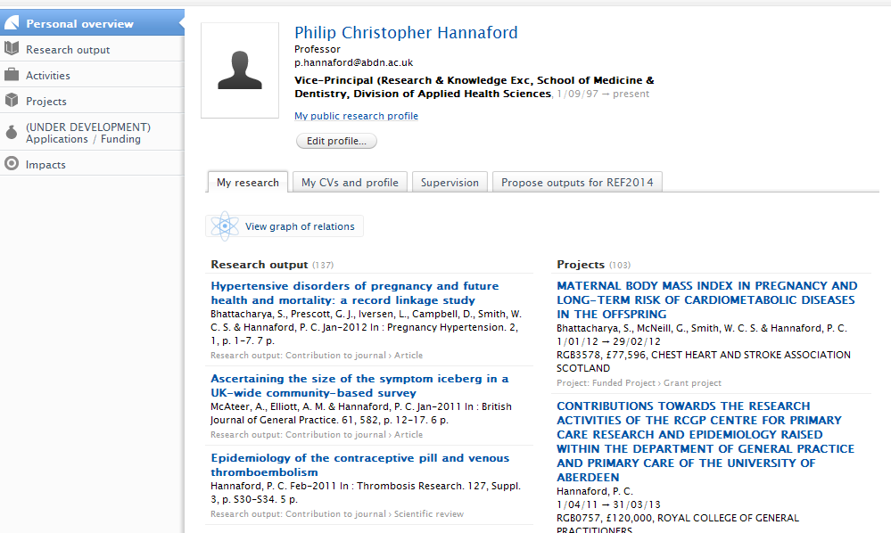

Are there any support guides available?

- For further information about how to set the Visibility setting please refer to the “How To” guide Adding New Content available from the Pure Support website.

http://www.abdn.ac.uk/staff/pure.php

Who should I contact for further information?

Further information is available from Marlis Barraclough on m.barraclough@abdn.ac.uk or 27 (2038) or from Iain Grant, i.grant@abdn.ac.uk, (27) 2776.

