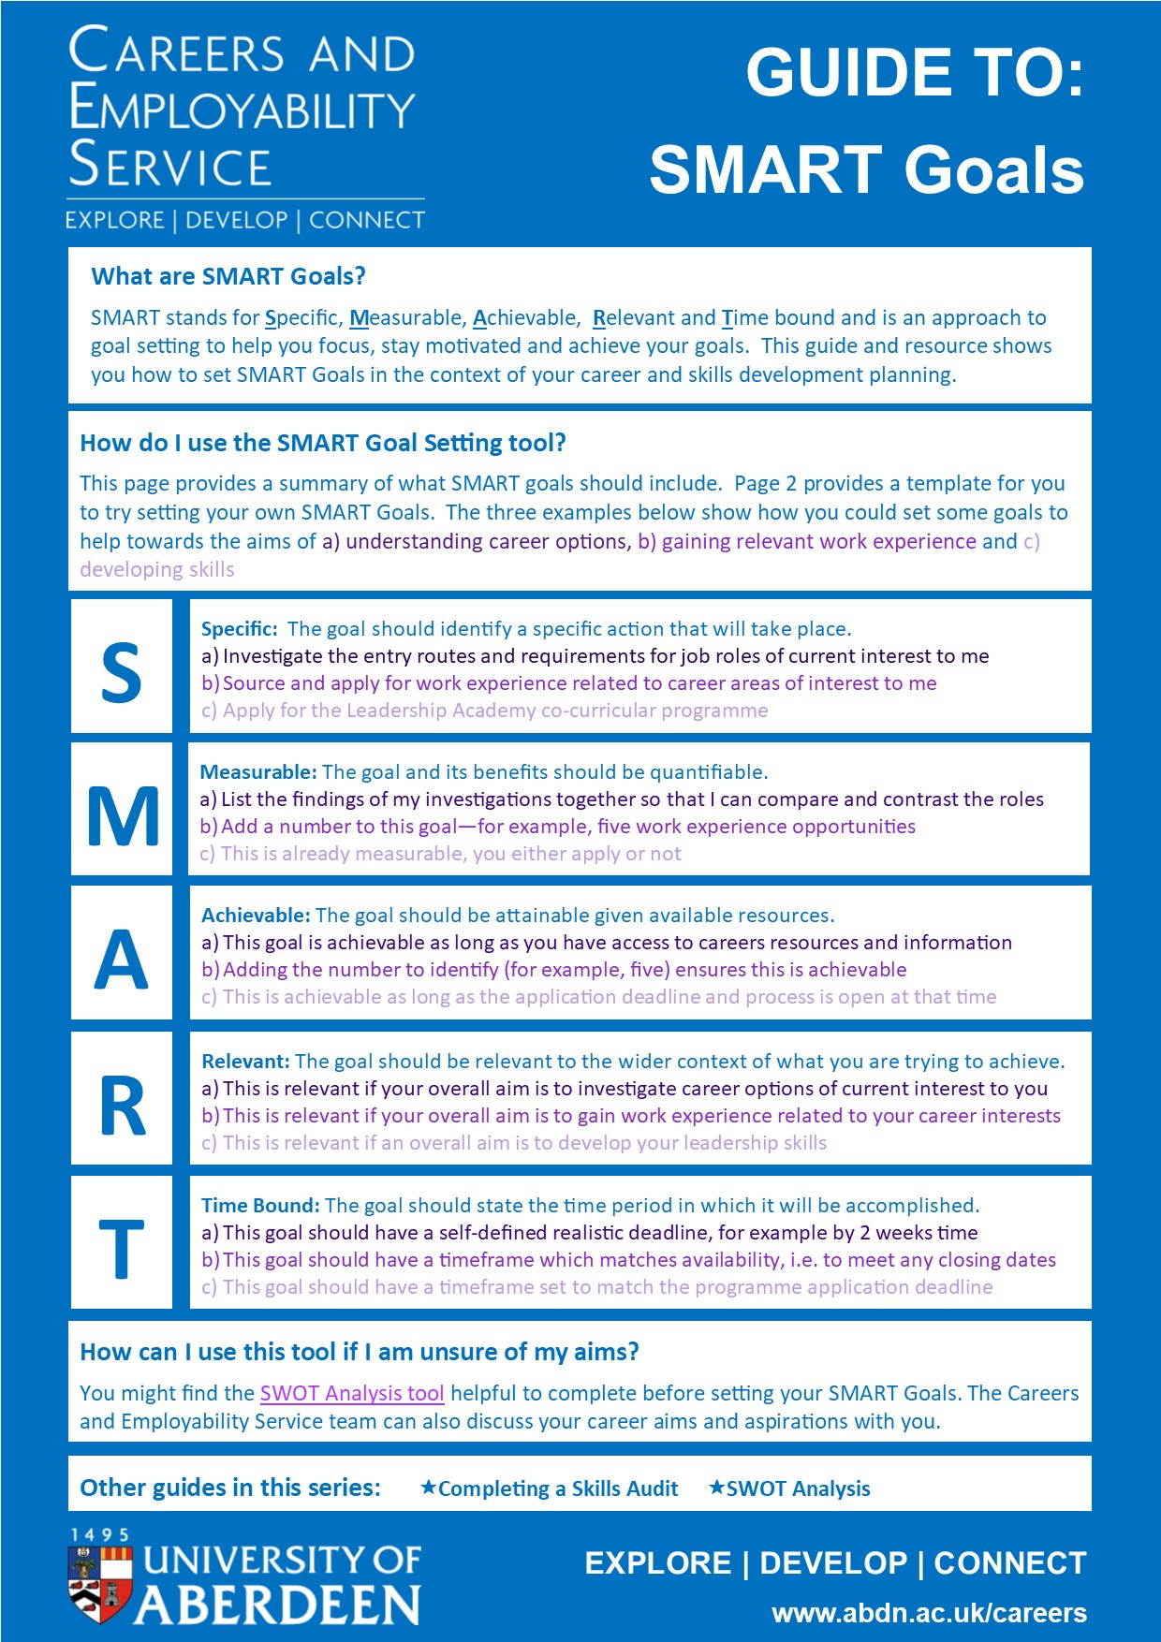
TO COMPLETE:
SMART Goal Setting
STEP 1: Note down some of your career or skills development aims here: if you are not sure, you can refer to our SWOT Analysis tool to generate some ideas for this:
Click or tap here to enter text.

STEP 2: Set a SMART goal which will help towards your aims:
Click or tap here to enter text.

Check off that your goal is Specific ☐ Measurable ☐ Achievable ☐ Relevant ☐ Time Bound ☐

STEP 3: Set a second SMART goal which will help towards your aims:
Click or tap here to enter text.

Check off that your goal is Specific ☐ Measurable ☐ Achievable ☐ Relevant ☐ Time Bound ☐

STEP 4: Set a third SMART goal which will help towards your aims:
Click or tap here to enter text.

Check off that your goal is Specific ☐ Measurable ☐ Achievable ☐ Relevant ☐ Time Bound ☐

What do I do once I’ve set my goals?
Use a diary system to note down the actions you need to take, and when you will do this. Put the deadline for each goal into your diary as a reminder and to tick off once complete as a motivating boost.

Other guides in this series: Completing a Skills Audit SWOT Analysis

