UNIVERSITY OF ABERDEEN

Travel Hierarchy

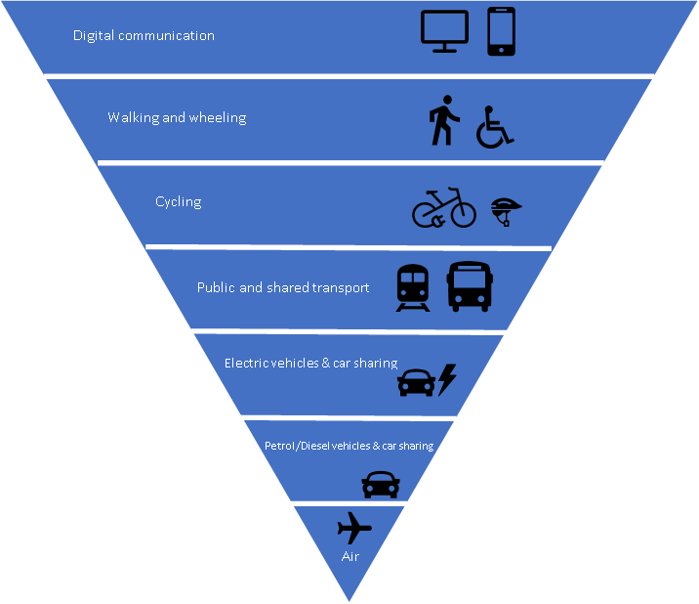
Based on Sustainable Travel Hierarchy, Energy Saving Trust

