HOW TO RAISE A DELIVERED CATERING ORDER

- Log into the University online Finance System

- Click Procurement > Click Requisitions – advanced

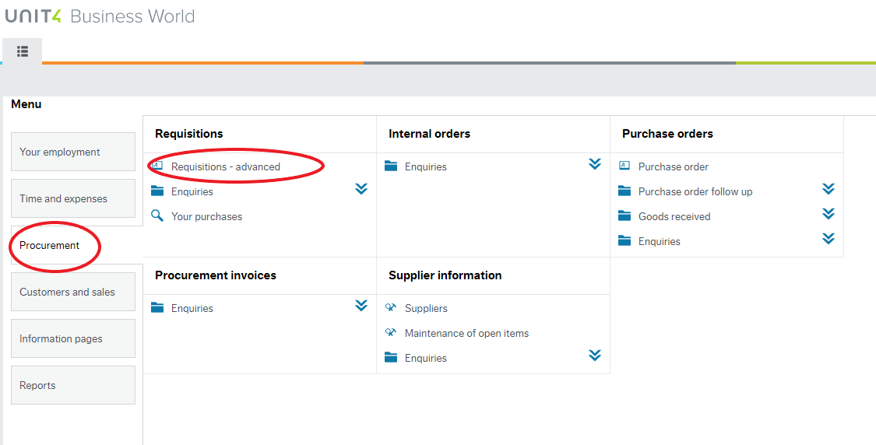

- Click Go Shopping which will redirect you to the Supplier Directory

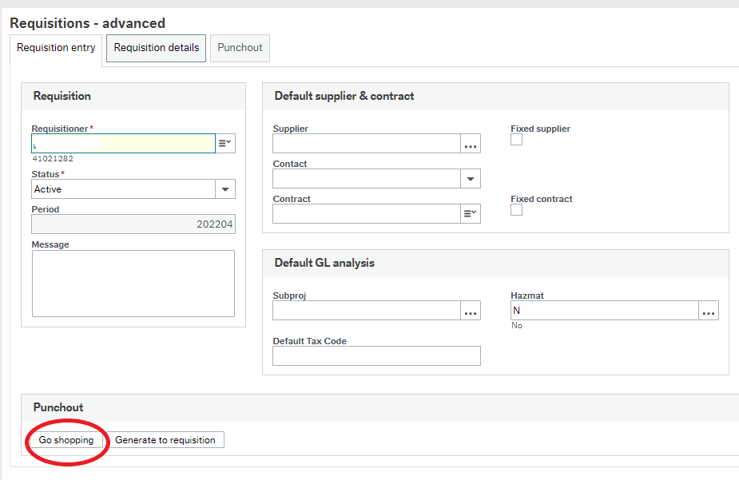

- In the Search for a supplier text box input Campus Services > Click Search > Click the three red line icon to open the Delivered Catering Catalogue

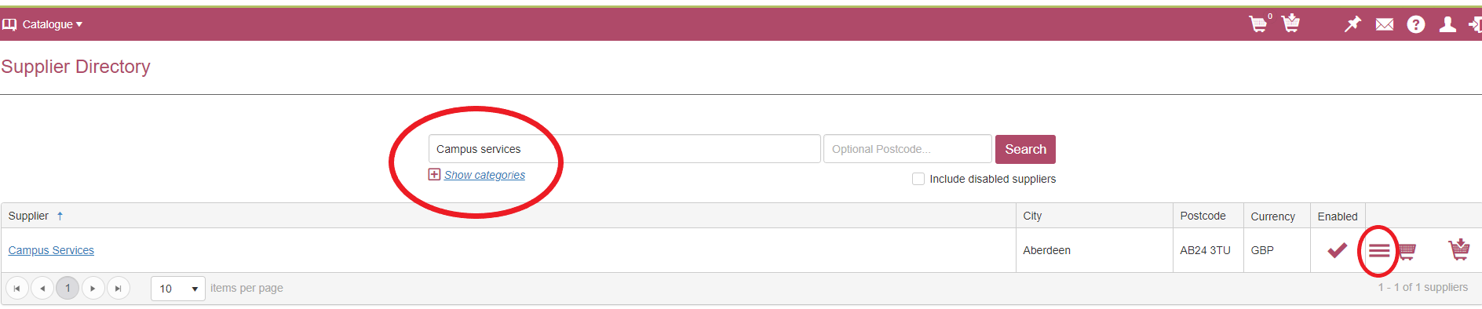

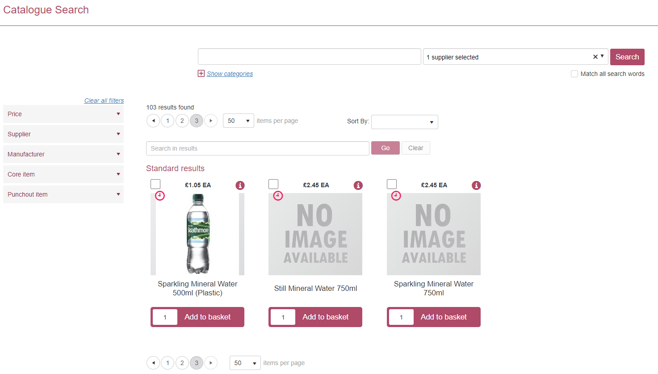

- Add all applicable items into your basket, item quantities can be amended on the Add to Basket button. Once all items have been added, go into the Basket > Click Checkout which then redirects you back to the Finance System.

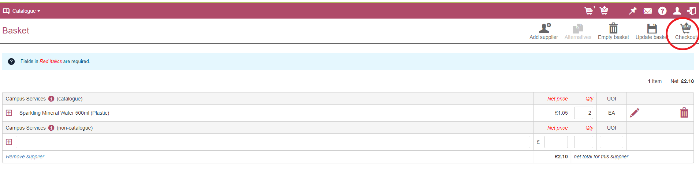

- Click the Punchout tab > Click Retrieve Shopping > Tick the relevant line > Click Generate to Requisition

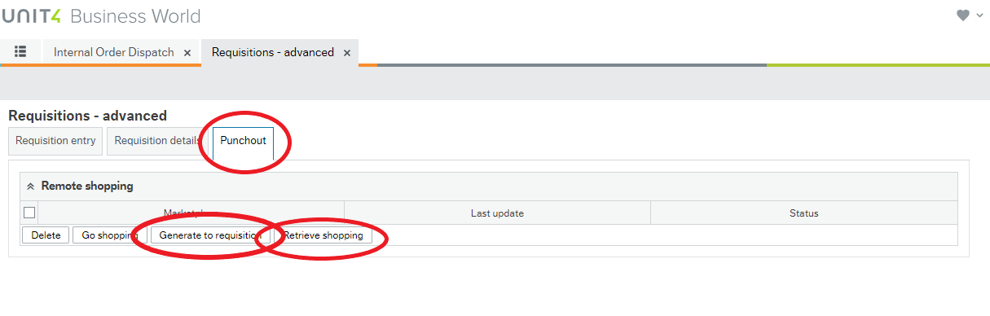

- Click the first line in your order > Expand the Detailed Product Information box and GL Analysis box

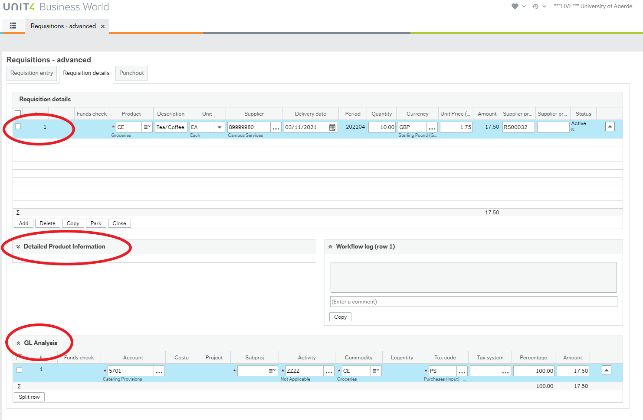

- In the Additional Product Text box input order date, time/s, location, any sandwich fillings (if applicable) and any further information

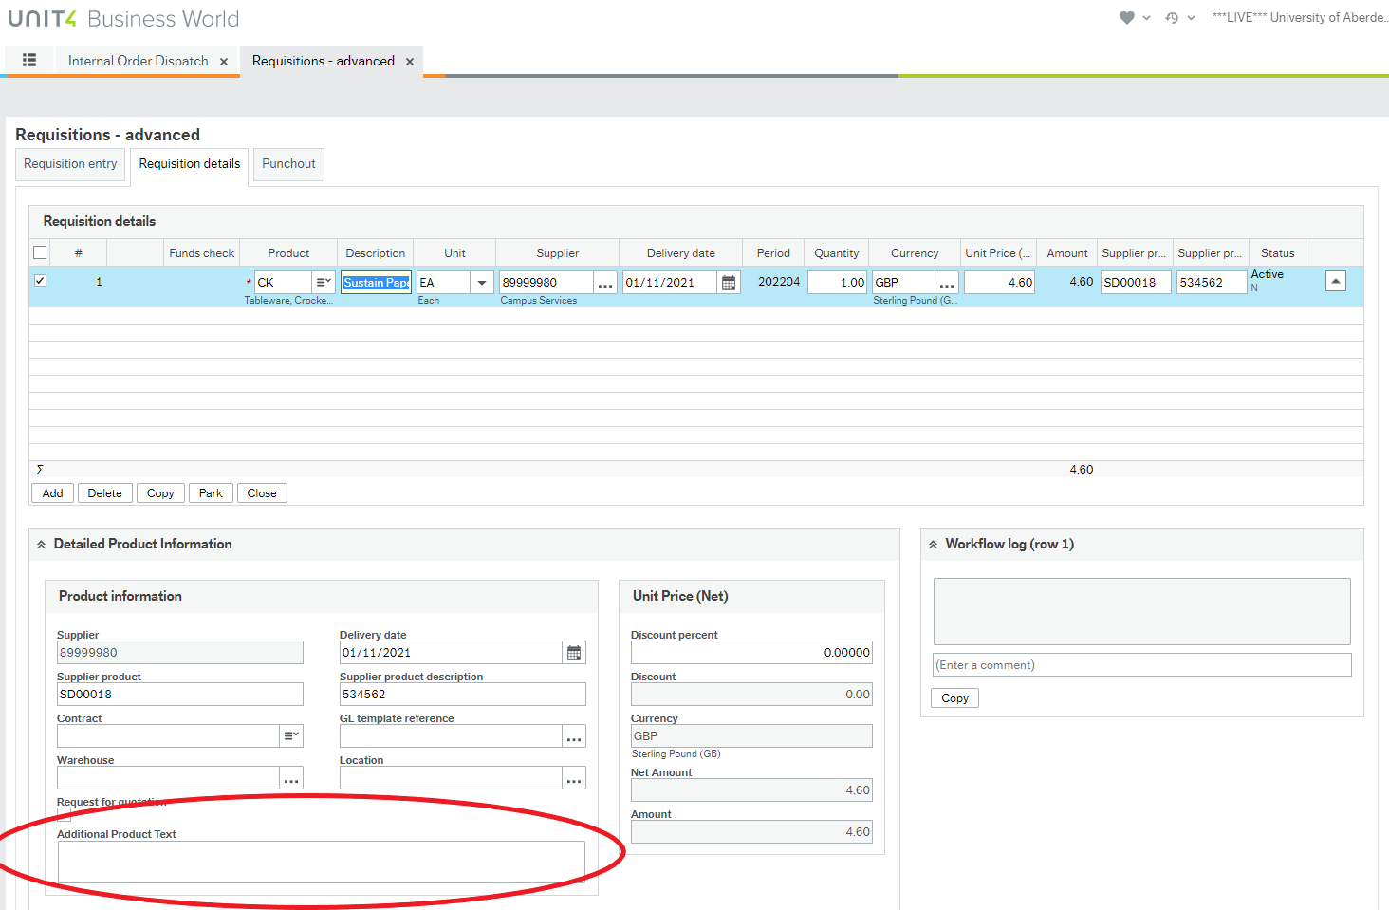

- In the GL Analysis box input relevant budget code in SubProj box, amend Tax Code box to PO and Tax System box to NR

- Ensure you have amended the SubProj and Tax code & system for every line in your order

- Click Save

- Ensure the PR Purchase Requisitions line is highlighted in the Posting Cycles box > Click OK (The system will generate a green number at the top of the screen if your order has been successfully submitted)

HOW TO RAISE A FREE TEXT LINE

There are a few items which are not listed in the catalogue which can be ordered on request – Please see the procedure below how to order non-catalogue items

- Follow steps 1 to 3 as above
- In the Search for a supplier text box input Campus Services > Click Search
- Click Basket > Enter the following
  - Product description in the long box
  - Net price – Price per item
  - Qty – How many required
  - UOI – Enter UA
- Click Update Basket > Click Checkout

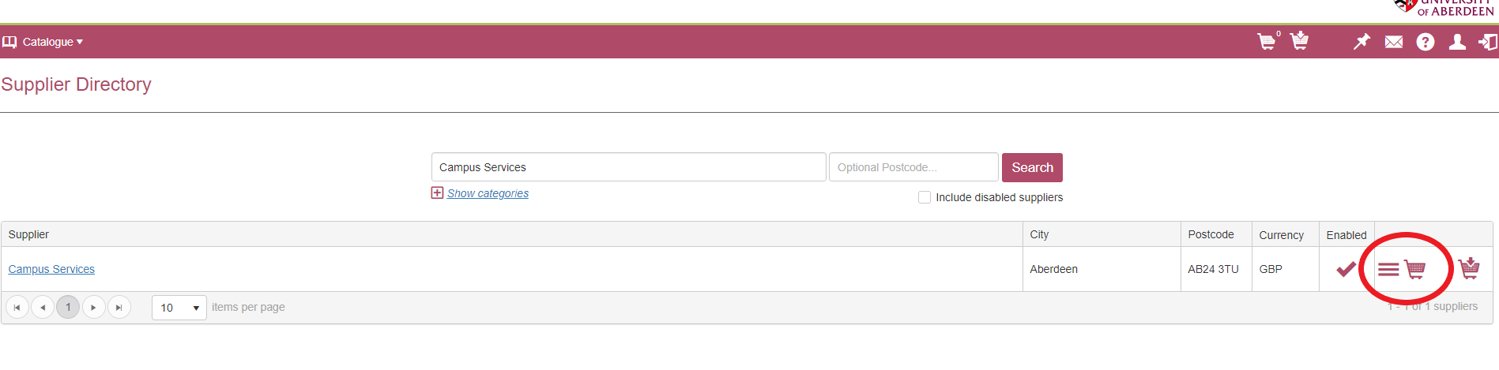

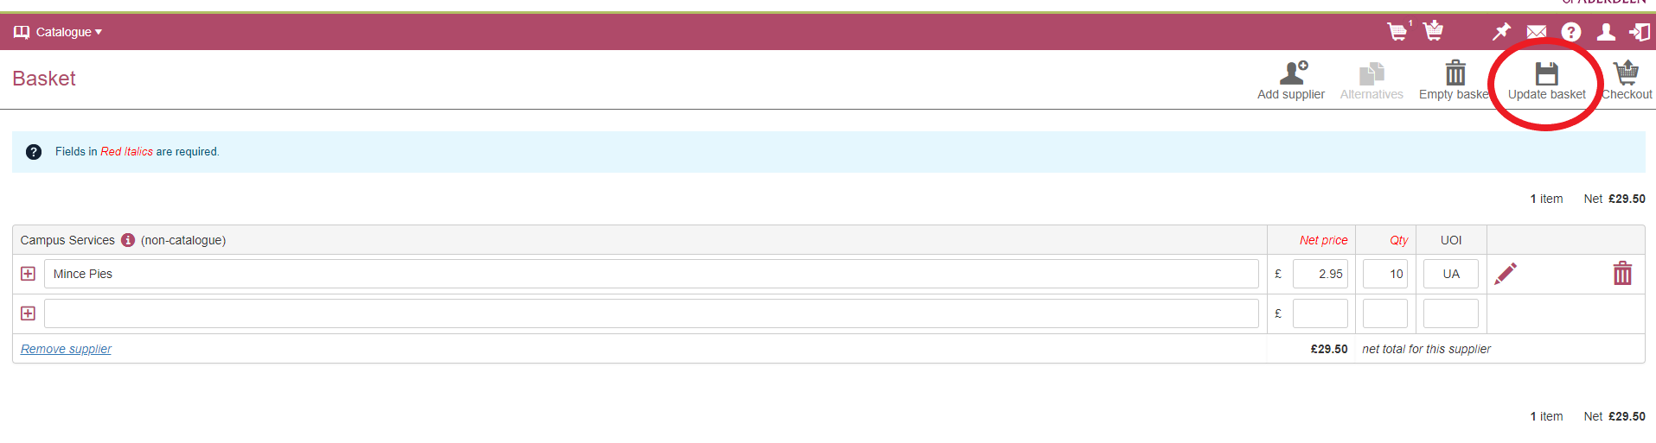
- Click Assign Codes and allocate the most suitable category from the lists above *Tip – There may not be a suitable category for the item, match as closely as possible* > Click Assign All > Click Continue which will redirect you back to the OneSource System
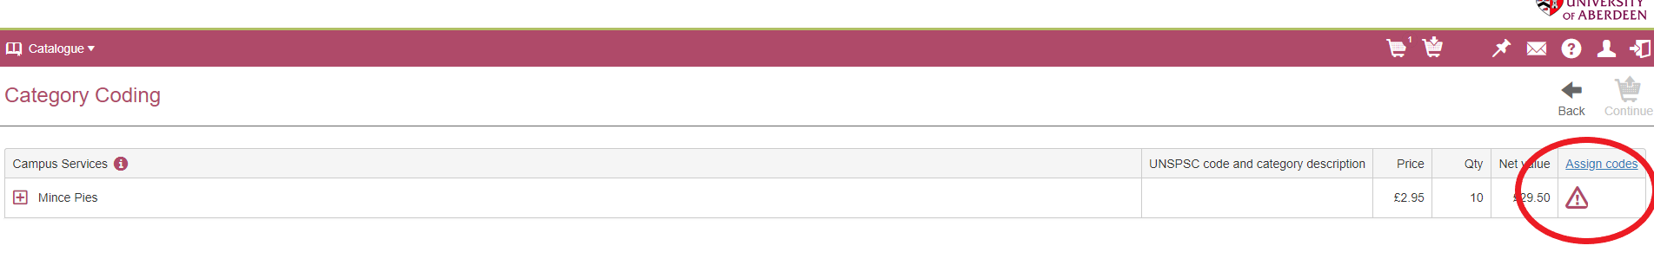
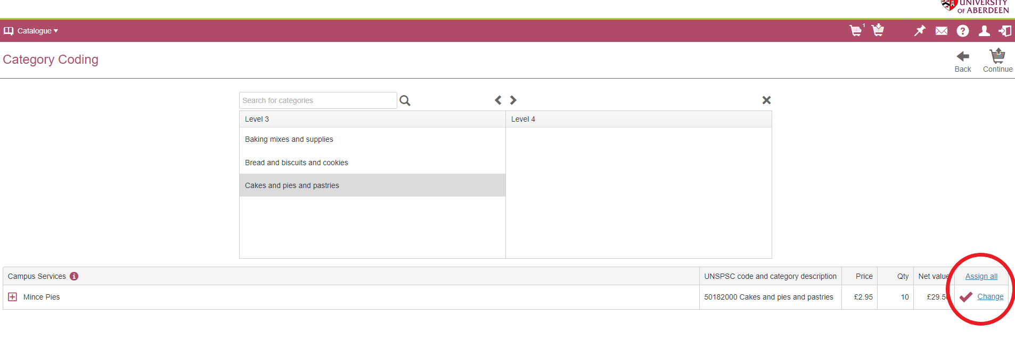
- Follow steps 6 to 12 as detailed above

